臺北市立瑠公國民中學106學年度第一學期第一次段考七年級英語科試卷
七年___班 座號：___ 姓名：__________
範圍：翰林版Starter, Unit1~ Review 1
※選擇題請用2B鉛筆在電腦卡上劃記;非選擇題請用藍色或黑色原子筆在答案卷上作答

第一部分:聽力測驗 (第1-15題，共15題， 20%)
- 辨識句意：選出符合句子描述的圖片。(每題1分, 5%)
1.（ ）(A)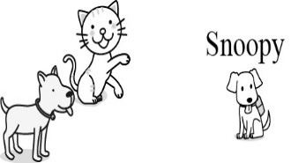(B)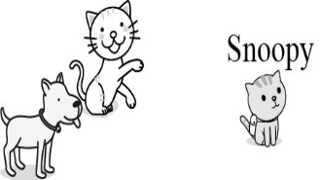
(C) 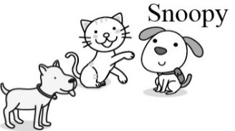
2.（ ）(A)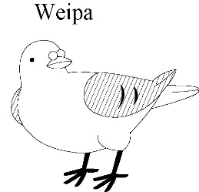(B)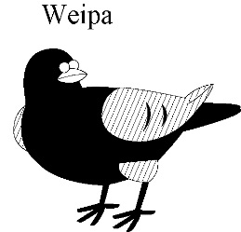
(C)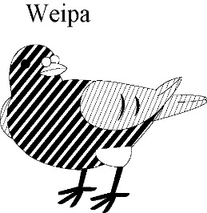
3.（ ）(A)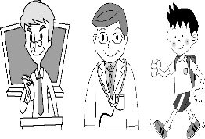 (B)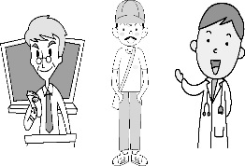
(C)
4. （ ） (A)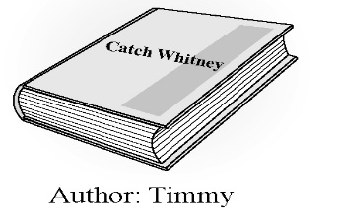(B) 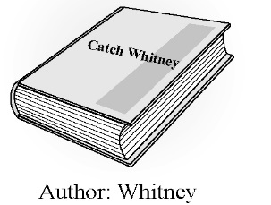
(C) 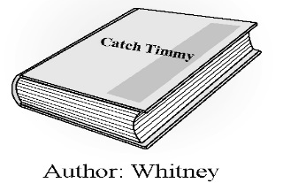

5.（ ）(A)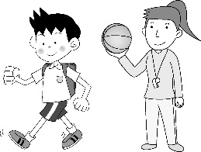 (B)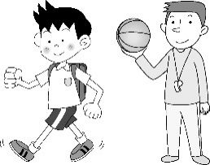
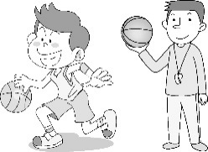
(C)
B. 基本問答：選出最適合的回答，完成對話。
(每題1分, 5%)
- (A) He is Mary’s cousin. (B)He is a nice student.
(C) He is very fine.
- (A) She is seven. (B)She is a new student.
(C) She is fine.
- (A) 3152-9650. (B) AVX-425. (C) Number 7.
- (A) He is at the park. (B) He is an doctor.
(C)He is seventy-two.
- (A)Wow! How good they are!
(B) Wow! They are tall and beautiful girls.
(C) Wow! Sharon and Scott are at the park.
  - 言談理解：請聽對話或短文，選出問題最適合的答案。
(每題2分, 10%)
- (A) Paul. (B) Helen. (C) Catherine.
- (A) Dru. (B) Gru. (C) Magro.
- (A) Andolf’s father. (B) Andolf’s grandmother.
(C) Helen’s father.
- (A)John. (B) Ted. (C) Billy.
- (A)Twenty-five. (B)Thirty. (C)Fifty.
第二部分:第16-40題，共25題，40%
Ｄ. 單題 （第16-25題，共10題，10％, 每題1分）
- Miss Chen is my pretty English teacher. I am
good student.
(Ａ) our (Ｂ)your (Ｃ)her (Ｄ)his
- This is ____ new bike, not ____ ugly one.
(A) an; an (B) a;a (C) an; a (D) a; an
- Helen and Hank’s father _________ a doctor.
(Ａ)am (Ｂ)is (Ｃ)are (Ｄ)X
- A﹕___________ a teacher?
B：Yes, I am.
(Ａ)Is she (Ｂ)Are you
(Ｃ)Are they (Ｄ)Isn’t he
- A：_________is your father?
B：He isn’t very well.
(Ａ) How (Ｂ)What (Ｃ)Who (Ｄ)How old
- A：Is your mother’s phone number 0921-121-321?
B：_______________
(Ａ)Yes, it is her number.
(Ｂ)Yes, it’s my father’s number.
(Ｃ)No. it’s her number.
(Ｄ)No. It is her number.
- Iron Man﹕How’s Captain America’s new car?
The Hulk﹕____________
(A) Really? (B) He’s cool!
(C) It’s great! (D) See you later!
- A：_______________
B：She is Tiffany.
(Ａ)Is that girl, Tiffany, your sister?
(Ｂ)Who is that tall girl in the park?
(Ｃ)How old is that tall girl?
(Ｄ) What’s Tiffany’s phone number?
- A：Is our grandfather happy?
B：No, ______________
(Ａ) he isn’t. He is very sad.
(Ｂ)he’s not. He is very happy.
(Ｃ)she is. She is very sad.
(Ｄ)they aren’t. They are happy.
- A： How old are you?
B：________________
(Ａ)I’m sad, and you? (Ｂ)Not very well.
(Ｃ) Yes,I’m 13 years old. (Ｄ) I’m 13 years old.
E. 題組（第26-40題，共15題，30％, 每題2分）
克漏字選擇（第26-30題）
Hi, my name is Elsa. Anna is 26. sister. She is 16. She is nice and pretty . Kristoff is a kind and 27. boy. He can lift me and Anna on his shoulders. Olaf is 28. small Snowman. He is happy, and we are happy, 29.  *lift舉起 *shoulders肩膀 | 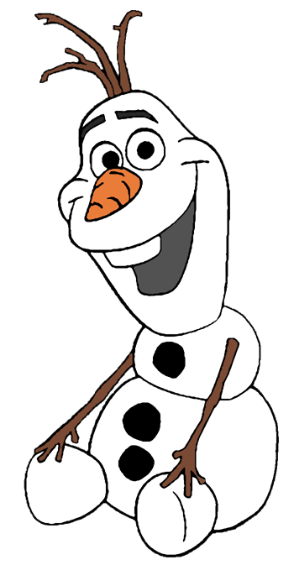
- (A) a (B) its (C) it’s (D) my
- (A) strong (B) weak (C) ugly (D)full
- (A) an (B) X (C) a (D) the
- (A) either (B) too (C) X (D) really

(In the park)
Patty﹕Good morning. I’m Patty Lin.
Amy﹕ 30. Patty. I’m Amy Brown.
Nice to meet you, Amy.
Patty﹕ 31.
Amy﹕Who is the tall girl in your cellphone? She is
very beautiful.
Patty﹕ 32. She’s Sophia, my sister.

- (Ａ) Good morning. (Ｂ)Good evening.
(Ｃ) Good afternoon. (Ｄ)Thank you.
- (A) Nice to meet you, too. (B) Thank you.
(C)Hello! I’m fine. (D)You are welcome.
- (A) How cute! (B) Thank you.
(C) I’m, too. (D) Very well.

四、閱讀測驗：10％（每題2分）
This is my family tree.
Ken (79)

Mark
(50)
Scott
(48)
I
(20)
David
(18)
Lisa (81)

)
May(47)
Emma
(50)
Gina (16)

- Who are not husband and wife?
(A) David and Gina. (B) Ken and Lisa.
(C) Scott and May. (D) Mark and Emma.
- Is Scott Lisa’s son?
(A) No, she isn’t. (B) No, he isn’t.
(C) Yes, he is. (D) Yes, she is.
- Who is Gina’s uncle?
(A) David. (B) Ken.
(C) Scott. (D) Mark.
- My father is Ken. My mother is Lisa. I’m fifty
years old. Who am I?
(A) David. (B) Emma. (C) May. (D) Scott.

Momotaro is young. He is a 6 –year-old boy. He is a smart and cute boy. He is very strong. He can move a heavy desk.
There are many people in Momotaro’s family. They are Momotaro, his father and mother. They are eighty years old. They are old but kind. His mother is a tailor and his father is a farmer. His father grows apples. They live in a small town.
A dog, a cat and a rabbit are Momotaro’s good friends.

*heavy 重 *tailor 裁縫師 * grow種植 *town鎮
- How many family does Momotaro have ?
(A) Five (B) Two (C) Three (D) Four
- Isn’t Momotaro weak ?
(A) Yes, he isn’t strong. (B) Yes, he is weak.
(C) No, he isn’t weak . (D) No, he isn’t strong.
- What is not his friend?
(A) A dog. (B) A cat. (C) A rabbit.(D) A chicken.
- 選錯的描述
(A) Momotaro’s father and morther are 80 years
old.
(B) Momotaro’s father grows apples.
(C) Momotaro is ugly.
(D) Momotaro’s six years old.
第三部分:非選擇題 (第41-55題，共16題，40%)
F. 文意字彙,（第41-50題，共10題，20%, 每題2分）
41. A︰Is Leo your c n ?
B︰Yes. His dad and my mom are brother and sister.
42. The girl is a new student in my class. She’s my
c te.
43. The comic book, the Avengers, is my f e. I
love it very much.
44. My grandmother is a h fe . She cooks for
our family.
45. John is k d to old people(人). He likes to
help(幫助) them.
46. A: I am h y now.
B: How about some cookies(餅乾)? They’re good to eat.
47. My pretty English teacher is twenty-two years old. She is y g.
48. Mr.White has two kids(小孩). Mark is his son, and Mary is his d er.
49. I think Shrek is not ugly. He is nice and h e.
50. Lisa’s mom is a n se. She works at a hospital
(醫院).

G.依提示作答,8%(第51-54題，每題1分;第55-56-每題2分)
(一) 請以印刷體寫在格線裡2%（每題1分）
51. TECHNOLOGY大寫改成小寫

52. earthquake小寫改大寫

(二)改正下列句子書寫格式上的錯誤，寫出正確答案2%
53. ( ) It’s name’s Pipi.
54. ( ) Howis their father?
55. 寫出阿拉伯數字的英文寫法 2%
Fifteen+twenty-six = ________.
56. This is David. He is a ________. 2%

H.中翻英,請將答案寫在劃線上12%(第57-59題，每題4分)
57. 你可愛的朋友,Lucky不是一隻老狗嗎?是的,牠是。
58. 他的叔叔是一個廚師也是個籃球教練。
59. 看這張照片！這女人是我漂亮的阿姨。
※ 試題結束

