臺北市立瑠公國中 106 學年度 第 1 學期 九年級 第 1 次定期評量 英語科 試題

第1頁 共3頁

- 辨識句意：選出符合句子描述的圖片。5%
1.（C）
Ａ) 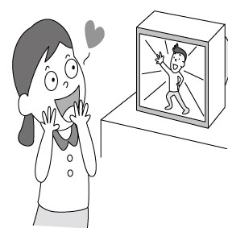 Ｂ) 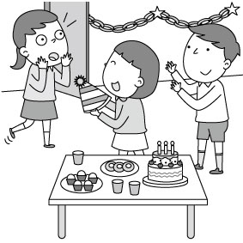 Ｃ) 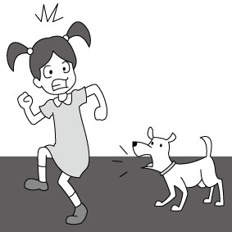
2.（A）
Ａ) 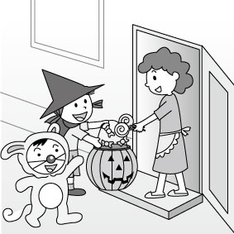Ｂ) 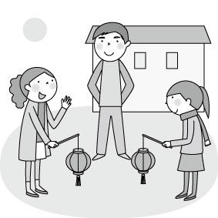Ｃ) 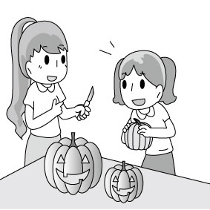
3.（A）
Ａ) 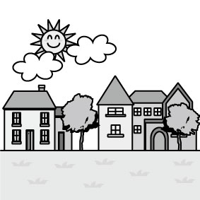Ｂ) 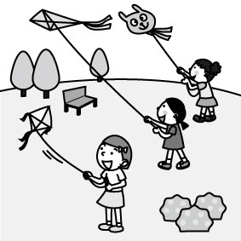Ｃ) 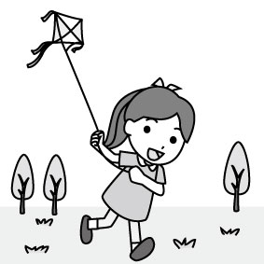
4.（C）
Ａ) 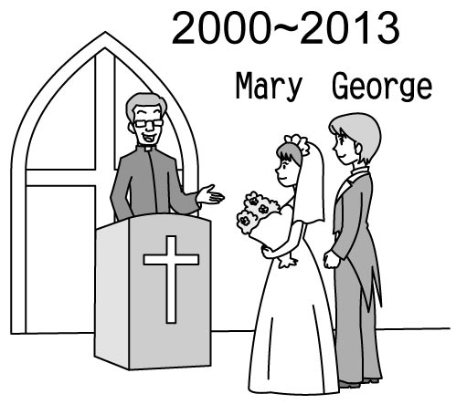Ｂ) 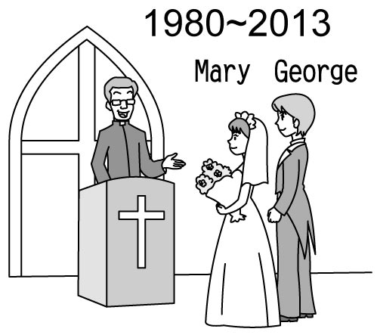Ｃ) 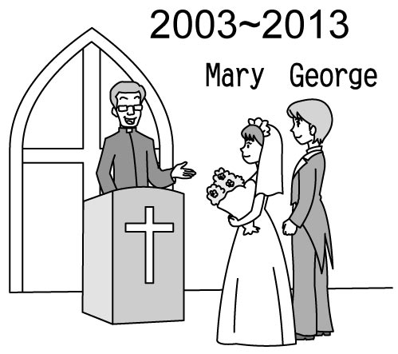
5.（B）
Ａ) 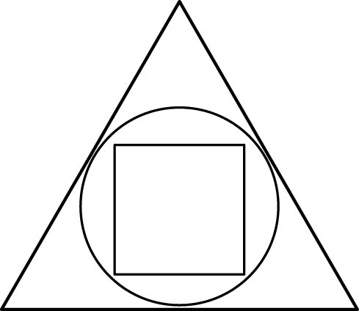 Ｂ) 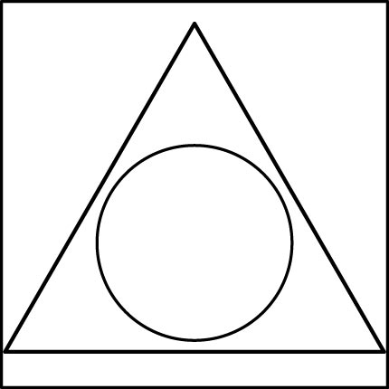 Ｃ) 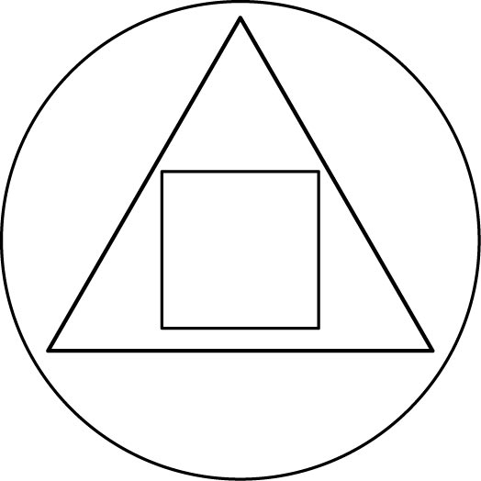

二、基本問答：根據聽到的內容，選出最適合的回應。5%
6.（C）(Ａ) Great. And you?
(Ｂ) I was at the museum.
(Ｃ) I’ve been there twice.
7.（C）(Ａ) Yes, umbrellas are perfect gifts.
(Ｂ) No, I don’t use paper umbrellas.
(Ｃ) Yes, many times.
8.（B）(Ａ) I’ve never been short.
(Ｂ) You’re the tallest person in the world.
(Ｃ) I’m five feet and six inches tall.
9.（A）(Ａ) Why not clean the house? It’s very dirty.
(Ｂ) I got as bored as you.
(Ｃ) I’m bored with everything.
10.（B）(Ａ) Yes, she can swim well.
(Ｂ) No, she doesn’t like to swim.
(Ｃ) Yes, she is practicing swimming.

三、言談理解：根據聽到的內容，選出最適合的答案。10%
11.（C）(Ａ) The woman bought a paper umbrella from the man.
(Ｂ) The man thinks that circles can bring him good
luck.
(Ｃ) The woman didn’t believe the man.
12.（A）(Ａ) Swept the floor.
(Ｂ) Swept and mopped the floor.
(Ｃ) Mopped the floor and thrown away the trash.
13.（A）(Ａ) “My Heart Will Go On” is a song from a movie.
(Ｂ) The woman loves the background music of the
movie.
(Ｃ) The man is watching Titanic with the woman.
14.（C）(Ａ) The woman thinks the games are interesting.
(Ｂ) The woman thinks the baseball games are boring.
(Ｃ) The woman thinks the man is boring.
15.（B）(Ａ) A picture.
(Ｂ) A house.
(Ｃ) A letter.

四、綜合選擇。40% (每題2分)
16.( )Ms. Brown is ____ at telling stories, so all her students
enjoy story time in her class very much.
A)strange B)creative C)crazy D)excellent
17.( )Taking too many tests and having too much homework are boring ____ students.
A)at B)with C)in D)to
18.( )How amazing! The lanterns on the festival come in
different sizes and ____.
A)holes B)shapes C)brains D)reports
19.( )We had better put the medicine in a higher place to make
sure the kids won’t ____ it.
A)reach B)trick C)trust D)separate
20.( )Taylor has learned playing the guitar ____ she was five.
She hopes she will become the top guitar player someday.
A)since B)as C)for D)by
21.( )With modern knowledge, now students are used to(習慣) getting ____ on the Net.
A)backgrounds B)leather C)information D)parades
22.( )Many people have trouble falling asleep, but ____. In
my case, I can fall asleep even within three seconds.
A)seeing is believing
B)it makes sense of our world
C)I can’t make heads of tails of it
D)I can’t help it
23.( )The room isn’t bright enough. You need a ____.
A)ring B)comb C)wallet D)lamp
24.( )A: Have you ever ____ Meinong to experience Hakka
culture?
B: Sure, twice.
A)visited to B)gone to C)been to D)went to
25.( )Ken: ____?
Amanda: This year is my twentieth year.
A)How did you like teaching?
B)When did you get your first teaching job?
C)How often do you teach?
D)How long have you been a teacher?

※背面有題，請繼續作答※
26.( )I didn’t feel ____ failing my science exam again. I
didn’t prepare for it at all last night.
A)surprised B)surprised at
C)surprising to D)surprising that
27.( )I like the shirt but not its color. Do you have one in
____ color?
A)another B)certain C)everyday D)other

(28-32)
Many people in Taiwan celebrate the Ghost Festival _28_ the seventh lunar month. They believe _29_ are ghosts coming out at a certain time of the year. Americans also have a day for ghosts. They call it Halloween. Children feel excited _30_ trick-or-treating. They usually wear masks or costumes and go door to door to _31_ candy. To everyone’s surprise, they won’t go home until they __32__ their bags.
28.( )A)on B)at C)in D)between
29.( )A)that B)there C)it D)this
30.( )A)in going B)because C)about go D)to go
31.( )A)pay for B)decide on C)work on D)ask for
32.( )A)show off B)fill up C)check out D)get to

(33-37)
Kevin,
How have you been? I’ve never _33_ you for months. This semester, I joined the origami club. Doing origami _34_ students. No wonder there are so many members in it. It is interesting _35_ we don’t need to cut with scissors or paste with glue to turn a piece of paper into a dragon. What club are you in at your school?
Melody’s birthday is _36_. It’s on October fifteenth. She is going to have a birthday party at her house that night. Let’s go to her party together, _37_? We will have a whale of a time then. Wish you good luck!
Sincerely,
Terry
semester學期； origami摺紙
33.( )A)heard of B)heard C)reached to D)heard from
34.( )A)excites B)is excited about
C)is bored with D)interested in
35.( )A)to B)that C)in D)this
36.( )A)a piece of cake B)so far so good
C)not my cup of tea D)around the corner
37.( )A)isn’t we B)will you C)shall we D)all right

(38-40)
In Western countries, people celebrate Halloween on October 31st each year. Here in Taiwan, we honor the dead with a whole month. We call it the Ghost month.
It is believe that, on the first day of the seventh month on the Chinese calendar, the gate to Hell opens, and all the ghosts come out to the world, visiting their family, having big meals, and even looking for victims. The living will then prepare all kinds of food and burn paper money for both their own ancestors and other ghosts without family. Since it’s a time specially for the dead, the living will try their best not to get in the way of them in order
第2頁 共3頁
to keep themselves from bad luck. For example, this month, people will avert activities like going out during the night, taking trips, moving into new places, getting married, or starting a new business. Also, parents will tell their children not to get near the water or the ghosts in the water may take them away.
Believe it or now, it’s always a wise move to show your respect for the dead.
honor紀念；Hell 地獄；victim 受害者；ancestor祖先；respect尊重

38.( )What can we learn about the Ghost Month from the
reading?
A)The gate to Hell opens only once a year at the end of the
seventh month.
B)People put on costumes to show their respect for the
dead.
C)In the Ghost month, it’s quite lucky to get married.
D)The living will show their respect to the ghosts by
treating them with big meals.
39.( )What does avert mean in the reading?
A)Try new things. B)Not to do something.
C)Prepare something. D)Work hard on something.
40.( )According to the reading, which is NOT a bad thing to do during the Ghost Month? according to根據
A)Swimming in the river.
B)Taking a walk after dinner at the park.
C)Opening a new Chinese restaurant.
D)Burning paper money for the dead.

(41-42)
You Raise Me Up
By Brenda Graham
When I am down, oh my soul, so weary;
When troubles come and my heart burdened be;
Then, I’m still and wait here in the silence,
Until you come and sit awhile with me.

You raise me up so I can stand on mountains.
You raise me up to walk on stormy seas.
I am strong when I am on your shoulders.
You raise me up to more than I can be.

There’s no life - no life without its hunger;
Each restless heart beats so imperfectly;
But when you come and I am filled with wonder,
Sometimes, I think I glimpse eternity.

You raise me up so I can stand on mountains.
You raise me up to walk on stormy seas.
I am strong when I am on your shoulders.
You raise me up to more than I can be.
weary疲憊的； burdened有負擔；restless不平靜的；
imperfectly不完美的；glimpse瞥見；eternity永恆
41.( )What does stormy seas mean in the song?
A)Difficult times. B)Happy hours.
C)Big waves. D)wooden lands.
※請繼續作答※
42.( )What is the writer trying to say through the song?
A)The higher you fly, the farther you’ll see.
B)Nobody is perfect. Everyone may make mistakes.
C)You help me become a better person than I think of
myself.
D)There’s no mountain too high for me to climb.

第43~56題 請在答案卷上作答

五、文意字彙。10% (每題2分)
43.________ A: Why don’t you put it in an envelope before you
send it?
B: I don’t have to. It is a p____d.
44.________ People under eighteen years old can’t see the movie.
It is for a____ts.
45. ________ A: What l____e do most people speak in the USA?
B: English.
46.________ In the 21 century(世紀), it is p____e for us to
take a trip to the moon.
47.________ I got the idea from the TV p____m, and it will be on
later at 7 p.m.

六、請填入附加問句。6%
48. There won’t be any parties or concerts here in our town, ____?
49. Jane has to hand in her homework on time, ____?
50. I am proud of you because you won the champion(冠軍) this
time, ____?
51. Mr. and Mrs. Lin have never visited Meinong Hakka Cultural
Museum, ____?
52. Getting up early on a cold morning is not easy, ____?
53. That’s our new history teacher, ____?

七、中翻英。 10%
54.你認為他對聽鬼故事感到害怕嗎? 3%。
55. Ethan在紙上畫了一個正方形和四個三角形，不是
嗎?。3%
56.為了保險起見，我已經決定送他們一對紙傘當作結婚禮物。
4%

※試題結束※

第3頁 共3頁

