台北市立瑠公國民中學106學年度第一學期八年級第一次段考 英語科 考試卷
年 班 座號： 姓名：

第一部分：聽力測驗 25 %
- 辨識句意：根據聽到的內容，選出符合描述的圖片或符合圖片的描述。(每題1分，共5分)
- (Ａ) 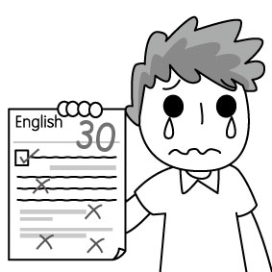 (Ｂ) 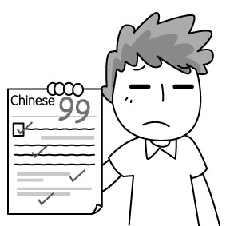 (Ｃ) 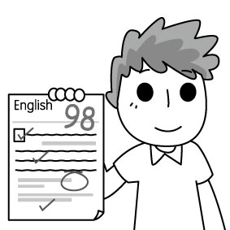
- (Ａ) 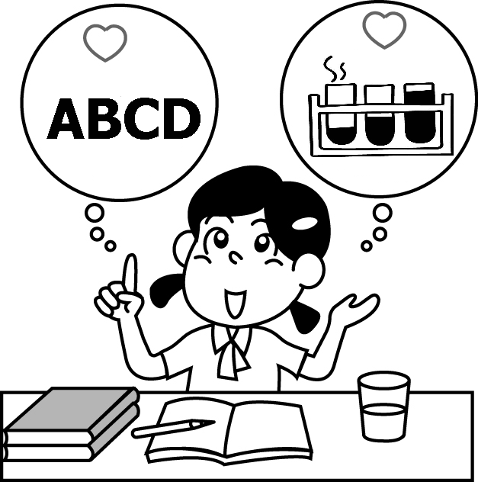 (Ｂ) 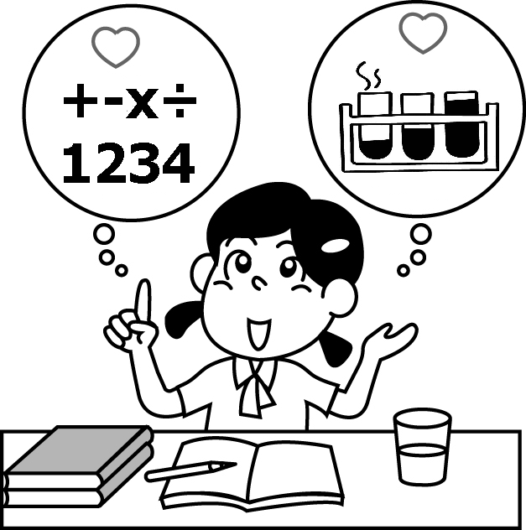 (Ｃ) 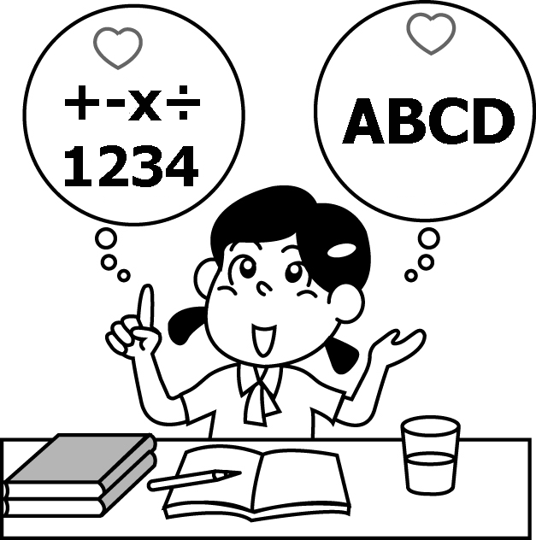
- (Ａ) 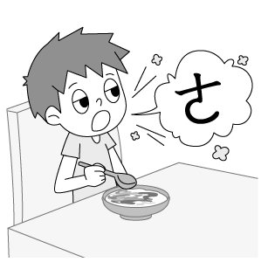 (Ｂ) 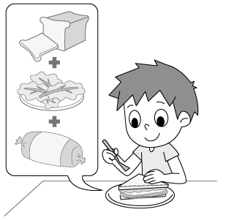 (Ｃ) 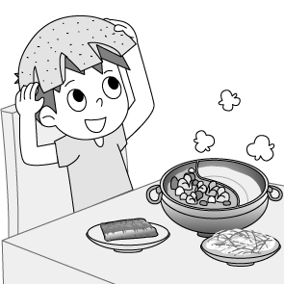
- (Ａ) 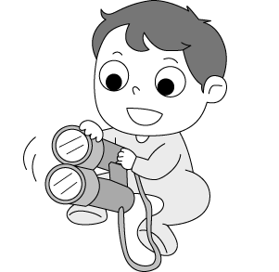 (Ｂ) 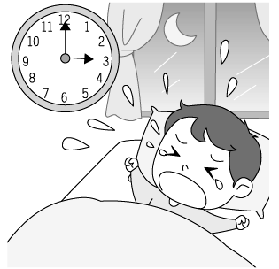 (Ｃ) 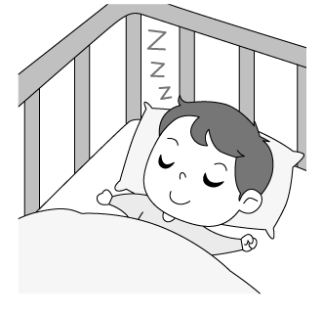
- (Ａ) 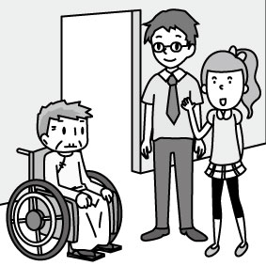 (Ｂ) 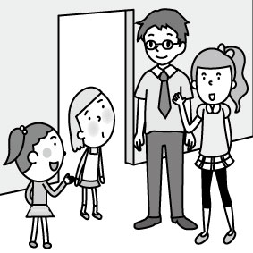

(Ｃ) 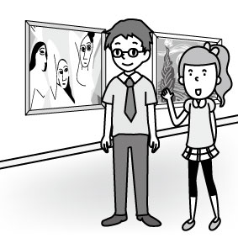
- 基本問答：根據聽到的內容，選出一個最適合的回應或最適合的問句。(每題2分，共10分)
- (Ａ) Yes, he did. We had much fun.
(Ｂ) Yes, he played baseball with me.
(Ｃ) He plays cards every night.
- (Ａ) Yes, I hated the days so much.
(Ｂ) Not really. There were too many tests.
(Ｃ) Yes, I was a junior high school student then.
- (Ａ) Me, too. I miss my grandparents very much.
(Ｂ) I’ll make some moon cakes for Moon
Festival.
(Ｃ) You can get together with your family on
Chinese New Year.
- (Ａ) Because today is my birthday.
(Ｂ) Mr. Smith opened a toy shop two years ago.
(Ｃ) They’re from my cousin. He sent them to me
last week.
- (Ａ) Let’s visit him someday.
(Ｂ) Let’s buy him a cake.
(Ｃ) Let’s go together.

- 言談理解：根據聽到的內容，選出一個最適合的答案。(每題2分，共10分)
- (Ａ) She asks questions and finishes worksheets
with her classmates.
(Ｂ) She tells interesting stories and plays games.
(Ｃ) She only listens to the teacher.
- (Ａ) The woman sold moon cakes on the Moon
Festival.
(Ｂ) The Moon Festival is coming.
(Ｃ) The man sold the moon cakes with the
woman.
- (Ａ) In the song, the goddess was married with a
man.
(Ｂ) The woman was listening to a love story.
(Ｃ) Samuel Harris sang a song about a goddess
and a man.
- (Ａ) Computers and books.
(Ｂ) Only computers.
(Ｃ) Nothing.
- (Ａ) The man likes to eat dumplings.
(Ｂ) The woman bought a lot of foods.
(Ｃ) They are having their dinner in a restaurant.

第二部分：選擇題 28 %
克漏字 (每題1分，共16分)
A.
Cindy: Hi! Joe! How was your birthday?
Joe: It was great! I went to a children’s home and
donated my toys to those children.
Cindy: Wow! It’s your birthday and why did you give
them __16.__?
Joe: I have many toys, but the kids at the children’s
home __17.__.
Cindy: You’re really __18.__! What did you donate?
Joe: A cap and two __19.__ of Nike shoes.
Cindy: They are not cheap. Did your parents __20.__
them for you?
Joe: No. They were from my uncle. He sent them to
me from the USA.
Cindy: Did the kids at the children’s home do anything
special for you?
Joe: Yes, they made a big cake for me and the principal of children’s home thanked me __21.__.
*principal 校長
16. (A) picnics (B) lessons (C) vests (D) presents
17. (A) aren’t (B) weren’t (C) don’t (D) didn’t
18. (A) generous (B) interesting
(C) sound (D) handsome
19. (A) pair (B) pairs (C) deck (D) decks
20. (A) lend (B) give (C) buy (D) sell
21. (A) in person (B) in the past
(C) in the world (D) through the game

B.
In the past, English was not an easy subject to me. I listened to the teacher in class and __22.__ for tests very morning but I was never good at English. Things were different because __23.__ happened to me. One summer night, the goodness of English came to me and she was beautiful so I __24.__ her right away. Then she kissed me __25.__ my head. __26.__ the magic kiss, I could read English faster. Thanks to the goodness, I now have new hope for English.

22. (A) study (B) am studying (C) studied (D) studies
23. (A) special something (B) something special
(C) special any things (D) anything special
24. (A) fell in love with (B) woke up
(C) took a test with (D) played cards with
25. (A) on (B) in (C) by (D) to
26. (A) Because (B) Because of
(C) Thanks (D) For

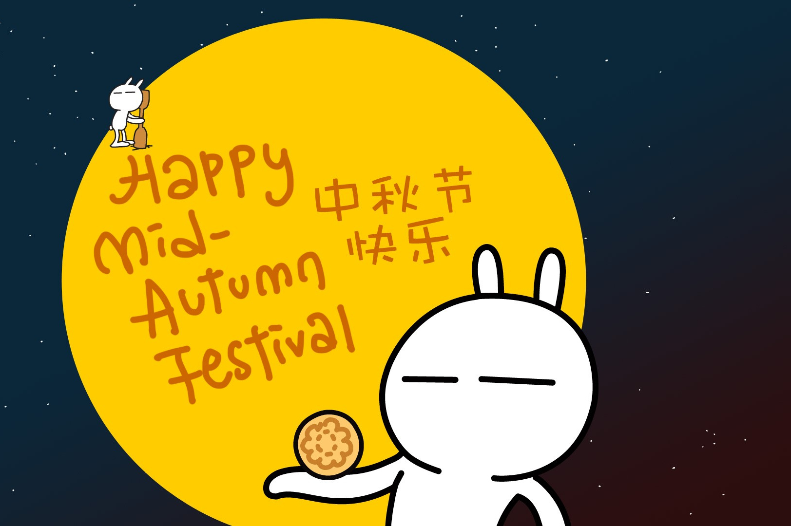
C.
David: What did you do on
the Moon Festival?
Susan: It was rainy __27.__
we didn’t have a
barbecue under the moonlight. My family and I
went to our tree house together.
David: I know that tree house! We used to play there
10 years ago. __28.__ that tree house
still great?
Susan: Of course! We did many things there. My parents read a fun story and my brother __29.__ a magic trick.
David: How about the yellow sofa inside the tree
house?
Susan: It __30.__ great before, but it is very old now.
And look! I found a blue cap there.
Is this blue cap __31.__?
David: No, that’s Tony’s. Mine is red. Did you have a
good time?
Susan: You bet! It was a wonderful evening.

27. (A) or (B) but (C) so (D) because
28. (A) Is (B) Does (C) Was (D) Wasn’t
29. (A) perform (B) performs
(C) is performing (D) performed
30. (A) is (B) are (C) was (D) were
31. (A) your (B) yours (C) his (D) ours

閱讀測驗 (每題2分，共12分)
A.
Most people in Asia have fun on the Moon Festival. For many, this means eating moon cakes, having barbecue and spending time with family. But in the small area of Hong Kong known as Tai Hang, the Moon Festival is the same as the Fire Dragon Dance, which lasts for three days. For more than 100 years, the people of Tai Hang have had this special tradition during the Moon Festival.
People in Tai Hang had this Fire Dragon Dance because they wanted to get rid of the bad luck in 19th century. And it took hundreds of people to parade the burning dragon through the streets because it is so long and heavy. They take turns lifting the dragon’s body as it dances through the streets. The strongest men among the group have a chance to take the 48-kilogram head and lead the dance. What an amazing show!
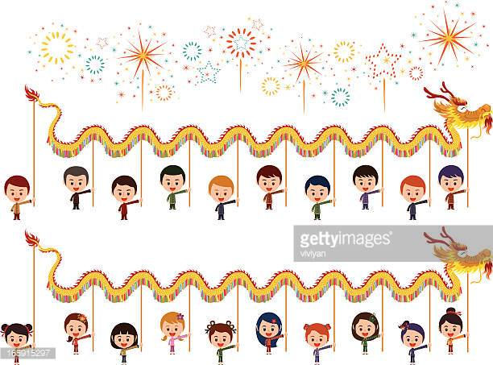

* Asia亞洲 last 維持 tradition傳統 buring燃燒的
get rid of 擺脫 parade 遊行 lead引導 celebrate 慶祝

32. What might not people in Asia do on the Moon
Festival?
(A) To watch TV with their family
(B) To make moon cakes
(C) To walk with people on the street
(D) To eat Zhong-zi(粽子)

33. Why did people in Tai Hang do the Fire Dragon
Dance during the Moon Festival?
(A) They like to dance.
(B) They want to see the fire.
(C) They don’t want bad luck.
(D) They don’t like dragon.

34. According to the article, which is NOT true?
(A) The head of the fire dragon is the heaviest of its
body.
(B) People in Tai Hang celebrated the Moon Festival
for more than 1 days.
(C) The fire dragon burns when people dance on the
street.
(D) The Fire Dragon Dance is a new way for Chinese
people to celebrate the Moon Festival.

Echo and Narcissus
Echo was a wood nymph. She talked too much so Hera, the queen of the goddess, took her voice and she could only say the same words made by others. One day, Echo walked into the woods and met a handsome young man, Narcissus. She fell in love with him right away.
One day, she saw Narcissus looking into a river.
"Come to me," Narcissus said, looking into the water.
"Come to me," Echo said.
"Who's there?"Narcissus said.
"Who's there," Echo said loudly.
"Stop that!" Narcissus said.
"Stop that!" Echo said.
"Let's meet," Narcissus said.
"Let's meet!" Echo said happily.
She showed up in front of Narcissus.
"Go away," Narcissus shouted at her.
"Go away," Echo said sadly.
Echo went sadly away.
Echo was so sad and then she died. Her voice lives forever and answers men’s words from afar. Narcissus kept going back to see the man in the river but he didn’t know that it was his reflection. Day after day, he loved his reflection too much and he kissed the man in the river. Then he fell into the river and never showed up. In the end, there was a beautiful white flower growing from where he fell in the river. That was the flower that we called ‘Narcissus.’
* nymph 仙女 voice聲音 woods 森林 reflection倒影

35. Where might be a better place for people to hear
the ‘echo’?
(A) A classroom
(B) A mountain
(C) A swimming pool
(D) Taipei 101

36. When you say someone is a ‘narcissus,’ what
might be the man like?
(A) A man likes to share everything
(B) A man likes to grow flowers.
(C) A man likes to swim in the river.
(D) A man likes himself very much.

37. What does the flower, Narcissus, look like?


(A) (B)


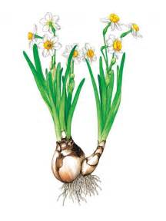
(C) (D)

第三部分：手寫題 47%
一、文意字彙 (每題2分，共18分)
_____ 1. During our stay in France, we v____ted
many beautiful churches there.
_____ 2. Josh told his son that he couldn’t do anything
until he f____hed all his homework.
_____ 3. I just could answer some of the q____ns on
the test, so I only got forty.
_____ 4. Jason was tired of his work, so he decided to
take a v____n. He planned to go to Hawaii
and enjoy the beautiful beach.
_____ 5. Much to our s____e, Charlie lost the games.
We thought he would win the game.
_____ 6. After living in the hospital for a long time,
Jason learned a l____n that he can’t drive
car when he is tired.
_____ 7. A: What did you learn in sc____ce class
today?
B: Some fun things about frogs.
_____ 8. There are binoculars on the 91st f____r in the
Taipei 101 building.
_____ 9. Everyone loves the big robot—the kids
n____ed it Robert.

二、依括號內的提示，填入正確的所有格代名詞 (每格2分，共10分)
1. The dolls are __1.___ (their dolls.) And __2.__ (our dolls) are there.
2. A: Whose hat is it on the door?
B: It’s ___3.___ (Karen’s hat).
3. A: Is the basketball yours?
B: No. It’s ___4.___ (those girls’ basketball).
4. Your watch is new, but __5.___ (his watch) is old.

三、寫出下列動詞的過去式 (每題2分，共12分)
1. go →
2. hope →
3. plan →
4. worry →
5. play →
6. put →

四、翻譯題 (共7分)
1. 我們透過遊戲學習數學。(3分)
2. 我比賽前吃了太多月餅，所以我在唱歌時打嗝了兩次。(4分)

-- 試題結束 --

