台北市立瑠公國民中學106學年度第一學期七年級第三次段考 英語科 考試卷
年 班 座號： 姓名：

第一部份：聽力測驗 25%
- 辨識句意：根據聽到的內容，選出符合描述的圖片或符合圖片的描述。(每題1分，共5分)
- (Ａ)(Ｂ) 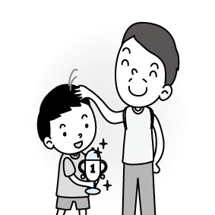(Ｃ) 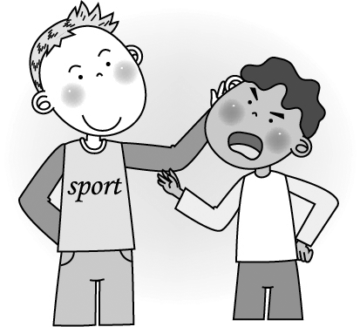
- (Ａ) 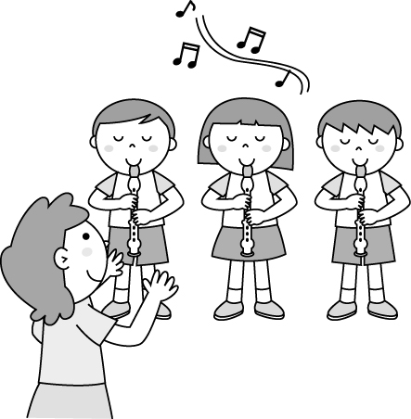 (Ｂ)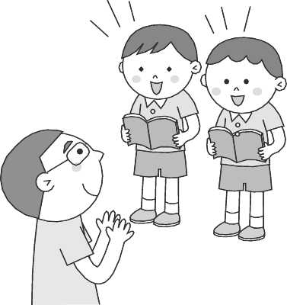(Ｃ) 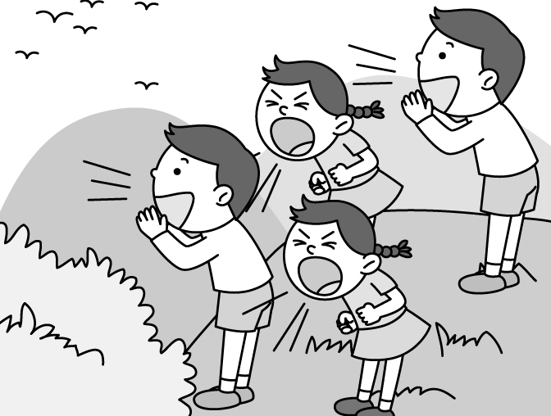
- (Ａ) 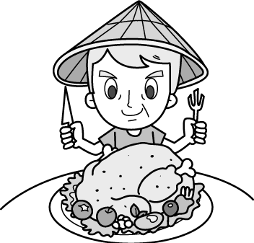 (Ｂ)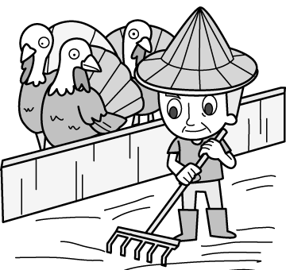(Ｃ) 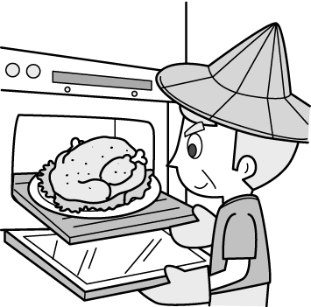
- (Ａ)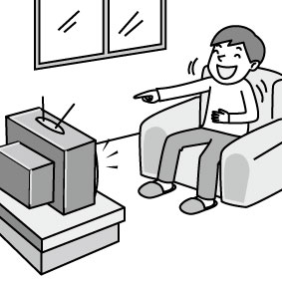(Ｂ)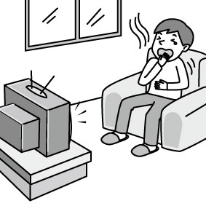(Ｃ) 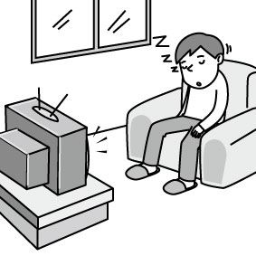
- (Ａ) 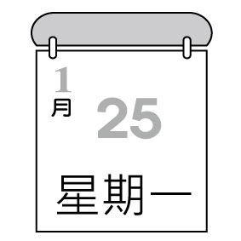(Ｂ)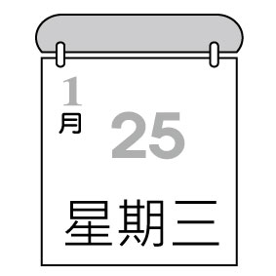(Ｃ)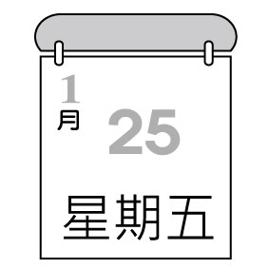
- 基本問答：根據聽到的內容，選出一個最適合的回應或最適合的問句。(每題1分，共5分)
- (Ａ) Don’t talk.
(Ｂ) Wait for me.
(Ｃ) It’s so yummy.
- (Ａ) Wow. Thanks.
(Ｂ) Don’t open it, please.
(Ｃ) Let’s sing a birthday song.
- (Ａ) Please don’t cry at the park.
(Ｂ) He is having a great time.
(Ｃ) Let’s go help him.
- (Ａ) She is from America.
(Ｂ) Her songs are really great.
(Ｃ) She is very nice and beautiful.
- (Ａ) Coco’s concert is over there. They are
singing and dancing with her.
(Ｂ) Really? There are many dogs and cats at the
park.
(Ｃ) Wow! The concert at the park is wonderful.

- 言談理解：根據聽到的內容，選出一個最適合的答案。(每題1分，共5分)
- (Ａ) Don’t take a picture.
(Ｂ) Don’t talk.
(Ｃ) Don’t look at the picture.
- (Ａ) There is a watch on Terri’s table.
(Ｂ) The watch is Terri’s.
(Ｃ) There is a superhero on Terri’s notebook.
- (Ａ) The turkeys are nervous.
(Ｂ) Mr. Smith, the farmer, is cleaning the house.
(Ｃ) There is only one turkey in the turkey house.
- (Ａ) Today is Friday.
(Ｂ) Today is Sunday.
(Ｃ) Today is Monday.
- (Ａ) Lulu’s birthday party is on Sunday.
(Ｂ) Patrick is making cards for his family.
(Ｃ) Patrick’s birthday is on Sunday.

第二部份：單選題 29%
I. 克漏字 (16-30題，每題1分；共15分) 15%
1.
(In Joe’s turkey house, the baby turkey and grandpa turkey are talking.)
B: Grandpa, __16__ are Mom and Dad?
G: They are next to the pool.
B: __17__ are they doing?
G: They are jumping up and down.
B: And what are you doing, grandpa?
G: I __18__ for Joe. Tonight is Christmas Eve.

B: Are you OK?
G: I’m __19__. Listen! Joe the farmer is coming and I’m going to his kitchen. __20__ a good turkey, my dear.
B: OK. I love you. Merry Christmas!

16. (A) Where (B) Who (C) How (D) What
17. (A) Where (B) Who (C) How (D) What
18. (A) am wait (B) am waiting
(C) is waiting (D) waiting
19. (A) dirty (B) funny (C) nervous (D) full
20. (A) be (B) being (C) is (D) are

2.
Look here, LINE friends!
This is Mr. Brown and I’m a happy farmer on my farm.
I am cleaning the pig’s house, not __21__.
I am busy __22__ my works every day.
Listen now!
Don’t be the bad boys and girls.
There are many animals __23__ a good time here.
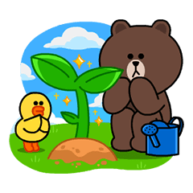
__24__ touch little animals.
Be nice to them.
__25__ jumping.
It is dangerous (危險).

21. (A) play (B) playing
(C) am playing (D) am play
22. (A) do (B) is doing
(C) to do (D) doing
23. (A) have (B) be
(C) having (D) being
24. (A) No (B) Let’s don’t
(C) Let’s not (D) Not
25. (A) No (B) Don’t
(C) Let’s not (D) Be

3.
Jason: Are you studying now, Amy?
Amy: No, I’m not.
Jason: Are you doing your homework?
Amy: __26__. I’m making a birthday card.
Jason: Wow! It’s pretty. __27__ is it for?
Amy: It’s for my favorite singer, Ed Sheeran. Are you __28__ this weekend?
Jason: Yes, I am.
Amy: Let’s go to the concert together. It’s __29__.
Jason: Cool. __30__?
Amy: He is from England.

26. (A) I see. (B) Wrong again.
(C) That’s funny. (D) Oops!
27. (A) Who (B) What day
(C) Where (D) What time
28. (A) busy (B) ready (C) free (D) thirsty
29. (A) every Saturday evening
(B) on Saturday evenings
(C) in Saturday evening
(D) on Saturday evening
30. (A) What’s his name? (B) Who is he?
(C) Where is he from? (D) How is he doing?

II.閱讀測驗 (31-37題，每題2分；共14分) 14%


A.

Time Table – TV Program
Day Time | Sun. | Mon.-Thu. | Fri. | Sat.
18:00-18:55 | CNN News | Star Wars | Pitch Perfect 3 | CNN News
19:00-19:55 | Wonder | The Greatest Showman | CNN News | Wonder
20:00-20:55 | Wonder | Frozen | A Beautiful Day | Wonder
21:00-21:50 | Coco | Frozen | A Beautiful Day | Star Wars
31. It’s nine thirty in the evening. Star Wars is on TV. What day is today?
(A) Monday (B) Wednesday
(C) Friday (D) Saturday
32. It’s seven fifteen on Friday evening. What’s on TV?
(A) Wonder (B) Coco
(C) CNN News (D) Pitch Perfect 3
33. Today is Sunday. It’s 7:45 in the evening. What’s on TV now?
(A) CNN News (B) Wonder
(C) The Greatest Showman (D) Frozen

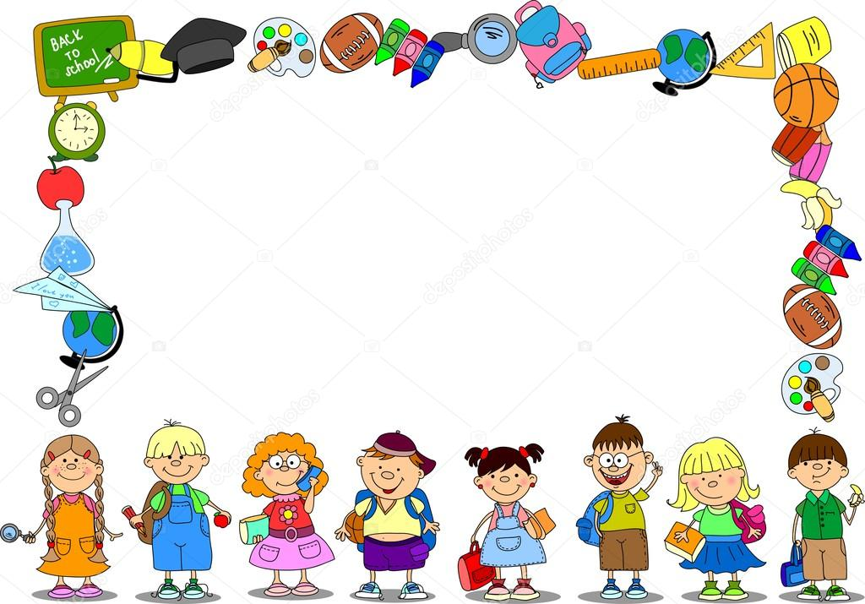
B.

1. Come to class on time.
2. Do not eat in class.
3. Do not run in the classroom.
4. Listen to your teachers.
5. Hand in your workbook on time.
6. Be nice to your classmates.

on time 準時 hand in繳交
34. You can see the rules _____.
(A) on the slide (B) at school
(C) at a zoo (D) at a park
35. Cindy is good. She is helping her classmates do homework. She is following ____.
(A) Rule 1 (B) Rule 3
(C) Rule5 (D) Rule6

C.
There is a little fir tree wanting to be a Christmas tree. But this is not a good idea for old trees. They think people are bad.
One day, a family sees the little fir tree and takes him home. On the Christmas Eve, they are putting candles, candies, and bells on the little fir tree. The little fir tree is beautiful and he is very happy.
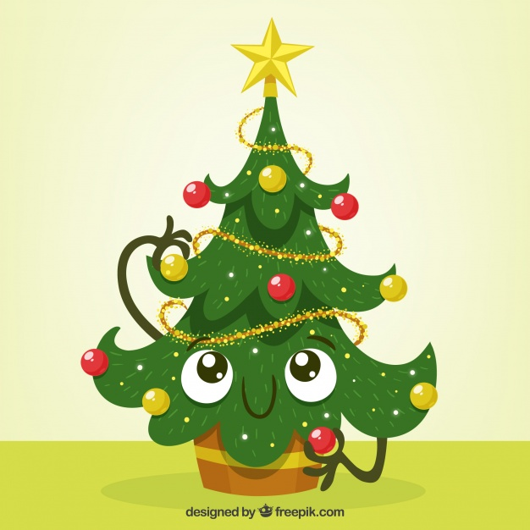
After Christmas, the little fir tree is sad. He is in the box. After a long wait, the family takes him out again and gives him water. To the family, the little fir tree is clean and safe in the box.
The next Christmas, the little fir tree is a beautiful Christmas tree again. Not all people are bad.
people 人 take 拿；取 after 在…之後 next下一個

36. Which is the best title (標題) of the story?

(A) The Little Christmas Tree

(B) Good People as Santa

(C) On the Christmas Eve

(D) Bad Christmas Trees

37. According (根據) to the story, which is NOT true?

(A) The family are nice to the little fir tree.

(B) The little Christmas tree is pretty.

(C) The box is not dirty.

(D) There are two trees in the family.

第三部份：手寫練習 46%

A. 文意字彙 (每題2分；共20分) 20%
(1) David is putting gifts into the Christmas st___ings.
(2) Don’t s_____t to Lisa. She is just a little girl.
(3) Th_____y is between Wednesday and Friday.
(4) Girls, let’s w____e our hands and sing together.
(5) Coco is playing the gu____r in his concert.
(6) There are four w____ks in a month (月份).
(7) Please don’t l_____er on the bus, Alice.
(8) Be qu____t, boys. The baby is sleeping.
(9) Don’t u___e your cellphone on the bed.
(10) It’s nine fifty. It’s t___e for bed.

B. 寫出現在分詞 (每題1分;共6分) 6%
1. sit →
2. study →
3. eat →
4. write →
5. say →
6. cry →

C. 填入適當的介係詞 (每題1分;共6分) 6%
1. A: What time is Kevin’s party?
B: It’s __a.__ 7 p.m.
2. A: Is Billy Chen’s concert __b.__ Saturday?
B: Yes, it is.
3. A: What time is it?
B: It’s eight fifteen __c.__ the morning.
4. A: Where are George and Mary?
B: They are __d.__ the concert.
5. A: Let’s have dinner together __e.__ your birthday.
B: That’s great!
6. I go to school __f.__ Monday to Friday.

D. 翻譯題 14%
1. 今天是星期幾？
2. 一隻恐龍正在博物館裡奔跑。
3. 請不要跟你的同學打架。
4. 愛咪正在客廳包裝一份禮物嗎？

試題結束
Happy Winter Vacation!

