臺北市立瑠公國中一０六學年度第一學期九年級英文科第三次定期評量試題
班級:____ 座號:____ 姓名:__________

※聽力測驗：25%
- 辨識句意：根據聽到的內容，選出符合描述的圖片或符合圖片的描述5%
1.( )
(A) | (B)
(C)
2.( )
(A) | (B) 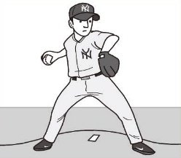
(C) 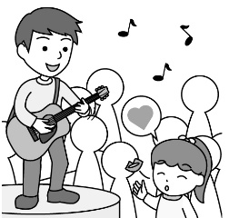
3.( )
(A) 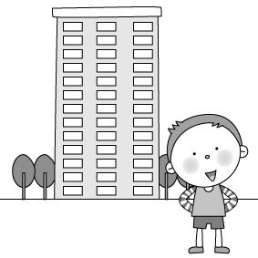 | (B)
(C)
4.( )
(A) 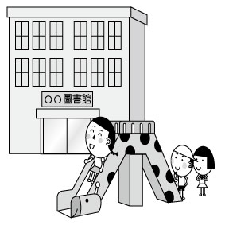 | (B) 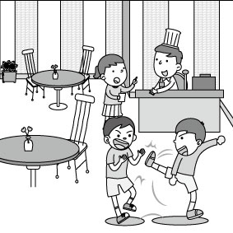
(C)
5.( )
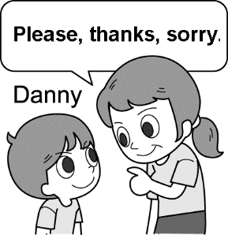
二、基本問答：根據聽到的內容，選出一個最適合的回應或最適合的問句2%
6.( ) (A) Neither can I.
(B) The spaghetti is yummy.
(C) Let’s eat spaghetti now.
7.( ) (A) You’re very lucky.
(B) Don’t turn me down.
(C) Cheer up. Let’s work them out.
8.( ) (A) Eighty cents.
(B) A pack of forks, thanks.
(C) One pound, thanks.
9.( ) (A) He pushed me aside.
(B) I was late for the meeting.
(C) He likes to share thoughts with us.
10.( ) (A) No way!
(B) Don’t follow me.
(C) You can take a day off.
三、言談理解：請聽對話或短文，選出一個最適合的答案10%
11.( ) (A) Rose and Karen.
(B) Karen and Peter.
(C) Rose and Peter.
12.( ) (A) She did something good to a child.
(B) She smiled at everyone she came across.
(C) She got a day off.
13.( ) (A) The woman is so nice to him.
(B) The woman looks like an angel.
(C) The woman is as beautiful as an angel.
14.( ) (A) They are shopping online.
(B) They are having an online meeting.
(C) They are looking for information online.
15.( ) (A) He is telling lies.
(B) He is having dinner with the woman.
(C) He is following the woman who he cares much about.
【聽力測驗結束，請翻頁繼續作答】
四、選擇題：75% (16-22每題1分⸴ 其餘每題2分)

( ) During the breaks, many students play ______ in the playground. (A)the chess (B) computer games (C)the piano (D)badminton

( ) Thank everyone for working so hard, our _______ at the restaurant is getting better and better. Everyone will get a raise. (A)business (B)career (C)space (D)news

( ) The _______ of the sun makes all of the students tired and thirsty. (A)quantity (B)heat (C)cent (D)gram

( ) The movie _______ for more than two and a half hours. Isn’t it too long? (A)packs (B)seems (C)lasts (D)fixes

( ) He ______ the library door open and then walked in. (A)covered (B)entered (C) typed (D) pushed

( )Riding a bike on a busy street is _________. (A) polite (B)honest (C)simple (D)dangerous

( ) Too much work and too little rest will _______ illness(生病).(A)take up (B)lead to (C)turn down (D)come true

( ) Have you read the book ______ a lot of pictures? (A)in (B)on (C)at (D)with

( ) He spent too much time playing video games, and ________.

(A)neither did I (B)I don’t, either (C)so did I (D)I do, too

( ) Our history teacher told us a true story _____ happened in 1947.

(A)who (B) which (C) what (D)when

( ) Do you want to buy a sports car _______ color is red?

(A)who (B)which (C)that (D)whose

( ) He has never seen the man to ____ they spoke just now.

(A)whom (B)who (C)that (D) X

( ) She is the most beautiful girl _____ I’ve ever seen in the world. She is my dream girl. (A)whom (B)who (C)that (D) which

( )Carl has to see a doctor, and ____________. (A)so have you (B)you have, too. (C)so do you (D)you don’t, either.

( )The boy ___________ blue jeans is Ben.

is in (B)which is wearing

(C)who like to wear (D) that is wearing

( ) The medicine ___________this morning should be taken three times a day.

I gave it to you

was given to you

Which were given to you

I gave you

( ) Mary: Honey, how about going to the movie tonight?

Bryan: How long does it last?

Mary: Less than two hours. I know you hate to stay in the theater too long.

Bryan:__________

Just kidding.

You made my day.

You said it.

Cross the bridge when you come to it.

(33-39)
The Internet has become a good place to meet people. However, we need to learn (33) to protect ourselves because it is not always safe (34) friends through the Net.
Chatting online (35) fun, but remember (36) out your home address or telephone number. Also, if you want to meet your Internet friend (37) person, always tell your parents first. It may be wise to have your parents (38) with you when you meet an Internet friend. Finally, always choose a(n) (39) place to meet.
33.( ) (A) who (B) which (C) how (D) what
34.( ) (A) make (B) made (C) making
(D) to make
35.( ) (A) is (B) are (C) has (D) have
36.( ) (A) to give (B) giving (C) not to give
(D) not giving
37.( ) (A) on (B) in (C) with (D) by
38.( ) (A) go (B) to go (C) going (D) went
39.( ) (A) interesting (B) wise (C) stupid
(D) public

(40-43)

Dear diary,

Last Wednesday when I entered the gym, some boys were playing basketball. A boy caught my eye right away. He looked tall and cute. He was wearing a blue T-shirt, but other boys were wearing green T-shirts. I couldn’t forget his face after that day.

Guess what? This morning, I talked to the boy (40). I met him at the library again. I was so surprised when he and his friends were walking near me. I even dropped the book from my arm. He stopped talking to the boy (41) stood next to him and picked the book up for me. That was a book from Canada. “I like to read travel books, “ I said. “ (42) , “ with a smile. I was so nervous but happy. After we chatted for a few minutes, he asked me, “ Maybe we can have some coffee and get to know each other more.” I don’t have any plans this Saturday. What about you?” “ (43) ,” I said that although I have math class on Saturdays. But the teacher will forgive me, right?

40. ( ) (A)who was wearing the green T-shirt

(B)whose T-shirt was blue

(C)that looks short and cute

(D)that I saw in the gym last Monday

41. ( ) (A)who (B)which (C)whose (D) X

42. ( ) (A)So am I (B)So do I

(C)Neither am I (D)Neither do I

43. ( ) (A)I do, too (B)I am, too

(C)I’m too, either (D)I don’t, either.

(44-47)
Rola: Justin, is this your photo?
Justin: Yes. Who put it here?
Rola: I guess your brother did.
Justin: I guess so, too.
Rola: When was the photo taken? It looks old.
Justin: It was taken eleven years ago at my grandparents’ house. I was five, and I was chubby then.
Rola: Let me see. You were cute. Who is the boy that is sitting next to you?
Justin: He is my cousin, Ted. He had curly hair then, but he didn’t like it.
Rola: Which girl is your sister, Tracy?
Justin: She is the one who has a toy bear in her hand. She is on my right. The girl who has short hair and big eyes is my cousin, Diana. She was the tallest at that time.
Rola: Then who is the boy with a bat?
Justin: Don’t you know who he is?
Rola: Is he your brother, Tim?
Justin: Yes. He was short and heavy then. Now he is much taller than Diana.
Rola: You are also different. You are thin and handsome.
44. ( ) How old is Justin now?
(A) He is sixteen. (B) He is seventeen.
(C) He is twelve. (D) He is eleven.
45. ( )Who DIDN’T like his / her own hair before?
(A) Tracy. (B) Ted. (C) Tim. (D) Diana.
46. ( )Who is the tallest in the photo?
(A) Ted. (B) Tracy. (C) Justin. (D) Diana.
47. ( )Which one is Justin’s photo?
(A) 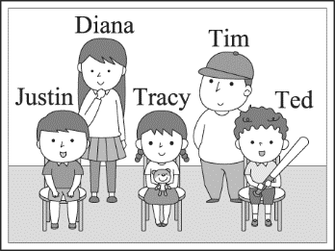 (B) 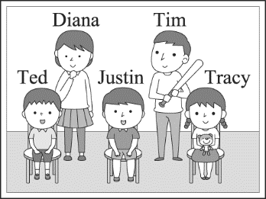 (C) 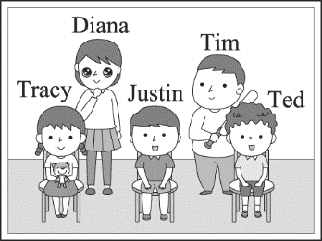 (D) 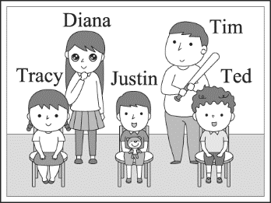
(48-51)
Liu Gong Junior High School (48) .
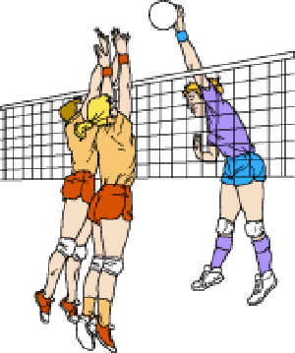
Thursday, January 18
Welcome new members:
1. Tenth graders.
2. No experience required.
3. A volleyball needed.
4. Pay the fee: NT$200.
We’ll have special lessons for you every month. Only our members are allowed to take part in our activities. Our first meeting will be at the volleyball court at 3:00 p.m. on Saturday, January 20. Our club coach, Mr. Chen, will show you “How to choose a good pair of sneakers.” Wearing good sneakers will help you to jump higher and run faster. Besides, good sneakers also keep you from getting hurt. Join us and have fun. We’ll choose a new leader at the next meeting.
48. ( )What can the blank（空格） be?
(A) Volleyball Club (B) Guitar Club
(C) Chess Club (D) Cooking Club
49. ( )What may sneakers be?
(A) A volleyball. (B) Shoes for sports.
(C) Volleyball court. (D) Leaders of the club.
50. ( )The club wants to have new members in the
______ grade.
(A) 7th (B) 8th (C) 9th (D) 10th
51. ( )Which is NOT true?
(A) Club activities are for club members only.
(B) New members don’t need any experience.
(C) Each new member should pay NT$200
for the lesson.
(D) Only professional（職業的）players can
join the club.

(52-54)
On the 30th of November, 2013, Paul Walker, a popular American actor, died in a car accident. He was only forty years old when he died.
Paul Walker was a famous actor, and he was also known for his charitable work. In 2010, he went to help people in Haiti after the serious Haiti earthquake. There, he thought people had to be well-prepared before they helped other people. So, he built Reach Out Worldwide Foundation. It helps people who suffer from disasters a lot.
In the beginning of November in 2013, more than 6,200 people died in the Philippines because of Typhoon Haiyan. Paul Walker’s foundation gave help to the people in the Philippines right away. He also went to a charity show with his friend. However, his friend drove too fast, and they had a car accident. They both died in it. Many people were sad because the world lost a great actor and a kind person.
accident 意外 charitable 慈善的
foundation 基金會 suffer受苦 disaster災難

52. ( ) Which is true about Typhoon Haiyan?

(A) It hit Haiti in 2013.

(B) It hit the Philippines in 2010.

(C) It killed more than 6,200 people.

(D) It killed Paul Walker.

53. ( ) What does it mean?

(A) The car accident.

(B) The 2010 Haiti earthquake.

(C) Typhoon Haiyan.

(D) Reach Out World Foundation

54. ( ) What can we say about Paul Walker?

(A) He was not only a great actor but also a

kind person.

(B) He didn’t really know how to drive.

(C) He thought that earthquakes and

typhoons were not scary.

(D) He drove the car to the charity show on

the 30th of November, 2013.

(55-56)

Nothing to Eat

Lewis Mancha

She had nothing to eat.

They made a movie about her

Because she had nothing to eat.

Her husband died in the war.

They wrote a book to tell his story.

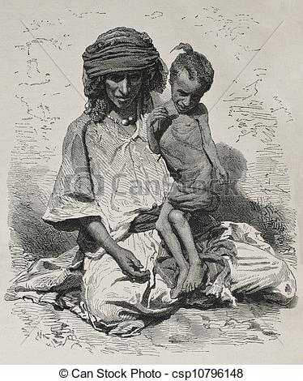
There was also a play about it.

Both her children died.

You can see the photos at the museums.

The someone wrote a poem.

Still

She had nothing to eat.

55. ( )What does “someone” refer to?

(A) A woman who took photos of the woman’s

children.

(B) One of the woman’s children.

(C) A man working at the museum.

(D) The writer of this poem.

56. ( ) What is the poem trying to tell us?

(A) We should try to keep wars from

happening.

(B) If you want to help people, help them in

time.

(C) Writing poems isn’t very useful in helping

others.

(D) There are many people who don’t have

food to eat.

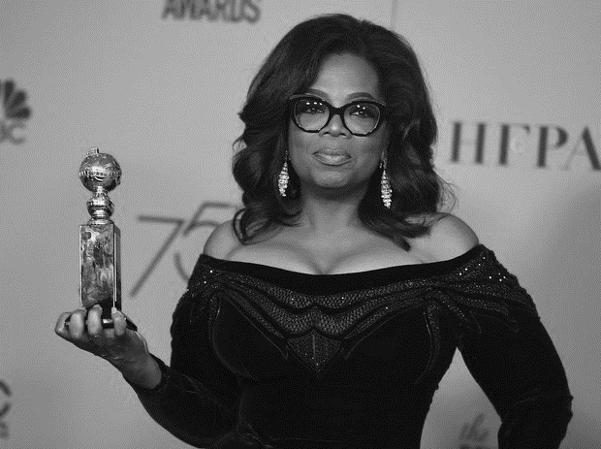
【本次測驗結束】

娛樂新聞快報!

第 75 屆金球獎，美國脫口秀女王歐普拉（Oprah Winfrey）獲頒金球獎的終身成就獎——塞西爾戴米爾獎（Cecil B. DeMille award）。作為首位領獎的黑人女性，歐普拉在這重要歷史時刻，藉著媒體關注，向全球正在收看的女孩們發表發表振奮人心的演說，承諾女性、弱勢和被壓迫者「新的一天即將來臨」

"I want all of the girls watching here now to know, that a new day is on the horizon. And when that new day finally dawns, it will be because of a lot of magnificent women, many of whom are right here in this room tonight, and some pretty phenomenal men, fighting hard to make sure that they become the leaders who take us to the time when nobody ever has to say, 'me too' again." Oprah Winfrey accepts the 2018 Cecil B. de Mille award.

歐普拉說：「此刻，我要所有觀看（頒獎典禮）的女孩們明瞭，新的一天即將來臨！當這新的一天終於破曉之時，會是因為有許多偉大的女性，其中許多人今晚坐在這個房間裡，以及許多了不起的男性拚命奮鬥，來確保自己成為能帶領我們前往一個再也沒有人必須說出『我也是』（Me Too）的時代。」

