臺北市立瑠公國民中學106學年度第一學期第三次段考八年級英語科試卷
範圍：翰林版第三冊Unit 7~ Review III 八年 ___班 座號：___ 姓名：__________

第一部分:聽力測驗 (第1-15題，共15題，25%)
- 辨識句意：選出符合句子描述的圖片。(每題1分, 5%)

1.（ ） (A)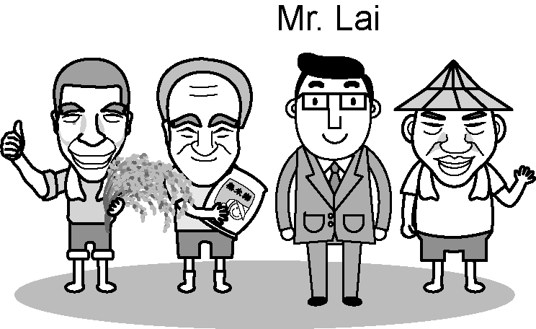 (B)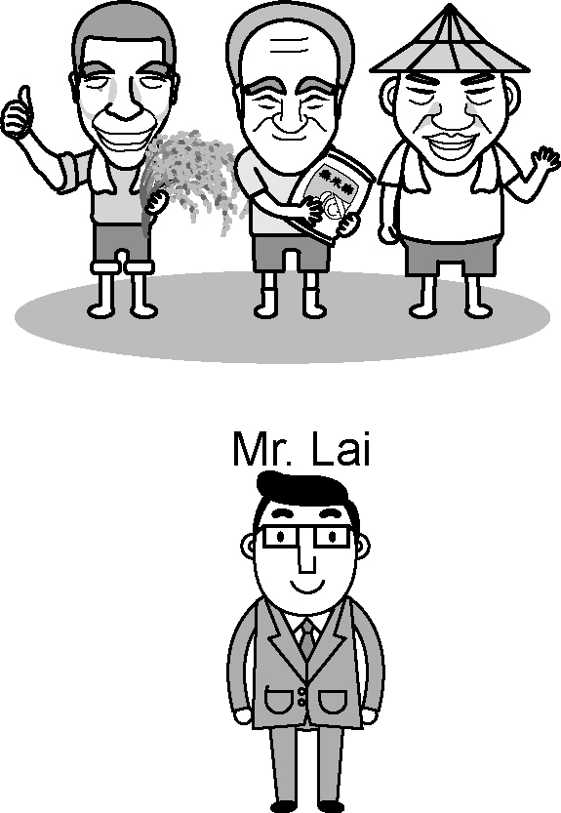
(C) 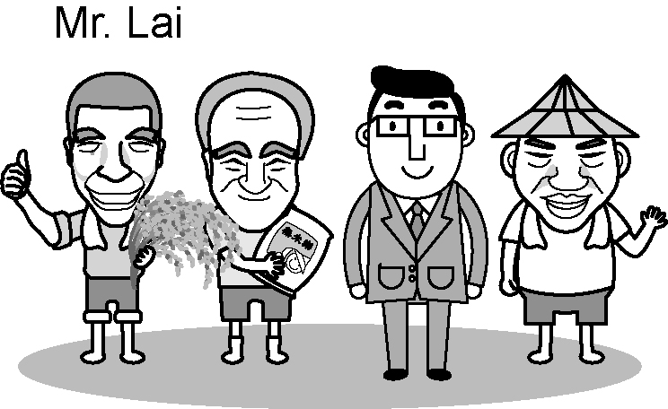

2.（ ） (A)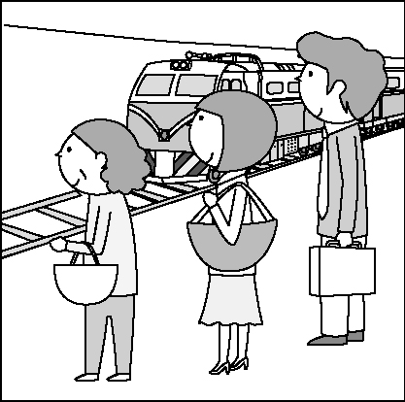 (B)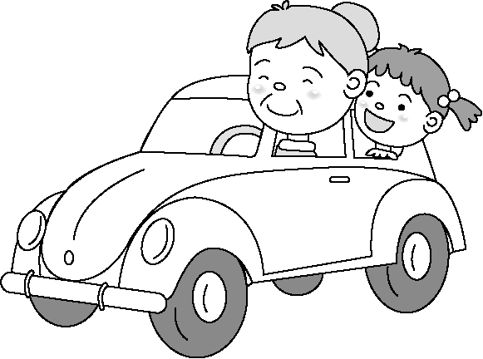 (C)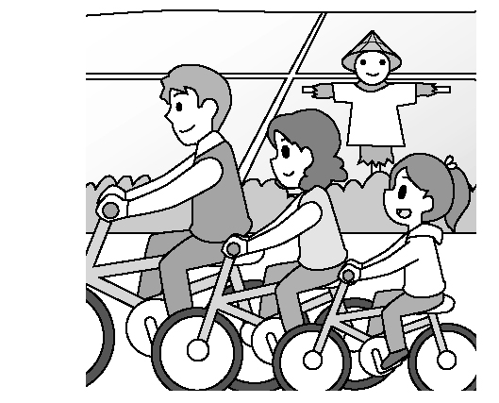

3.（ ） (A)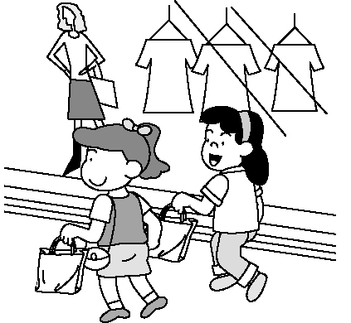 (B)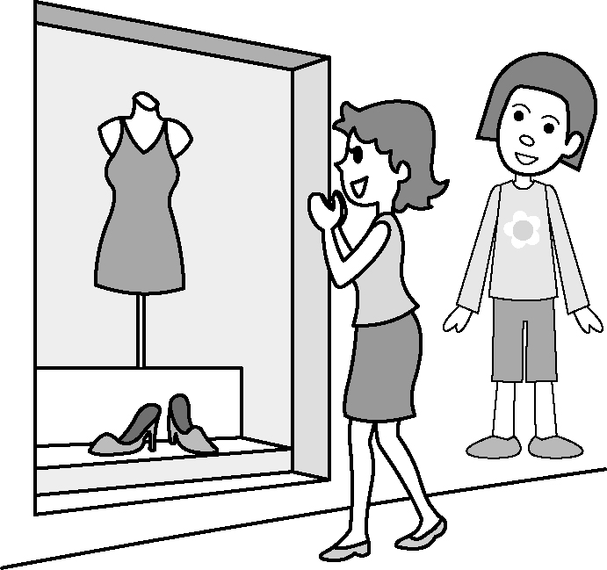
(C) 

4.（ ） (A)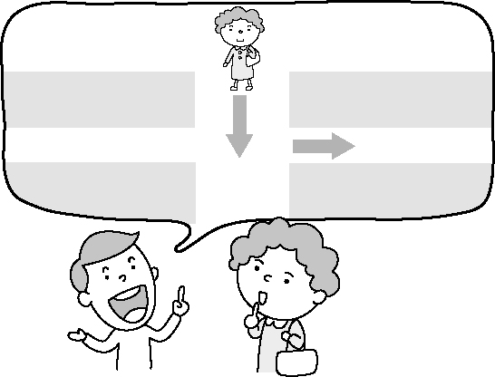 (B)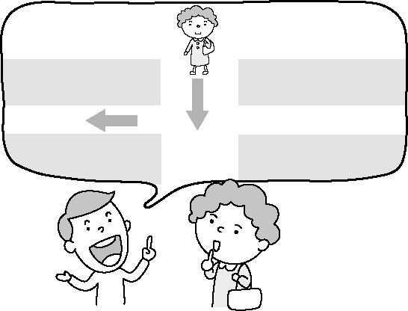 (C)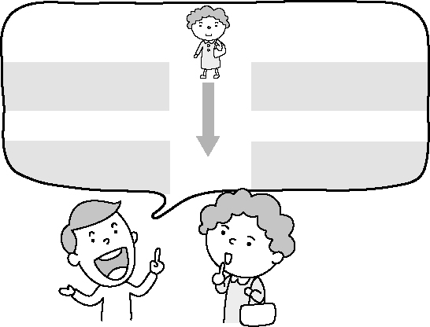

5.（ ） (A)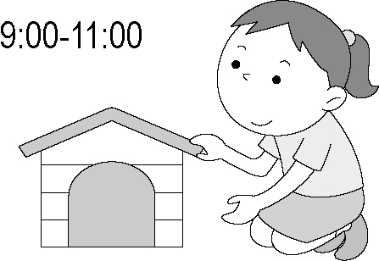 (B)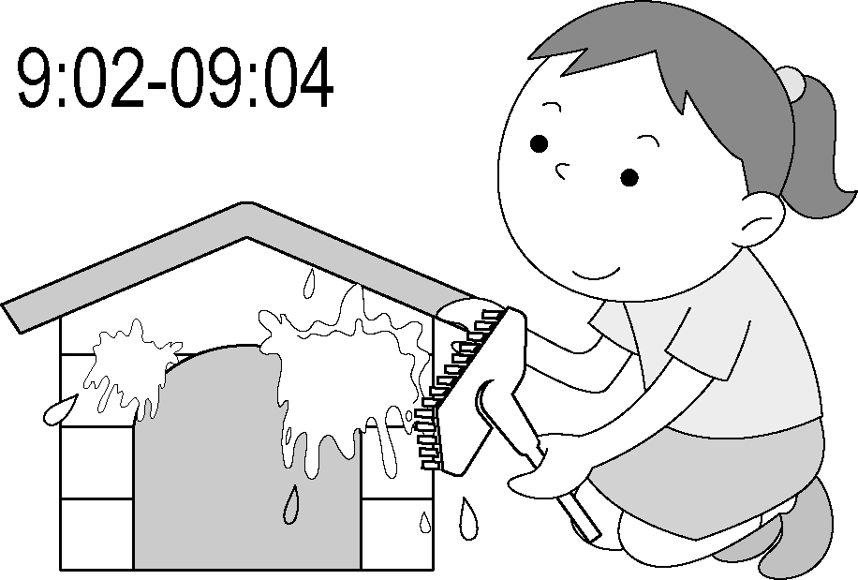 (C) 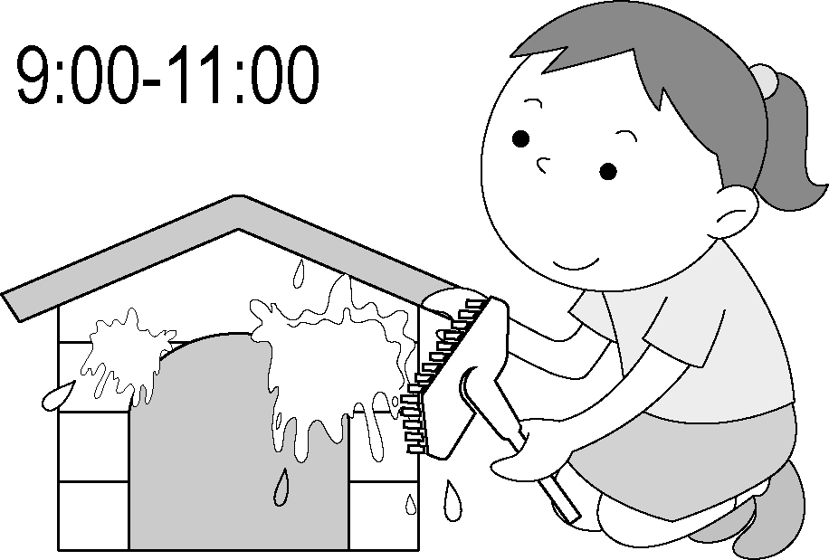

- 基本問答：選出最適合的回答，完成對話。(每題2分, 10%)
6.（ ） (A) The theater was near his home.
(B) He rode his new bicycle.
(C) There were a lot of people.

7.（ ） (A) No, I have no time today.
(B) No, going hiking is a lot of fun.
(C) No, I will wear my new shoes to go hiking.

8.（ ） (A) You can sell fruit on the farm.
(B) They keep cows, sheep and turkeys.
(C) Go down this road for three blocks.

9.（ ） (A) By ship or by plane.
(B) In July or in August.
(C) With his parents and friends.
10.（ ） (A) It’s also my favorite.
(B) Those birds are very special.
(C) I will let the birds there free.

C. 言談理解： 請聽對話或短文，選出問題最適合的答案。
(每題2分, 10%)

11.（ ） (A) Go to the movies.
(B) Have ice cream.
(C) Go bike riding.

12.（ ） (A) On foot.
(B) By bus.
(C) By taxi.

13.（ ） (A) In an MRT station.
(B) In Soho House.
(C) In an airport.

14.（ ） (A) At 2:00 p.m.
(B) At 7:00 p.m.
(C) At 9:00 p.m.

15.（ ） (A) Behind a shoe store.
(B) Across from a bookstore.
(C) Next to a hamburger house.

第二部分:閱讀測驗 (第16-45題，共30題)
Ｄ. 單題 （第16-21題, 每題2分）
- ( )Dora: How much time do you driving to work? Kelly: About forty minutes.
(Ａ) take (Ｂ) spend (Ｃ) cost (Ｄ) pay
- ( )I enjoy reading, so I often books the school library.
(Ａ) borrow; from (Ｂ) lend; to
(Ｃ) take; out (Ｄ) dress; up
- ( )Here comes .
(Ａ) he (Ｂ) she
(Ｃ) my parents (Ｄ) our teacher
- ( )There are two TVs the classroom.
(Ａ) in the front of (Ｂ) in front of
(Ｃ) across from (Ｄ) next to
- ( )They are going shopping, but we .
(Ａ) won’t (Ｂ) will (Ｃ) aren’t (Ｄ) are
- ( ) a good housewife is never easy. The housework a lot of my time.
(Ａ) To be; spends (Ｂ) Be; needs
(Ｃ) To being; costs (Ｄ) Being; takes
E. 題組 （第22-45）
克漏字選擇（第22-37題，每題2分）
I.
（ ）22.(Ａ) because (Ｂ) when (Ｃ) so (Ｄ) but
（ ）23.(Ａ) was (Ｂ) is
(Ｃ) will be (Ｄ) is going to be
（ ）24.(Ａ) stayed (Ｂ) are staying
(Ｃ) were staying (Ｄ) will stay
（ ）25.(Ａ) call (Ｂ) called
(Ｃ) will call (Ｄ) am calling
（ ）26.(Ａ) were preparing (Ｂ) prepared
(Ｃ) will prepare (Ｄ) are going to prepare

II.
Yesterday was our last day in Kenting. We 27. from our hotel early to visit Uncle Sam, Dad’s good friend. Uncle Sam had a big farm in the country. It 28. us about one hour to drive to his farm. He 29. many animals there. We 30. goats and pigs, and we also saw some ducks in the pond. There was a big playground at the farm. We rode on the seesaw, and then we played on the swing. I had much fun going 31. on the country roads. We had a very good day yesterday.
（ ）27.(Ａ) got to (Ｂ) started off
(Ｃ) turned off (Ｄ) woke up
（ ）28.(Ａ) spent (Ｂ) cost
(Ｃ) took (Ｄ) takes
（ ）29.(Ａ) kept (Ｂ) lost
(Ｃ) tested (Ｄ) burped
（ ）30.(Ａ) feed (Ｂ) was feeding
(Ｃ) fed (Ｄ) are feeding
（ ）31.(Ａ) riding horseback (Ｂ) horseback riding
(Ｃ) riding horses (Ｄ) a horseback riding
III.
There are many different ways to go to school. Some students go to school 32. foot. Some students go to school by 33. . Some students 34. a train to school.
Edward goes to school in a special way. He lives on a small island in Penghu. He gets up at five and takes 35. to his school in Magong（馬公）. He 36. lots of time 37. to school every day. It’s tiring but he is happy because it is a joy for him to learn new things in school!
 island 島 joy 喜悅
（ ）32.(Ａ) with (Ｂ) on (Ｃ) at (Ｄ) in
（ ）33.(Ａ) a bus (Ｂ) buses
(Ｃ) bus (Ｄ) the bus
（ ）34.(Ａ) fly (Ｂ) walk (Ｃ) take (Ｄ) wait
（ ）35.(Ａ) a boat (Ｂ)a taxi
(Ｃ) a scooter (Ｄ) the MRT
（ ）36.(Ａ) costs (Ｂ) spends
(Ｃ) takes (Ｄ) uses
（ ）37.(Ａ) getting (Ｂ) to get
(Ｃ) arriving (Ｄ) to arrive

閱讀理解（第38-45題，每題2分）
I.
Hello, everyone! This is Richard, your tour guide. Welcome to Kaka Island! I want to let you know our tour plans today. We are now at the Beach Hotel. The weather today is a little cloudy and it will have a shower this afternoon, so please take an umbrella or a raincoat with you. This morning, we will have a walk tour around the island, visit an apple farm and make apple pies for lunch there. Then, we will go visit a lovely fishing village to see the local special fishing skills in the afternoon. We will come back to the hotel around 4:00 p.m. The beach is just few minutes away. You can have fun swimming in the sea this afternoon. Please take good care. The hotel serves good dinner from 7:00 to 9:00 p.m. every day. But we will also have a free night fishing activity at 8:30 p.m. You are welcome to join us!
Well, please call me at 0932-123-456 if you need any help. I hope you can have a nice holiday here!
（ ）38. What DON’T they do this morning?
(Ａ) Have a walk tour.
(Ｂ) Visit an apple farm.
(Ｃ) Swim in the sea.
(Ｄ) Make apple pies for lunch.
（ ）39. Why do they want to visit a local fishing village? (Ａ) Because they want to see their special
fishing skills.
(Ｂ) Because they want to have good seafood
for lunch there.
(Ｃ) Because they want to go swimming in the
village.
(Ｄ) Because there is a good beach near the
fishing village.
（ ）40. Which is true?
(Ａ) The Beach Hotel only serves breakfast
every day.
(Ｂ) The weather today is hot and sunny.
(Ｃ) The beach is very far away from the hotel. (Ｄ) People don’t need to pay money for the
night fishing activity.

請繼續作答，加油！
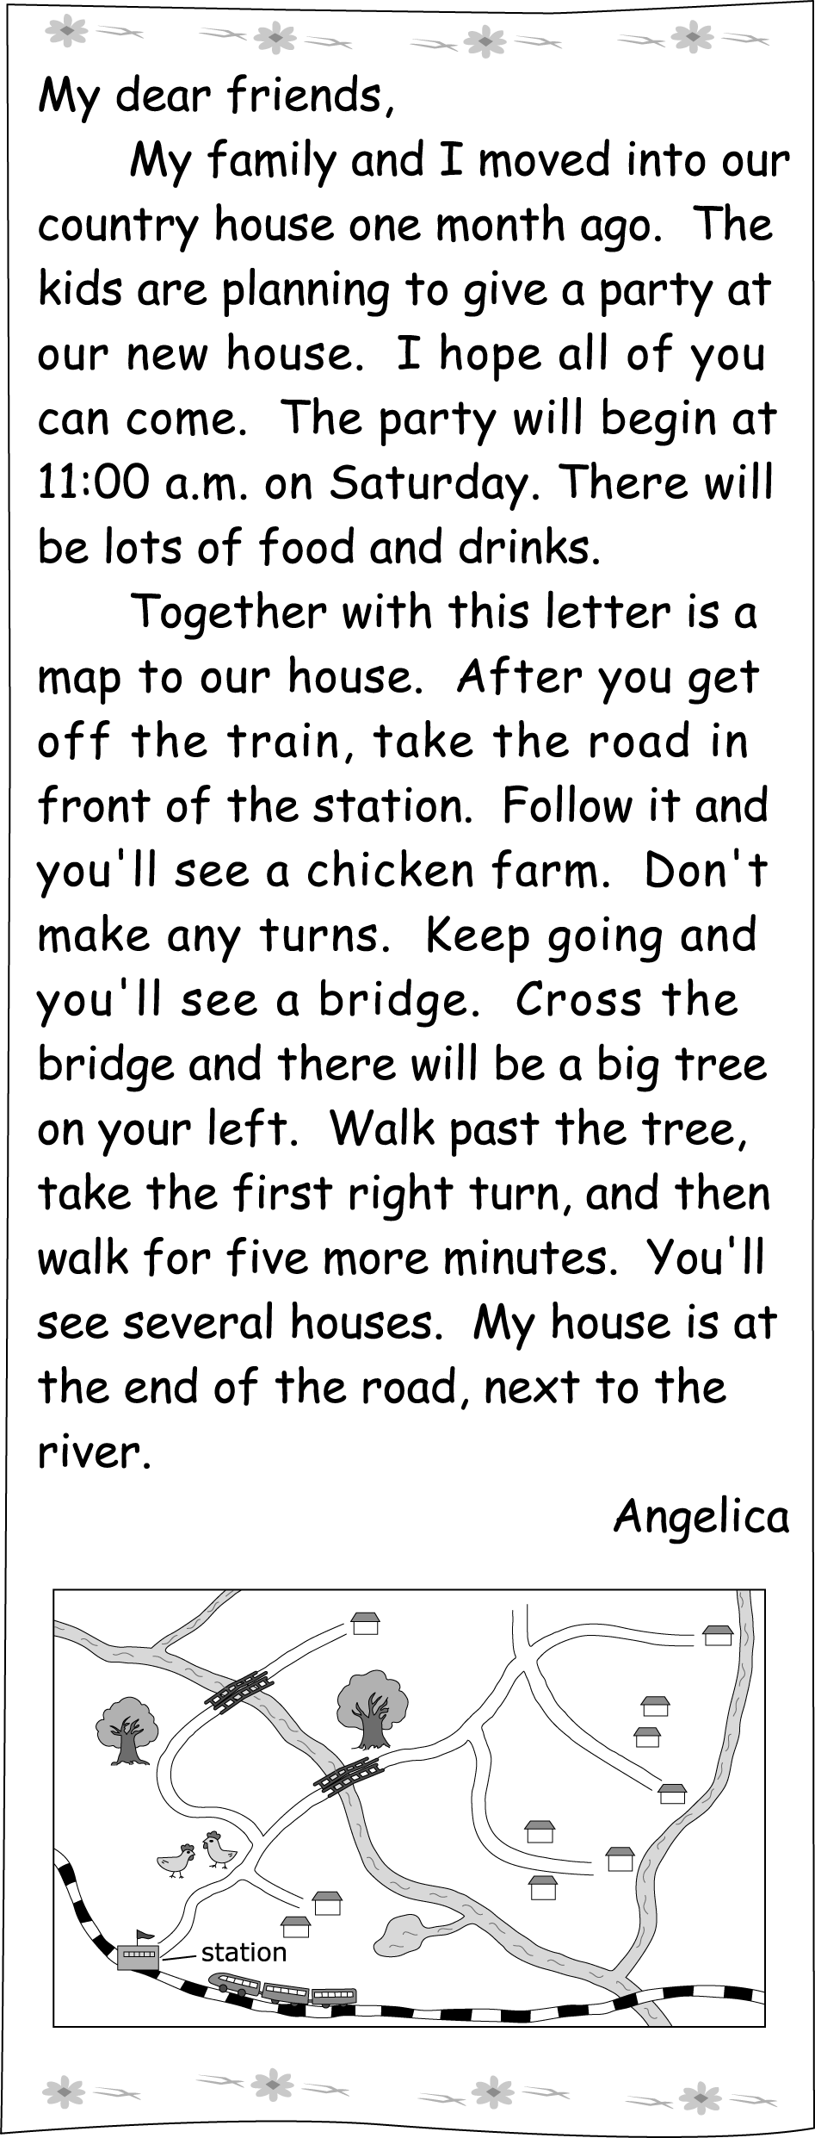
（ ）41. Why did Angelica invite（邀請）her friends? (Ａ) To see her new home.
(Ｂ) To visit the chicken farm.
(Ｃ) To take a train trip.
(Ｄ) To have a picnic.
（ ）42. Look at the map. Where does Angelica live?
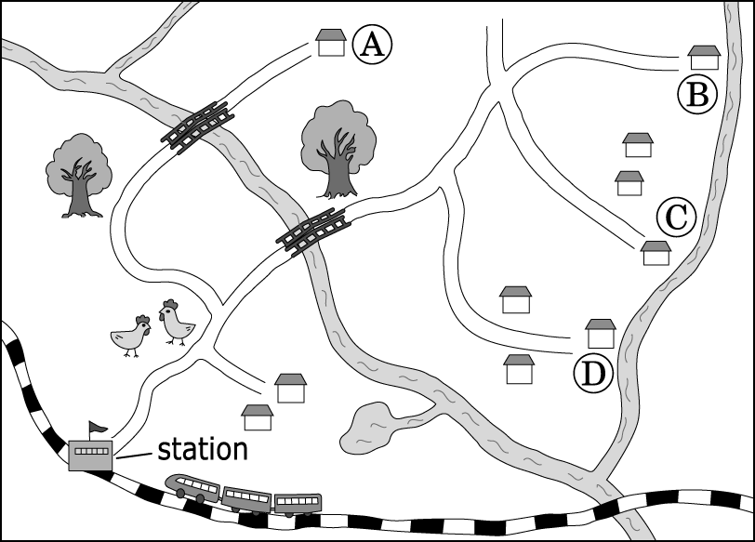
(Ａ) At $○A$. (Ｂ) At $○B$. (Ｃ) At $○C$. (Ｄ) At $○D$.
III.
David is an American. He visited his friend Da-hua in Taiwan. Below is David’s diary about how the two friends spent their vacation.
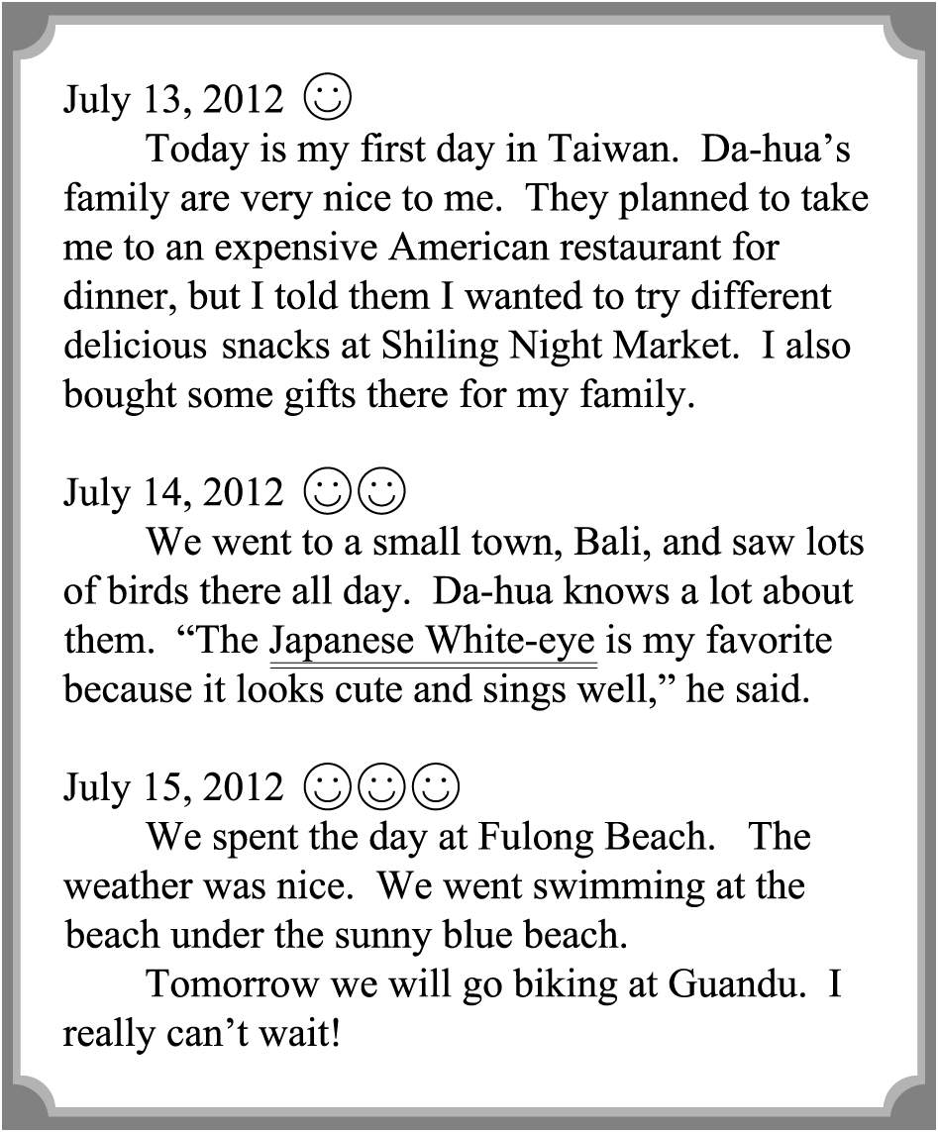
 below 下面
（ ）43. What is the Japanese White-eye?
(Ａ) A kind of bird. (Ｂ) A famous singer. (Ｃ) A small town. (Ｄ) A delicious snack.
（ ）44. What DIDN’T David and Da-hua do together? They didn’t .
(Ａ) eat delicious snacks at a night market (Ｂ) go bird watching in a small town
(Ｃ) go swimming at the beach
(Ｄ) go surfing or sailing in the sea
（ ）45. Which is NOT true?
(Ａ) David ate American food on his first day
in Taiwan.
(Ｂ) David stayed in Taiwan for at least（至少）
four days.
(Ｃ) It took David and Da-hua the whole day
to be in Bali.
(Ｄ) Both David and Da-hua can ride a bike.

第三部分：非選擇題試題，請用黑筆寫在手寫答案卷
F. 文意字彙：（第46-53題，共8題，15％, 除第53題1分，其餘每題2分）
- Don’t let kids play on the r y. Trains may come at any time.
- Don’t you need a ruler to draw a s t line?
- Dad, let’s get something to drink. I’m really t y.

- Gina: Did you buy the car at a high price? Beth: That’s right. I p d NT$1,500,000 for it. Gina: Wow! So much money!
- The cactus（仙人掌） is my favorite
d t plant because it does not need watering so often.
- How e ting the basketball game was! Jeremy Lin’s team won again!
- Her husband is good at pl ting all kinds of flowers. He has green fingers.
- We need to buy the t ts before watching the movie.

試題到此結束，辛苦了！

