臺北市立瑠公國民中學106學年度第一學期第二次段考七年級英語科試卷
七年 ___班 座號：___ 姓名：__________
範圍：翰林版U3 ~ Review II
※選擇題請用2B鉛筆在電腦卡上劃記;非選擇題請用藍色或黑色原子筆在答案卷上作答

第一部分:聽力測驗 (第1-15題，共15題，25%)
- 辨識句意：選出符合句子描述的圖片。(每題1分, 5%)

1.（ ）(A) 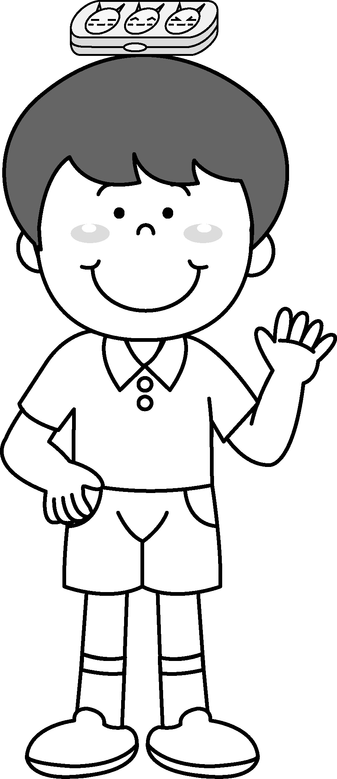 (B)  (C) 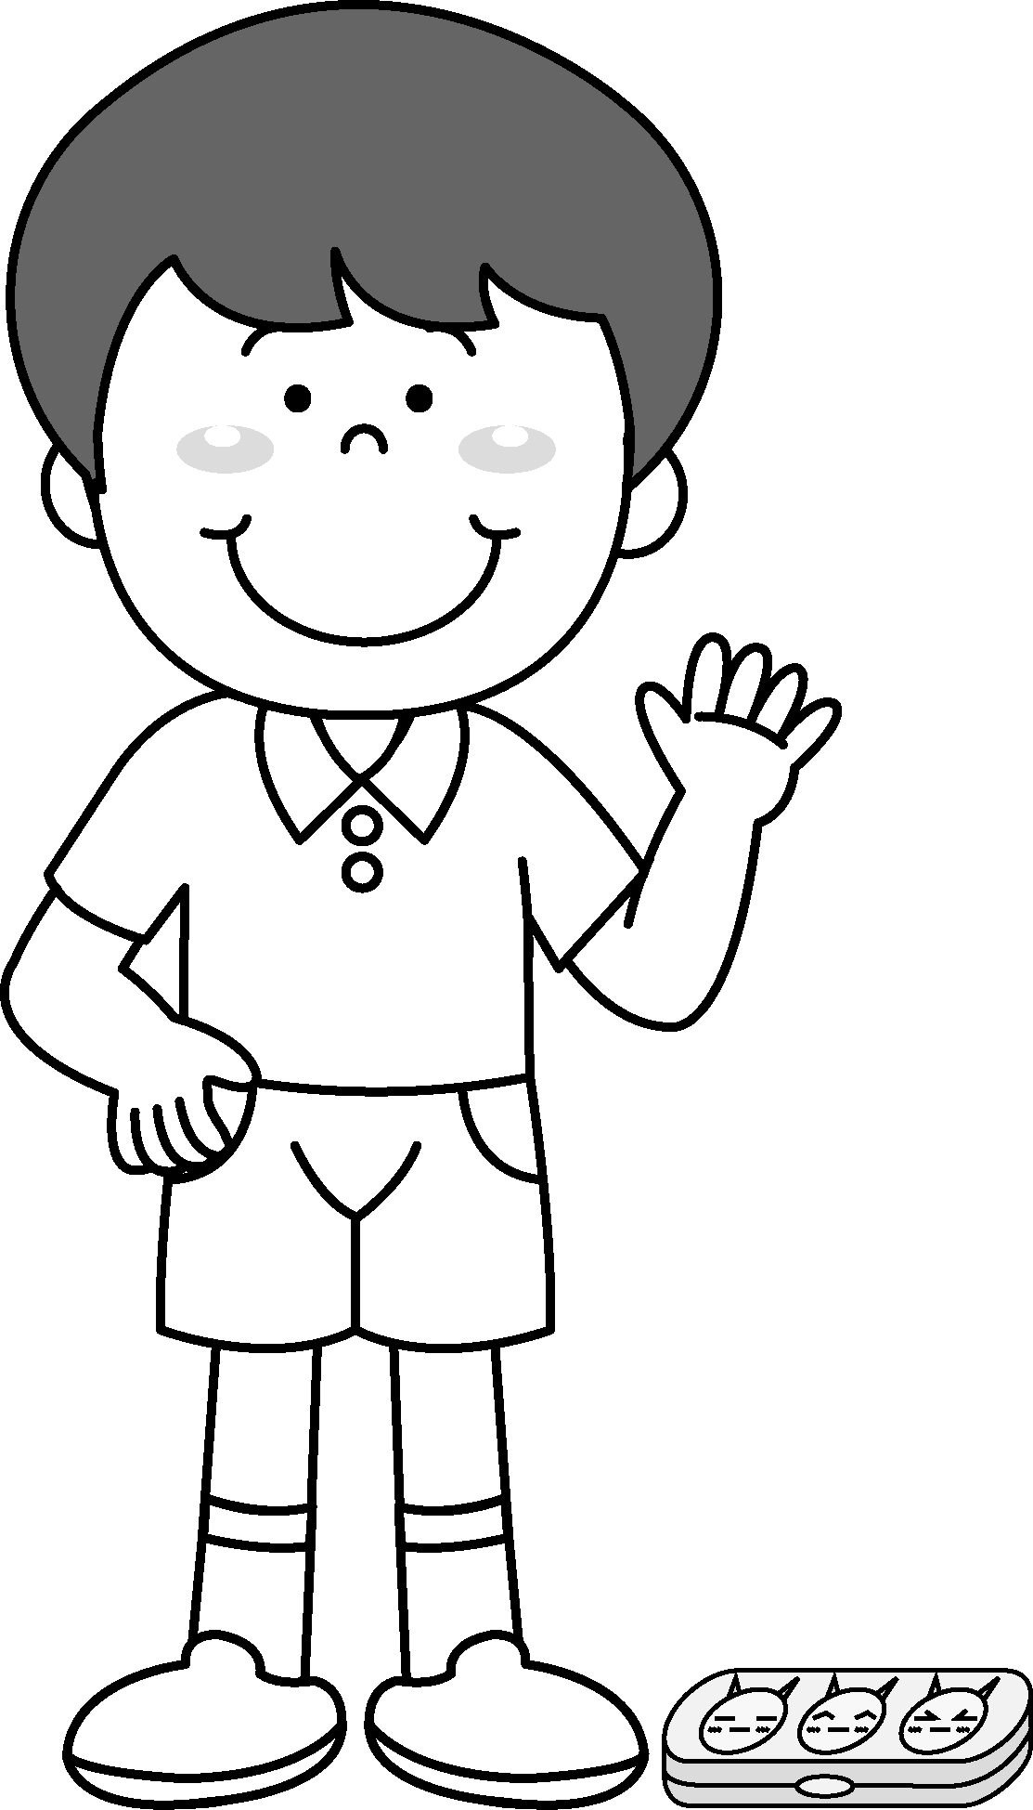

2.（ ） (A) (B)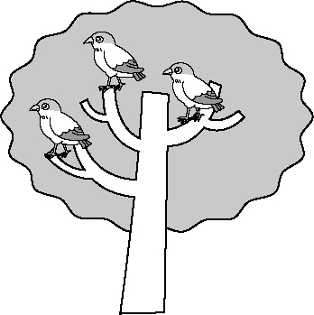 (C)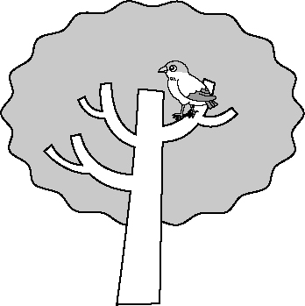

3.（ ） (A)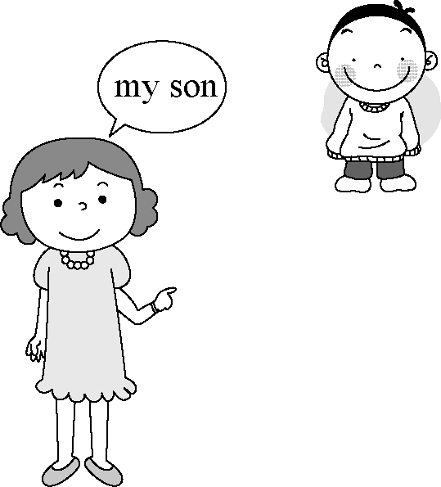 (B)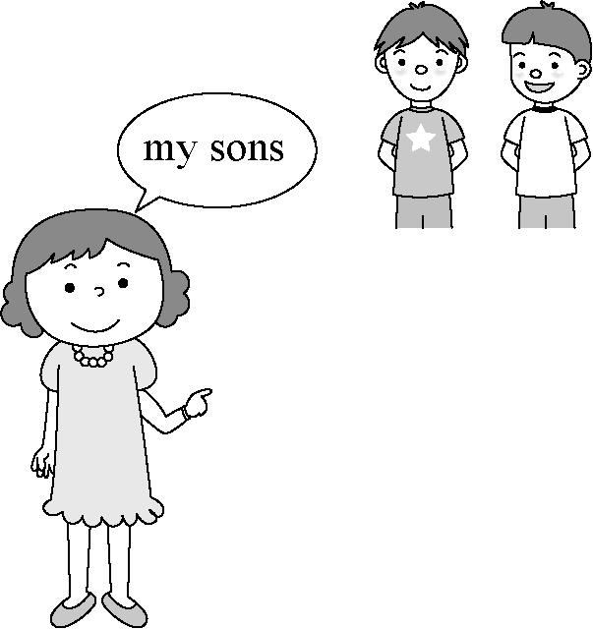
(C) 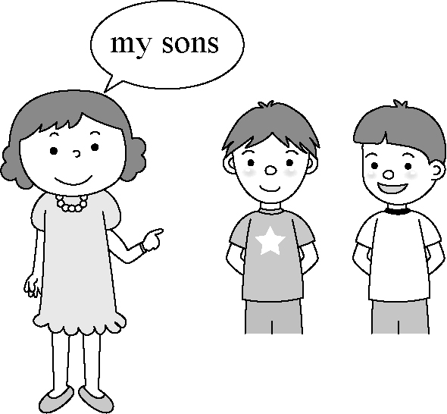

4.（ ） (A) (B) (C)

5.（ ）(A)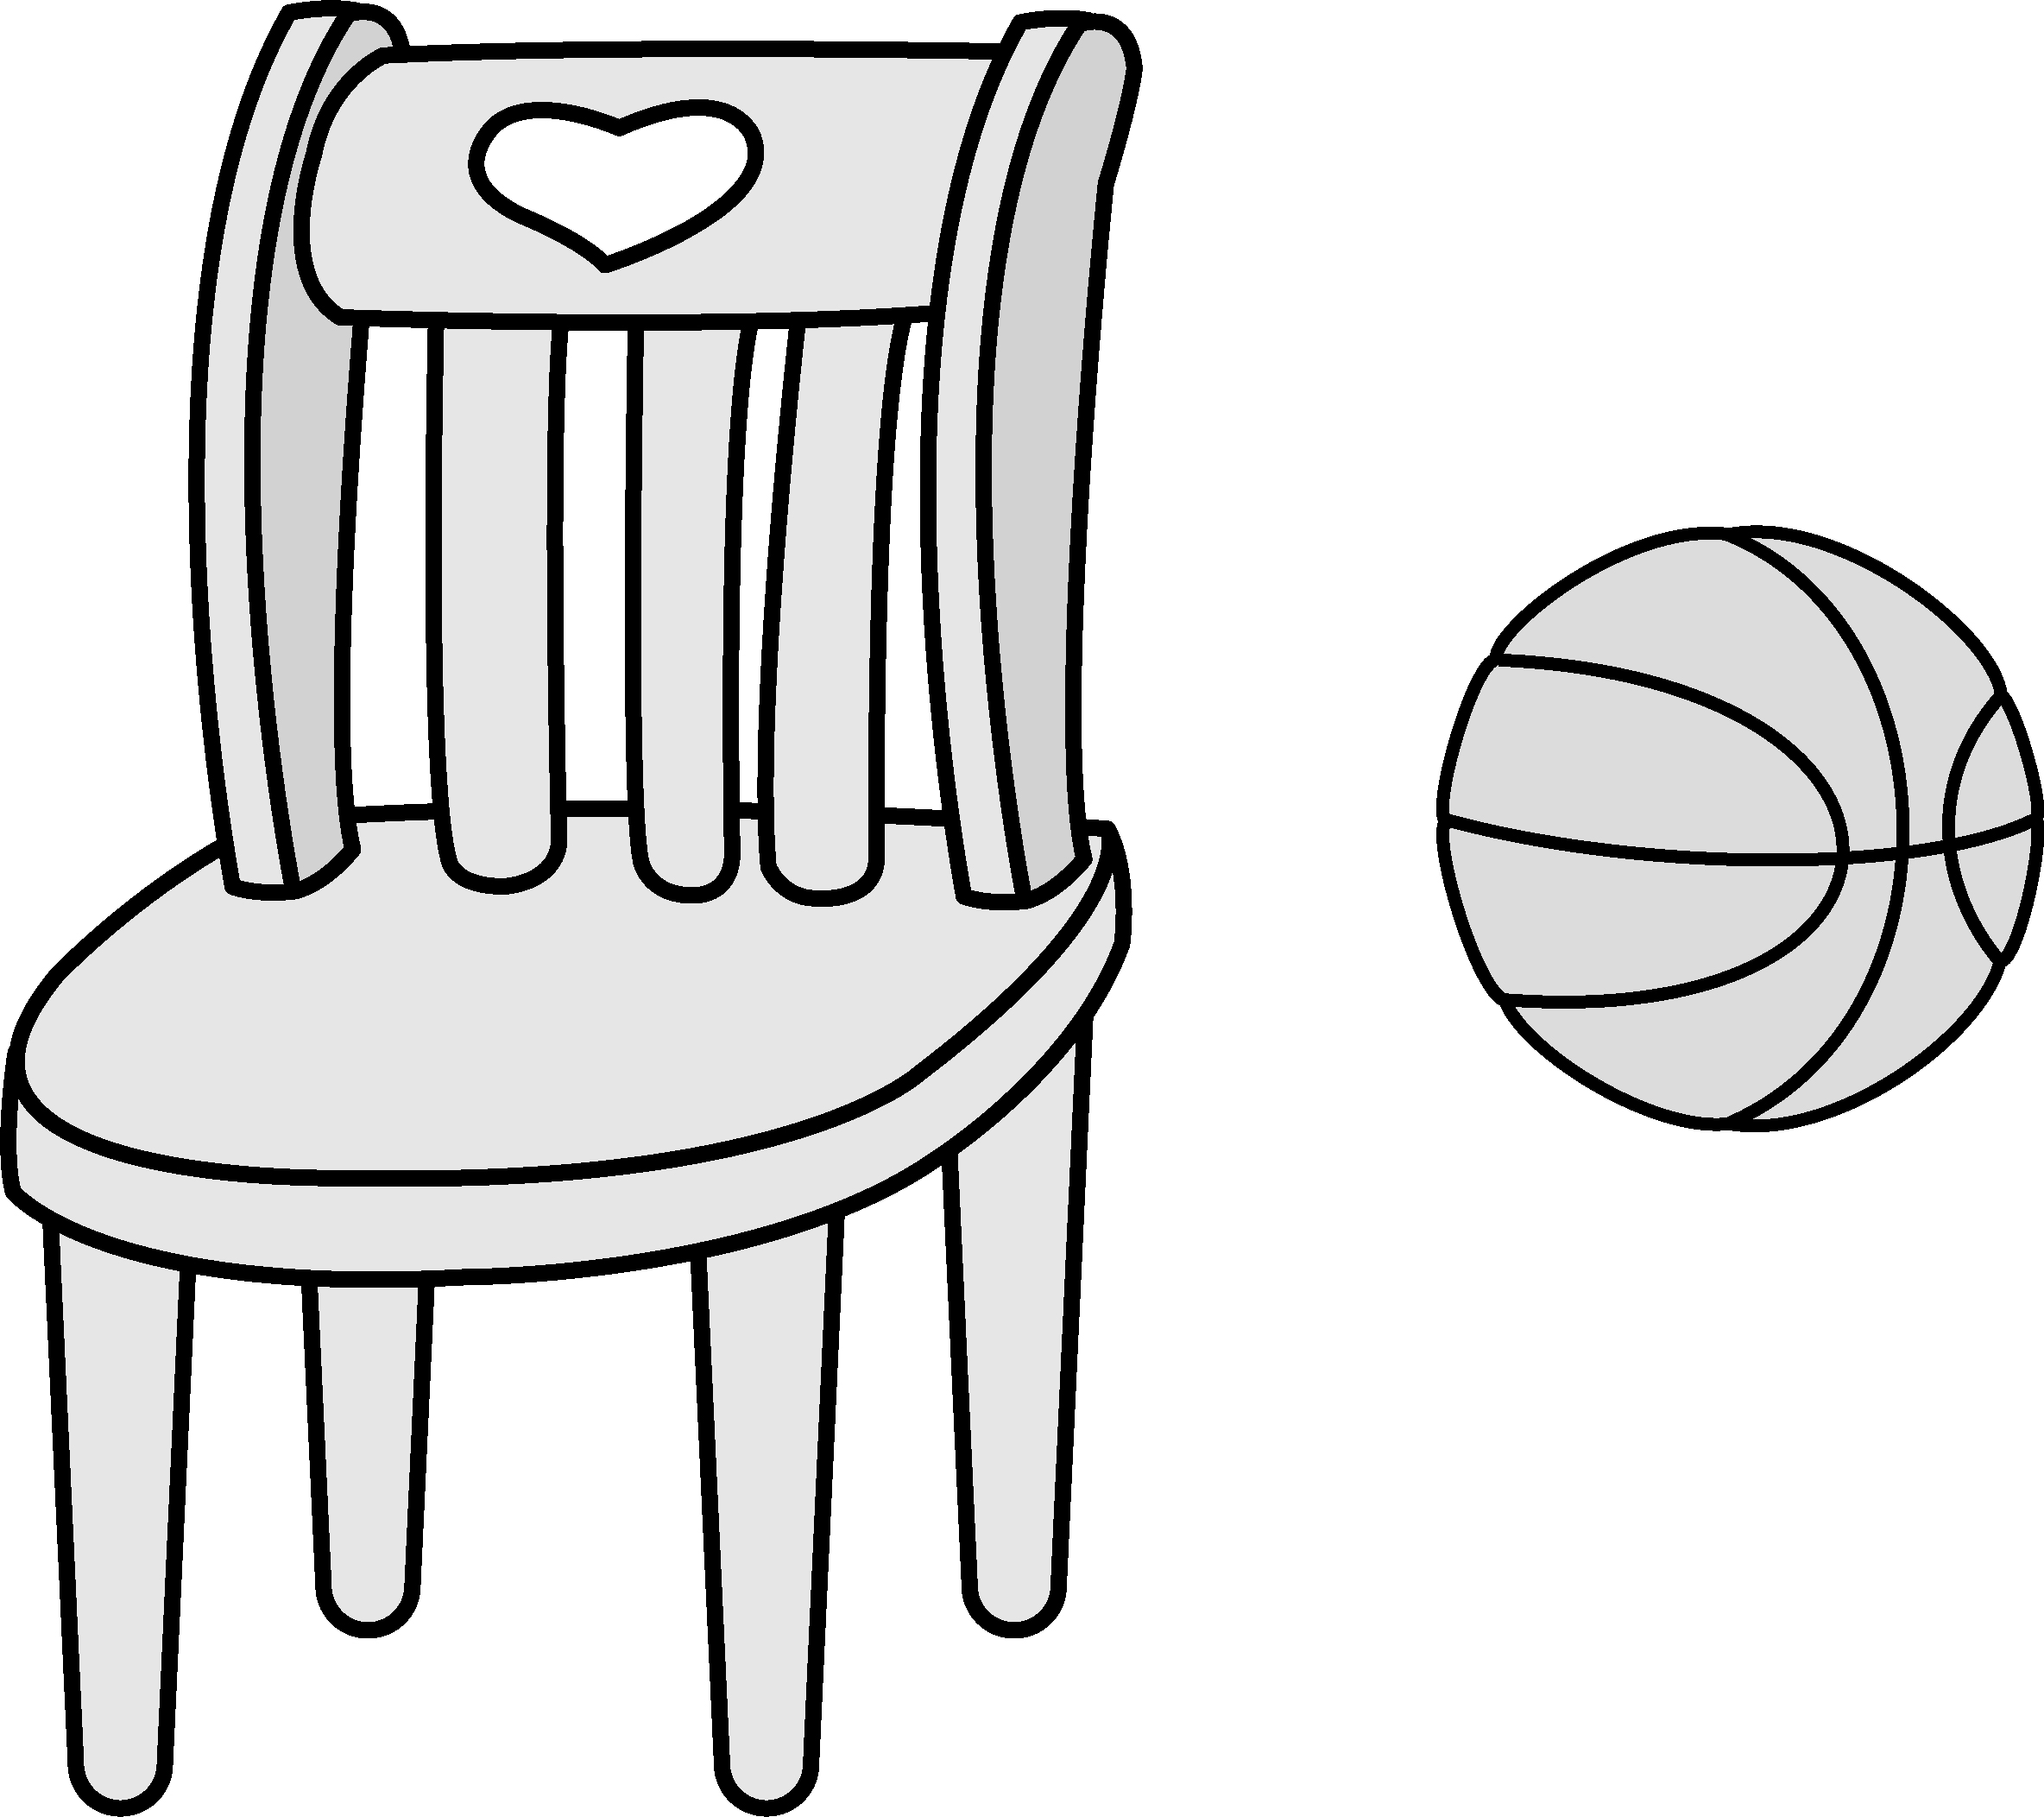 (B)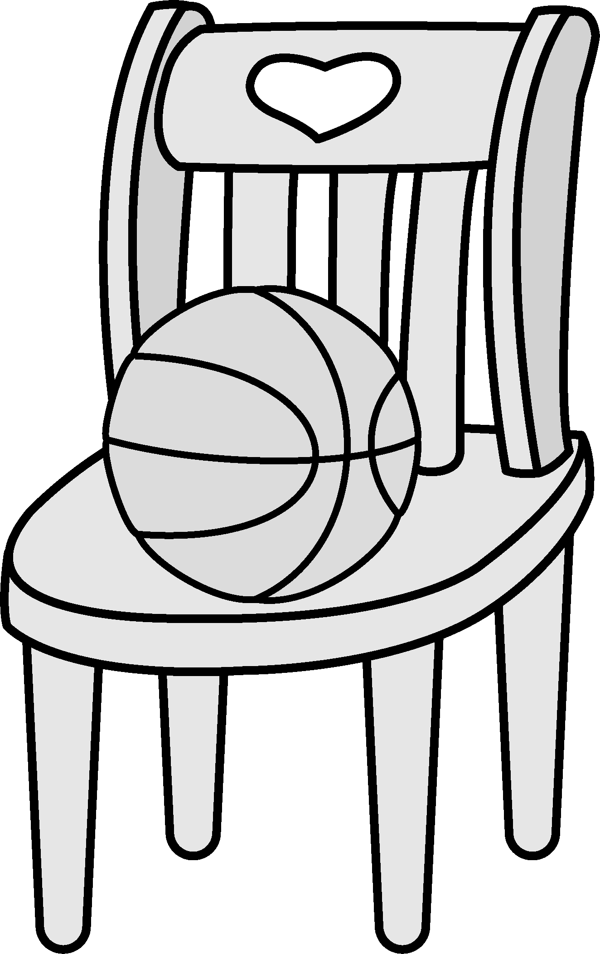

(C)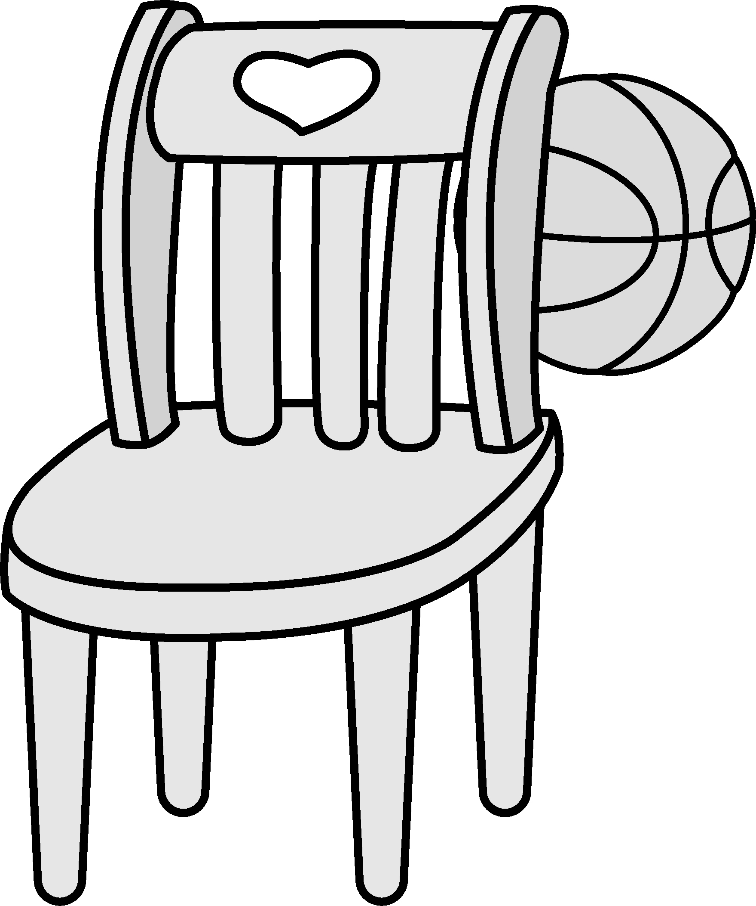

B. 基本問答：選出最適合的回答，完成對話。
(每題2分, 10%)
6.（ ） (A) They are rulers.
(B) They are May’s.
(C) They are strong.
7.（ ） (A) Isn’t it a new scooter?
(B) Isn’t it at the door?
(C) Isn’t it from Paul?

8.（ ） (A) It’s very cute
(B) Hi, you are good.
(C) OK! It’s for you.

9.（ ） (A) Yes, she is at the park.
(B) Yes, it is a big and new park.
(C) Yes, Joy Park is in back of our school.

10.（ ）(A) It is for you.
(B) The cake is yummy.
(C) Ha! Banana cookies.

- 言談理解：請聽對話或短文，選出問題最適合的答案。(每題2分, 10%)
11.（ ）(A) He is Jane’s father.
(B) He is Ted’s teacher.
(C) He is Jane’s classmate.

12.（ ）(A) At Jeff’s home.
(B) At her home.
(C) At Uncle Bob’s place.

13.（ ）(A) A bird shop.
(B) A school.
(C) A zoo.

14.（ ）(A) A bear.
(B) A tiger.
(C) A dog.

15.（ ）(A) The cats.
(B)The dog.
(C)The bird.

請繼續作答下頁試題
第二部分:閱讀測驗 (第16-39題，共24題，48%)
Ｄ. 單題 （第16-22題，共7題，14％, 每題2分）
- ( )Bob’s and Joe’s are .
(Ａ) wives; housewives (Ｂ) wife; housewives (Ｃ) wife; housewife (Ｄ) wives; a housewife
- ( )Everything in the house upside down, and the women in it , too.
(Ａ) are; are (Ｂ) are; is
(Ｃ) is; are (Ｄ) is; is
- ( )Meg: Are there any rabbits here? Emi: Yes, are. in the cage （籠子）.
(Ａ) they; They’re (Ｂ) there; There are
(Ｃ) they; There are (Ｄ) there; They’re
- ( )Jack: Who are the cake and the gifts ? Lisa: You! The birthday boy today.
(Ａ) with (Ｂ) for (Ｃ) about (Ｄ) from
- ( )Is your comic book good?
(Ａ) a English (Ｂ) an English
(Ｃ) the English (Ｄ) English
- ( )My sister, Jane, not home. She is at the park.
(Ａ) is; at (Ｂ) are; at
(Ｃ) is; in (Ｄ) are; in
- ( )Josh is only boy in his family.
(Ａ) a (Ｂ) an (Ｃ) the (Ｄ) that

E. 題組 （第23-39題，共17題，34％, 每題2分）
克漏字選擇（第23-31題）
I.
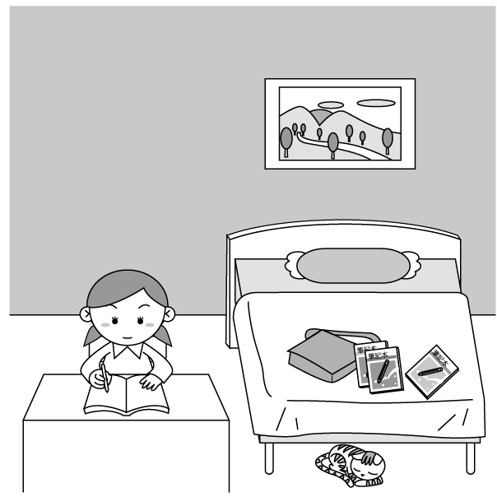
Look at this picture. Jane is 23. her bedroom. She is studying 24. the desk. There are many things in her room. Her picture is 25. the wall. Her schoolbag is on the bed, and her comic books are 26. it. Where is her cat? Oh, she is 27. the bed.
（ ）23.(Ａ) in (Ｂ) in front of
(Ｃ) behind (Ｄ) next to
（ ）24.(Ａ) in back of (Ｂ) on
(Ｃ) at (Ｄ) between
（ ）25.(Ａ) in (Ｂ) on (Ｃ) for (Ｄ) about
（ ）26.(Ａ) in (Ｂ) on (Ｃ) under (Ｄ) next to
（ ）27.(Ａ) behind (Ｂ) above
(Ｃ) under (Ｄ) near
II.
John: Hey, Tina. 28. there in your basket?
Tina : There is some food for the party tonight.
John: 29. the party tonight?
Tina : In my house. We have a party at home.
John: Cool! I like parties. What food do you have?
Tina : Some cookies, candy, and cake.
John: 30.
Tina : Yes, cola and orange juice.
John: Can I go to the party?
Tina : Sure. Welcome.
（ ）28.(Ａ) Are (Ｂ) How’s
(Ｃ) Is (Ｄ) What’s
（ ）29.(Ａ) Is there (Ｂ) Where’s
(Ｃ) What’s (Ｄ) Is it
（ ）30.(Ａ) Is there any ice cream?
(Ｂ) How about some oranges?
(Ｃ) Are there any drinks?
(Ｄ) Are they drinking now?
閱讀理解（第32-40題）
III.
There are lots of animals in Brad’s picture. There are four koalas and a bird in the tree. Under the tree, there are two lions and a snake. There are two rabbits in front of the tree. Next to the rabbits, there is a hippo. There are a big elephant and two kangaroos near the river. The elephant is between the kangaroos. They are all cute.
（ ）31. There are animals in the picture.
(Ａ) fifteen (Ｂ) fifty
(Ｃ) forty (Ｄ) fourteen
（ ）32. The rabbits are .
(Ａ) in the tree
(Ｂ) near the snake
(Ｃ) next to the monkeys
(Ｄ) between the kangaroos
（ ）33. Which（哪一個）is true（真實的）?
(Ａ) There are four animals in the tree.
(Ｂ) The rabbits are in front of the tree.
(Ｃ) There is a horse in front of the lions and the snake.
(Ｄ) There are some elephants and kangaroos in the river.
IV.
There are two hundred animals in the City Zoo.
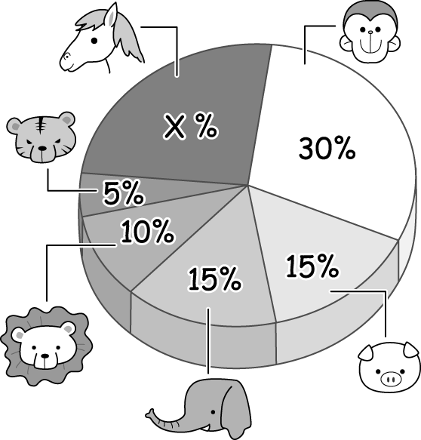
（ ）34. Which animals are NOT in the City Zoo?
(Ａ) Monkeys. (Ｂ) Elephants.
(Ｃ) Lions. (Ｄ) Hippos.
（ ）35. Are there any horses in the City Zoo?
(Ａ) No, there aren’t any.
(Ｂ) Yes, there are 25 horses.
(Ｃ) Yes, there are fifty horses.
(Ｄ) Yes, there are forty horses.
（ ）36. Which is true about the animals in the City Zoo?
(Ａ) There are thirty monkeys in the zoo.
(Ｂ) There are twenty elephants in the zoo.
(Ｃ) There are ten tigers in the zoo.
V.
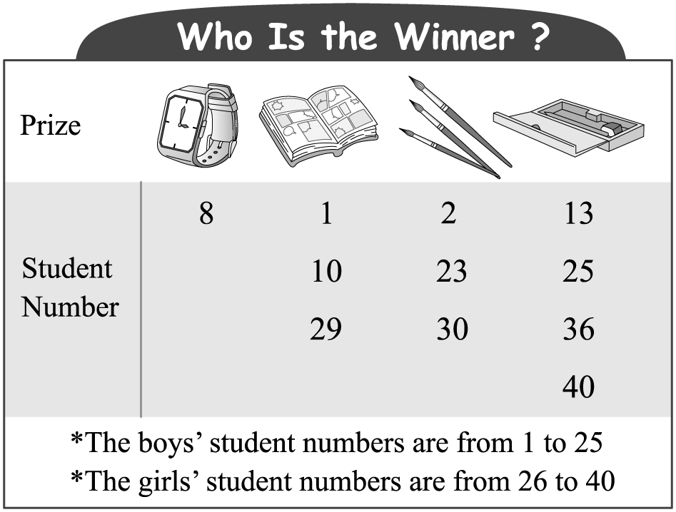
winner 獲獎者 prize 獎品 number 號碼
（ ）37. Jason’s student number is 8. What is his prize?
(Ａ) A watch. (Ｂ) A comic book.
(Ｃ) Brushes. (Ｄ) A pencil case.
（ ）38. Lily’s prize is a comic book. What is her student number?
(Ａ) 1. (Ｂ) 10. (Ｃ) 29. (Ｄ) 40.
（ ）39. Patty’s and Lucy’s prizes are the same（同樣的）. Are their prizes brushes?
(Ａ) Yes. Their prizes are brushes.
(Ｂ) No. Their prizes are watches.
(Ｃ) No. Their prizes are comic books.
(Ｄ) No. Their prizes are pencil cases.

請繼續作答非選擇題試題

