臺北市立瑠公國中一０六學年度第一學期九年級英文科第二次定期評量試題
班級:____ 座號:____ 姓名:__________

※聽力測驗：20%
- 辨識句意：根據聽到的內容，選出符合描述的圖片或符合圖片的描述5%
1.( ) (A)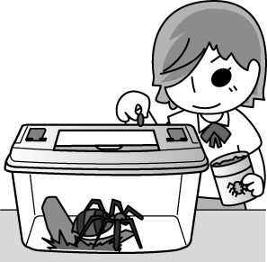(B)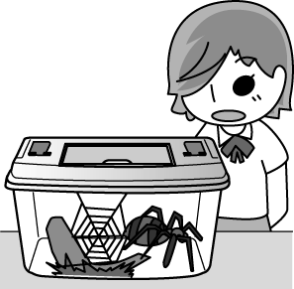
(C)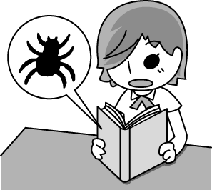

2.( ) (A)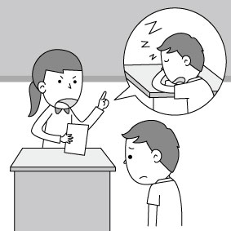 (B)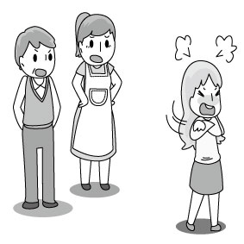
(C)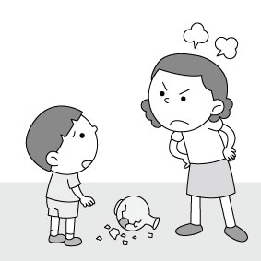

3.( ) (A)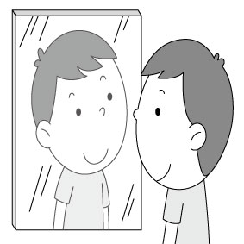 (B)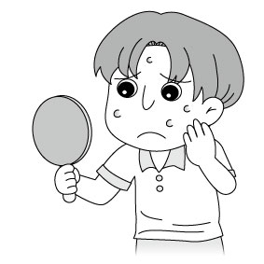
(C)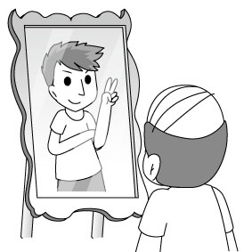

4.( ) (A)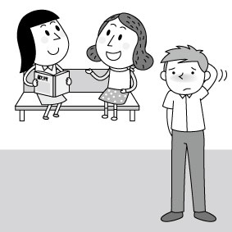 (B)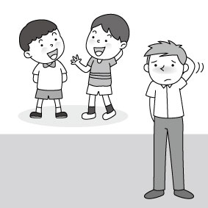
(C)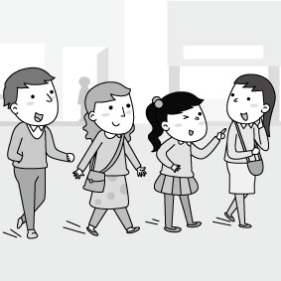

5.( ) (A) (B)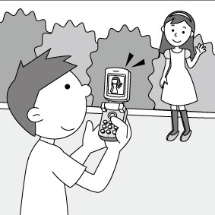
(C)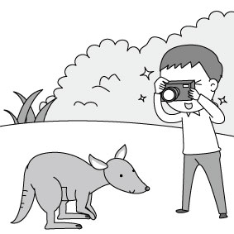
二、基本問答：根據聽到的內容，選出一個最適合的回應或最適合的問句5%
6.( ) (A)I think I have to run away and hide.
(B)Wow! What an amazing sight!
(C)I am glad to hear that.
7.( ) (A)Yes. Count me in.
(B)Sure. I won’t go there any more.
(C)That’s right. It’s around the corner.
8.( ) (A)She’s just a teenager.
(B)She told me to cheer up.
(C)Some boys laughed at her.
9.( ) (A)East or west, home is best.
(B)Let’s stay at the five-star hotel.
(C)Let me know if you want to stay with me.
10.( ) (A)Of course. He’s very kind.
(B)I’m really proud of you.
(C)No problem. It’s a piece of cake.
三、言談理解：請聽對話或短文，選出一個最適合的答案10%
11.( ) (A)In 1987.
(B)In 1997.
(C)In 2007.
12.( ) (A)He drove too fast.
(B)He didn’t wear the seat belt.
(C)He follows the traffic rules.
13.( ) (A)He is not confident in himself.
(B)He should become more attractive.
(C)He cares too much about his appearance.
14.( ) (A)He feels cold easily.
(B)He eats more than before.
(C)He became healthier.
15.( ) (A)He works in the hospital.
(B)He is staying in hospital because of the stomachache.
(C)He sent the woman to the hospital right after he got home.
【聽力測驗結束，請翻頁繼續作答】
四、選擇題：56%

( )When winter comes, millions of birds fly to the ______. (A)east (B)west (C)north (D)south

( ) Diane felt helpless, so she ______ her face with her hands and started to cry. (A)dug (B)covered (C)pointed (D)collected

( ) The restaurant is on fire. It is full of ______. Let’s call 119. (A)smoke (B)honey (C)mice (D)holes

( ) Mr. Lin is a ______ person. He seldom wears a smile on his face. (A)attractive (B)friendly (C)serious (D)confident

( ) Richard hurt his leg, so he has trouble walking up and down the ______. (A)row (B)chance (C)highway (D)stairs

( )I quickly closed the window to stop the bee ______ into my house. (A)on flying (B)by flying (C)from flying (D)to fly

( ) Grace is proud of herself. She ______ as a class leader several times since she entered junior high school. (A)will choose (B)has chosen (C)was chosen (D)has been chosen

( ) Listen! Someone is singing the song again. I’ve heard it ______ hundreds of times. (A)sing (B)sang (C)sung (D)to sing

( ) Tina is angry with David because he took her notebook without ______ her first. (A)ask (B)asking (C)to ask(D)asked

( ) I’m not sure whether I ______ able to come tomorrow. (A)will be (B)am going to (C)will(D)am

( ) It was strange ______ Kevin wasn’t invited to the Thanksgiving dinner. (A)whether (B)that (C)why (D)what

( ) I’d like to know ______________. (A)where can I find a restroom (B)what does Leo want to be in the future (C)how was their summer vacation (D)who is the tallest man in the world

( ) Teddy: ______________ Betty: No, all of them are from Taiwan. (A)Can these shoes be bought in Taiwan? (B)Will the shoes be shipped to Cambodia? (C)Are these shoes made in the UK? (D)Are those shoes made of leather?

( ) Anna: Does anyone know why Andy looks so down? Jimmy: ____________ (A)He dropped Patty a note and asked her to go out, but he was turned down. (B)He got the best grade on the science test. (C)Everyone in our class failed the science test except him. (D)He’s worked his skin problem out.

( )Jessica: Will you go to Emma’s birthday party this Saturday? Joe: Of course. ______________ (A)That sounds really boring. (B)I’m not sure if I can go or not. (C)I’m too busy to go to the party. (D)Her party will be too great to miss.

(31-34)

Hank: Do you know where I hid NT50,000? I put the money in a safe place. I believe (31) .

Bob: Really? Where did you put it?

Hank: It (32) inside a paper bag in a trash can.

Bob: A trash can? I took out the trash this afternoon and the trash truck has gone away.

Hank: What? You threw away NT$50,000? Are you crazy? Oh, my God!

Bob: I’m sorry. I didn’t know (33) .

Hank: What should we do now?

Bob: Let’s call the DEP to see (34) they can help us. Don’t worry. We’ll get the money back.

DEP環保局

( ) (A)even the thief can’t find it easily (B)what a right decision I made (C)whether anyone knows where it is (D)who can be so smart as me thief小偷

( ) (A)is put (B)was put (C)put (D)has put

( ) (A)whether the trash can was safe (B)the money was yours (C)how to get the money back (D)there was money inside the trash can

( ) (A)if (B)where (C)who (D)why

(35-38)

Have you ever heard of a blog? No? Then let me tell you (35) a “log” is first. A log is something that is written every day. When you write every day about (36) , you are keeping a log. Now many people do this on the Internet. Because the logs are on the Web, they (37) Web logs, and blogs for short. In blogs, some people write stories, some people write songs, but most people write about (38) they see, they hear, or they feel about the day. Blogs make people’s dream of becoming a writer come true.

( ) (A)whether (B)how (C)what (D)where

( ) (A)when does it happen (B)it happens (C)how does it happen (D)what happens

( ) (A)called (B)are calling (C)have called (D)are called

( ) (A)that (B)what (C)where (D)whether

(39-41)

You speak and write. Your words carry a message. People in the world communicate with words.

Do you ever think you can communicate without words? A smile on your face shows you are happy or friendly. Tears in your eyes tell others that you are sad. When you raise your hand in class, the teacher knows you want to say something or ask questions. You shake your head, and people know you are saying “No.” You nod and people know you are saying “Yes.” tear眼淚; nod點頭

Other things can also carry messages. For example, a sign at the bus stop helps you to know which bus to take. Signs on doors tell you where to go in or out. Have you ever noticed there are a lot of signs around you and you always receive messages from them?

People communicate in many other ways. Books, magazines, TV, and radio all help us to know what is happening in the world and what other people are thinking about.

( ) What does a student have to do first when he wants to say something in class? (A)He has to shake his head. (B)He has to raise his hand. (C)He has to show the tears in his eyes. (D)He has to speak “yes” loudly

( ) Which is true about the article? (A)Signs teach people how to speak. (B)People can’t communicate without words. (C)Few people know how to use body language to carry messages. (D)What is written in a book helps people understand the world better

( ) What is the best title for this article? (A)Smiles and Tears (B)Words and Signs (C)Actions Speak Louder Than Words (D)Ways To Communicate

(42-43)
James fell in love with his neighbor, Alice. Her birthday was around the corner and he wanted to give a special gift that she would never forget. One night, he got a great idea from a TV show. In the show, a man showed how much he loved a woman in a really interesting way. On Alice’s birthday, James used alcohol to write, “Happy birthday, Alice. I love you.—James” on the grass in a park. Then he set fire and showed it to Alice. She loved it and was very excited. They sat there and watched the fire happily. Suddenly, they heard someone shouting. They turned around and saw another neighbor and a police officer running up to them. They were then taken to the police station. James got in big trouble for damaging the public park. He had to spend NT$300,000 fixing the damaged land. When he was asked why he had done something so dangerous, James said that he got the idea from a TV show. “They did it on the show. Why can’t I?” James said. Everybody laughed and told James that he should not believe everything shown on TV. From that moment on, he knew that he should think harder before doing something like that again, but it was a very expensive lesson for him.
alcohol酒; damage破壞

( ) What did James have to pay for? (A)Buying a birthday cake for Alice. (B)Helping people go to the hospital (C)Fixing the grass in the park. (D)Buying more alcohol for Alice.

( ) What did James learn from that day?

(A)Do not believe everything you see on TV.

(B)Get more money before getting in trouble.

(C)Do not do anything special on a friend’s birthday.

(D)Do not get to know your neighbors.

【以下答案請寫在作答卷上】
五、文意字彙12%

There is no place like home. It always makes me feel safe and c____e.

The book is quite t____k. There are over five hundred pages in it.

John is a c____n name for boys. Many boys are named John.

In Taiwan, all the students in junior high school have to wear u____ms to school.

Lily is married to a f____r. Her husband is from the UK.

It’s p____e to knock on the door before you enter somebody’s room.

六、依指示作答12%

/I wonder.

\How many bugs did he catch?(合併成一句) 2%

The water is so dirty that nobody can drink it. (以too…to…改寫) 2%

至於這隻鵝，它將被燒烤。2%

這男子問我Tom是否被一隻大蜘蛛咬到腳趾頭。3%

Amy是如此的害羞，以致於她不知道如何向任何人敞開心胸。3%

【本次測驗結束】

