台北市立瑠公國民中學106學年度第一學期八年級第二次段考 英語科 考試卷
年 班 座號： 姓名：

第一部分：聽力測驗 25 %
- 辨識句意：根據聽到的內容，選出符合描述的圖片或符合圖片的描述。(每題1分，共5分)
- (Ａ) 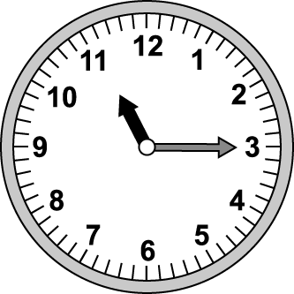 (Ｂ) 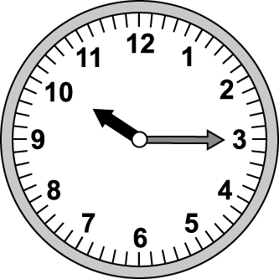 (Ｃ) 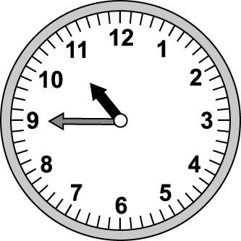
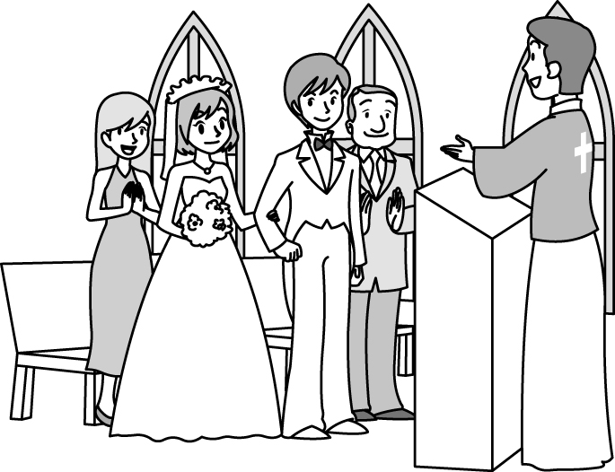
- (Ａ) 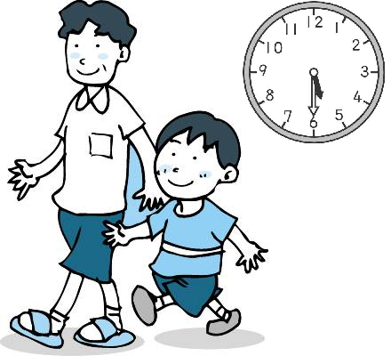 (Ｂ) 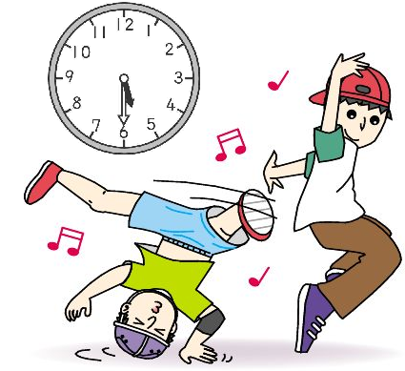 (Ｃ) 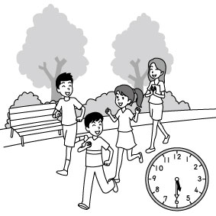
- (Ａ) 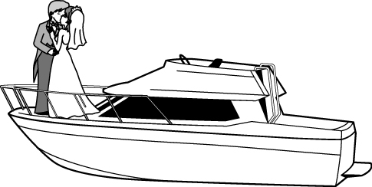(Ｂ)

(Ｃ) 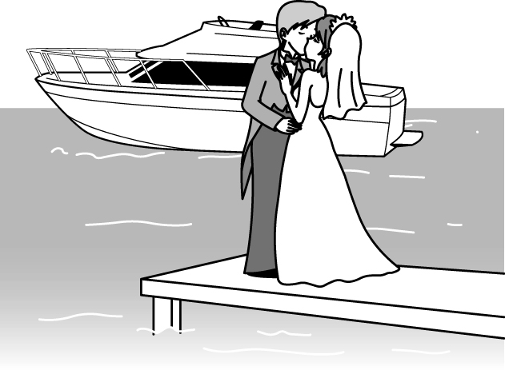
- (Ａ) 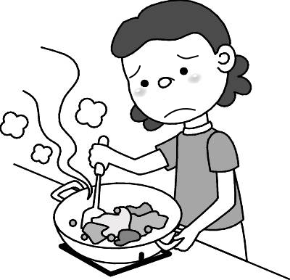(Ｂ) 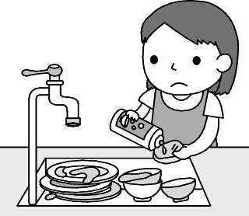
(Ｃ) 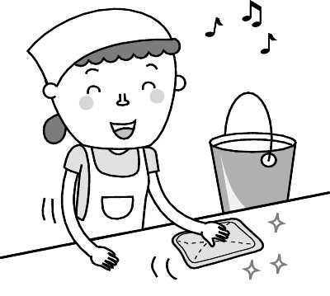
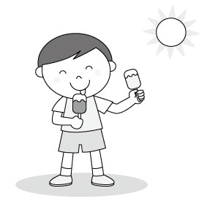
- (Ａ) 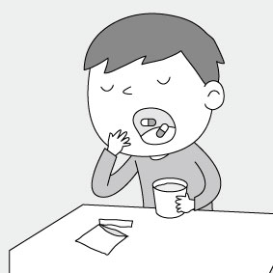(Ｂ)

(Ｃ) 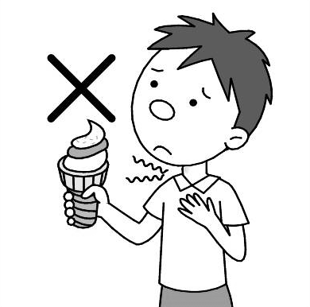

- 基本問答：根據聽到的內容，選出一個最適合的回應或最適合的問句。(每題2分，共10分)
- (Ａ) Take it easy. When did you last see it?
(Ｂ) I don’t remember. I did many things this
morning.
(Ｃ) I looked everywhere in the house and found
my bag.
- (Ａ) Yes, I like writing interesting stories.
(Ｂ) No, I hate to memorize lines. It’s hard for me.
(Ｃ) No, I like to act in front of everyone.
- (Ａ) I enjoy reading comic books like you.
(Ｂ) I like this movie very much.
(Ｃ) I love dancing.
- (Ａ) I went back home soon.
(Ｂ) I stayed there until dinner time.
(Ｃ) The library is very near my house.
- (Ａ) He hurt his head yesterday.
(Ｂ) He wore a pink hat yesterday.
(Ｃ) He didn’t remember to go to the hospital.

- 言談理解：根據聽到的內容，選出一個最適合的答案。(每題2分，共10分)
- (Ａ) The girl needs to dry her hair.
(Ｂ) The girl needs to wipe her nose.
(Ｃ) The girl needs to clean her fingers.
- (Ａ) On the table.
(Ｂ) In Colby’s hand.
(Ｃ) In the living room.
- (Ａ) She didn’t study for the test.
(Ｂ) She didn’t ask the teacher questions.
(Ｃ) She couldn’t memorize long English words.
- (Ａ) She has a toothache.
(Ｂ) She has a sore throat.
(Ｃ) She has a stomachache.
- (Ａ) The boy got up late because he had a bad
stomach.
(Ｂ) The bus came at eight forty this morning.
(Ｃ) The boy skipped his Chinese class today.

第二部分：選擇題 29 %
克漏字 (每題1分，共21分)
16. Ouch! My head _____ ! Don’t touch it.
(A) hurts (B) hurt
(C) hurts me (D) gets hurt
17. A: Why don’t you eat cakes? Are you full?
B: No. I _____ don’t like it.
(A) still (B) either
(C) finally (D) just
18. A: Why did you _____ to be a police man?
B: I want to catch bad guys.
(A) skip (B) tell
(C) stay (D) decide
19. Michael _____ study _____ this afternoon.
(A) not; until (B) doesn’t; until
(C) didn’t; until (D) X; for
20. A: Was he washing his face at that time?
B: Yes, he _____.
(A) did (B) does
(C) was (D) was washing.
21. Sally got on the bus and _____ her friends. They _____ for her.
(A) saw; are waiting
(B) see; are waiting
(C) saw; were waiting
(D) see; were waiting
22. _____ too much coffee and _____ bad for you.
(A) To drink; skipping breakfast are
(B) Drinking; skipping breakfast are
(C) Drink; skip breakfast is
(D) Drinking; skipping breakfast is
23. Driving lessons ____ important for students.
(A) does (B) is
(C) do (D) are
24. The bag is not _____. I can’t put all my books in it.
(A) enough well (B) well enough (C) enough big (D) big enough

A.
Geroge: Cindy, why did you come back so __25.__? Didn’t you plan to play with Lisa at the park?
Cindy: I don’t know. I looked for her __26.__but I just couldn’t find her. I was worried about her.
Geroge:__27.__ When did you last see her?
Cindy: At about a quarter to five, we __28.__ lunch at the hot dog stand.
Geroge: And then?
Cindy: I had a bad stomachache so I went to the bathroom.
Geroge: Was Lisa __29.__ with you?
Cindy: I can’t remember. I was busy cleaning my clothes in the bathroom then.
George: You need some __30.__ now. We can look for
her later.
Cindy: Ok.

25. (A) late (B) soon (C) well (D) high
26. (A) where (B) everywhere
(C) nowhere (D) somewhere
27. (A) Take it easy. (B) All right.
(C) That’s wondeful. (D) What’s wrong?
28. (A) have (B) has
(C) are having (D) were having
29. (A) still (B) last (C) until (D) all over
30. (A) jobs (B) windows (C) rest (D) west

B.
Jason: Thanks a lot __31.__ me the i-phone 12.
Jill: You’re welcome. Many people were standing in __32.__ for the new smartphone.
Jason: It is __33.__ people here in Taiwan. I want to be a great man __34.__ Steve Jobs. He shared lots of ideas when he was alive.
Jill: It is important for a boss to __35.__ good ideas in his company.
Jason: That’s right. What about you, Jill? What do you want to be in the future?
Jill:A writer. Stephen King is my favorite writer.
Jason: Cool! You’re good at writing and your dream will come true.
Jill: It’s sweet __36.__ you to say that. *alive 活著

31. (A) about giving (B) to giving
(C) to give (D) for giving
32. (A) factory (B) line (C) team (D) age
33. (A) popular with (B) terrible for
(C) worried about (D) difficult for
34. (A) with (B) to (C) like (D) for
35. (A) cry out (B) take off
(C) take out (D) come up with
36. (A) for (B) of (C) to (D) with
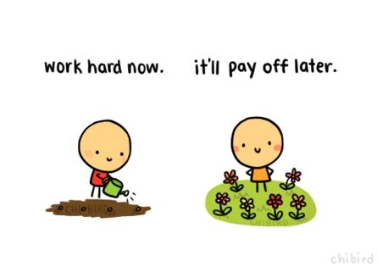

閱讀測驗 (每題2分，共8分)
A.

Sometimes people get hurt. When that happens, you can help. But before you help, make sure you won’t be hurt. Next, be sure the hurt person is safe. If the person is hurt badly, get professional help. If you know first aid, you can save a life. Is the hurt person breathing? Is his or her heart beating? If not, you may have to do CPR.
Next, check for blood. If the person is bleeding, try to stop it quickly. Put a clean cloth on the wound. If you don’t have a cloth, use someone’s clothes. Hold the cloth on the wound for at least 20 minutes. This will stop most bleeding. If blood comes through the cloth, don’t take it off the wound. Just place another cloth on top.
*professional專業的 aid 幫助 bleeding流血 wound受傷部位

37. What should people do first when they want to save the hurt people?
(A) Cry out for help right away.
(B) Call 1999 first and run away.
(C) Make sure the place is safe.
(D) Do CPR right away.

38. Tina cut her finger accidentally. According to the
reading, what shouldn’t she do to help herself?
(A) Stop the bleeding as soon as possible .
(B) Press the wound for thirty minutes.
(C) Use clean clothes to press the wound.
(D) Take off the cloth with the blood. *press按壓

B.
Here is an interesting new word, ‘Internet Trolls.”
Do you know what the ‘troll’ is?
In old stories, a troll is an ugly and bad bully who lives under a bridge and likes to scare away the goats passing by. But what does this terrible creature have to do with the World Wide Web?

“Internet Trolls” like to threaten people on line. They would like to give bad words or make fun of others by using words on the Internet. ‘Internet Trolls’ enjoy distressing others and making them feel bad. The internet is a happy place for these trolls.
How can we stop them and their cyberbullying? First, just ignore it. This may make these internet trolls bored. Second, report it. There are many anti-bullying tools on the social media platforms, such as Facebook and Twitter.
*creature 生物 threaten威脅 distress使挫折
*cyberbully網路霸凌 ignore忽略
39. What is the main idea of this reading?
(A) To talk about how ‘trolls’ live now
(B) To show the danger of the ugly animal
(C) To introduce a new word about internet users
(D) To ask people to stop bullying people online

40. What could we infer (推測) from the reading?
(A) We can not stop cyberbullying.
(B) Language could be dangerous.
(C) Trolls are real animals in the world.
(D) Skipping words by internet trolls is not good.

第三部分：手寫題 46%
一、文意字彙 (每題2分，共22分)
A. 看圖寫出職業名稱
(1)


f_________n

(2)


re________r


(3)

f______r

B. 文意字彙
1. Monica is s____k; she has a bad cough.
2. It is not nice to eat ice when you have a high f_____r.
3. Don’t eat junk food so often. It’s bad for your h_____th.
4. He was happy to take the doctor’s a____e and do more exercises.
5. Miss Lin went to the h____al last night because she had a terrible headache.
6. Iris plans to go to the l____y to look for a basketball history book later.

7. The baby had a sore throat so he had to take the m____ne every eight hours.
8. Ruby spent two hours pr____ring the meals for the Thanksgiving party.

二、依括號內的提示，填入正確的動詞形式(每格2分，共16分)
(1) __a.__ (take) a cold bath in a hot day is wonderful.
(2) It is difficult __b.__ (get up) early in winter.
(3) __c.__ (wake up) now. It’s 7:30, and you’re late.
(4) The teacher told the kids __d.__ (stand up).
(5) Mark kept __e.__ (look) at his watch in class.
(6) I want to __f.__ (interview) that popular singer.
(7) Mr. Brown began __g.__ (teach) in 1990.
(8) Victor enjoys __h.__ (sell) cookies in front of the Central Park.

三、翻譯題 (共8分)
1. 規律的飲食是很重要的。(3分)
2. 要改變習慣是困難的因為積習難改。(5分)

-- 試題結束 --

