**臺北市立瑠公國中一０六學年度第二學期九年級英文科第一次定期評量試題**

班級:____ 座號:____ 姓名:__________

**※聽力測驗：**20%

1. 辨識句意：根據聽到的內容，選出符合描述的圖片或符合圖片的描述5%

1.(  ) (A)(B)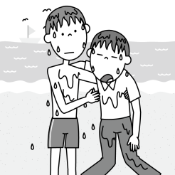

(C)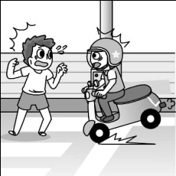

2.( ) (A)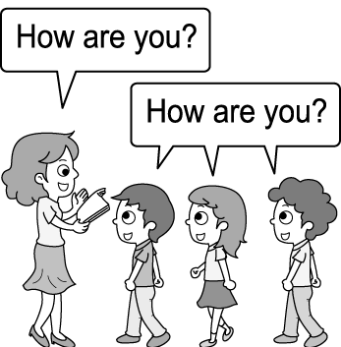 (B)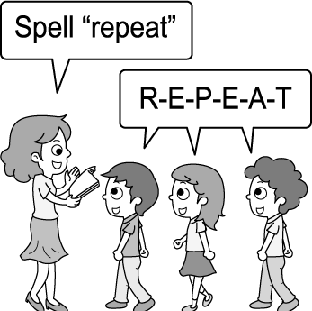

(C)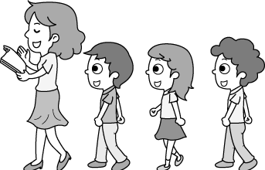

3.( )

(A)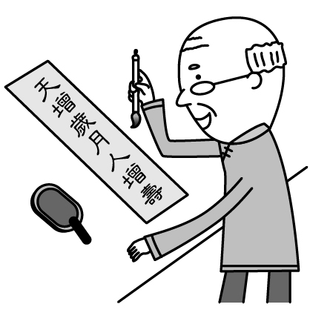 (B)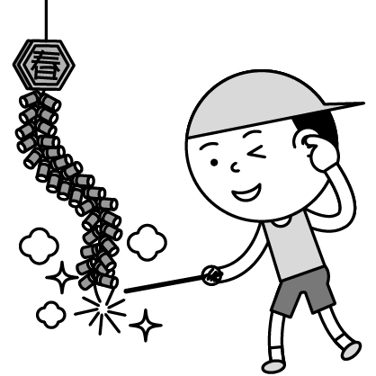(C)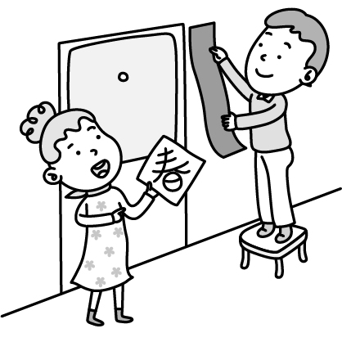

4.( ) (A)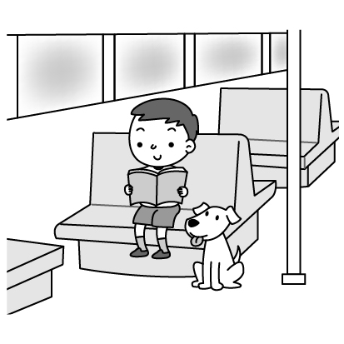 (B)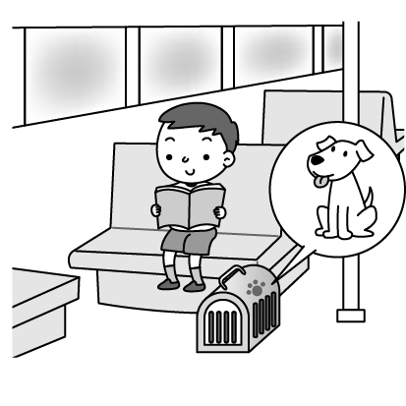

(C)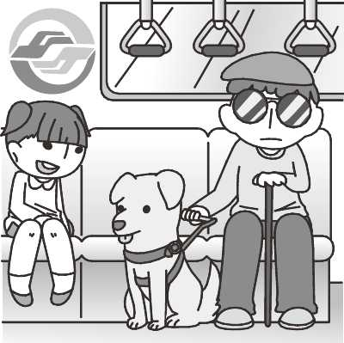

5.( )

(A)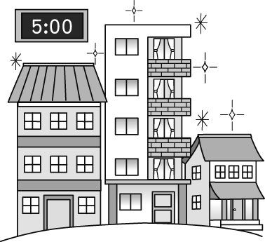 (B)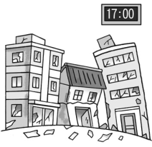(C)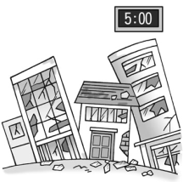

二、基本問答：根據聽到的內容，選出一個最適合的回應或最適合的問句5%

6.( ) (A)No. Rat is.

(B)Yes. Next animal sign is the Tiger.

(C)Yes. There are twelve.

7.( ) (A)The gas station is newly opened.

(B)On the corner of Park Street and Beach Road.

(C)I spend much money on gas each month.

8.( ) (A)Please don’t touch it when it’s working.

(B)Great! It can lead Simon to many places.

(C)So cute! I want to adopt it.

9.( ) (A)I’ll be off for one week.

(B)So far, so good. Thank you.

(C)Not yet. Any great idea?

10.( ) (A)Yeah, becoming an artist is my dream.

(B)What makes you say so?

(C)You are really interesting.

三、言談理解：請聽對話或短文，選出一個最適合的答案10%

11.( ) (A)Frank’s wife is a foreigner.

(B)The woman is going abroad.

(C)The man and the woman live in Japan.

12.( ) (A)She is teaching the boy to do his homework.

(B)She is copying her classmate’s homework.

(C)She is cheating on the math test.

13.( )(A)He’s getting stress from work and not resting enough.

(B)He’s not listening to the doctor.

(C)He’s not taking the medicine regularly.

14.( ) (A)An actor talked to her.

(B)Matt Damon waved to her.

(C)She saw her favorite actor.

15.( ) (A)Do housework happily.

(B)Do not play computer games.

(C)Go out with friends in her free time.

【聽力測驗結束，請翻頁繼續作答】

**※選擇題：**80%

1. ( ) Andy: I know the answers to the ______! It’s a drawer. Teacher: Correct! (A)row (B)bride(C)couch (D)riddle
2. ( ) We always can get a lot of useful ______ from books. (A)performances (B)knowledge (C)microchips (D)blackboards
3. ( ) Though the table was very high, the cat was still able to jump ______ it. (A)beside (B)through (C)into (D)onto
4. ( ) Mr. Chen is a ______ person. He always looks on the bright side of life and seldom thinks about something bad. (A)modern (B)responsible (C)positive (D)helpful
5. ( ) A guide dog is trained to help the ______. (A)blind (B)missing (C)alive (D)dead
6. ( ) If you feel cold, you can put a ______on your legs. (A)carton (B)lid (C)pin (D)blanket
7. ( ) To ______ our nature, we should stop using plastic bags. (A)respect (B)protect (C)adopt (D)push
8. ( ) Don’t stand in the ______ of the street. It’s very dangerous. (A)sorrow (B)bottom (C)middle (D)side
9. ( ) My sister is a(n) ______ in a big company. Her job is to answer phone calls and plan meetings for her boss. (A)saleswoman (B)engineer (C)lawyer (D)secretary
10. ( ) I thought Ted would help us with the science homework, but it ______ that he was too busy to give us a hand. (A)turned out (B)worked out (C)was afraid (D)turned around
11. ( ) Many people ______ a lot of food and clothes to Hualien right after the big earthquake happened last month. (A)have sent (B)sent (C)are sending (D)were sent
12. ( ) My wallet ______ by the time I touched my pocket at the bus stop. (A)has stolen (B)was stealing (C)is stolen (D)had been stolen
13. ( ) While my brother ______ a shower in the bathroom last night, the doorbell rang. (A)is taking (B)has taken (C)was taking (D)was taken
14. ( ) I have to make sure if my friend, John, ______ me next Wednesday. (A)will visit (B)visits (C)has visited (D)have been visited
15. ( ) After ______ the puppy, the vet told us he was very healthy. (A)check (B)checking (C)to check (D)checked
16. ( ) Gina either plays the piano or ______ in her free time. (A)be a good swimmer (B)at the gym (C)reading in the study (D)takes photos
17. ( )Amy is planning to take a trip to France by herself. ______ her parents ______ her friends will go with her. (A)Both; and (B)Either; or (C)Neither; nor (D)Not only; but also
18. ( ) ______ you follow the doctor’s advice and take a rest, you will get well soon. (A)As far as (B)As much as (C)As soon as (D)As long as
19. ( ) Brad has stopped being a black sheep in his class ______ he decided to change himself and work hard in everything. (A)although (B)since (C)until (D)if
20. ( ) They helped the boy ______ parents were killed in the typhoon. (A)who (B)which (C)whose (D)that
21. ( ) The hotel ______ we will stay is called The Moon House. (A)where (B)what (C)which (D)whose
22. ( )A: How come you missed the bus again? B: ____________ (A)I couldn’t get up early. (B)Good question. Let’s ask the bus driver. (C)I have never heard of this before. (D)Don’t you know about that?
23. ( )A: Tina hasn’t been herself lately. Is there anything bugging her? B: ____________ (A)No, she is afraid to go to the dentist. (B)Yes, she does excellently at school. (C)No, she worries about her poor grades. (D)Yes, she has trouble with acne.
24. ( )A: ____________ B: I heard it takes about two years. (A)How often does Ken feed his puppy? (B)How long does it take to train a police dog? (C)How soon will Ms. Li leave for Tainan? (D)How many years do you have the rabbit?

(40-43)

Bess: Mary, what happened? You look down.

Mary: My favorite movie star, Jerry Ford, is married. (40) I heard about the news, I felt very surprised.

Bess: Not only you but also I (41) surprised. Doesn’t he always say he is single?

Mary: It’s not true. He (42) married for two years before he became an actor.

Bess: How could he lie to his fans?

Mary At first, I was really angry with him. However, I still want to be his fan. After all, I (43) his movies since junior high school.

Bess: You are really a big fan of his.

🕮single單身的

1. ( ) (A)Before (B)While (C)When (D)Though
2. ( ) (A)are (B)were (C)was (D)being
3. ( ) (A)has been (B)had been (C)would be (D)was getting
4. ( ) (A)have watched (B)had watched (C)was watching (D)was watched

(44-46)

One day, my seven-year-old girl shouted in an exciting voice (44) she got home from school. “Mom, my teacher taught us (45) today in class.” I was surprised at what she said, and I felt strange why school started the sex education so early, but still I answered in a soft voice, “Sweetie, tell me what your teacher (46) you.” My daughter answered proudly, “It’s easy. Just take away “y” and plus “ies.”

🕮sex education性教育; soft溫柔的; plus加上

1. ( ) (A)before (B)although (C)as long as (D)as soon as
2. ( ) (A)the ways to make friends with others (B)how to save ourselves from drowning (C)why we should have good manners (D)how to make babies
3. ( ) (A)teach (B)was taught (C)has taught (D)had taught

(47-49)

One cold winter day, a poor young man was walking home with his wife. As they walked along, it started to snow heavily, making it very difficult for the couple to see the way. Soon the two were lost. The young man knew his wife would die in the cold if he did not do something. Standing there in the falling snow, he gave her his jacket and held her in his arms. Hours later, a man found the two on the ground. The wife, held by her husband and wearing his jacket, was fine, but her loving husband was dead. Since then, no snow has ever fallen in the place where the couple sat. No matter how cold the day gets, that place is said to be always warm.

🕮couple夫婦; no matter無論

1. ( ) Why couldn’t the couple get home? (A)They forgot where they lived. (B)They couldn’t see clearly because of the bad weather. (C)Their house was covered by snow. (D)The woman was too tired to walk.
2. ( ) How did the man keep his wife warm? (A)He gave his jacket and held her. (B)He took her home. (C)He bought a jacket for her. (D)He sent her to a warm place.
3. ( ) Which is true about the story? (A)The wife died in the heavy snow. (B)The husband did nothing in the snow. (C)Someone saved the couple’s lives. (D)It used to snow in the place where the couple sat.

(50-52)

Sometimes people enjoy noise. However, there are many kinds of noise that are not welcome at all. We hear different kinds of noise every day right after we get up. For example, traffic on the road can lead to some of the noises we hear. Even when we leave the street and go into a shop, there is loud music playing. We may not notice but it can be dangerous for us to stay in a noisy place for too long. It will increase our stress and make us feel tired. It may even give us a headache.

However, it costs money to make less noise. We have to use sound-proof walls to keep us from the noises. Laws are made to lower noise, but people seldom really care about them. Maybe we need stricter laws to show people how bad noise is. People will then understand how important it is to make less noise.

🕮increase增加; law法律; strict嚴格的

1. ( ) What is the main idea of this article? (A)Noise may affect our health. (B)Lowering noise costs money. (C)It’s a noisy world. (D)People should follow laws and rules.
2. ( ) With sound-proof walls, we may ______. (A)share loud music at home with others (B)hear what neighbors say clearly (C)block the sound from noisy neighbors (D)forget about manners and laws
3. ( ) Which is true about the article? (A)Noise is neither good nor bad. (B)Laws are the only way to protect our ears. (C)Don’t enter a shop with loud music. (D)As long as we can hear, we will hear noise in everyday lives.

(53-55)

I have three friends who are at the same age but have different horoscopes.🕮horoscope星座

Tom is a Capricorn (December 22~January 19). He is often still at work at 1:00 a.m. My friends always call him a “workaholic.”

Jenny is a Pisces (February 19~March 20). She is a dreamer. If her boyfriend gives her romantic gifts, she will marry him right away.

Peter is a Virgo (August 23~ September 22). He is a person who wants everything to be perfect. He can draw well and he enjoys art very much.

I am a Gemini (May 21~June 21). I’m a spender. When I see something new or special, I can’t keep from buying it.

1. ( ) Which is true? (A)Peter is older than any others of the four. (B)Jenny is the youngest of all. (C)The speaker is younger than Peter. (D)Tom may be either the oldest or the youngest of the four.
2. ( ) Which of the following person is a “workaholic?” (A)Jack spends more time in the office than at home. (B)Aunt Lucy enjoys shopping a lot. (C)Alex asks himself to do everything best. (D)My mom likes flowers, rings and presents.
3. ( ) Kelly’s birthday is near Chinese New Year. What horoscope might she be? (A)Capricorn. (B)Pisces. (C)Gemini. (D)Virgo.

【本次測驗結束】