臺北市立瑠公國中106學年度第二學期八年級英文科第一次定期評量試題
八年 班 號 姓名：
第1頁，共3頁

※選擇題請在電腦卡上作答，共62分
一、聽力測驗20%
- 選出符合句子描述的圖片5 % (每題1分)
1.
(A) 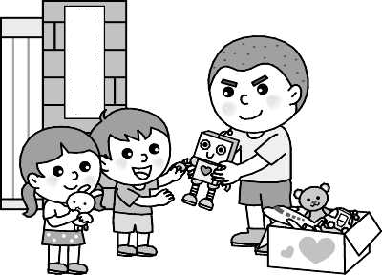 | (B) 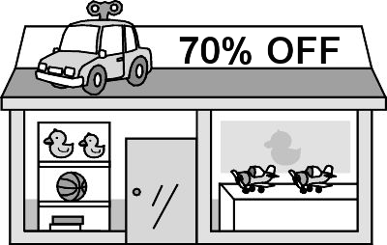 | (C) 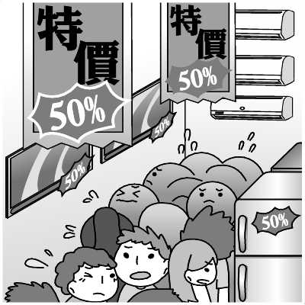
2.
(A) 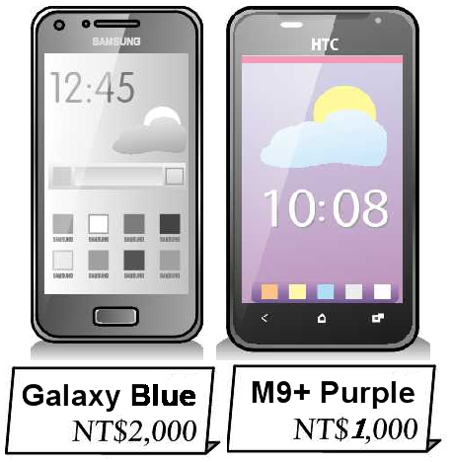 | (B) 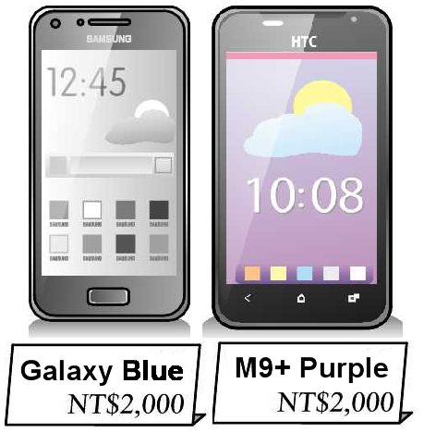 | (C) 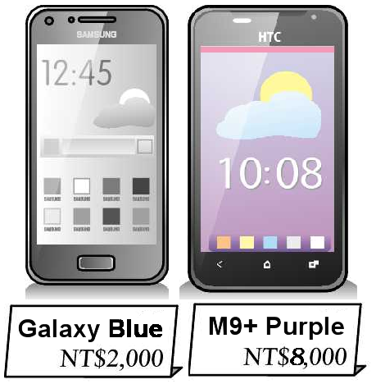
3.
(A) 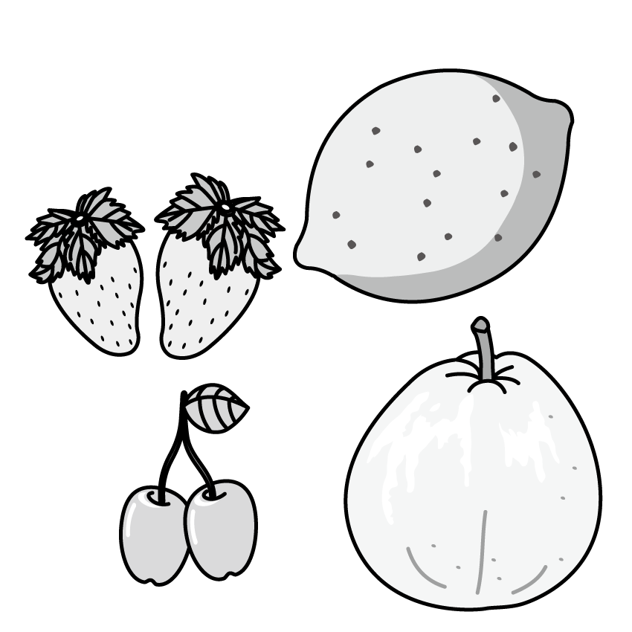 | (B) 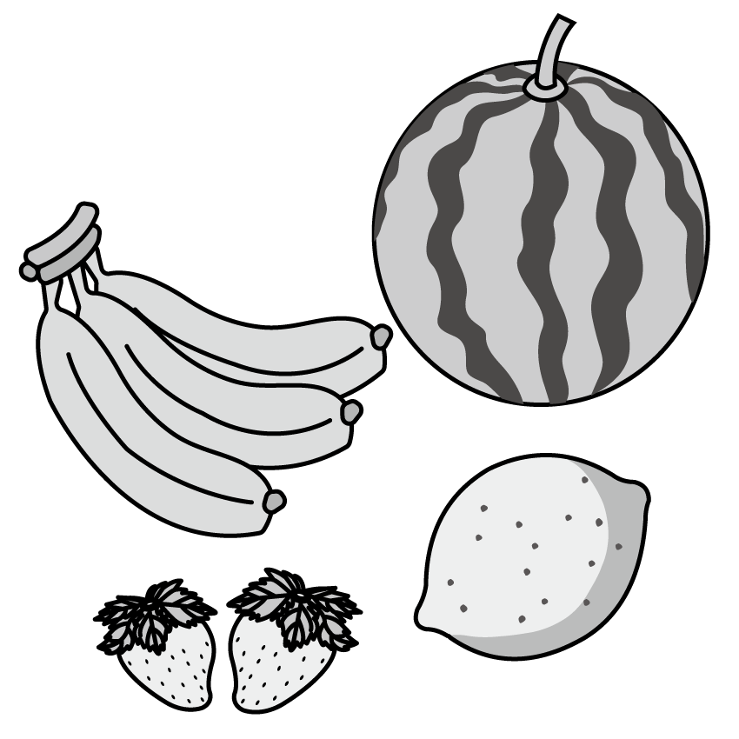 | (C) 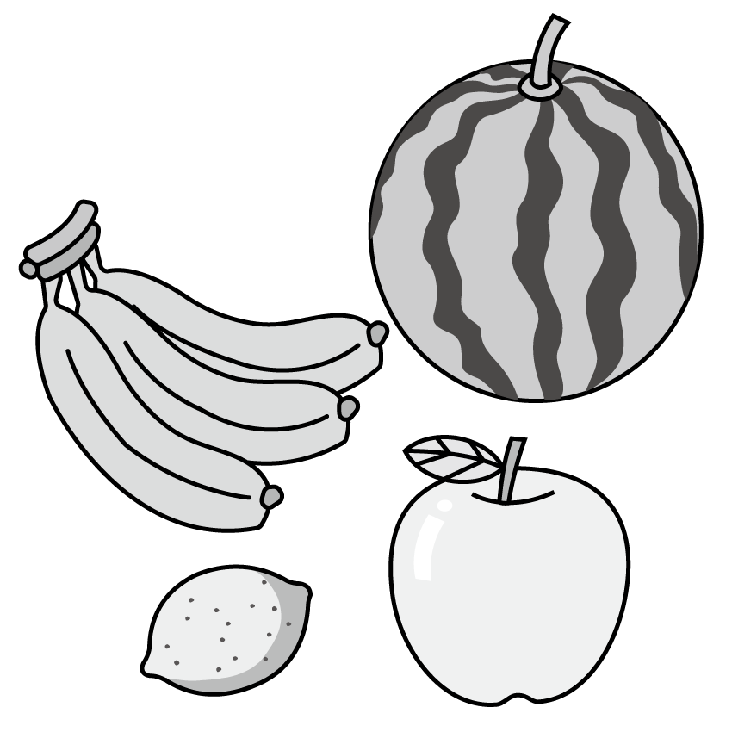
4.
(A)  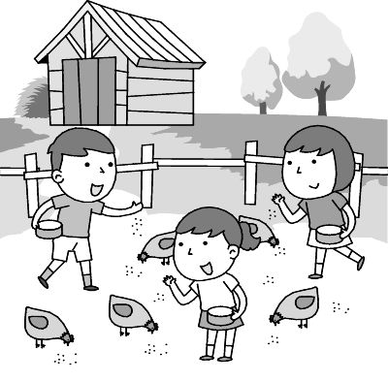 | (B)  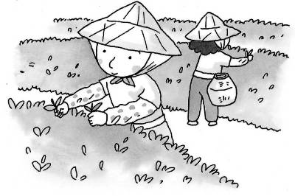 | (C)  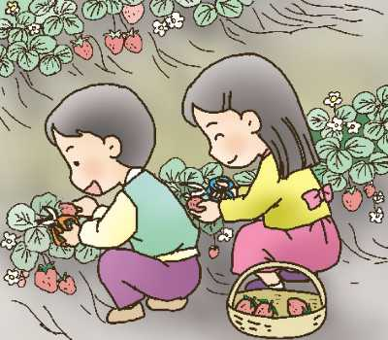
5.
(A) 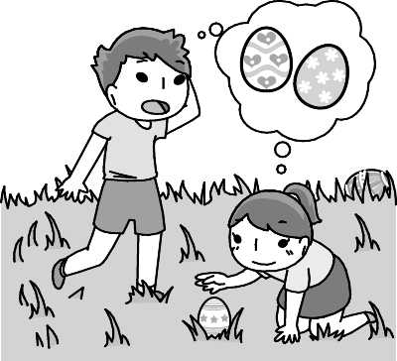 | (B) 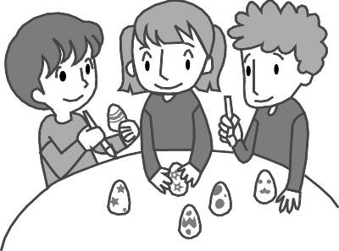 | (C) 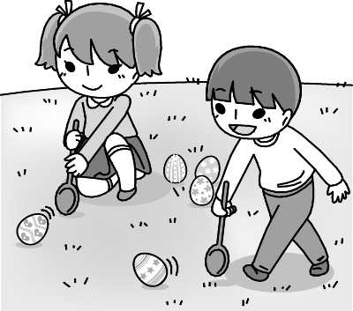
B. 選出最適合的回答，完成對話5% (每題1分)
6. (A) By credit card.
(B) One thousand dollars.
(C) I don’t have any pocket money.
- (A) Nice to meet you, too. I’ll buy it for you.
(B) I’d like a MP3 player. Can I take a look at
that one?
(C) The purple CD player is heavier than that
gray one.
- (A) She’s a businesswoman. She owns a toy
factory.
(B) She’s the best grandma in the world.
(C) She moved to the country many years ago
9. (A) The guavas are sweeter than the bananas.
(B) The pears are as sweet as the grapes.
(C) The grapes are.
10. (A) Hurry up, then.
(B) It’s inside the movie theater.
(C) That sounds great.
C. 請聽對話或短文，選出問題最適合的答案。10%
- (A) The gray one.
(B) The red one.
(C) He doesn’t know.
- (A) They just saw an amazing movie.
(B) The movie is the worst one of the year.
(C) The man didn’t agree with the woman.
- (A) The woman needs to buy some books after
work.
(B) The woman wants her husband to drive her
home after work.
(C) The woman will meet her husband at the bus
stop near their house.
- (A) Yes, she feels happy.
(B) No, she feels tired and sick.
(C) Yes, and the man will drive her home.
- (A) The weather is getting hotter these years.
(B) In Kaohsiung, people usually wear heavy
coats.
(C) It’s summer now.
二、文法選擇20%(每題2分)
16. The music at your party ______ great. I like it.
(A) heard (B) looked (C) tasted (D) sounded
17. Ted usually borrows money from me because he has _______ pocket money than I.
(A) the most (B) the least (C) fewer (D) less
18. Of the two girls, Jill is __________.
(A) more beautiful (B) more handsome (C) stronger (D) the prettier
19. Is there anything to eat? I am ____________ now.
(A) as busy as a bee (B) as slow as a turtle
(C) as hungry as a bear (D) as cool as a cucumber
20. Ken, ______ do you feel or _____ do you think about your new class?
(A) what; how (B) how; what
(C) what; what (D) how; how
21. Of all the tomatoes, the yellow ones are ______.
(A) much more expensive (B) the sweetest
(C) most popular (D) the highest
22. In ______ weeks, Mom will be ______ busy and can’t make dinner for us.
(A) a few; a few (B) a little; a little
(C) a few; a little (D) a little; a few
23. The businessman is good at ________ a 3C store, and he sometimes enjoys _______a farmer in the country ______a day.
(A) picking; to be; in (B) moving; be; during
(C) running; being; for (D) growing; being; at
24. I am sorry. I _______ going to bed early.
(A) want (B) plan (C) would like (D) feel like
25. Mia: Didn’t your mom buy you a smartphone?
Max: Yes, she bought ____ for me and I like ___.
(A) one; it (B) it; one (C) one; one (D) it; it

三、克漏字選擇 10%（每題 2分）
(Ruby and Mason are outside a coffee shop.)
Ruby: Wow! That new watch looks nice (26) you. It is beautiful!
Mason: Thanks. My wife gave it to me (27) my birthday. It’s not just a watch. It’s a smartwatch. It can help me with a lot of things, like making a phone call, surfing the Net, answering questions, and etc.
Ruby: Wait! Answering questions?
Mason: That’s right. We call this application “Siri.” It’s really a lot of fun.
Ruby: So you can talk with it? It (28) your friend.
Mason: Haha… Well, when I feel sad, I do try to talk to it. And it answers, “I would give you a shoulder to cry on if I had one.” It seems that it really (29) my feeling.
Ruby: Oh! It’s sweet.
Mason: True. Do you want to ask it a question?
Ruby: Sure. Do you… (30) Oh my! The bicycle almost hit you.
Mason: Thanks. Maybe next time Siri can tell me that a bicycle is coming my way.
26. (A) at (B) with (C) for (D) on
27. (A) with (B) of (C) for (D) in
28. (A) smells (B) smells like
(C) sounds (D) sounds like
29. (A) sounds (B) sounds like
(C) listens (D) listens to
30. (A) Hurry up! (B) Watch out!
(C) Why not! (D) I see!

四、閱讀測驗 12% (每題2分)
1.
Dear Howard,
Jimmy and I went to Vicky’s home to visit her. She didn’t go to school for a long time because she was very sick. She looked much thinner than she was at school, but she still looked quite good. For me, she is the strongest girl of all my friends. She is brave to keep fighting for her life. She was very happy when she saw us. Jimmy and I told her a lot of interesting things about our class and school. We also brought her a good book and a get-well card from our classmates. She was just a little sad that she couldn’t go back to school soon, so we tried to cheer her up. But Vicky was so great that she always looked on the bright side of life. We all believe that she will get well and come back to school soon!
By the way, our class will take a two-day trip to Ilan next weekend. You are welcome to join us. Let me know if you feel interested.
  quite 很… brave勇敢的
bright side光明面 believe相信
31. How did Vicky look yesterday?
(A) She looked very weak and tired.
(B) She looked thinner than before.
(C) She looked pretty and amazing.
(D) She looked strong and healthy.
32.What did Victoria bring for Vicky yesterday?
(A) A book and a card. (B) A chocolate cake.
(C) Some apples and cherries. (D) Some flowers.
33.Which is true?
(A) Jimmy brought Vicky a CD and some cookies. (B) Vicky will go to Ilan with her classmates next weekend.
(C) Howard stayed in hospital for a long time. (D) Victoria will take a trip to Ilan next weekend.
2.
 | The Luckiest One  By Victor Sparks  Price: NT$310  Sale:21% →NT$245  ★★★★☆ 2,416 customer reviews
Customer Reviews
★★★★★ The Best Of All Sparks’ by Woody D
This is Mr. Sparks fourteenth boo, and I think it is the best. The Luckiest One tells a story of common people just like you and me. With simple words, Mr. Sparks makes me believe in love and hope again.
★★★★★ A Great Love Story by Kiki Chen
A picture of a woman brings a US soldier, Morgan William, luck, so he carries it all the time. When he sets out to find the woman, the picture leads him to face his dark past and also find his true love. The ending is touching though a little too much.
★★★☆☆ A Good but Not Great Read by Ben
The luckiest One is another great love story by Victor Sparks. But the story becomes boring when Morgan and Liz start falling in love with each other.
★★★★☆ Interesting by J. K. Twenty
I don’t usually read love stories, but I am glad I found this one. After finishing this novel, I decided to get Victor Sparks’ other books.
★★★☆☆ Good Story, Poor Ending by Sera A.
I am a big fan of Victor Sparks. The story is still great, but the ending is predictable. I could tell the ending after finishing only one-third of the book. I don’t know if it’s because I read many of Mr. Sparks’ books.
 Customer review消費者評論
though雖然 predictable可預期的
34. What does it refer to?
(A) Good luck.
(B) Morgan’s true love.
(C) A picture of a woman.
(D) A picture of an American soldier.
35. What do we learn about the book from the reading?
(A) It tells a true love story of Victor Sparks.
(B) Taking photos of others is Morgan William’s job.
(C) The writer of The Luckiest One is Morgan William.
(D) Before The Luckiest One, the writer already wrote other 13 books.
36. Which is true about the review?
(A) Kiki Chen loves the ending of the story very much.
(B) Sera A felt surprised when she read The Luckiest One.
(C) After reading The Luckiest One, J. K. Twenty will read Victor Sparks’ other books, too.
(D) Ben thinks the whole story is very interesting.

※下列題目請在答案卷上作答，共38分
五、文意字彙 20%(每題2分)
37. Please put the meat and vegetables in the r______r.
38. I don’t have any homework, so my bag is l______t, not heavy.
39. I like to listen to Studio Classroom on the r_____o to learn English.
40. The color is not black, not white. It’s g_____y.
41. Kids have an egg hunt and put all the eggs in the b______k.
42. Do you want to e____________e the joy of fruit picking? Come to our farm!
43. I like to eat watermelons in summer and s______ies in spring.
44. Next Sunday is my birthday. Let’s c_________e it!
45. Please c_____p for the singer. She sings really well.
46. Where did you h_____e the keys? I can’t find them.
六、寫出形容詞的比較級或最高級8%(每題2分)
47. The air in Taiwan is getting _________ (bad) recently.
48. August is ___________ (hot) month of the year.
49. Book Four is ___________(difficult) than Book 3.
50. The koala is __________ (cute) of all the animals in the zoo.

七、翻譯(中翻英) 10%
51. 這台夢想智慧型手機又輕又容易攜帶。它拍出高
品質相片以及比相機還有用。(4 %)
52. 歡迎你在我們的農場上種植葡萄及桃子(3%)
53. 我不需要花時間在煮蛋和畫蛋。它聽起來真是好
主意! （3%）



