台北市立瑠公國民中學106學年度第二學期七年級第三次段考 英語科 考試卷
年 班 座號： 姓名：

第一部份：聽力測驗 25%

一、辨識句意：根據聽到的內容，選出符合描述的圖片或符合圖片的描述。(每題1分，共5分)

- (Ａ) 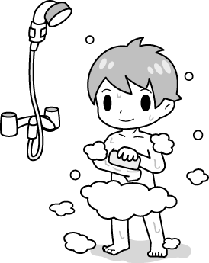(Ｂ) 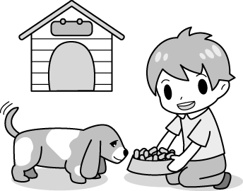(Ｃ) 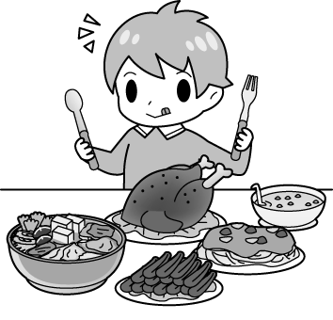
- (Ａ)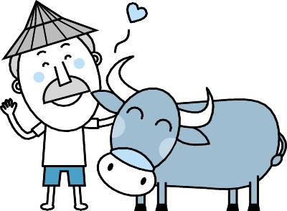(Ｂ)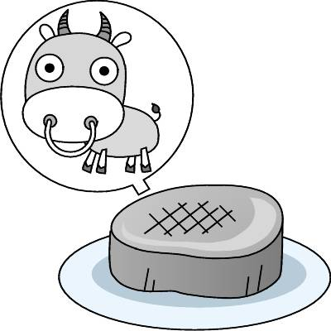(Ｃ) 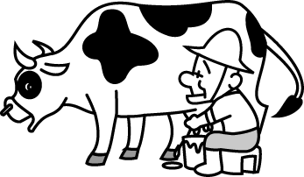
- (Ａ)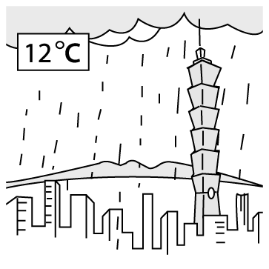(Ｂ) 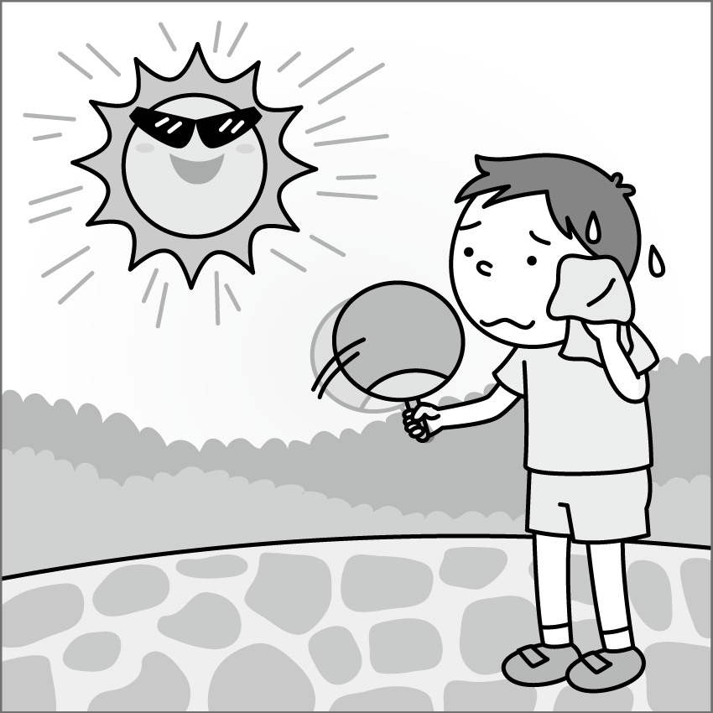(Ｃ) 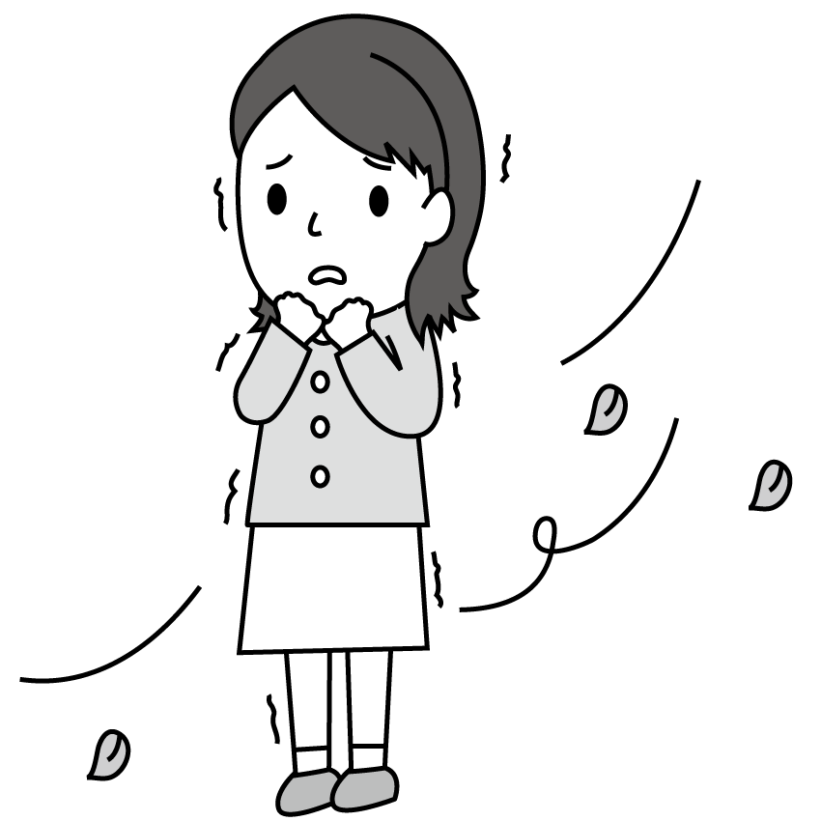
- (Ａ)(Ｂ) 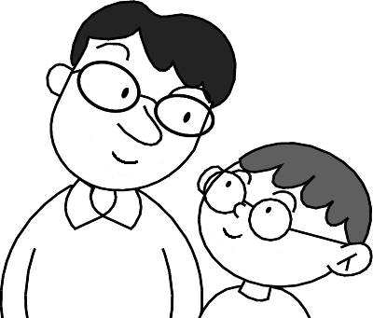(Ｃ) 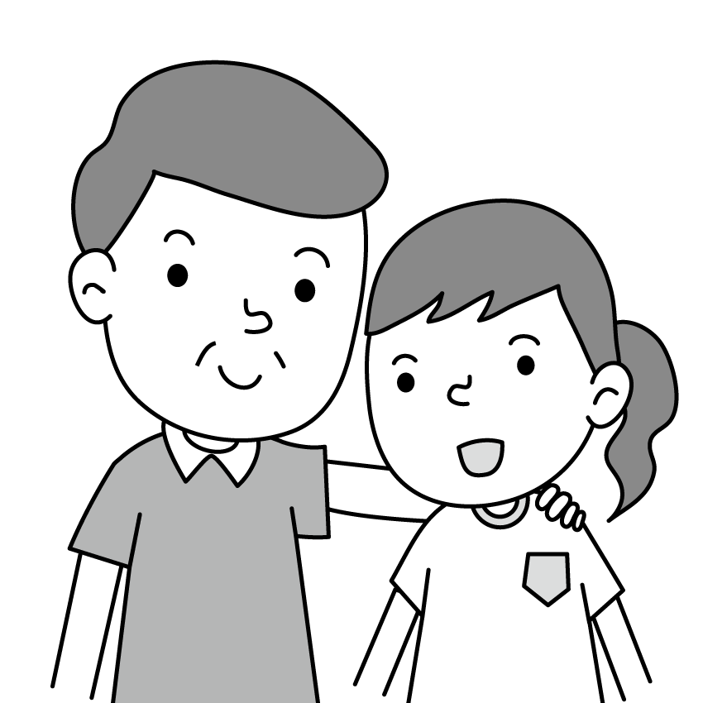
- (Ａ)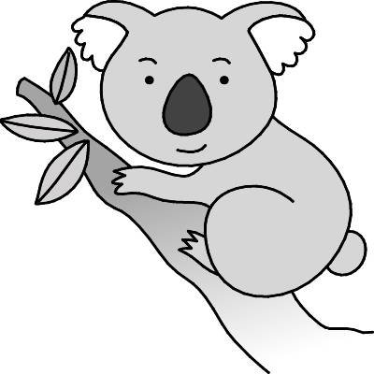(Ｂ)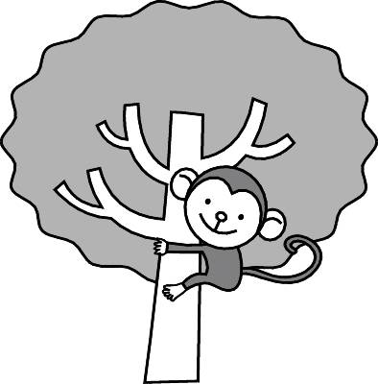(Ｃ) 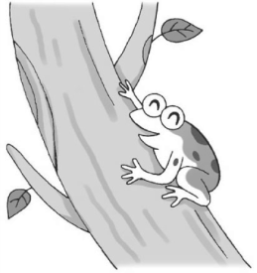

二、基本問答：根據聽到的內容，選出一個最適合的回應或最適合的問句。(每題2分，共10分)

- (Ａ) No, I don’t have to go to school on Sunday.
(Ｂ) Yes, I always do.
(Ｃ) I have to be on time.
- (Ａ) I take a bath once or twice a day.
(Ｂ) I never take a bath on time.
(Ｃ) I clean it very often.
- (Ａ) It is always wet in the summer.
(Ｂ) Please don’t touch the wet dog.
(Ｃ) Here is a dry towel. Let’s dry it.
- (Ａ) Yes, this place is busy in fall.
(Ｂ) The spring flowers. People come for them.
(Ｃ) This place is in the mountains.
- (Ａ) It was cold, wet, and windy.
(Ｂ) It usually rains a lot.
(Ｃ) It is very fine.

三、言談理解：根據聽到的內容，選出一個最適合的答案。(每題2分，共10分)

- (Ａ) She washes Mary very often.
(Ｂ) She loves taking a bath.
(Ｃ) She is always full.
- (Ａ) They will go picnicking.
(Ｂ) They will plan to study at home.
(Ｃ) They will keep the change.
- (Ａ) It’s the rain season in the city.
(Ｂ) It’s hot in the morning.
(Ｃ) It’s cool in the afternoon.
- (Ａ) May 6.
(Ｂ) May 20.
(Ｃ) June 2.
- (Ａ) The teacher was in the mountains.
(Ｂ) The girl was at the beach with her family.
(Ｃ) The boy has a house near the Sunny Lake.

第二部份：選擇題 44%
文法選擇 (每題2分，共26分)
16. What’s the weather ____ in Taipei in summer?
(A) like (B) x (C) be (D) has
17. ___ snows a lot in New York in winter.
(A) There are (B) It
(C) They have (D) The mountain
18. Does _____ a lot in Seattle?
(A) there rain (B) we rain
(C) it has rains (D) it rain
19. My cousin _____ a singer in 2010 but he isn’t now.
(A) was (B) wasn’t (C) is (D) were
20. My dad _____ busy. He doesn’t have time to have dinner at home.

(A) always does (B) is always

(C) does always (D) was always

21. Annie: ____ do you brush your teeth?

Bill: Three times a day.

(A) How much (B) When

(C) How often (D) What time

22. Tracy sometimes sleeps in class, but ______.

(A) me, too (B) sometimes I do

(C) I never do (D) I seldom don’t

23. Eric is often happy at work, but Ivy _____.

(A) seldom is (B) seldom does

(C) does seldom (D) is seldom

Teddy: Were you home __24.__ Saturday?
Judy: No, I wasn’t. My family and I were at my grandparents’ house for Dragon Boat Festival. Look at these pictures.
Teddy: Wow! The eggs stand still under the sun.
Judy: Yes. It was __25.__ then but it rained cats and dogs in the afternoon.
Teddy: The weather was a__26.__. Where was your father at that time?
Judy: He was in the kitchen with my grandparents the whole morning. They always make Zongzi together and this is the only time they meet every year.
Teddy: I see. They meet __27.__.Were they on cloud nine?
Judy: Of course.
Teddy: __28.__ bags of Zongzi are there in the picture?
Judy: 100! They were really delicious.

*Dragon Boat Festival端午節 still靜止的 zongzi粽子

24. (A) before (B) ago (C) every (D) last
25. (A) sunny (B) cloudy (C) rainy (D) windy
26. (A) dry towel (B) wet blanket
(C) hot snowman (D) breeze
27. (A) once a year (B) every weekend
(C) twelve times a year (D) twice a month
28. (A) How often (B) How much
(C) How many (D) How old

閱讀測驗 (每題2分，共18分)

A.

Once upon a time, there was a story about monkeys.

A man keeps many monkeys and teaches them how to dance. The monkeys are very clever and can dance well.

They often dress in beautiful clothes with masks and dance at the party. People enjoy watching their shows and like them very much. No one knows they are monkeys.

One day, a boy throws something in front of the dancing monkeys. When the monkeys see them, they are so happy and forget about dancing. They throw away the clothes and masks and begin to eat their food. All the people at the party begin to laugh. “They aren’t dancers at all. They’re just monkeys!”

*enjoy享受forget忘記

29. Why can’t people tell the dancers from monkeys?

(A) They often wear glasses.

(B) They always work like dogs.

(C) They seldom see things clearly.

(D) They never like monkeys.

*tell….from分辨 clearly清楚地

30. What might the boy throw to the monkeys?



(A) (B)

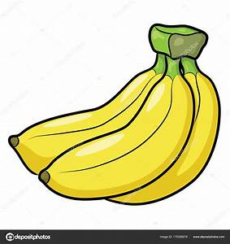


(C) (D)

31. According to the story, which is true?

(A) We should buy beautiful clothes to our pets.

(B) We should be careful about the delicious food.

(C) We should feed our pets with a lot of food.

(D) We should never try to be something we’re not.

*should應該

B.

Grandfather says the tree frog,
That to our garden has come,
Is just a little cute frog
No bigger than his thumb!
And that his coat's so magic it
Can turn from green to blue!
Whatever color's near it,
Why, that's its color, too!
And then Grandfather snickers
And says, "Would you know
He climbs with little stickers
On all his little toes?
"And don't you wish your toes now
Were just like his? For, see,
Right up the elm he goes now
And sticks tight to the tree!"


Written by & adapted from Evaleen Stein
*snicker竊笑 *elm榆木 *stick黏貼

32. Why can a tree frog climb trees?
(A) Their bodies are special.
(B) Their skin is colorful.
(C) Their size is small.
(D) Their hearts are kind.

33. Which color can tree frogs change into when they are on the sunflower?
(A) White.
(B) Yellow.
(C) Green.
(D) Black.

34. What might be the best title for this poem?
(A) The Tree Climber
(B) The Magical Toes
(C) The Tree Frog
(D) The Wonderful Tree
*poem詩

C.
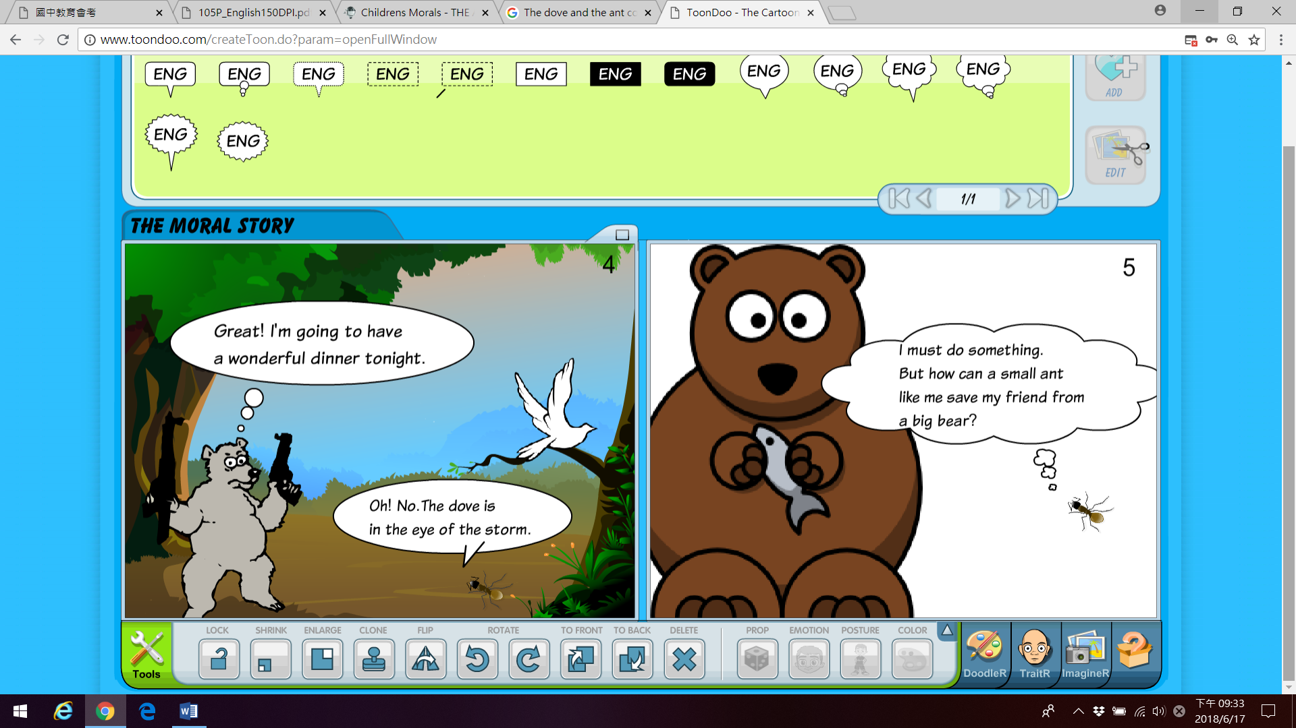
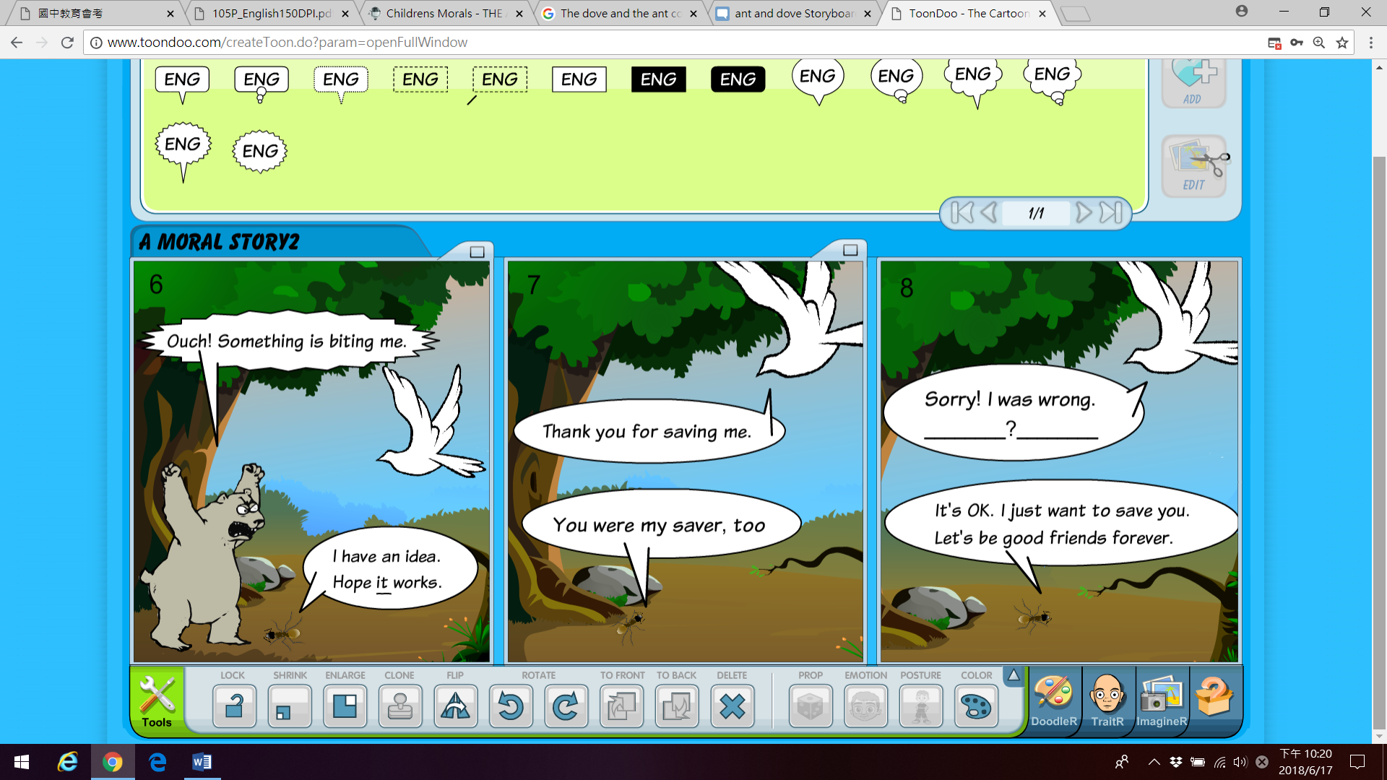
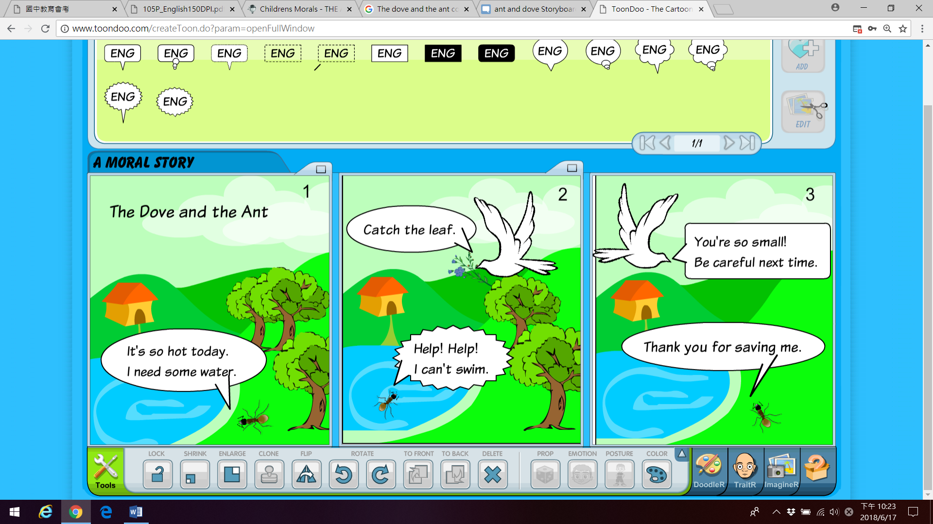

35. What does it in picture 6 mean?
(A) To bite the bear.
(B) To shout to the bear.
(C) To do the magic.
(D) To feed the bear.

36. What might the dove say in the picture 8?
(A) You are big now and the bear is small.
(B) You are small so you can’t save me.
(C) You are small but you can do something big.
(D) You are just lucky to save me.

37. Peter learns a lesson from the comics, what might NOT he do?
(A) Sarah helps him do homework and he helps her mop the floor.
(B) He is only 10 years old but he helps businessmen sell the bananas.
(C) He always turns off lights and closes the window in the classroom.
(D) Tommy is cold and wet but he gives him a glass of ice lemon juice.

第三部分：手寫題 31%

一、文意字彙 (每格2分，共24分)

1. My dad gets up very early. He sells fish at the fish m_____t.

2. Connie is thin. She eats only two m____ls a

day.

3. Students usually h____e to do homework.

4. Take an u_____a with you. It’s raining now.

5. Winter is my favorite s______n.

6. There are many flowers in s_____g but not in winter.

7. Billy: Wow! You’re so wet, Jim.

Jim: Yes. The rain is so h_____y.

8. Where do you l___e now, at home or school?

9. My parents were at the b____ch under the big sun the whole afternoon. And their skin is very d___k now.

10. Many Japanese like to visit Sun Moon L___e.

11. There are tadpoles swimming in the p___d.

二、看圖填空 (共7分) *每格全對才給分
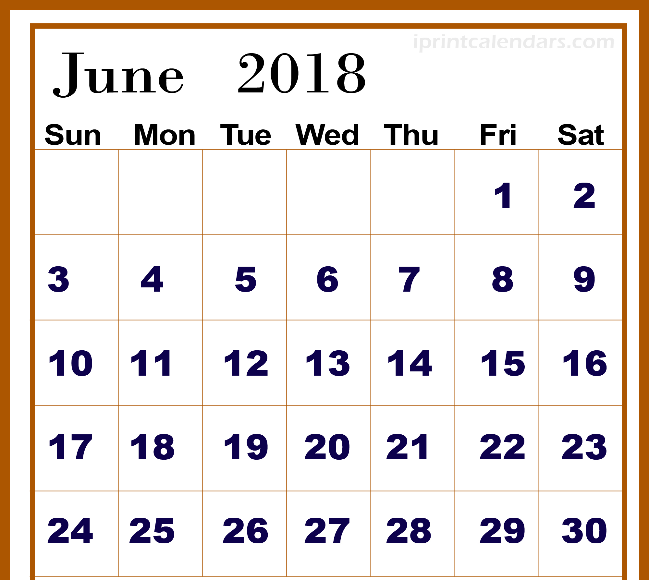

Today is June 27.

(1) June 25 → ___a.___ (2分)

(2) June 23、24 → __b.__ (2分)

(3) June 13 → two __c.__ (2分)

(4) June __d.__ → last Thursday (1分)

---試題結束---

