臺北市立瑠公國中 106 學年度 第 2 學期 八年級 第 3 次定期評量 英語科 試題

- 辨識句意：選出符合句子描述的圖片。5%
( )1.
(A) 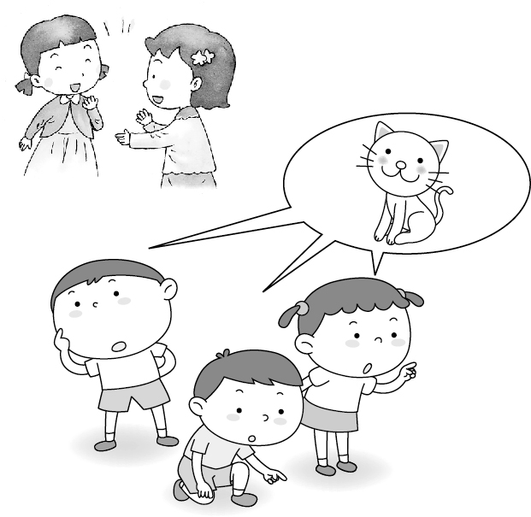 | (B)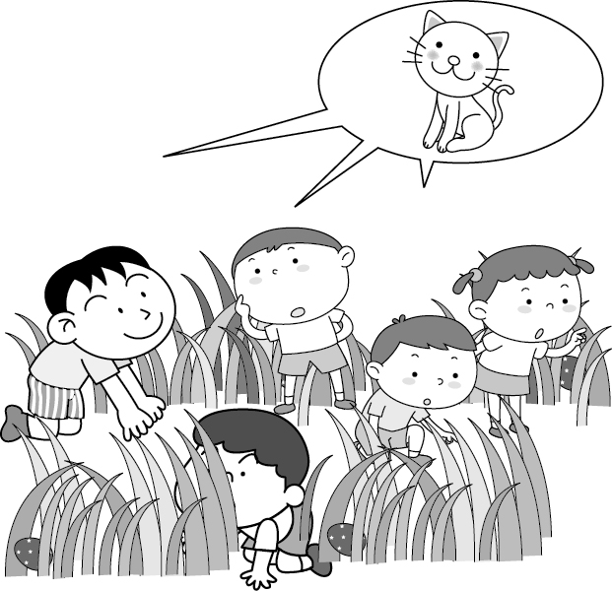 | (C) 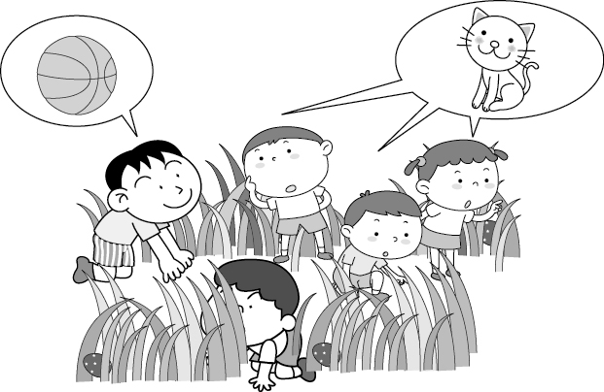
( )2.
(A) 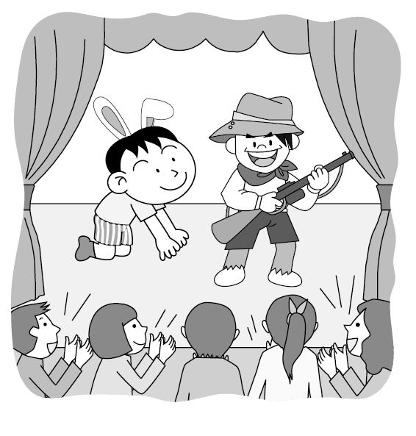 | (B) 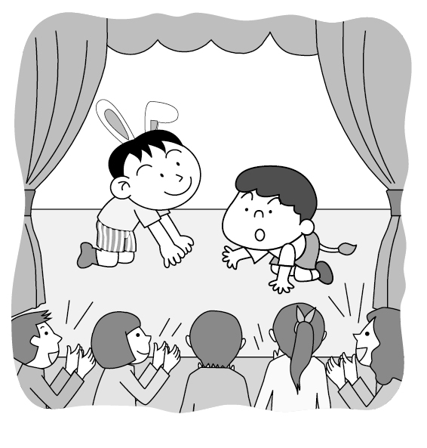 | (C)  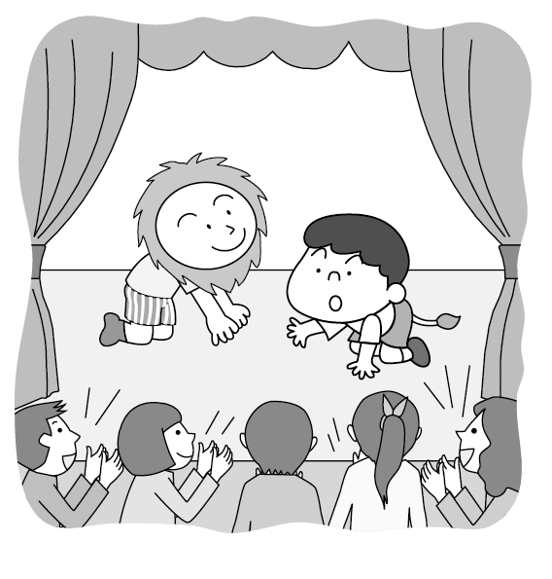
( )3.
(A) 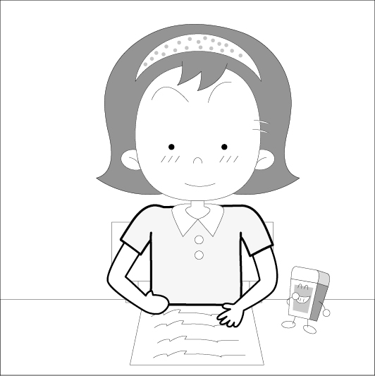 | (B)  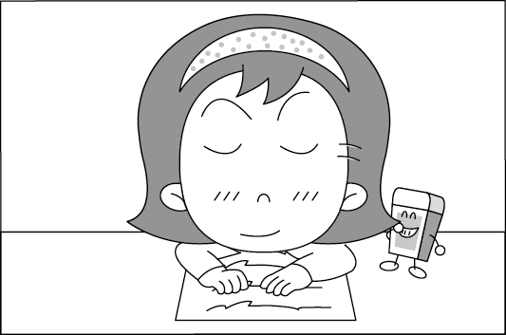 | (C) 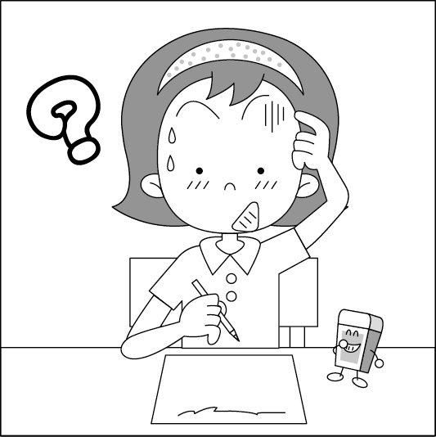
( )4.
(A)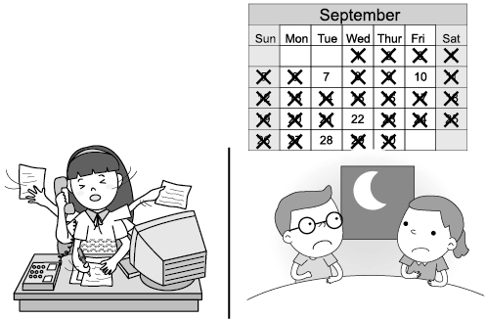 | (B)  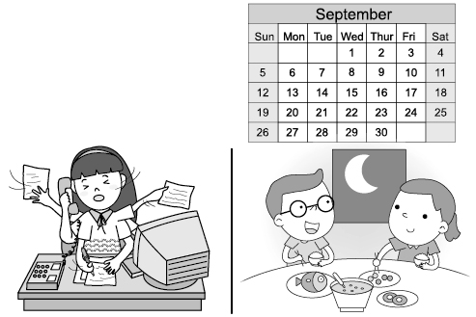 | (C) 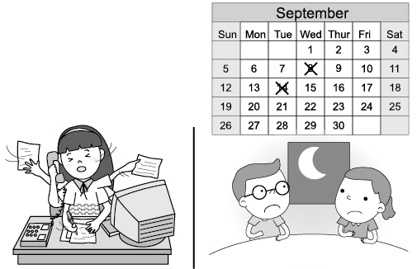
( )5.
(A)  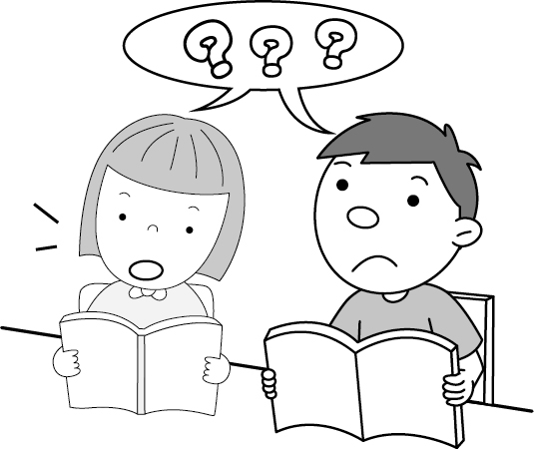 | (B)  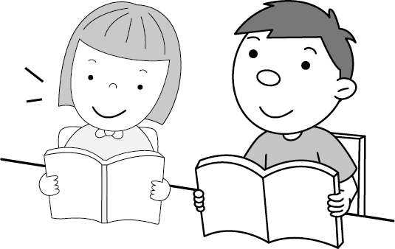 | (C)  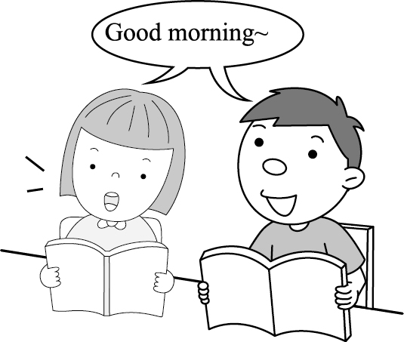

二、基本問答：選出最適合的回答，完成對話。5%
( )6. (A)Before I left the room, I forgot to turn off the
fan.
(B)If I am here, she will feel very happy and great.
(C)She was very tired, so she went to bed very early.
( )7. (A) Of course. Let’s practice reading the lines
together.
(B)I am worried about playing a king.
(C) Did you get the tickets to it?
( )8. (A)After I move for you, what are you going to
give me?
(B)I don’t like the game at all. It’s not interesting.
(C)Playing a king sounds much fun to me.
( )9. (A)Hey, don’t laugh at me because of my poor
English.
(B)Well, the book cost me an arm and a leg.
(C)Well, no one can learn English well in a short
time.
( )10. (A)Peter, Judy, and Helen will make a large
Easter chocolate egg.
(B)I invited all of the members of our dance club
to join you.
(C)Before we hike in the mountains, we must do
some warm-ups first.

三、言談理解：請聽對話或短文，選出問題最適合
的答案。10%
( )11. (A)A popular food in Taiwan.
(B)A smart pig.
(C)A kind of cake.
( )12. (A)Susan and her dad will clean the kitchen
together.
(B) Susan had fried noodles for dinner today.
(C) Susan did the dishes after she made dinner.
( )13. (A)She is afraid the dishes will not be that great
as she heard.
(B)She is afraid the bank will be closed after they
finish the meal.
(C)She is afraid the man will spend too much on
the meal.
( )14. (A) They are playing magic tricks.
(B) They are making interesting toys.
(C) They are writing a play.
( )15. (A)Aaron never gave up his life because of his
brothers’ company and help.
(B) The man would like to become as great as
Aaron after he read his story.
(C) Aaron became great at acting and swimming
although he had no legs.

16-42 共56分﹔每題2分
( )16. the Lin family are poor, they are still
happy .
(A)If (B) Although (C)Or (D) But
( )17. of my classmates likes playing online
games.
(A)Each (B) A few (C) Some (D)A little
( )18. There are two plates on the dining table.
of them are pink.
(A) Most (B) Many (C) One (D) Both
( )19.The world is like a book. If you don’t open its
pages, you how wonderful it is.
(A)never know (B)never knew
(C)would never know (D) will never know
( )20. The players on each team bowed to each other
before the game
(A)starts (B)is starting (C)started (D) will start
( )21. Which reading tip is WRONG when the readers
study English?
(A)Read the title and take a look at the pictures.
(B)Should never go over the article again and
again.
(C) Don’t be afraid to talk about the main idea of
the article with classmates.
(D)Always ask classmates or teacher questions
after you found questions..
( )22. Eric︰Mom, May I eat something different
tonight?
Mom︰How about the steak with a big bowl of
lettuce with the cheese you like most?
Eric︰ How wonderful.
(A)Don’t you finish all of the food?
(B)It’s great to finish all of it.
(C)I’m tried of eating the same food every day.
(D)Many of us voted for Japanese food, and you
did too.
( )23. A:
B: Yes. I’d like my steak with spaghetti and
French Fries, please.
(A)What would you like to order?
(B) May I take your order?
(C)Do you enjoy eating steak?
(D)How would you like steak?
( )24. Lisa︰What’s your part in the play ”Romeo
&Juilet?”
Tina:
(A)Why don’t you come and find it out for
yourself?
(B)Isn’t your part in the play a handsome prince?
(C)My part is the less important in the play. Do you get it?
(D)Both you and I acted as princes, right?
( )25. Sally︰Spend thirty minutes
studying English every day, and you will learn English better.
Leo︰No wonder I did poorly on all the English tests before because I always studied it only before tests.
(A) at last (B) at all (C) after all (D) at least

題組26-43 ﹔每題2分

克漏字I ﹕26-29
These are some lines from the play “ Friendship ”.
Robin︰Dear princess, when we are flying high in the
sky, 26.
Tracy︰ Of course I will. I enjoy flying with you all the
time.
Robin︰What? The evil prince Henry wants to kill you
and me, so don’t be kidding.
Tracy︰ 27. , I will shout as loudly as I can. My
voice is the best weapon!
Robin︰That doesn’t work at all. Look! He is shooting an
arrow at us. Let’s fly away quickly.
Tracy︰Don’t worry. I got the arrow. I will shoot it back
to him.
Robin︰You did a good job. 28. .
Tracy︰ Then let me fight with all the other knights. I
will kill 29. of them. No one of them will
come home safely. Please fly to save my parents
in the old castle.
Robin︰OK! Good luck.
Tracy︰ Meet you at Flute Beach and let’s have a party.

( )26. (A) please let me fly by myself
(B) please let out the pollen
(C) please hold me tight
(D) please let your down
( )27. (A) If he attacks us
(B) After you and I got hurt badly
(C) No wonder he is so mean
(D) Because he would like to kill us
If he ( )28. (A) You hunted him for food.
(B) You gave up running after him.
(C) You broke his right leg.
(D) You shot it into his right arm.
( )29. (A) every (B) many (C) all (D) a lot

克漏字II﹕30-33
Title﹕ 30.
1. Before you start, go over the questions quickly and
plan your time
2. Read the questions carefully before you answer them.
If you 31. , come back to it later. Answer the
easy questions first.
3. Write clearly. The teacher will probably 32.
your answers wrong if they can’t read and understand them.
4. Check your answers 33. you hand in your test.

( )30.(A)Tips for Making Teachers Happy
(B)Tips for Doing Homework easily
(C)Tips for reading English Article
(D)Tips for Taking Tests

( )31. (A)don’t know the tips to take notes.
(B) don’t know the answer to a questions
(C) don’t know the meaning of new words
(D)don’t want to spend time studying
( )32. (A) pass (B) vote (C) mark (D) order
( )33. (A) before (B) after (C) when (D) if

閱讀測驗I﹕34-35
On the top of a mountain in Peru is a dead city. Its name is Machu Picchu. It is one of the New Seven Wonders of the world. Hundreds of years ago, the Incas built it in the mountains. They made many buildings and streets out of rocks. About four hundred years ago, the Incas left the place. So, trees and plants grew and covered the city. Over time, no one remembered that the city was there. Many years later, in 1911, an American named Hiram Bingham found it again. Now, it is a popular place to visit in South American. People called it “The Lost City of the Incas.” About 5,000 people visit it every day. If you are interested in the place, you should think about planning a trip there.
&wonder奇景 building建築物
( )34. Where is “The Lost City of the Incas.”?
(A) In Asia. (B)In Africa.
(C)In Europe (D) In South America.
( )35. Which is TRUE about the reading?
(A) Hiram Bingham found Machu Picchu again
in 1911.
(B)The Incas built the great Machu Picchu near
the beach.
(C)There are 5,000 people living in Machu
Picchu.
(D)Machu Picchu became a popular city with visitors right after the Incas left.

閱讀測驗II﹕36-37
Once upon a time, a man taught some monkeys how to dance. The monkeys were very clever, and they learned how to dance very well.
The man was very happy. He dressed the monkeys up in fancy clothes and masks. Then he took them to a party. He wanted people to admire his dancing monkeys.
The dancing monkeys were very popular at the party. Nobody knew they were monkeys, and everyone enjoyed watching them dance.
Then a naughty boy threw some bananas in front of the dancing monkeys. At the sight of the bananas, the monkeys forgot about the dancing. They tore off their masks and rushed over to the bananas and began to eat.
All the people at the party began to laugh. “They aren’t dancers at all,” said one guest. “They are just monkeys! I guess not everything you see is what it appears to be!”
“And,” said another, ”You should never try to be something you are not.”
( )36.Which is TRUE?
(A) The man made a lot of money after he taught
his monkeys to dance in the fancy costumes.
(B)Everyone in the party didn’t enjoy watching the monkeys dance when the monkeys showed up.
(C) Only some of the monkeys liked to eat bananas,the others hate them .
(D)When the monkeys saw the bananas, all of them went crazy and ran to eat them
( )37.What is the main idea of the article?
(A)After watching the monkeys dance, people start to think everything we see is what it appears to be.
(B)Although people found out the dancers are monkey at last, the dancing still touched their heart.
(C)If you try to be something or someone you are not, people might laugh at you in the end.
(D) Try your best, and all the people will come to help.

閱讀測驗III﹕38-39
Be The Real King Of Olympus
The key to the greatest power appears
No deity will let the chance go by
Want to be one of them?
Choose the part and let your fight Rock

Zeus
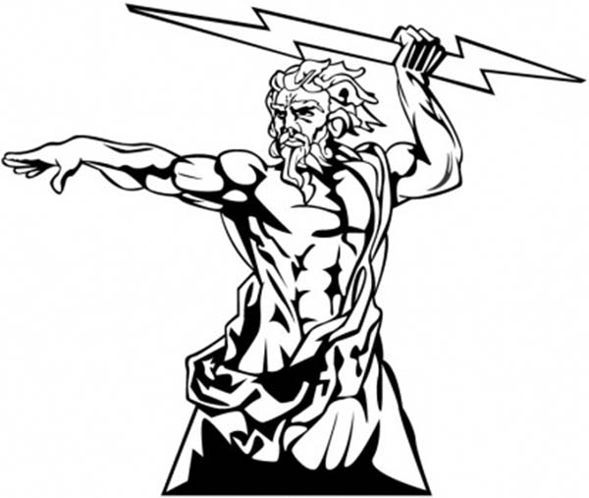
He is the king of the sky. The thunderbolt is his deadly weapon. His power is greater than all the other deities’, but he must hide from his wife, Hera, when she is angry, or he will lose all his power for ten minutes.
Hera
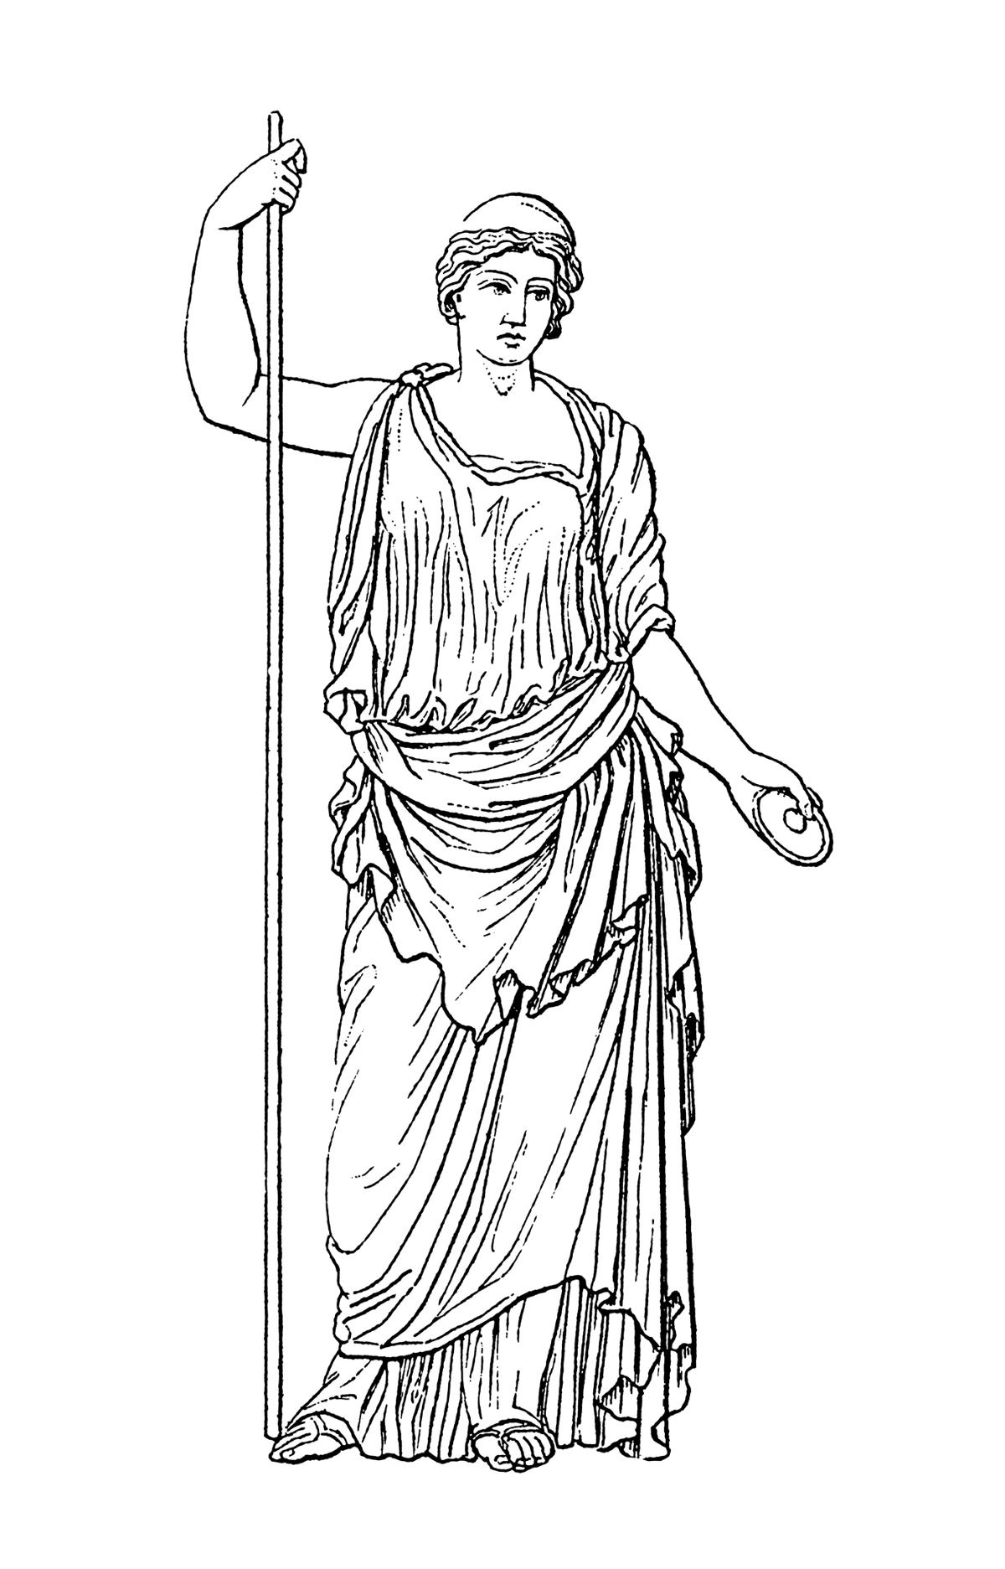
The wife of Zeus, deity of married woman, doesn’t have any deadly weapons, but when a married woman comes to her for help, her attack becomes deadly when the married woman is around.
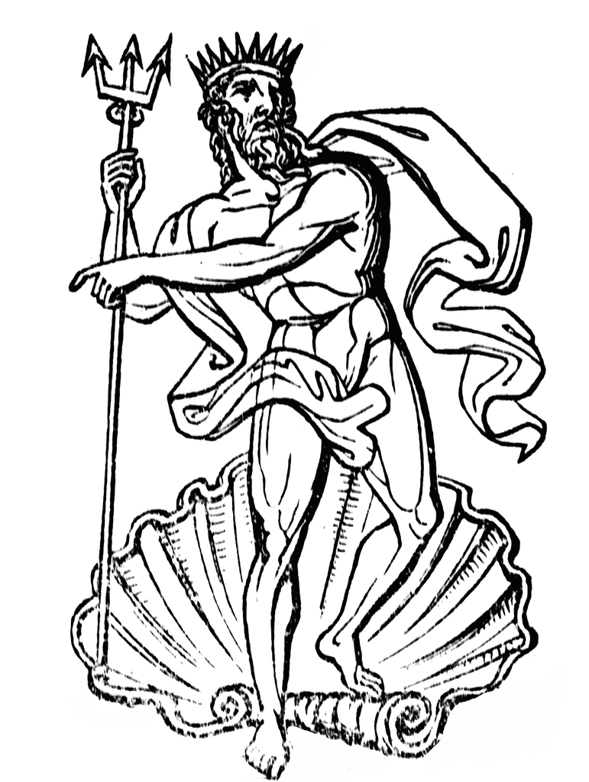
Poseidon
He is the king of the sea and one of Zeus’ brothers. Everything in front of him breaks when he shakes his trident. Giving him a horse can stop his attack.
Hades
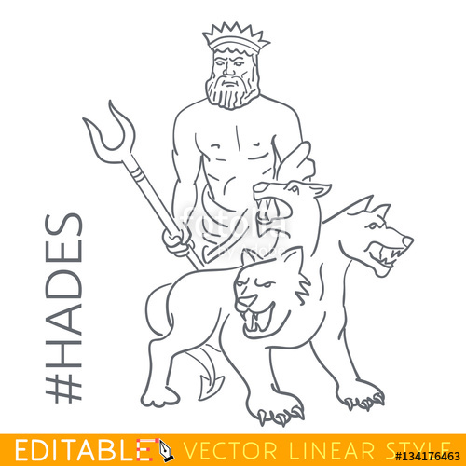
He rules over the dead, so all his power comes from them. The more dead people come to him, the more power he has. However, he doesn’t kill or attack anyone when his beautiful wife, Persephone, with him.
deity神thunderbolt雷電weapon武器

( )38. What is Poseidon’s “trident”
(A)Poseidon’s lovely and rich wife.
(B)One of Poseidon’s favorite pets.
(C)A friendly and nice deity in the game.
(D)A kind of tool to kill or attack people in the
game.
( )39.What should we know when we play the game?
(A)Zeus cannot use his power when a married
woman comes to him.
(B)You can attack Hades when Persephone is with him.
(C)You cannot attack Poseidon if he has a horse
with him.
(D)Every role must hide from Hera when she is
mad.

閱讀測驗IV﹕40-43
It was just another Friday evening. A man took his wife and their 4-year-old son to see a movie. When the lights went out, everybody sat comfortably waiting to enjoy the movie.
Then some people saw a person standing in front of the big screen with something like a machine gun in his hands. One of them shouted, “He’s got a machine gun!” Then, people heard the sound of gunfire. The man holding what looked like a machine gun fell down. All the scared people started running and pushing each other to get out.
During the stampede, the man’s wife, holding her son in her arms, was knocked over to the floor, so she covered her son with her body to keep him from getting hurt. At the hospital, the doctors couldn’t do anything to save her life because her head got hurt badly. Luckily, the little boy was saved because of his mother’s love.
Also sent to the hospital was the “gunman” The police found out he was a teenager and he often made YouTube videos about how he played tricks on people. The “machine gun” was just a toy gun, and the gunfire was from a person with a real gun at the theater.
The doctors said he would lose his life if he didn’t get a new liver. The man finally agreed to give his wife’s liver to the teenager though he got his wife killed. The teenager can now keep on living with the woman’s liver. It’s a really terrible thing and a lesson for everyone to learn from.
( )40. What does them mean in the reading?
(A)Some of the people at the theater-they noticed
the gunman.
(B)The actors and the actresses in the movie.
(C)The man and his family.
(D)All the people at the theater-they were waiting
to see the movie.
( )41.What does the word stampede mean?
(A)Eating and drinking.
(B)Sitting and waiting.
(C)Running and pushing.
(D)Laughing and clapping.
( )42.Why did the people in the movie theater start
running out?
(A)The movie was over.
(B)They were afraid they might get hurt or killed.
(C)There was a fire in the theater.
(D)They saw some people shooting at each other
with guns.
( )43. What’s the story mostly about?
(A)You can never know who may be the one to save your life, so be nice to all the people around you.
(B)Something fun or funny at first might lead to a
sad or terrible thing in the end.
(C)Before you get into the movie theater, make
sure how you can get out safely.
(D)Always put your family first because they are
more important than anyone else on the world.

第三部分:非選擇題 44-54，24%
文意字彙﹕44-53 每題2分，共20分
44. A: How would you like your steak?
B: M m, please.
45. If I can’t drink my favorite pearl milk tea with plastic
s ws ,what may I use?
46 In stories, evil d ns usually have wings and
long tails. They breathe fire to attack people.
47. My job is to fight for my own country when it faces
the threats(威脅) because I am a s r.
48.There are too many m kes in your English
homework. You need to correct all of them
49.More and more people like to look up the words they
don’t understand on the Internet, but I still love to use a d y from my English teacher.
50. I like play sports, for e e, soccer and basketball.
51. All the world is like a s e, and everyone plays a
part.
52. Customer﹕May I have a m u, please?
Waitress﹕Here you are. Today’s special is spaghetti.
53. If you mark important point and do e es, you
will learn better.
中翻英﹕4%
54.藉著向大自然求救﹐麗莎皇后得以消滅所有在城堡
裏的殭屍。

Enjoy your summer vacation.

