臺北市立瑠公國民中學 106學年度第二學期第二次段考 七年級英語科試卷
範圍：翰林版第二冊Unit 4~ Review II 七年 ___班 座號：___ 姓名：__________

第一部分:聽力測驗 (第1-15題，共15題，25%)
- 辨識句意：選出符合句子描述的圖片。(每題1分)

1.（ ） (A)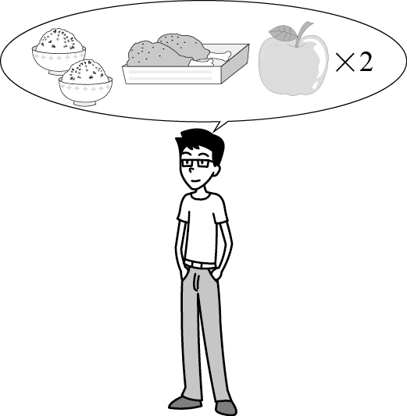 (B)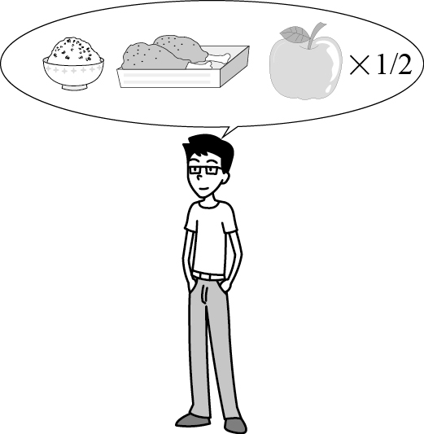
(C) 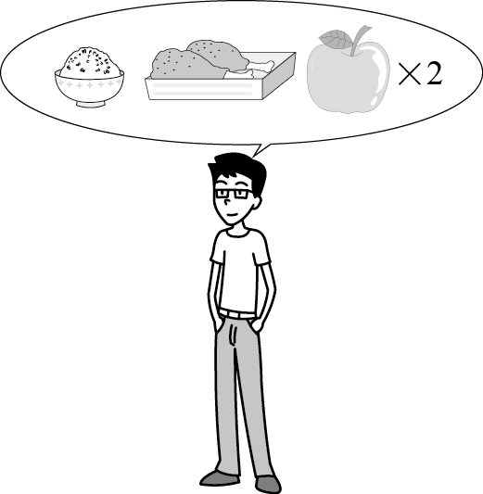
2.（ ） (A)
Feedback Form

Date: June 1st

□orange juice □banana salad
□fried chicken □apple cake
□fish pizza □music
□chicken pizza □bathroom

Name: Jason
(B)
Feedback Form
Date: June 1st

□orange juice □banana salad
□fried chicken □apple cake

□fish pizza □music

□chicken pizza □bathroom

Name: Jason
(C)
Feedback Form
Date: June 1st

□orange juice □banana salad

□fried chicken □apple cake
□fish pizza □music

□chicken pizza □bathroom

Name: Jason
3.（ ） (A)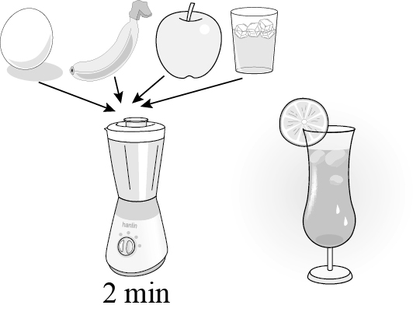 (B)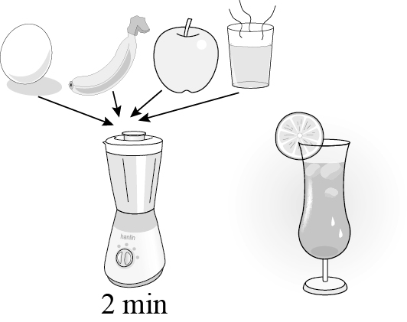
(C) 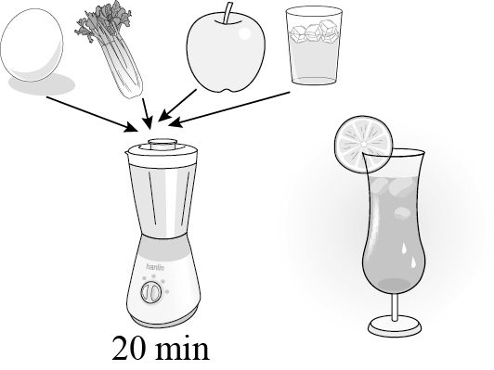
4.（ ） (A)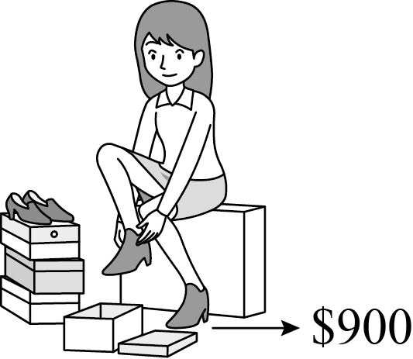 (B)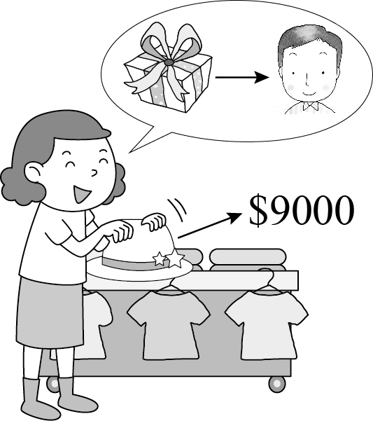
(C)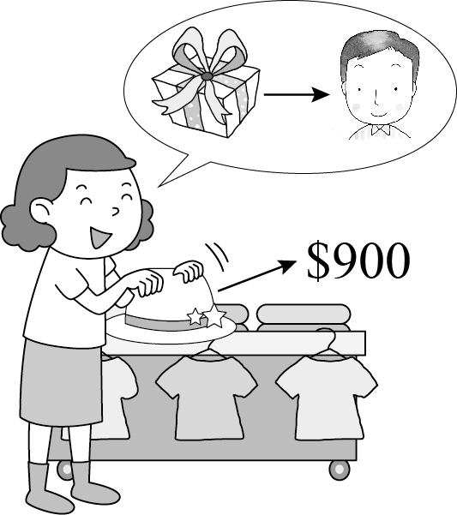
5.（ ） (A)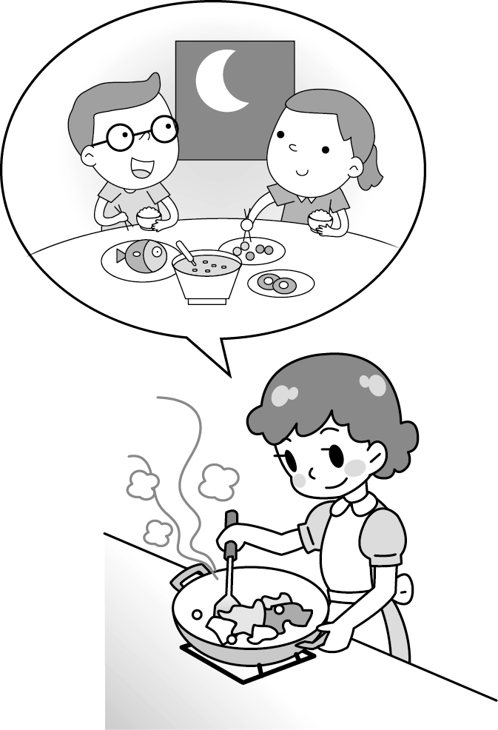 (B)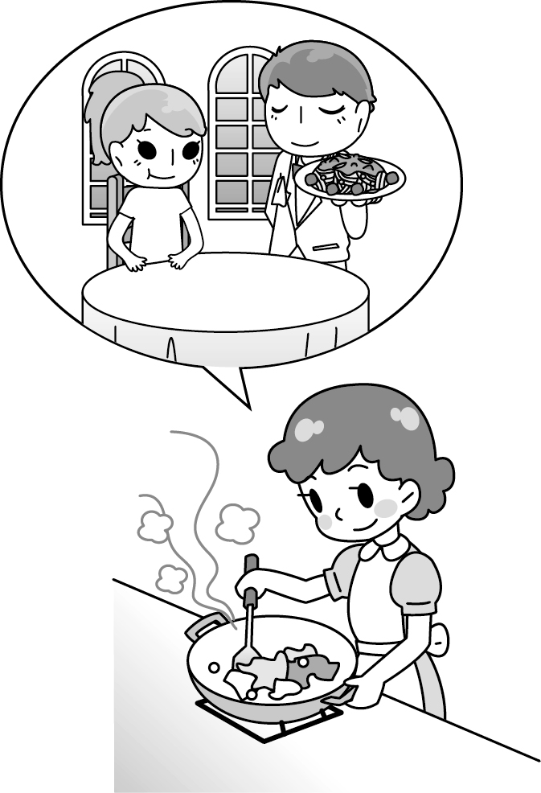
(C)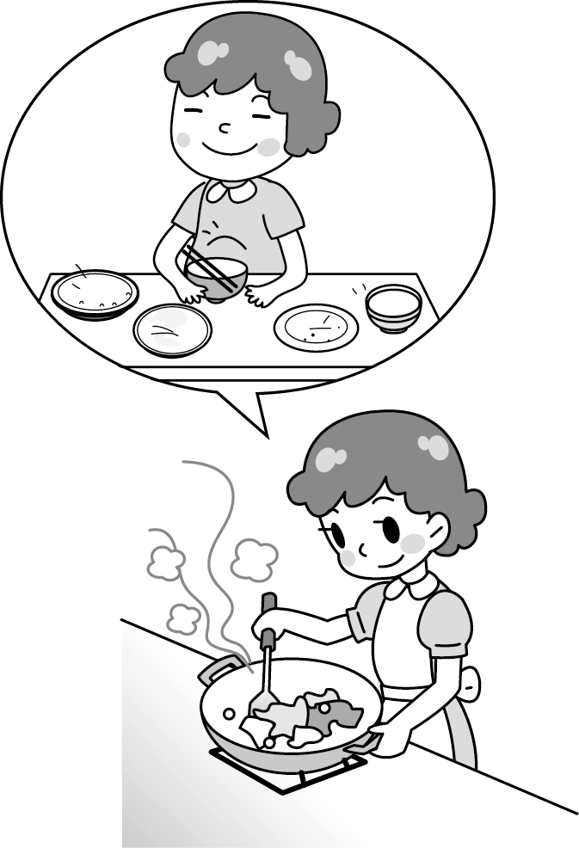

- 基本問答：選出最適合的回答，完成對話。(每題2分)
6.（ ） (A) Have some juice every day, and you can be fine.
(B) We can buy juice at Hippo Store. It’s cheap.
(C) Orange juice is Mom’s favorite drink.

7.（ ） (A) It’s in the early summer, on June 12th.
(B) We don’t have classes on Teacher’s Day in Germany.
(C) Chocolate can be good gifts for our teachers.

8.（ ） (A) Susie and Trudie are very tall and have long arms.
(B) Sheldon and Trudie are both 185 cm tall.
(C) Who else? I am 185 cm tall.

9.（ ） (A) I am happy with your gift.
(B) The gift is for you and your family.
(C) That’s all right. You are a kind student to me.

10.（ ）(A) No, thanks. The shop sells yummy food.
(B) No, thanks. I am very hungry and need food.
(C) No, thanks. I don’t like American food.

C. 言談理解： 請聽對話或短文，選出問題最適合的答案。
(每題2分)

11.（ ）(A) The boy’s birthday is in fall.
(B) The woman is the boy’s mother.
(C) The woman is waiting for her birthday party.

12.（ ）(A) They are selling drinks.
(B) They are having cookies from First Farm.
(C) They are making milk shake.

13.（ ）(A) At a restaurant.
(B) Near his school.
(C) In the kitchen at school.

14.（ ）(A) It is the boy’s mother’s birthday today.
(B) The boy doens’t mind her mother’s birthday.
(C) The boy and the girl are talking about roller-skating.

15.（ ）(A) Friends’ Day at school.
(B) The food in Taiwan and Japan.
(C) Today’s breakfast.

第二部分:閱讀測驗 (第16-45題，共30題)
Ｄ. 單題 （第16-21題, 每題2分）
- ( )Jay: Is today January ?
Liz: Yes. It’s of January.
(Ａ) 1; first (Ｂ) one; the first
(Ｃ) 1; one (Ｄ) first; the first
- ( )Mom, don’t worry the money. Here my pocket money. You can use . (Ａ) ×; are; them (Ｂ) about; are; them
(Ｃ) for; is; it (Ｄ) about; is; it
- ( )Liz: is there?
Max: There three bags.
(Ａ) How many bags of flour; is
(Ｂ) How much flour; are
(Ｃ) How much flour; is
(Ｄ) How many bags of flour; are
- ( )Today is November 5th, and Jay’s concert
is November 19th. I really can’t wait for that day to come.
(Ａ) ×; × (Ｂ) on; on (Ｃ) ×; on (Ｄ) on; ×
- ( )Ms. Lee is our teacher. She is very nice to . (Ａ) we (Ｂ) us (Ｃ) I (Ｄ) our
- ( )I don’t have money. Do you have with you?
(Ａ) some; any (Ｂ) one; one
(Ｃ) any; lots (Ｄ) any; some

E. 題組 （第22-45題）
克漏字選擇（第22-32題，每題2分）
I.
I have a goldfish. 22. name is Johnny. My sister says
23. is a girl fish. She calls 24. Jenny. But I know Johnny is a boy. Johnny is a nice fish. He 25. to swim. When I talk to him, he swims. When I look at him, he swims. When I feed him, he eats and swims. My sister says Johnny is boring because he 26. anything special. But for me, Johnny is quiet, cute, and graceful. My sister isn’t quiet, cute, and graceful. I think she is the boring one.
because因為；graceful優雅的
( ) 22. (A) He (B) His (C) Him (D) He’s
( ) 23. (A) he (B) he’s (C) his (D) him
( ) 24. (A) he (B) his (C) him (D) he’s
( ) 25. (A) is like (B) likes
(C) doesn’t like (D) like
( ) 26. (A) does (B) doesn’t
(C) do not do (D) can’t do

II.
Kate: Dad, these are the coupons. You can use
27. to get things at my school fair.
Mr. Lee: Thank you. Hey, 28. does your class sell,
29. books?
Kate: We sell food. Food stands are popular at a fair. We have the 30. . They are easy to make.
Mr. Lee: What else do you sell?
Kate: We have some 31. , too.
Mr. Lee: That’s nice. Do you have coffee?
Kate: No, but we have juice and black tea.
Mr. Lee: That’s great. I love juice. 32. do you sell it for?
Kate: It’s fifty dollars for a cup.
Mr. Lee: Wow! That’s not cheap!
fair園遊會；popular受歡迎的
( ) 27. (A) they (B) it (C) its (D) them
( ) 28. (A) where (B) who (C) which (D) how
( ) 29. (A) food or (B) toys and
(C) toys or (D) food and
( ) 30. (A) chicken (B) rice balls
(C) fried rice (D) milk tea
( ) 31. (A) drinks (B) fruit
(C) money (D) noodles
( ) 32. (A) How many (B) What else
(C) Which shop (D) How much

閱讀理解（第33-45題。33-40題:每題2分; 41-45題:每題1分）
I.
It’s Mother’s Day. Jack has a book of coupons for his mother. If his mother wants Jack to do some housework, she can give him one of the coupons.

Mother’s Day Coupon  Good for three times of dish washing after dinner. |  | Mother’s Day Coupon  Good for one bathroom cleaning.

Mother’s Day Coupon  Good for one week’s living room cleaning. |  | Mother’s Day Coupon  Good for five times of taking care of my little sister.

Mother’s Day Coupon  Good for mopping the floor on Saturday or Sunday. |  | Mother’s Day Coupon  Good for two times of dog washing and two times of cat washing.
if如果; mop拖地
( ) 33. When does Jack mop the floor?
(A) During the week.
(B) After dinner.
(C) Anytime.
(D) Only on the weekend.
( ) 34. What is NOT true?
(A) Jack washes the dishes three times.
(B) Jack cleans the living room.
(C) Jack has a dog and a cat at home.
(D) Jack takes care of his little sister every day.

II.
Jane is going to make some food for her friends. Now, read the two lists and answer the questions.
 | I CAN  come | I CAN’T  come |  | How many/much do I have now?
Mimi |  |  |  | pumpkin soup  - pumpkin  - cream  - chicken  spaghetti  - spaghetti  - shrimps  - clams | 1  2 cans  4 bags  3 bags  12  3 bags
Kiki
Nono
Lisa
Linda
Jay
Rita
Joy

list單子；spaghetti義大利麵；sauce醬；shrimp蝦
clam蛤蠣
( ) 35. How many people will (將)be at Jane’s party?
(A) Five. (B) Six.
(C) Seven. (D) Eight.
( ) 36. Jane wants to put four shrimps in one plate of spaghetti. How many plates can she make from the shrimps?
(A) One plate. (B) Two plates.
(C) Three plates. (D) Four plates.

( ) 37. There are twenty-four clams in one bag. Twelve clams can make one plate of spaghetti. How many plates can she make from the clams?
(A) Six plates. (B) Two plates.
(C) Three plates. (D) Four plates.

III.
Anna Wang’s sixth album, Love Me More, and her new book, Practice Love, are coming out!
-----------------------------------------------------------------------
* Love Me More pre-order starts on December first.
- pre-order one album online, and you can get a LOVE CUP
- pre-order two albums online, and you can get a LOVE BAG
- And, you can get a coupon for the pre-order and use it at Waiting For You Café!
* Practice Love is coming out on Tue., January 1st
* Anna Wang is meeting you on these dates and at these places!
- January 9 (Sat.) 3—5 p.m., Waiting For You Café
- January 10 (Sun.) 2—4 p.m., Cool Club
- January 10 (Sun.) 7—9 p.m., Ivy Bookstore
- January 16 (Sat.) 3—5 p.m., Kiki Bar
------------------------------------------------------------------------
album專輯；pre-order預購；start開; café咖啡店
( ) 38. What does Anna Wang do?
(A) A cook. (B) A writer.
(C) A coach. (D) A singer.
( ) 39. What does “it” mean (意指)?
(A) The bag. (B) The cup.
(C) The book. (D) The coupon.
( ) 40. Anna Wang is talking to her fans (粉絲) at Ivy’s Bookstore now. What’s the date today?
(A) January 1. (B) January 9.
(C) January 10. (D) January 16.
IV.
Mrs. Chen buys many things at King’s Shop. Here is the receipt. Read it and answer the questions.
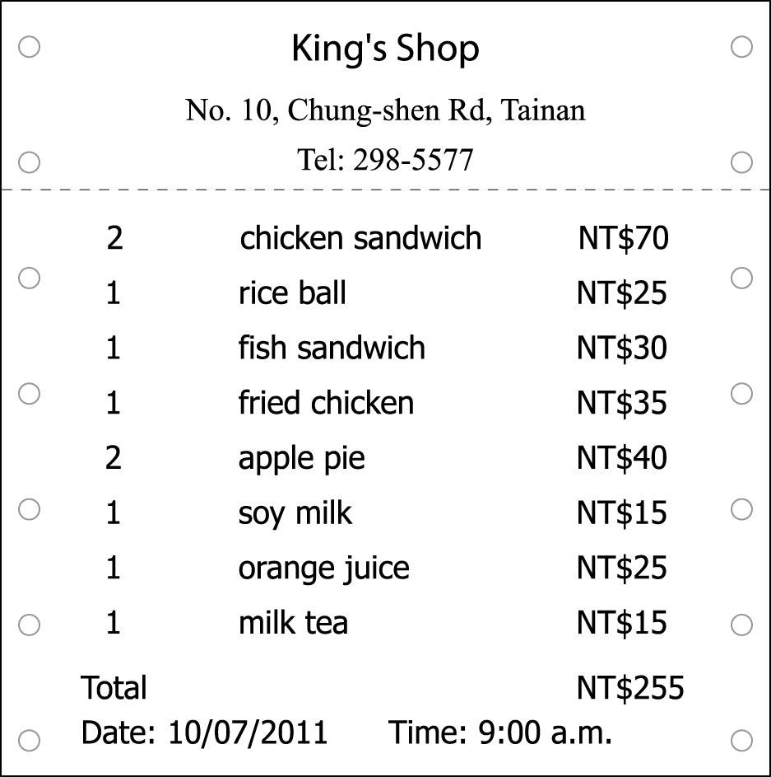
（ ）41. How much is a chicken sandwich?
(Ａ) NT$70. (Ｂ) NT$35.
(Ｃ) NT$30. (Ｄ) NT$40.
（ ）42. What CAN’T we know from the receipt?
(Ａ) Where is King’s Shop?
(Ｂ) How much are they?
(Ｃ) When does Mrs. Chen buy them?
(Ｄ) Are the things on the receipt yummy?

V.
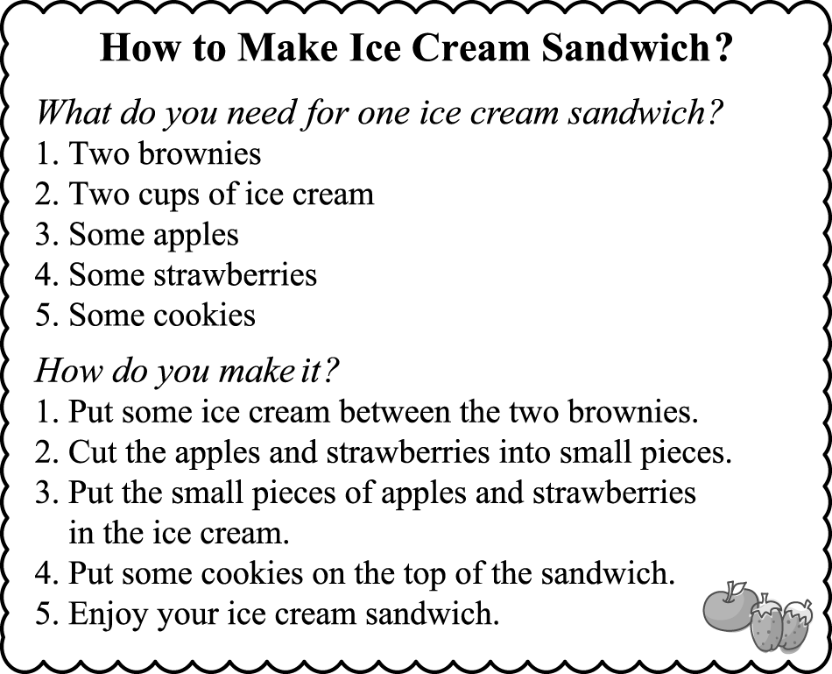
（ ）43. Which one is the ice cream sandwich?
(Ａ) 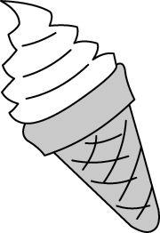 (Ｂ) 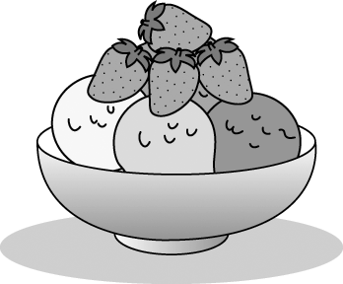
(Ｃ) 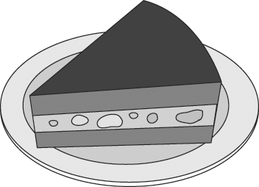 (Ｄ) 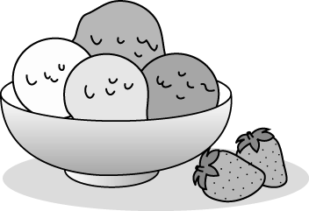
（ ）44. What DON’T you need to make the ice cream sandwich?
(Ａ) Ice cream. (Ｂ) Strawberries.
(Ｃ) Cookies. (Ｄ) Juice.
（ ）45. You can see this page in .
(Ａ) Popular Music Today
(Ｂ) Yummy Food
(Ｃ) TV Talent Show
(Ｄ) Hot Movies

第三部分：非選擇題試題，請用黑筆寫在手寫答案卷
F. 文意字彙（第46-52題，共7題，每題2分）
- The watch is cool but e e. I cannot buy it with my pocket money.
- The girl in a pu e dress is my cousin, Cathy.
- September is the n th month of the year.
- Let’s go Johnny’s for dinner. I love that
r t. The chicken soup there is amazing.
- Leo, put the oranges in the b r and make some orange juice for us.
- Which do you want for lunch, beef noodles or ?
- There are usually（通常）twenty-eight days in .

G. 填入適當的介系詞，若無請填Ｘ（第53-58題，共6題，每題1分）
1. Christmas Eve is 53. the evening 54.
December 24.
2. There is a dodge ball game 55. five 56. Sunday
afternoon.
3. We can go to the movie 57. this weekend.
4. The party is 58. July. I can’t wait for it!

試題到此結束，辛苦了！

