臺北市立瑠公國中 106 學年度 第 2 學期 八年級 第 2 次定期評量 英語科 試題

- 辨識句意：選出符合句子描述的圖片。5%
1.( )
A) 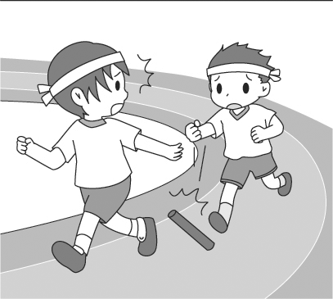 B) 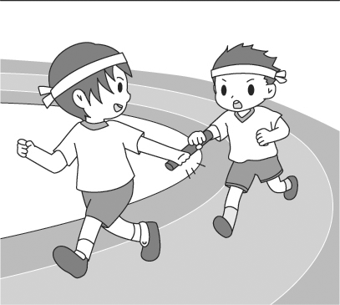 C) 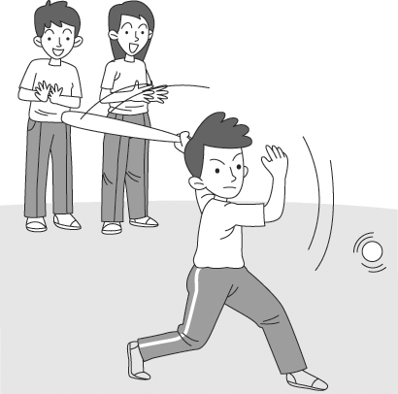
2.( )
A) 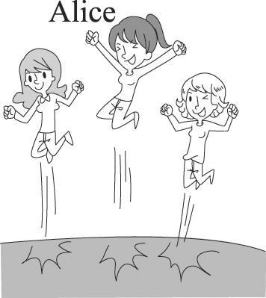 B) 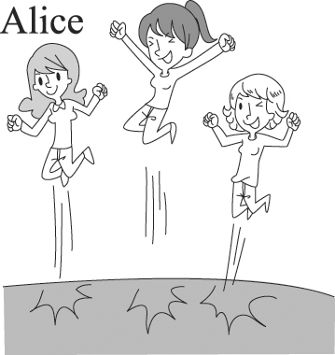 C) 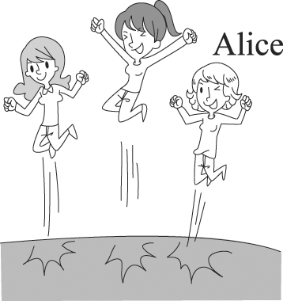
3.( )
A) 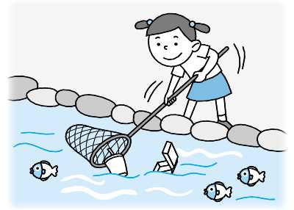B) 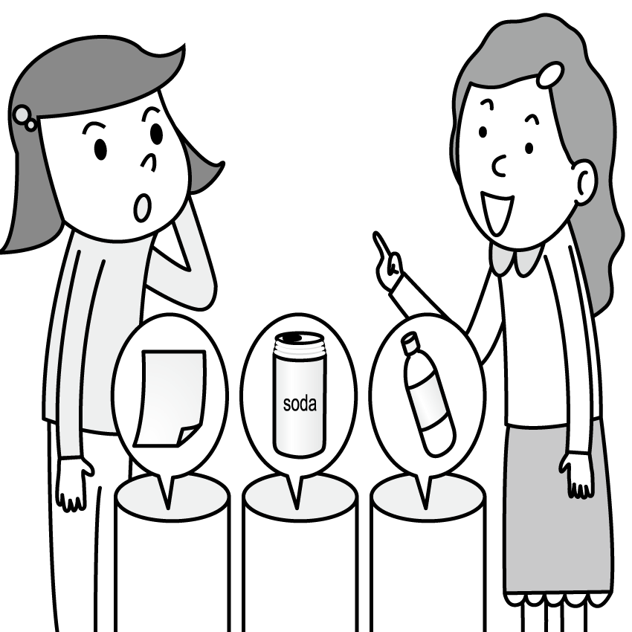C) 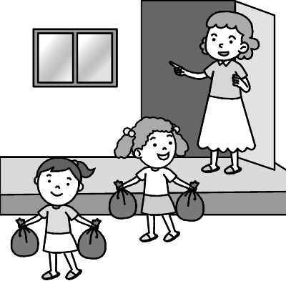
4.( )
A) 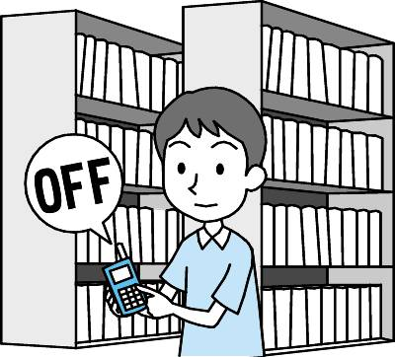 B) 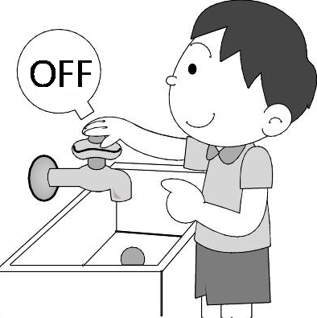 C) 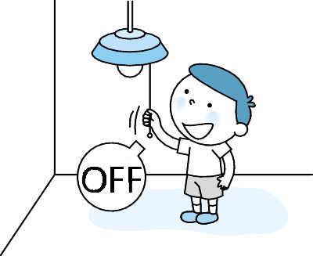
5.( )
A) 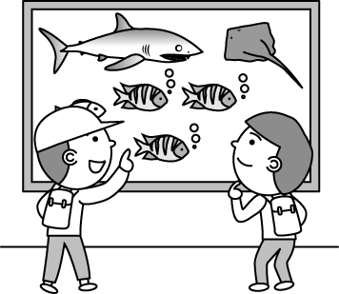 B) 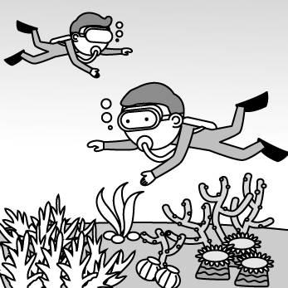C) 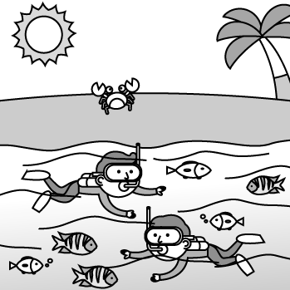

二、基本問答：根據聽到的內容，選出最適合的回應。5%
6.( )A)I had much fun and liked the hot spring bath best.
B)You can see the beautiful underwater world.
C)We were able to fly to Green Island.
7.( )A)No problem. We can pick her up at the station.
B)Well, we can go by bus by ourselves.
C)It’s too late for us to take a train.
8.( )A)Sorry, I can’t hear your voice.
B)I can’t agree with you more!
C)Well, I don’t like the music teacher.
9.( )A)Thank you. I love you guys.
B)However, you won in the end.
C)Cheer up. You’ll do better next time.
10.( )A)My mother lets me go hiking with you.
B)I always bring my own shopping bag when going
shopping.
C)I know we’re going shopping and then going
hiking in the mountains.

三、言談理解：根據聽到的內容，選出最適合的答案。10%
11.( )A) Loving her pet.
B) Saving the world.
C) Helping street animals.

12.( )A)Everyone should drive their own car to work.
B)People should take a bus or the MRT to work.
C)People use water more wisely. Don’t waste it.
13.( )A)She has a terrible sore throat.
B)She will join the singing contest.
C)She sings the most terribly of all the girls in her class.
14.( )A)They can hear waves hitting rocks.
B)They can watch the sun going down.
C)They can feel the rocks rolling down.
15.( )A)At a market.
B)In the kitchen.
C)At the health center.

四、綜合選擇。40% (每題2分)
16.( )John practiced the hardest this week, but he lost the game.
Let’s ____.
A)turn him off B)cheer him up
C)try his best D)make it a habit
17.( )In the video, I saw a baby pilot whale ____ on the beach.
It was weak and dying. How sad!
A)lying B)telling C)laying D)landing
18.( )Mom buys things wisely. She uses coupons and ____
much money.
A)saves B)kills C)throws D)means
19.( )My brother loves to take pictures of ____.
A)themselves B)himself C)he D)his
20.( )The water in the river is so clean and clear. The birds’
singing sounds great. I also breathe the fresh air.
Oh, I enjoy ____.
A)benches B)rainbows C)nature D)planets
21.( )Because I got very poor grades last semester, my parents
____ me study at home after school every day.
A)asked B)told C)made D)wanted
22.( )Please follow the rules in the museum. Don’t eat or
drink. You ____, either.
A)shouldn’t littering B)mustn’t litter
C)don’t have to litter D)should litter
23.( )Patty: How far are we going to ride, Mom?
Mom: Only ____ miles.
A)a little B)a second C)a lot D)a few
24.( )I know Mr. Smith very ____. He comes from Canada,
teaches English here in Taipei, and is ____ at playing sports.
A)well; poorly B)good; poor
C)good; poorly D)well; poor
25.( )Mom: ____ You look unhappy. Something bad
happened on sports day?
Emily: You got it. I dropped the baton in the relay race,
and my class didn’t win any prizes.
A)What should you do?
B)How could this happen on sports day?
C)What do you mean by trying to be green?
D)What’s the matter with you?
※背面有題，請繼續作答※
26.( )Julia: Mom, must I buy a bag of sugar for you right away?
Mom: No, ____. But if you do so, I’ll be very thankful.
A)you don’t B)you don’t have
C)you haven’t D)you don’t have to

(27-32)
Last weekend, I took a trip with my family. We _27_ Green Island for two days. On the first day, we _28_ and saw many fish swimming along the way. We even found sea turtles and sea snakes in the stones. Being in the water made us _29_.
On the second day, we _30_ Zhaori Hot Spring early in the morning. It’s famous for its saltwater hot spring. We soaked in the hot spring and watched the sun _31_ at the same time. We _32_ very much.
27.( )A)stayed on B)lived on
C)stayed in D)lived in
28.( )A)go snorkeling B)were going snorkeling
C)went to snorkel D)went snorkeling
29.( )A)very happily B)very happy
C)feeling happily D)to feel happy
30.( )A)visited to B)left to
C)went D)left for
31.( )A)to rise B)setting
C)rise D)go down
32.( )A)enjoyed ourselves B)by ourselves
C)helped ourselves D)had ourselves

(33-35)
In 2010, the worst oil spill in history took place in the Gulf of Mexico. Lots of oil _33_. Every living thing in the water was covered with oil, and hundreds of thousands of sea animals died because of this.
In fact, sea pollution happens every day, such as oil from ships, dirty water from factories, and trash from people on land. They can _34_ in the sea. Sea animals, plants, and sea birds would get sick or die from this kind of pollution. People may get sick or die if they happen to touch or eat the sick animals from the sea. Though we may not be able to stop accidents from happening, we can still help cut down pollution. For example, after we go to the beach, we should take the trash home. By taking some simple actions, we can _35_.
oil spill漏油；cover 覆蓋；pollution汙染；such as例如；
accident意外

33.( )A)saved many animals
B)went into the sea
C)fed many sea animals
D)were very expensive
34.( )A)have animals grow faster
B)speak up for themselves
C)make more and more trouble
D)help sea animals live happily
35.( )A)catch a lot of animals
B)change everything in the world
C)make our dreams come true
D)have a cleaner sea
(36-37)
WHEN ALL OF YOUR BAD DREAMS BECOME TURE

“Don’t Fall Asleep is surely this year’s best horror story.
— Amazing Books
“Steve Alfred is the “Genius of Thrillers.” It’s his best book ever!” — iReaders
“A heart-racing thriller. The more you read, the more scared you
get. But you just can’t let go of the book, not for a second.”
— Reviewer

Anna is a writer. She lives by herself in a small house by a lake in the forest. One day, bad things start to happen to her out of nowhere. She falls into a cold lake because the bridge over the lake suddenly breaks. A tree falls right in her way when she is driving, and she gets badly hurt because of it. She finds out that these are all her dreams. The more scared she is, the more bad dreams she has. She starts to try not to sleep. But as she keeps herself awake each night, she finds out there is something wrong about the house she lives in…

thriller恐怖小說；suddenly突然地；scared驚恐的；awake醒著

36.( )Which is NOT true about Don’t Fall Asleep?
A)It is a horror story.
B)Anna lives on her own in the forest.
C)Anna’s bad dreams come true.
D)Anna writes about her dreams in her books.
37.( )What can we learn from the reading?
A)Anna writes Don’t Fall Asleep.
B)Don’t Fall Asleep is the funniest book this year.
C)Readers say the book is the best ever by Steve Alfred.
D)You’ll be less scared when you read more of the book.

(38-39)
Bridges are works of art and precision math.
Bridges connect people and watch people come and go.

Long turtle, the oldest bridge of Green City, is celebrating its two hundredth birthday! With 4D video, you can experience how Long Turtle changed from a simple wooden bridge to a strong and beautiful one. With old pictures and photos, you can see how people live along Dan River and how they are connected to each other by Long Turtle and other bridges of Green City.

History Museum of Green City
Date: 2017/09/01~12/31
Opening Hours: Tue. to Sun. 10:00~17:30
Closed on Mondays
Admission: Free
Tel: 02-3487-6665

Museum Tea House (Restaurant)
Tue. to Thur. 11:00 ~ 19:30
Fri. to Sun. 11:00 ~ 21:00
Closed on Mondays
With a VIP card, you can enjoy the meal at half price from Tuesday to Friday.
Tel: 02-3487-6666

precision精密；connect連接；wooden 木製的

38.( )What do you we know from the reading?
A)Workers will build Long Turtle next year.
B)Green City is two hundred years old.
C)Bridges in Green City are all wooden.
D)Long Turtle helps people cross Dan River.
39.( )Cindy and Paula are going to the museum and also wants
to have dinner at Museum Tea House. Both of them
don’t meet each other for a long time, so they want to stay
at the restaurant a little longer after dinner. If one of
them has the VIP card, what day is the best day for them
to visit the museum?
A)On Sunday. B)On Monday.
C)On Saturday. D)On Friday.

第40~57題 請在答案卷上作答

五、文意字彙。16% (每題2分)
40.________ When I was a kid, I enjoy sitting on my dad’s s____rs. This way, I can see farther ahead.
41.________ Dad smoked again. The fact really s____ked us. He always keeps his word and never lets us down.
42. ________ If it is c____t for you, please buy me a dozen eggs on your way home.
43.________ Look! There is a giant b____t star shining in the
clear sky.
44.________ Be c____l with the knife when you cut meat, or you may get hurt.
45.________ We usually s____n our names at the end of a letter.
46.________ At first, Shelly led the way. H___r, she tripped and fell near the finish line. She lost the race in the end.
47.________ Don’t put boiling hot water in the p____c bottle. It’s dangerous and poisonous(有毒的).

六、請填入正確的形容詞或副詞形式。7%
48. After exercising for three hours, I felt ____(hungry).
49. This bakery sells the most delicious chocolate cake in Taipei.
You can’t find ____(good) chocolate cake in the city.
50. Of the four questions, I work out question number one
____(quick).
51. Tina studies ____(hard) to enter her ideal senior high school.
52. Jill draws ____(bad) of the three.
53. My grandma is over ninety years old. She is healthy, but she
walks as ____(slow) as a turtle.
54. Lillian dances ____(beautiful) than Judy.
七、中翻英。 9%
55. 攜帶你自己的湯匙和筷子可以幫助減少垃圾。4%
56. 因為我傷了膝蓋，Ethan必須代替我的位置。3%
57. 請記住這個：坐而言不如起而行。(用keep…)2%

※試題結束※

