臺北市立瑠公國中 107 學年度 第 1 學期 七年級 第 1 次定期評量 英語科 試題

第1頁 共2頁

- 辨識句意：選出符合句子描述的圖片。3%
1.（ ）
Ａ)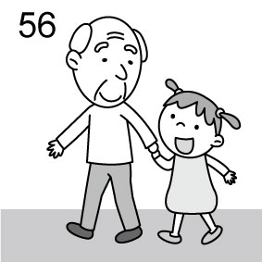Ｂ)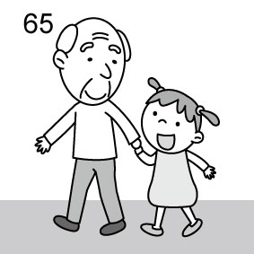Ｃ)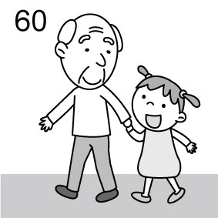
2.（ ）
Ａ)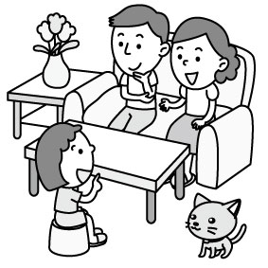Ｂ)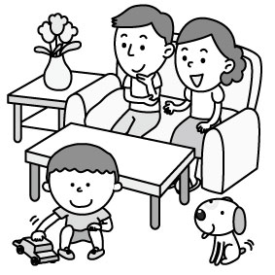Ｃ)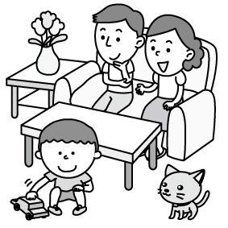
3.（ ）
Ａ)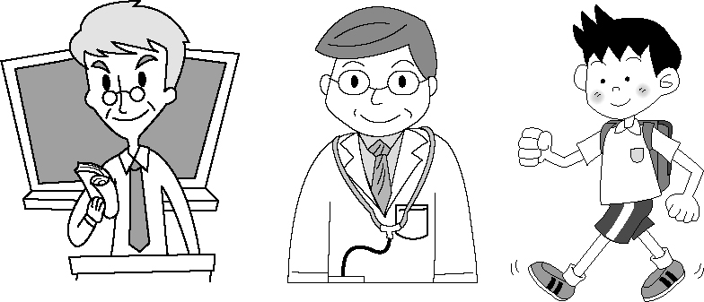
Ｂ)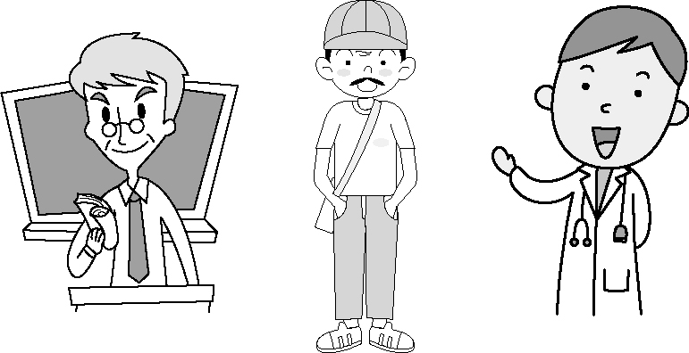
Ｃ)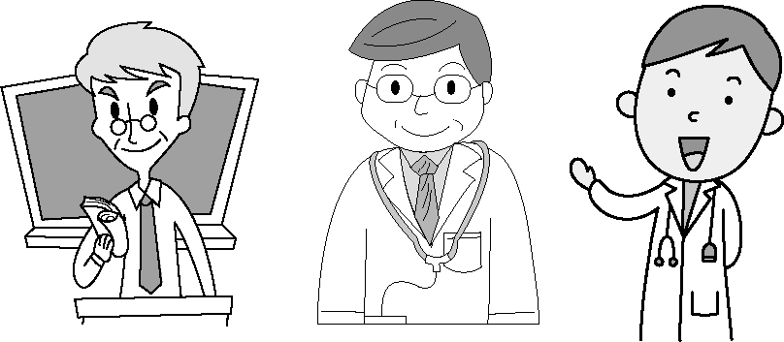

二、基本問答：根據聽到的內容，選出最適合的回應。5%
4.（ ）(Ａ) Good morning, Louis.
(Ｂ)Not bad. And you?
(Ｃ)Oh, I’m a student.
5.（ ）(Ａ)Yes, I’m a good student.
(Ｂ)No, my grandpa isn’t a teacher.
(Ｃ)Yes, and you’re my student.
6.（ ）(Ａ)I’m not your classmate, David.
(Ｂ)I’m in class 107.
(Ｃ)My student number is 17.
7.（ ）(Ａ)She is a cook.
(Ｂ)She is a three-year-old singer.
(Ｃ)Oh, she’s Doris’ aunt, Jessica.
8.（ ）(Ａ)Yes, I’m your student. Nice to meet you, teacher.
(Ｂ)Nice to meet you, too. My name is Terry.
(Ｃ)Nice to meet you, Nicole. I’m not your teacher.

三、言談理解：根據聽到的內容，選出最適合的答案。10%
9.（ ）(Ａ) He is the man’s father.
(Ｂ) He is the woman’s father.
(Ｃ) He is a good doctor.
10.（ ）(Ａ) Rocky is a student, too.
(Ｂ) The girl’s mother is a housewife.
(Ｃ) Evan is a teacher.
11.（ ）(Ａ) The boy.
(Ｂ) The boy’s grandma.
(Ｃ) Sasha.
12.（ ）(Ａ) Two. (Ｂ) Twenty-five. (Ｃ) Pretty.

13.（ ）(Ａ) They are new friends.
(Ｂ) They are husband and wife.
(Ｃ) Scott is fine, and Penny is, too.

四、綜合選擇。46% (每題2分)
14.( )____ are kind, and ____ is, too.
A)Fiona; Shrek B)You; I
C)Snow White; Babe D)You; Toby
15.( )Allen: ____ in the classroom?
James: Sam and Jim are.
A)Who B)Who are C)Who is D)What are
16.( )My daughter, Bella, is ____.
A)six month old B)a thirteen-years-old girl
C)an one-month-old baby D)eleven
17.( )Bill: Let me tell you. Iron Man, the Hulk, and Captain
America are superheroes from the Avengers.
Pam: ____. They are cool, aren’t they?
A)I see. B)Not well. C)Very bad. D)Pretty bad.
18.( )Ivan: What’s your student number?
Karen: ____ 1070811.
A)It B)Its C)My number D)It’s
19.( )Lynn: Isn’t your friend’s wife beautiful?
Anne: ____ But she has a kind heart.
A)Yes, she isn’t. B)No, she is beautiful.
C)Yes, he is beautiful. D)No, she’s ugly.
20.( )Cathy: Is ____?
Zed: No, it isn’t.
A)that cute a bag B)that cute bag
C)that bag cute D)that an cute bag
21.( )Taylor:____ is Uncle Ted?
Victor: Pretty well. Thanks. And you?
A)How old B)What C)Who D)How
22.( )____ the picture on the wall. They are my family.
A)Look B)Meet at C)Meet D)Look at

(23-27)
Kiki: Hello, I’m Kiki. __23__ your names?
Lala: I’m Lala, and __24__ my twin brother, Hank. Are you in Class 801?
Kiki: Yes, __25__. And you?
Lala: We are new students in your class.
Kiki: Wow! Welcome to my class.
Lala: How is __26__ teacher, Miss Chang?
Kiki: She’s beautiful and nice.
Lala and Hank: We are very __27__ and lucky.

23.( )A)How is B)What are C)What is D)How are
24.( )A)this’s B)this C)she’s D)this is
25.( )A)I am B)I’m C)we are D)I’m not
26.( )A)our B)a your C)my a D)the our
27.( )A)sad B)happy C)small D)weak

※背面有題，請繼續作答※

(28-30)
Tony: What is that?
Mary: A cellphone. It’s a gift from Mom.
Tony: A cellphone? Why? You already have one.
Mary: But my cellphone is too old. What is your birthday gift from Mom?
Tony: Guess what? Carcassonne, a board game!
Mary: A board game? That’s cool!
Tony: Yes, it is. And it’s also a great gift because we can play
with it together.
※gift禮物；because因為；enjoy 享受；together一起
28.( )Mary and Tony are ____.
A)friends B)sister and brother
C)classmates D)mother and son
29.( )What is Carcassonne?
A)A cellphone. B)A birthday.
C)Tony’s friend. D)A game.
30.( )Tony says Carcassonne is a great gift. Why?
A)Because it is from Mom.
B)Because his father loves it.
C)Because all the family can play with it together.
D)Because Mother needs it. ※need需要
(31-33)
Students in Class 708 and Class 709 at Liu Gong Junior High School have brothers or sisters.
(人)

※have有；older較年長的；younger較年幼的
31.( )There are ____ students in class 709.
A)21 B)22 C)23 D)19
32.( )How many students in Class 708 and Class 709 have
brothers?
A)17 B)10 C)8 D)16
33. ( )Which is true(正確的)?
A)Two students in Class 708 have younger sisters.
B)Eight students have no brothers or sisters.
C)All the students have brothers.
D)There are nine girls in Class 708.
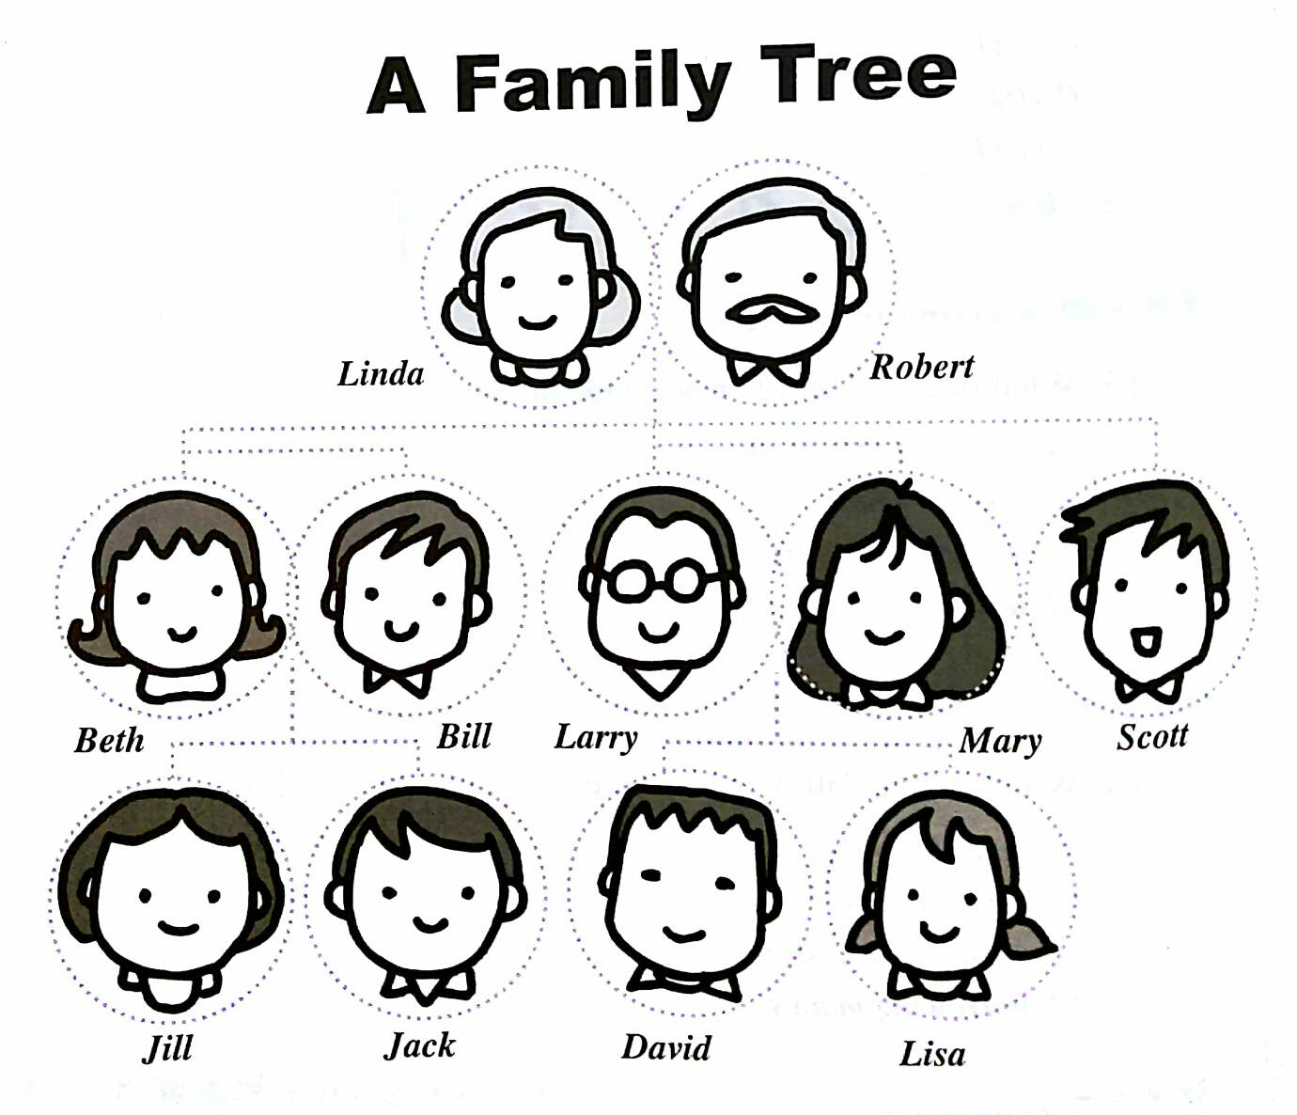
(34-36)

第第2頁 共2頁
※know知道；table圖表；member成員；relationship 關係
34.( )What can’t you know from the table?
A)The jobs of the members in the family.
B)The names of the family members.
C)The relationship of the members in the family.
D)The number of people in the family.
35.( )Who is Jack and Jill’s uncle?
A)Robert. B)David. C)Larry. D)Bill.
36.( )Which is NOT true?
A)Robert and Linda have two sons and a daughter.
B)Mary’s husband is Larry.
C)Beth has a daughter. Her name’s Lisa.
D)Scott has no wife.

第37~53題 請在答案卷上作答

五、文意字彙。18% (每題2分)
37.________ I am t____e years old. I am a junior high school
student.
38. ________ Owen: Ms. Lin is fifty years old.
Vivian: R____y? She looks so young.
39.________ My sister is very s____t. She is only three years
old, and she can count(數) from one to ten.
40.________ Thirty-nine plus(加) one is f____y.
41.________ I am very h____y now. Can I have(吃) some hot
dogs?
42.________ Lillian is my c____n. Her mother is my aunt.
43.________ J. K. Rowling is a w____r. Harry Potter is her
book.
44.________ The Hulk is big and s____g. He beats(打擊) bad
guys.
45.________ Jill is a n____e, not a doctor. She works in a
hospital(醫院).

六、依提示作答。5%
46. UGLY 大寫改成小寫。1%
47. family小寫改成大寫。1%
48. Mr. and mrs. Lin’s son is Jimmy. 1%
請改正句子的書寫錯誤，寫出正確句子。
49. His my brother. He’s name’s John. 2%
請改正句子的書寫錯誤，寫出正確句子。

七、中翻英。 13%
50.A：這台黑色的滑板車不是新的嗎?
B：不，它是台舊的滑板車。 3%
51. 看! 這是Meg最喜歡的漫畫書。3%
52. A：他們的祖父幾歲?
B：他九十歲了。(請用英語表達數字) 3%
53. A：那個又高又帥的男人是誰?
B：他是你哥哥的籃球教練，Peter。4%
※試題結束※

