臺北市立瑠公國中一０七學年度第一學期九年級英文科第一次定期評量試題
班級:____ 座號:____ 姓名:__________

※聽力測驗：20%
- 辨識句意：根據聽到的內容，選出符合描述的圖片或符合圖片的描述5%
1.( )
(A)(B)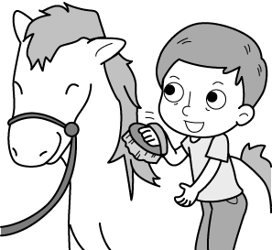(C) 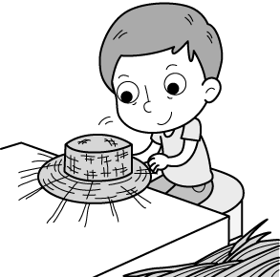

2.( )
(A) 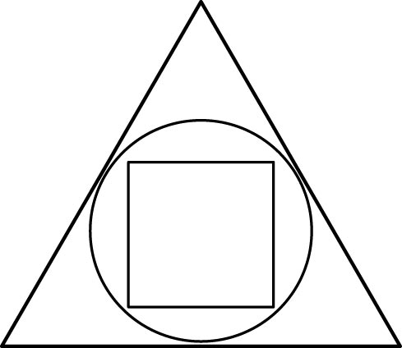(B) 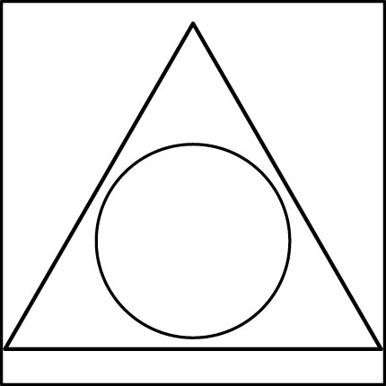 (C) 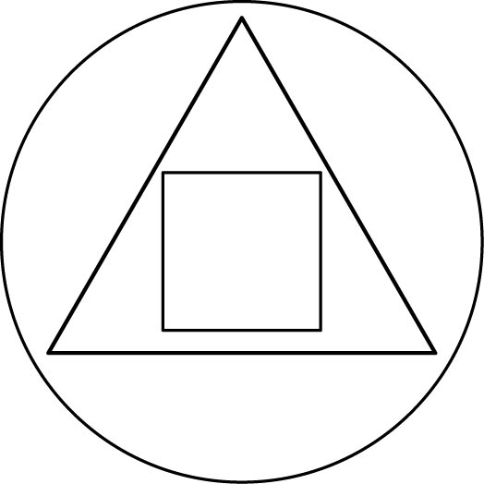

3.( )
(A) (B) 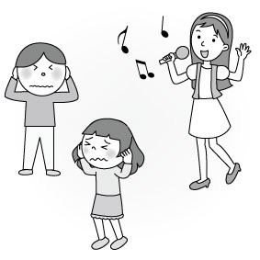
(C) 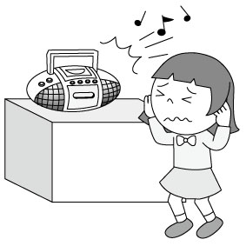

4.( )
(A) (B)
(C) 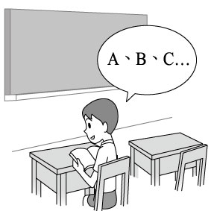

5.( )

(A) (B) (C) 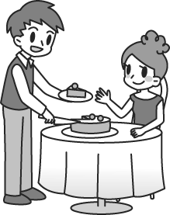

二、基本問答：根據聽到的內容，選出一個最適合的回應或最適合的問句5%
6.( ) (A)Yes, I always want to go there.
(B)Yes, we’ve planned to go there soon.
(C)Yes, I’ve been there with my family before.
7.( ) (A)Sorry to keep you waiting.
(B)Because I’m getting married.
(C)Yeah. It’s really been a long time.
8.( ) (A)No, but I swept the floor.
(B)Yes, she mopped the floor.
(C)Yes, I like mopping the floor.
9.( ) (A)3 inches.
(B)5 meters.
(C)15 centimeters.
10.( ) (A)Why not clean the house? It’s very dirty.
(B)Playing computer games is boring.
(C)I’m bored with everything.

三、言談理解：請聽對話或短文，選出一個最適合的答案10%
11.( ) (A)They were all wet.
(B)They were letters from the man.
(C)The man separated them by hand.
12.( ) (A)Eight years.
(B)Fifteen years.
(C)Twenty-three years.
13.( ) (A)The woman likes her son’s painting.
(B)The robot has a triangle head and rectangle body.
(C)There was a dog on the painting.
14.( ) (A)To teach Alice to make a pumpkin lantern.
(B)To let Alice make dinner for his mother.
(C)To ask Alice to finish the pumpkin lantern for him.
15.( ) (A)One player got hurt.
(B)Lions’ team lost.
(C)Lions’ team won.

【聽力測驗結束，請翻面繼續作答】

- 選擇題：50%

( ) Lisa made a ______ before she blew out the candles on her birthday cake. (A)lamp (B)wallet (C)wish (D)envelopes

( ) The Neil River, the longest river in the world, is 6853 ______ long. (A)kilometers (B)meters (C)inches (D)size

( ) Don’t ______ your eyes to the computer for too long. It’s bad for your eyes. (A)miss (B)reach (C)trust (D)glue

( ) We need to ______ our bottles with water before we go hiking. It’s important to drink enough water during the hike. (A)wake up (B)fill up (C)dress up (D)cheer up

( ) Amanda has lived in Taipei ________. (A)in 2015 (B)when she was twenty-five (C)two years ago (D)since she got married

( ) Cathy has ______ the movie before. (A)sees (B)seeing (C)saw (D)seen

( ) Mom: Have you finished your homework? Son: Yes, I ______ it ten minutes ago. (A)will finish (B)have finished (C)finish (D)finished

( ) John ______ the dog, doesn’t he? (A)fed (B)has to feed (C)has fed (D)is feeding

( ) Bob isn’t afraid ______ English in front of his class. (A)at speaking (B)of speak (C)to speak (D)speaking

( ) Shopping on the Internet ______ a lot of women. (A)is interested in (B)interest (C)has an interest in (D)is interesting to

( ) Mendy: You aren’t going to buy that dress, are you? Grace: __________ (A)No, I don’t have enough money. (B)No, I’ll buy it. (C)Yes, it’s a little too expensive. (D)Yes, I just don’t like its color.

( ) Andy: Did you enjoy the Halloween party last night? Bill: Yes, __________. (A)it wasn’t my cup of tea (B)I couldn’t make heads or tails of it (C)I had a whale of a time (D)it was a piece of cake

(28-31)

Dear Lucy,

I just want to tell you that we are all fine. The strong typhoon hit our town last weekend. When it came, it was 28 . It was raining so hard that we couldn’t see out of the window. We couldn’t go to sleep either because of the strong winds. At around 12 a.m., all the lights went out. We 29 . My mom sat with my sister and me while my dad read us stories to help us forget about what was going on outside. When we went outside the next morning, we were surprised that 30 . Luckily, everybody in the town was safe. Since then, we 31 others clean up. Although we are tired, we are happy. Please don’t worry about us.

Emily

( ) (A)a scary night (B)a wonderful evening (C)a funny show (D)a strange case

( ) (A)got excited about it (B)were scared (C)felt bored with it (D)was proud

( ) (A)the typhoon was around the corner (B)the typhoon wasn’t real (C)our eyes tricked us (D)there were trees down all over the ground

( ) (A)helped (B)was helping (C)will help (D)have helped

(32-33)

Everyone is happy about the coming of a new life and there are several ways to celebrate it. For example, people in Taiwan usually have a party for a newborn baby when she or she is one month old. That’s why this kind of party is often called Full Month Party. The parents usually invite their relatives and friends to a big dinner. They may send oil rice to share their joy. Like Taiwanese parents, people in the USA have a “baby shower” for a mother-to-be before the baby is born. At the party, American people bring presents for the baby and food for the mother-to-be. Although there are different ways to celebrate a new life, the happiness of parents is the same.

born出生; relatives親戚

( ) Which one below should send oil rice to others now? (A)Barbara. She won a cooking contest. (B)Mr. and Mrs. Lin. They had a lovely baby last month. (C)Joe. He just moved into a new house. (D)Sara. She is going to be a mother next month.

( ) What is the same about the parties for newborn babies in Taiwan and in the USA? (A)In Taiwan and the USA, the parties for babies have the same name. (B)In Taiwan and the USA, people eat the same food at the parties. (C)Parents hold the parties right after they have newborn babies. (D)Parents invite their friends to celebrate a new life.

(34-37)

Have you ever seen emperor penguins in the zoo? They are popular with children and adults. What is so special about these birds that do not fly? Below are some facts about them.

Most penguins live on the rocky islands in the Antarctic. It is often as cold as -27℃. The largest of all the penguins is the emperor penguin. An emperor penguin is almost four feet tall and can weigh almost 100 pounds. When on land, the emperor penguin walks slowly and looks cute. But in the water, it can swim fast and go as deep as 800 feet to find fish to eat.

There is one thing very interesting to us about the emperor penguin. After the mother penguin lays an egg in winter, she leaves on a fishing trip right away. It is the father penguin that takes care of everything. He puts the egg on his feet under his warm stomach feathers. He stands in the dark of the Antarctic winter for two months. During this time, he eats almost nothing.

The mother penguin comes back when it is time for the baby penguin to come out of the egg. The father stays for a while to be sure the new baby penguin has a good start. If there is only enough fish for one, the father will give it to the baby and go hungry himself. When everything is OK, it is time for the father to leave. Then he will go to fill himself with delicious fish until next year.

the Antarctic南極; weigh重達;

pound磅; deep深的; lay生蛋; feather羽毛

( ) What is the main idea of the story? (A)How emperor penguins live and take care of their babies. (B)Why emperor penguins can’t fly into the sky. (C)Visiting the emperor penguins in the zoo. (D)How to keep penguins as pets.

( ) How long does it take for an emperor penguin egg to hatch? hatch孵化 (A)About two weeks. (B)90 hours. (C)About 60 days. (D)one year.

( ) Which is NOT true about the reading? (A)Penguins are very good swimmers. (B)There is only one kind of penguin in Antarctic. (C)Penguins live in a very cold weather. (D)You can see penguins on the Antarctic rocks.

( ) What can we learn from the story? (A)The father penguin eats nothing for the whole year. (B)The father penguin leaves for food right after the mother penguin comes back. (C)The father penguin is a good parent, but the mother penguin isn’t. (D)It’s the father penguin hatches the egg, not the mother penguin.

(38-40)
“In Georgia, you must close your windows at night to keep it out of the house,” said James Dickey in his poem, Kudzu.
Someone brought Kudzu from Japan to the United States in 1876. To celebrate the 100th birthday of the USA, Japanese built a garden full of plants from Japan, and Kudzu’s large leaves and sweet-smelling flowers soon caught people’s eye.
In Japan and China, people use Kudzu to make cloth, tea, and medicine. In Florida, the USA, Kudzu has become a kind of food for farm animals because it needs very little care and grows fast. However, the problem is that it just grows too fast. The warm weather in the south of America is so good that during the summer months it grows a foot every day. It climbs anything it touches. It kills trees and damages houses.
Kudzu has become a headache for thousands of people. To kill it is not an easy job. But at the same time, some people are trying to make paper from Kudzu. Maybe it is a better idea to live with it and use it.
poem詩; cloth布; damage傷害

( ) What is “Kudzu?” (A)A kind of plant. (B)A kind of animal. (C)A kind of garden. (D)A kind of people.

( ) What does “you must close your windows at night to keep it out of the house” infer to? (A)Kudzu likes to go in the house at night. (B)It is easier for farm animals to find and eat Kudzu out of the house. (C)Kudzu needs sunshine. It must grow outside the house. (D)Kudzu grows too fast. It may climb into houses easily. infer意指

( ) Which is true about the reading? (A)It was wrong to plant Kudzu in the USA. (B)People need to take good care of Kudzu, or it will die soon. (C)People can make good use of Kudzu in many ways. (D)Kudzu has feet when it grows up.

【請翻面，以下答案請寫在作答卷上】30%

五、文意字彙12%

JJ is e______t at singing. He won many prizes in a lot of singing contests.

Jack always wears a smile on his face because he thinks it’s the best l______e to make friends.

I need to surf the Internet to get some i______n for my science report.

Is it p______e for me to borrow your camera?

The police officer r______g the doorbell, but nobody answered.

I don’t like the color of the smartwatch. Please show me a______r one.

六、填充題10% (一格填一字，每格1分)

Those are not my pencils, ________ ________?

My aunt’s never taken a plane, ________ ________?

Kevin put the cap on the sofa, ________ ________?

There should be something in the box, ________ ________?

You seldom worry about your son, ________ ________?

七、依指示作答8%

Rick went to New York last year. (將畫線部分改為twice) 2%

我相信這是一個相當瘋狂的點子。 (中翻英) 3%

你難道不同意去玩不給糖就搗蛋令兒童很興奮嗎？ (中翻英) 3%

【本次測驗結束】

