台北市立瑠公國民中學107學年度第一學期八年級第一次段考 英語科 考試卷 年 班 座號： 姓名：

第一部分：聽力測驗 20 %
- 辨識句意：根據聽到的內容，選出符合描述的圖片或符合圖片的描述。(每題1分，共5分)
- (A)
(B) 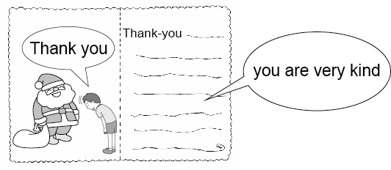
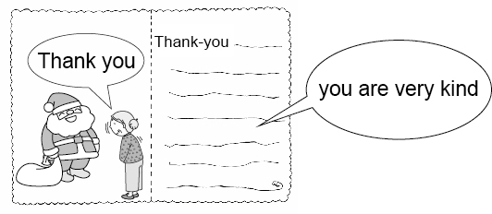
(C)
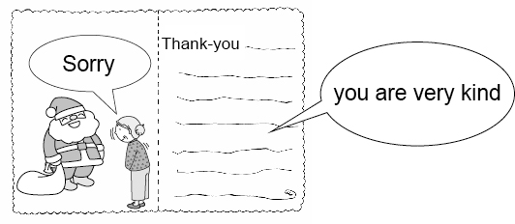

- (A)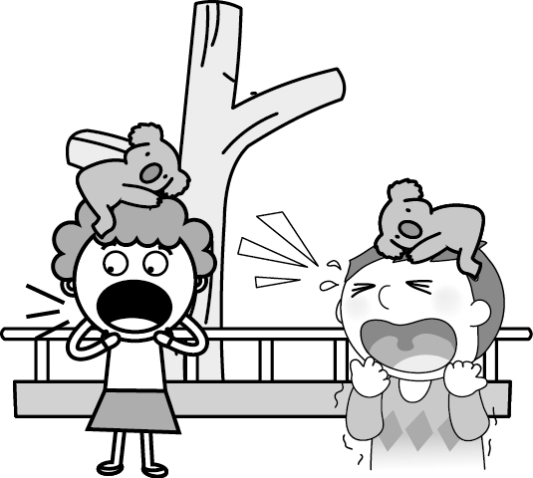
(B) 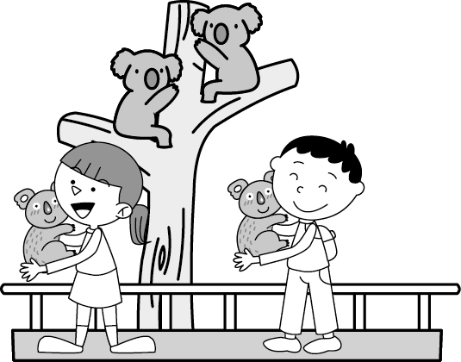
(C)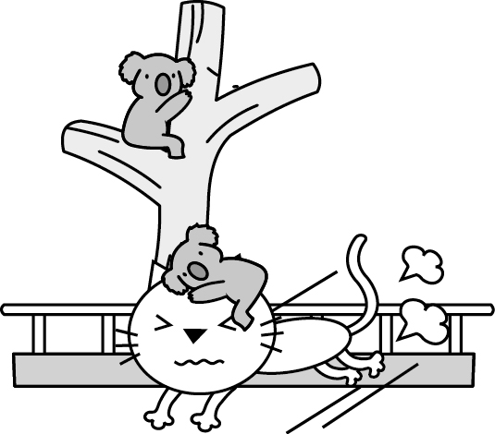

- (A)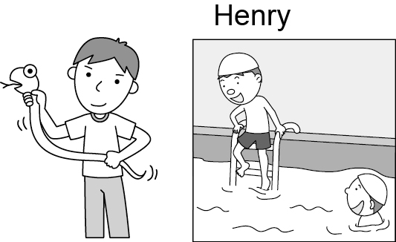 (B)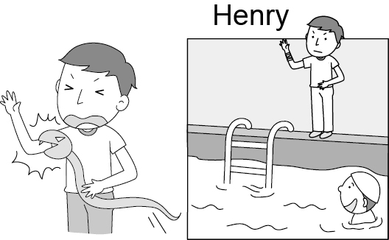
(C)
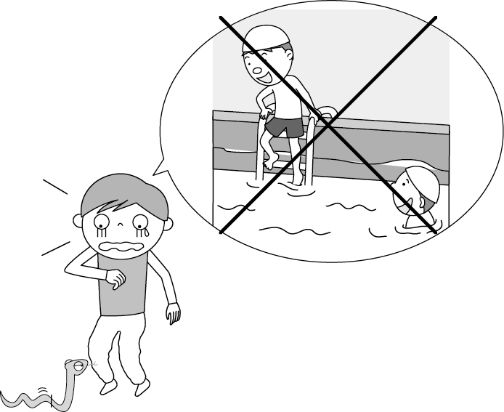
- (Ａ) (Ｂ)
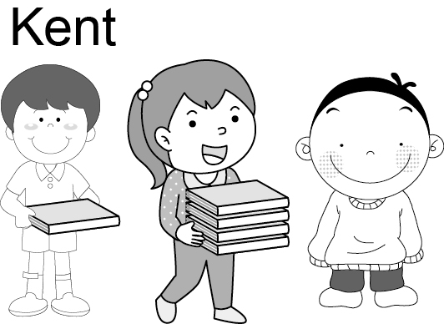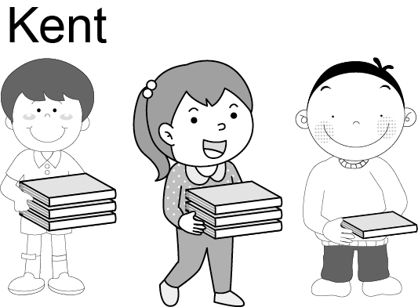
(C)
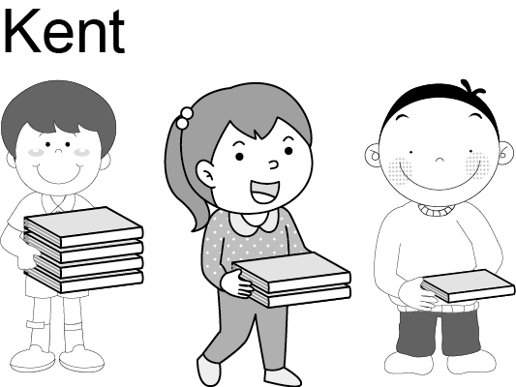

- (A)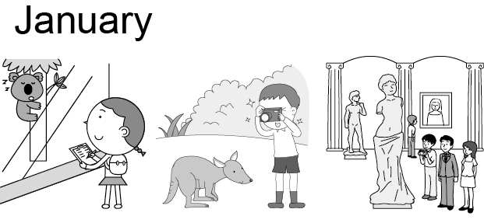
(B)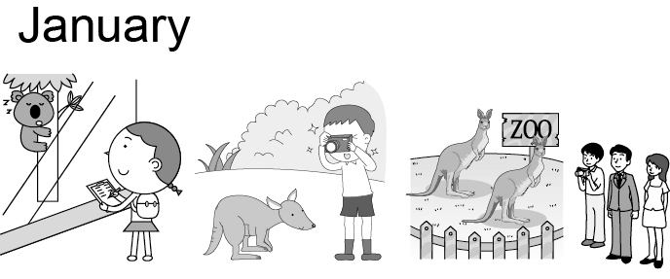
(C)
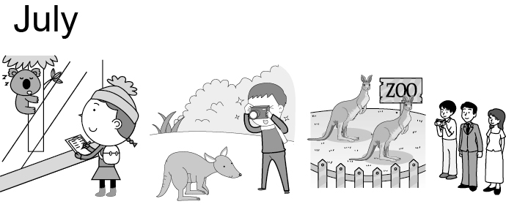

- 基本問答：根據聽到的內容，選出一個最適合的回應或最適合的問句。(每題1分，共5分)
- (Ａ) The coffee at Louis Café is great.
(Ｂ) I met my classmates in junior high.
(Ｃ) I helped my dad at the market.
- (Ａ) The picture over there is from Germany.
(Ｂ) My teacher painted well, and I did, too.
(Ｃ) You’re pulling my leg. John painted it.
- (Ａ) Whose is that birthday party?
(Ｂ) Well, I was busy playing Tower of the
Devil.
(Ｃ) Yeah, I ate a lot of moon cakes last night.
- (Ａ) Oh, no! It’s too late for us.
(Ｂ) I’m sorry. I didn’t mean it.
(Ｃ) Poor her! Is she all right now?
- (Ａ) I bought it for your birthday.
(Ｂ) Sorry. I don’t need any blue hats.
(Ｃ) Wonderful! Let’s get blue shoes for you.

- 言談理解：根據聽到的內容，選出一個最適合的答案。(每題2分，共10分)
- (Ａ) Pomelo hats. (Ｂ) Moon cakes.
(Ｃ) Pomelo juice.
- (Ａ) The man’s. (Ｂ) Mr. Wang’s.
(Ｃ) Oscar’s.
- (Ａ) She was a great English teacher.
(Ｂ) She is Emily’s mother.
(Ｃ) She doesn’t have any friends.
- ( (Ａ) The man’s gift for his mother are gloves.
(Ｂ) The woman thinks much for her parents.
(Ｃ) They are having a Christmas party.
- (Ａ)
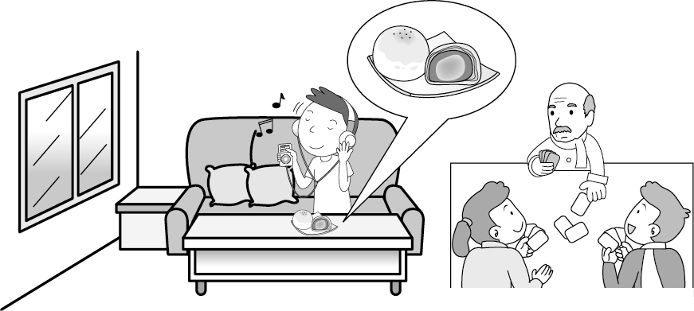
(Ｂ)
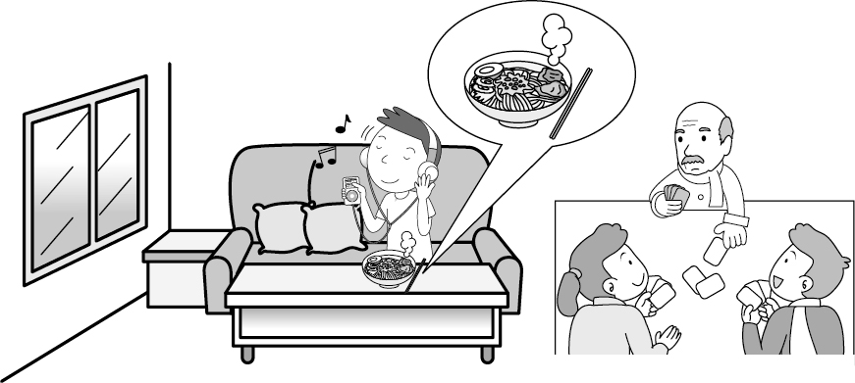
(Ｃ)
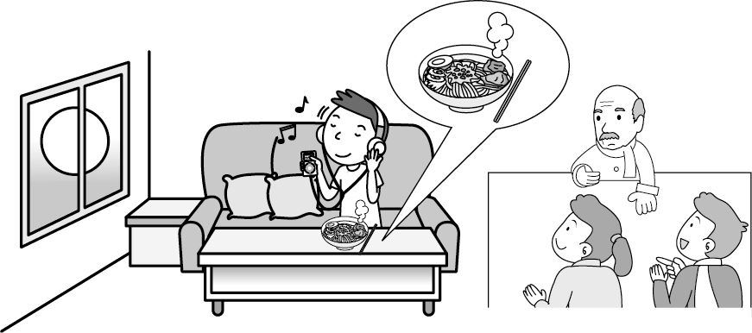

第二部分：選擇題 35 %
單題(每題2分，共10分)
16. A：Who put the money in the tree house?
B：May
(A)is (B)does (C)do (D) did
17. Uncle Sam sent us a robot and we it
“Hope”.
(A)names (B)named after
(C)named (D)named with
18. A：Why did you toss Ms. Wood into the
lake last night?
B： she was the birthday girl, we had this special plan.
(A)Because; so (B)So; because
(C)Because; X (D)X; because
19. Mom: Was your trip to fun?
Cindy: It rained for three days
and I didn’t go out. I just watched
TV at my cousin’s place. Poor me!
(A) You bet. (B) Ask for the moon.
(C) Of course not! (D) Sure I did.

20. Terry: You didn’t go to the Moon Festival
party last night.
Paul: I had too many pomelos in the morning
and burped all afternoon.
(A) What happened to you?
(B) Where did you go?
(C) How was the party?
(D) Who got the moon cakes?

克漏字 (每題1分，共15分)
A
Tom： __21.__ your summer vacation?
Jerry：Wonderful!I went to Gongliau(貢寮). There was a music festival every year. Many people __22.__ there for the nice beach, especially the great music. Sodagreen
(蘇打綠) is my favorite band. I really
enjoy their singing.
Tom：Why was the festival so popular? Was there __23.__ at the festival?
Jerry：Yeah. People talked, had food and listened to the music at the same time on the beach.
Tom：__24.__
Jerry：Well, I also met a girl from Australia and learned some Australian English from her.
Tom： Like what?
Jerry：“Let’s watch Telly and have some chokkie.”
Tom： __25.__
Jerry：It means “Let’s watch TV and have some chocolate.”
Tom：Wow,That sounds wonderful. I can’t wait to go with you next year.

especially 特別是 stage舞臺

21. (A) How was (B) Why was
(C) What was (D) Where were
22. (A) visit (B) visits
(C) is visiting (D) visited
23. (A) anything special (B) something special (C) special anything (D) special something
24. (A) How would you like to do it?
(B) Why did you go there?
(C) What else did you do?
(D) Who else did you meet?
25. (A) Did it mean a lot to you?
(B)What does it mean?
(C)What a wonderful gift!
(D)What did you learn?

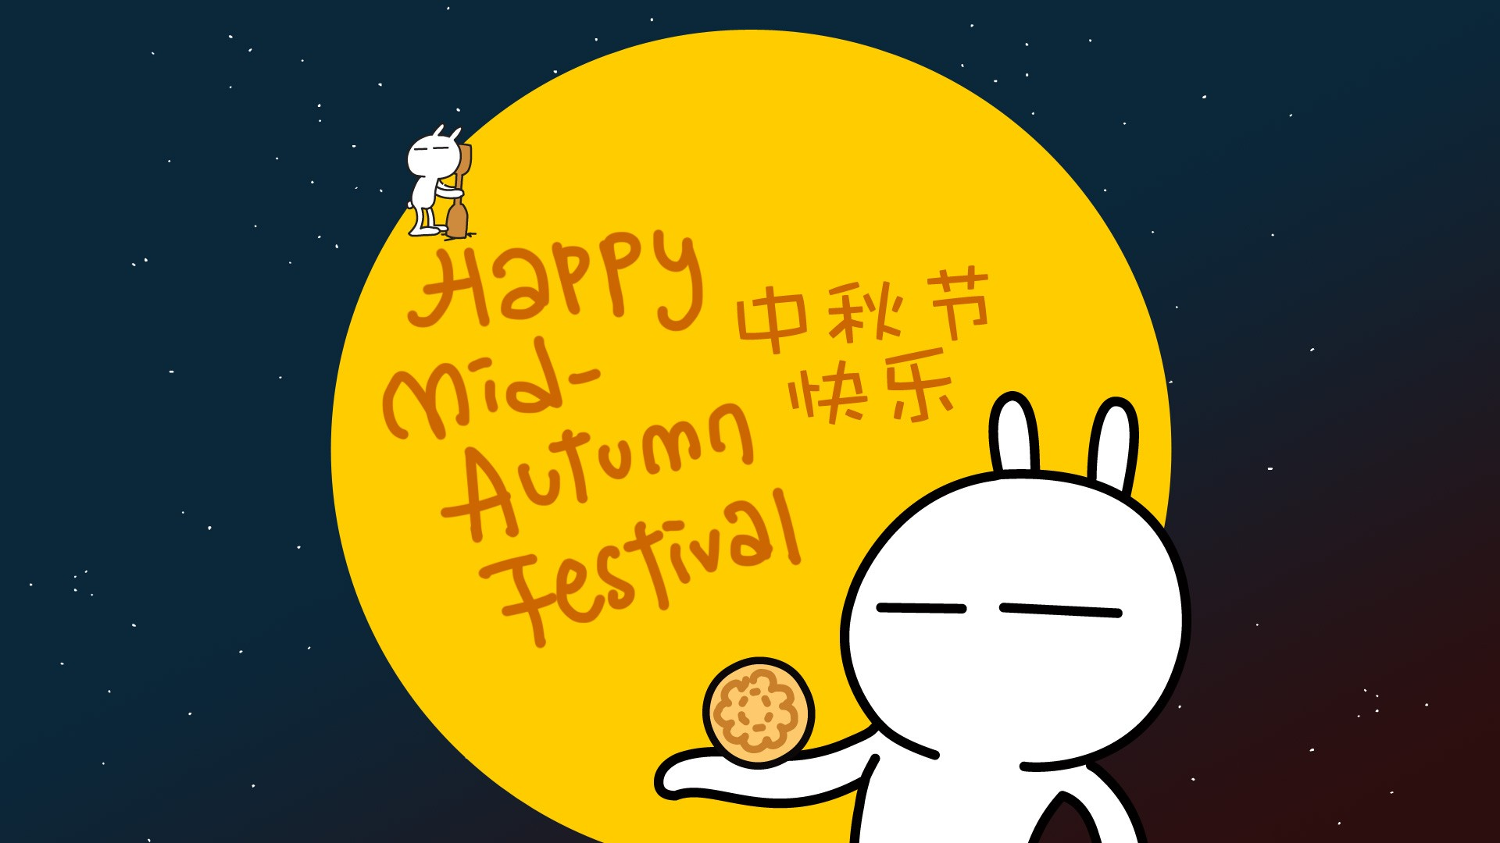
B.
Yesterday was the Moon Festival. My best friend, Amy, __26.__ to Jay’s concert at Taipei Arena(小巨蛋) with me. There were lots of people there. Everybody __27.__ and danced with Jay __28.__ the song. At the end, he __29.__ kisses and he __29.__
“I love you” to all the fans. We __30.__ last night.

26. (A) go (B) goes (C) is going (D) went
27. (A) sing (B)sings (C) is singing (D) sang
28. (A) during (B) into (C) at (D) by
29. (A) blows﹔says (B)blew﹔said
(C) is blowing﹔is saying (D)blow ﹔said
30. (A)We shook a leg.
(B) We had much fun.
(C) We showed a leg together.
(D) We gave him a hand.

C.
This summer vacation, I joined a history camp. Ms. Lin __31.__ us a story about love. She wanted us to think what true love is! Let me share the story with you.
Diana, the goddess of the moon living in Mount Olympus. On a summer night, she took a walk under the full moon. She __32.__ Endymion in the forest for the first time. She __33.__ him right away. __34.__ her kiss, he never dies, but he also never __35.__.
I think Diana is a terrible lover. What do you think?
 Mount Olympus(奧林帕思山)

31. (A) tell (B) tells (C)was telling (D) told
32. (A) see (B) sees (C)was seeing (D) saw
33. (A) threw a volleyball to
(B) sent a thank-you card to
(C) fell in love with
(D) shouted like a Tarzan for
34. (A) Thank for (B)Because of
(C)Because (D) By
35. (A) wakes up
(B) stood up
(C) stayes up
(D) got up

閱讀測驗 (每題2分，共10分)
A.
Ruby: I went to Henry’s birthday party last
Sunday. Guess what? Daniel Porter was there!
Mike: He came to Taiwan for Henry’s party?
Ruby: That’s true. He danced and sang a lot of songs at the party. And I sang the
song “What a wonderful World” with
him.
Mike: How nice!
Ruby: After the party, he walked to my home
with me.
Mike: Wow! I can’t believe it! He is a famous
singer and walked home with you? You sang and talked with my idol.
Ruby: There’s more! He kissed me goodbye at the door.
Mike: Really? Wait! Today is Monday, September 9 and Henry’s birthday is on September 15, not last Sunday! You couldn’t meet him yesterday!
believe相信 idol偶像
36. What date was last Sunday?
(A) September 1.
(B) September 8.
(C) September 9.
(D) September 15.
37. Which is true?
(A) Henry had a birthday party last night.
(B) Ruby didn’t sing with a famous singer.
(C) Ruby can’t sing Daniel’ song “What a
wonderful World.”
(D) Mike, Henry, Daniel, and Ruby had a lot
of fun at the party.

B. Emma Watson is a summer camp teacher. The children at the camp wrote her a big card to show thanks.

Dear Ms. Watson,
I didn’t like baseball or basketball before. I was poor at running. But thank you for your fun lesson, now I like to learn more about it. Hope to be like Jeremy Lin, the basketball player,someday.
Thank you,
Jessica

Dear Ms. Watson,
I enjoyed the summer camp, I met a lot of special people. We were a good team. We helped each other and got many prizes. What a wonderful experience!
Mia

Dear Ms. Watson,
Thank you for your nice gifts and all students
they made me a big cake on my special day.
With this gift, I can catch the ball and play it well.
Jeremy

Dear Ms. Watson,
Your class was so much fun. I learned many
new things and could run well there. Man thanks.
What a wonderful teacher!
NNina

38. What did Ms. Waterson teach at the camp?
(A) PE.
(B) English.
(C) Music
(D) Art.
39. What might Ms. Waterson give Jeremy for his
birthday gift?
(A) A vest.
(B) A belt.
(C) A pair of baseball gloves.
(D) A pair of new shirts.
40. According to the article, which is NOT true?
(A) Jessica likes to learn more about dinosaur.
(B)Nina learned something new through the
camp.
(C) Ms. Waterson prepared a gift for Jeremy’s
birthday.
(D) Mia’s team won many games

第三部分：手寫題 45%
一、文意字彙 (每題2分，共20分)
_____ 1. Beef and chicken are m___t.
Apples and pomelos are fruits.
_____ 2. There are many easy q___ns on this math test paper. I can answer them.
_____ 3. S___ce is a subject in high school. I can learn chemistry(化學) through it.
_____ 4. Our history teacher is i___g. We laugh a lot in her class.
_____ 5. My classroom is on the second f___r.
Class 808 is on the third.
_____ 6. With a pair of bi____ars, I can watch the drop bear in the tree from the tree house.
_____ 7. My aunt from Australia sent me two pairs of shorts for my 14-year-old birthday p___t.
_____ 8. I couldn’t find my money. Maybe I lost it s___e in my bedroom.
_____ 9. To my s____se, Henry didn’t win the singing contest because she burped many times. He is the best(最好的) singer at Liugong high School.
_____ 10. On D___n Day, Class 809 gave a lot of toys, books and clothes to poor homeless people.

二、依括號內的提示，填入正確的
所有格代名詞 (每格2分，共10分)
1. Mom, Could you buy me a purple vest?
__1.___ is too small now.
2. The skirts are __2.___ (their skirts.)
And __3.__ (our skirts) are there.
3. These are our pomelos, not ___4.___
(those girls’ pomelos).
4. A: There’s a cap on the wall. Is it ___5.___, Jennifer?
B: No. That’s Sally’s.
三、寫出下列動詞的過去式
(每題1分，共5分)
1. bet →
2. catch →
3. spot →
4. stay →
5. picnic →
四、翻譯題 (共10分)
1.因為祖母熟睡中所以我無法叫醒她。
(4分)
2. 兩天前，我親自拜訪我的數學老師。
(4分)
3.我參加了一場營火晚會(派對) 。(2分)

試題結束

