臺北市立瑠公國中 107 學年度 第 1 學期 七年級 第 3 次定期評量 英語科 試題 B卷

- 辨識句意：選出符合句子描述的圖片。5%
1.（ ）
Ａ)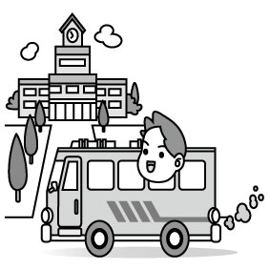Ｂ)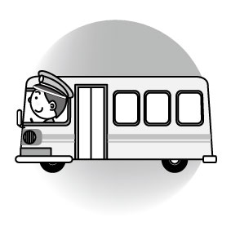Ｃ)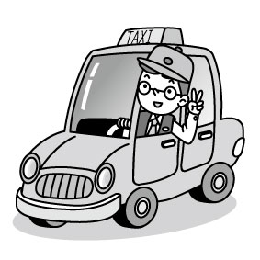
2.（ ）
Ａ)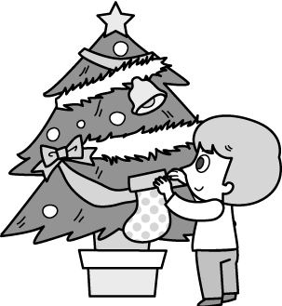Ｂ)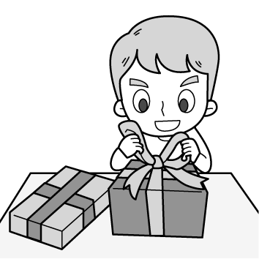Ｃ)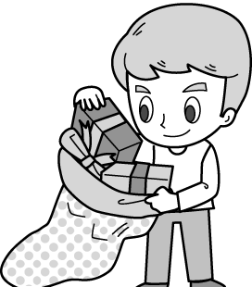
3.（ ）
Ａ) 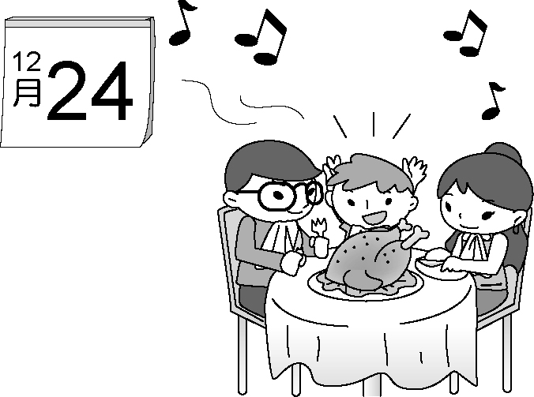
Ｂ) 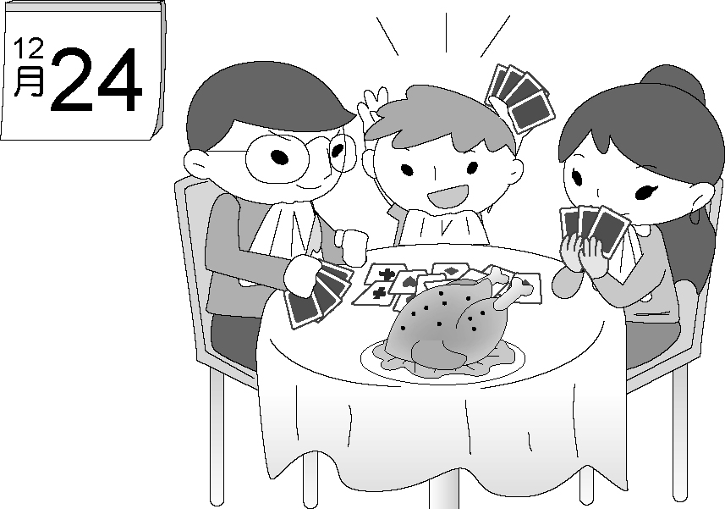
Ｃ) 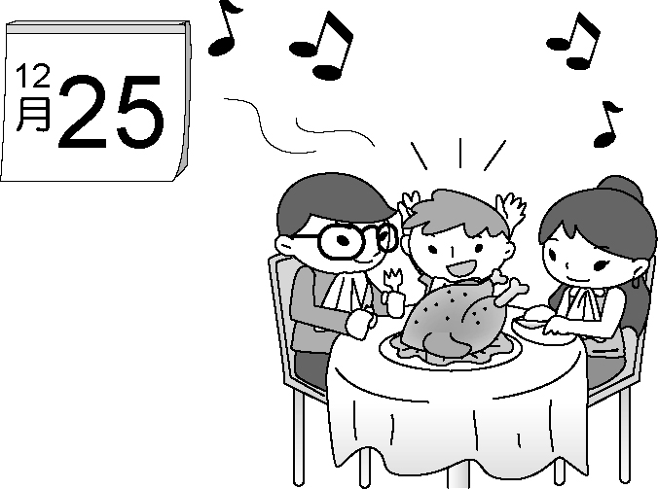
4. ( )Ａ)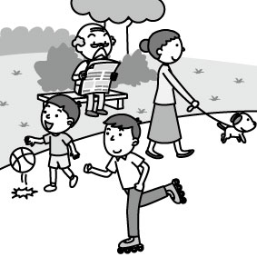
Ｂ) 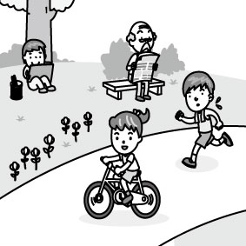
Ｃ) 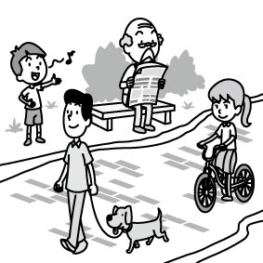
5.（ ）
Ａ) 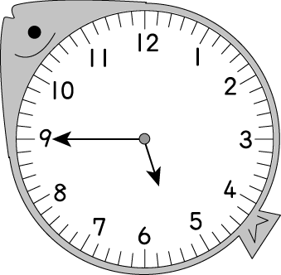Ｂ) 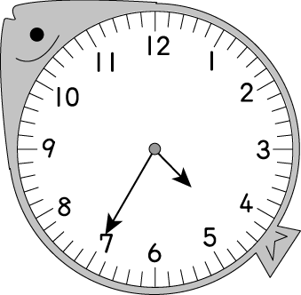Ｃ) 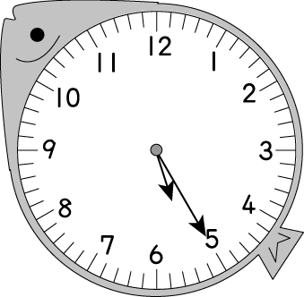

二、基本問答：根據聽到的內容，選出最適合的回應。5%
6.（ ）(Ａ) It is on Wednesday.
(Ｂ) Let’s have a Christmas party tonight.
(Ｃ) Christmas is a happy time for everyone.
7.（ ）(Ａ) Really? There are many dogs and cats at the park.
(Ｂ) They are playing basketball.
(Ｃ) Wow! The concert at the park is wonderful.
8.（ ）(Ａ) Don’t talk, and don’t eat in class.
(Ｂ) Let’s follow the classroom rules.
(Ｃ) Ms. White is our new teacher.
9.（ ）(Ａ) Let’s sing.
(Ｂ) Be nice.
(Ｃ) Oop. I’m very sorry.
10.（ ）(Ａ) Aren’t they your students?
(Ｂ) No, they are playing at the park.
(Ｃ) Guess! They are happy.

三、言談理解：根據聽到的內容，選出最適合的答案。10%
11.（ ）(Ａ) White Christmas
(Ｂ) Santa Claus Is Coming to Town
(Ｃ) Merry Christmas, Everyone
12.（ ）(Ａ) It’s at 8:00 a.m.
(Ｂ) It’s at 7:00 p.m.
(Ｃ) It’s at 9:00 p.m.
13.（ ）(Ａ) Today is Sunday.
(Ｂ) Today is Monday.
(Ｃ) Today is Friday.
14.（ ）(Ａ) In the museum.
(Ｂ) At the zoo.
(Ｃ) In the classroom.
15.（ ）(Ａ) William.
(Ｂ) The girl’s grandmother.
(Ｃ) Peter and Jane.

四、綜合選擇。80% (16-25，每題1分；26-60；每題2分)
16.( )We have a big meal ___ Christmas Eve. Come and join us.
A)in B)on C)at D)X(不用填字)
17.( )On weekdays, we stay at school __ 7:30 a.m. to 5:00 p.m.
A)at B)on C)in D)from
18.( )I’m free ____ tonight. How about going to the movies?
A)X(不用填字) B)in C)at D)on
19.( )It’s six ____ the morning. Time to wake up.
A)X(不用填字) B)at C)in D)on
20.( )Kevin’s birthday is coming. Let’s make a birthday card for him ____ this weekend.
A)on B)in C)X(不用填字) D)at
21.( )It’s raining outside. I need a/an ____.
A)festival B)trip C)umbrella D)flashlight
22.( )When you go camping, you can set up the ____ next to
the tree. It is safe.
A)tent B)hospital C)mouse D)cab
23.( )My ____ lives next door.
A)fare B)cockroach
C)downtown D)neighbor
24.( )Leo: It’s cold today. What’s the ____ outside?
Melody: About 10°C.
A)neighborhood B)apartment
C)temperature D)parking

※ 背面有題，請繼續作答 ※

25.( )Maggie is not my only sister. I have ____ sister at home.
A)another B)rainy C)terrible D)cloudy
26.( )Mother’s Day in Taiwan is on the second ____ of May. In South Korea celebrates(慶祝) Parents’ Day on May 8th.
A)Sunday B)Friday C)Wednesday D)Saturday
27.( )Keep ____ in the museum.
A)funny B)ready C)quiet D)lucky
28.( )The final exam is coming. We are busy ____ for the tests.
A)following B)waiting C)touching D)studying
29.( )Emily: What are you doing, baby?
Owen: I’m ____ a gift and ___it in the Christmas
stocking for our boy.
A)wrapping; putting B)wraping; puting
C)putting; wrapping D)put; wrap
30.( )Allen: Wow, a Christmas tree! You are ____ for
Christmas Day, right?
Star: Yes. It looks so great here.
A)having a good time
B)hanging the bells on the Christmas tree
C)roasting a turkey
D)making a Christmas card
31.( )Dad: What is your sister doing in her room, Kevin?
Kevin: She’s writing a ____ to her friend, Billy, in Japan.
A)mummy B)litter C)dinosaur D)letter
32.( )Mr. Lee: Boys and girls, don’t____ the cellphone in class.
Students: Yes, sir.
A)use B)talk to C)fight with D)listen to
33.( )Mom: Ben, your room is too ____. Clean it up now.
Ben: Oop. Sorry, Mom. I’m watching TV, but I will
make it clean later.
A)dirty B)great C)together D)nervous
34.( )Jack: ____
Ziv: Thanks goodness.
A)We are finally(終於) here.
B)Help me with the heavy box.
C)Eat some cookies.
D)This toy car is for you.
35.( )Rex: What day is Billy Fujuki’s concert?
Thomas: It’s ____.
A)seven o’clock B)at six o’clock
C)Tuesday D)on Monday
36.( )Pam: Where is Justin Bieber from? Is he from Japan?
John: No.
Pam: Is he from the USA?
John: ____ He is a Canadian. He comes from Canada.
A)It’s great. B)Wrong again.
C)I see. D)That’s right.
37.( )Everyone in the Brown family ____ busy, so they leave notes on their refrigerator when they aren’t at home.
A)X(不用填字) B)be C)is D)are
38.( )Joe isn’t a teacher ____ a bus driver. He is a farmer.
A)and B)but C)or D)too
39.( )Let’s ____ here on the bus and be good students.
A)don’t run B)not run C)running D)not running
40.( )Choose a RIGHT one.
A)Read the book aloud, Michael, please.
B)Please, don’t eat here, Karen.
C)Leo, do your homework now please.
D)Vivian, help me make the toys, please.

(41-44)
These are the messages to Helen. Read them carefully and find the best answers to the questions.
※find找；answer答案；question問題
Helen,
I am going to the bookstore tomorrow. How about coming with me? Call me at 0912-123-456.
Kelly
Helen,
Aquaman is on now at the Showtime Theater. Let’s see it together.
Amanda
Helen,
Come home early at night. We’re going to celebrate your grandpa’s eightieth birthday.
Dad
Helen,
Your watch is ready. You can call 0939-456-789 first and come to get it on your way home.
Sam from Joy’s
41.( )What is Aquaman?
A)A book. B)A song. C)A movie. D)A singer.
42.( )Whose(誰的) cellphone number is 0912-123-456?
A)Kelly. B)Amanda. C)Sam. D)Helen’s dad.
43.( )Who asks(要求) Helen to go home early?
A)Amanda. B)Kelly. C)Sam. D)Helen’s dad.
44.( )Which is TRUE?
A)Helen’s dad is eighty years old.
B)Joy’s is a watch shop.
C)Amanda is going to the bookstore.
D)Sam works at a movie theater.

(45-47)
The Lin family like watching TV after dinner. Mr. Lin really likes watching sports programs, and Mrs. Lin likes movies. Their daughter, Emily is a big fan of shows about animals. Her little brother’s favorite is the Children’s Channel.
※channel頻道；World Cup世界盃；legend傳奇
Time  Channel | 18:00  ~19:00 | 19:00  ~20:00 | 20:00  ~21:00 | 21:00  ~22:00
Movie World | 007 | Cat’s Eye | Life and Death | I Love Linda
Sports Stars | World Cup Soccer | The Bird Man-Quincy | How to Play Basketball Well | Baseball in the USA
Big Animals | A Mouse’s Life | The Stories of Lin-Wang | Dog’s Funny Stories | Dogs in Our Life
Children’s Channel | Channel S | Tom & Jerry | Christmas Legends | Let’s Sing and Dance
- 尚有試題，請繼續作答 ※
45.( )What channel may be Mr. and Mrs. Lin’s daughter’s
favorite?
A)Children’s Channel B)Movie World
C)Sports Stars D)Big Animals
46.( )Mrs. Lin is watching Life and Death now. What time
is it?
A)19:30 B)20:15 C)21:45 D)18:59
47. ( )Which is NOT true?
A)Mr. and Mrs. Lin have two children.
B)When Emily is watching The Stories of Lin-Wang,
Tom and Jerry is playing.
C) It’s 8:40 p.m. The Lin family are having dinner
and watching Dog’s Funny Stories.
D)The Lin family have dinner before 6:00 p.m.

(48-50)
Cindy: Dad, look over there! What are those playing on the
slide?
Dad: They are Formosan Black Bears.
Cindy: They look like koalas! Are they the same?
Dad: No, they look similar, but they are different.
Cindy: I don’t know how many bears there are in the zoo.
Dad: I don’t know, either. Let’s count together!
Cindy: One, two, three, four…six. There are six bears here!
Dad: No, you missed one.
Cindy: Where?
Dad: See? There’s one more on the mother bear’s back!
Cindy: Wow! It’s so small. And so cute.
Dad: Yes, it is. What does your watch say, Cindy?
Cindy: It’s five to twelve. Why?
Dad: Let’s go to get something to eat now.
Cindy: But I want to visit more animals.
Dad: Why don’t we take a break at the snack bar and come back
later?
Cindy: All right.
※similar相似的; different 不同的

48.( )What may missed mean(意指) here?
A)Not count B)A woman C)Not like D)Not put
49.( )Why may “What does your watch say” mean?
A)How much is your watch?
B)Where is your watch?
C)What day is it today?
D)Do you have the time?
50.( )Which may be TRUE?
A)Cindy thinks koalas and bears look different.
B)It is about noon and time for lunch.
C)There are six bears in the zoo.
D)They are going home now.

(51-55)
(at the school fun fair)
Hebe: There’s a handsome man _51_ on the stage? Who’s he?
Ella: He is my cousin. His name is Tom. Look! He _52_ and _52_ at the same time now.
Hebe: Wow! Some girls are _53_ him. They are so excited.
Ella: Yeah! They’re _54_, too. He’s so popular with girls.
Hebe: Look! Tom is _55_ me. I feel surprised.
Ella: He’s waving to everybody, not only you.
Hebe: I know. Why are you telling me the truth?
※school fun fair學校園遊會；popular受歡迎的；truth事實
51.( )A)dance B)danceing C)is dancing D)dancing
52.( )A)is playing the guitar; singing
B)is singing; playing guitar
C)play the guitar; sing
D)singing; playing the guitar
53.( )A)shouting at B)having a great time
C)having a fight with D)blowing kisses to
54.( )A)shouting his name B)running around
C)crying for help D)cleaning the house
55.( )A)playing the music for B)singing a song to
C)waving hands to D)reading a card from

(56-60)
Today is Chinese New Year’s Eve. It is raining outside now, but it’s very warm in our house. It’s five thirty. Mom_56_ all the dishes for the dinner party. She is always the busiest one in the family every year at times like this. Look! _57_ already many dishes on the dining table. Wow! The roast turkey is really big, and it smells good. Grandpa and Grandma are not with us this year. They are on their trip to Japan. So, Dad will cut the turkey for us. Little Joyce is _58_ up and down because he can’t wait to eat the roast turkey. The dinner is finally ready. “Everybody, _59_ down at the table and let’s _60_ thanks to Mom for the yummy dinner,” Dad says.
※dishes菜餚；the busiest one最忙的人；smell聞起來；cut切

56.( )A)make B)making C)is makeing D)is making
57.( )A)There is B)It is C)There are D)They are
58.( )A)jump B)jumpping C)to jump D)jumping
59.( )A)not sit B)siting C)sitting D)sit
60.( )A)don’t say B)saying C)not say D)say

※試題結束※

第

