臺北市立瑠公國民中學107學年度第一學期第三次段考八年級英語科試卷
範圍：翰林版第三冊Unit 7~ Review III 八年 ___班 座號：___ 姓名：__________

第一部分:聽力測驗 (第01-15題，共15題，25%)
- 辨識句意：選出符合句子描述的圖片。(每題1分, 5%)
( )01.
(A)  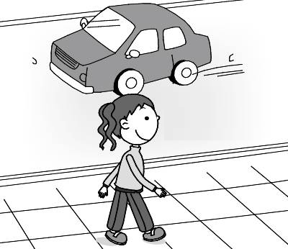 | (B)  INCLUDEPICTURE "http://hlart.hanlin.com.tw/artscript/art/artpreview.ashx?mode=show&fileID=752311&typeNo=false" \* MERGEFORMATINET 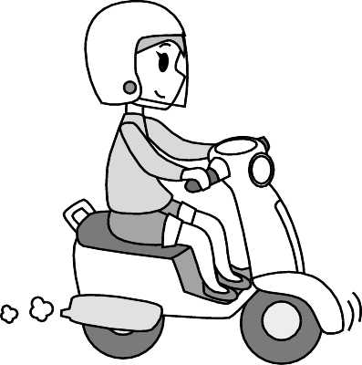 | (C)  INCLUDEPICTURE "http://hlart.hanlin.com.tw/artscript/art/artpreview.ashx?mode=show&fileID=778643&typeNo=false" \* MERGEFORMATINET 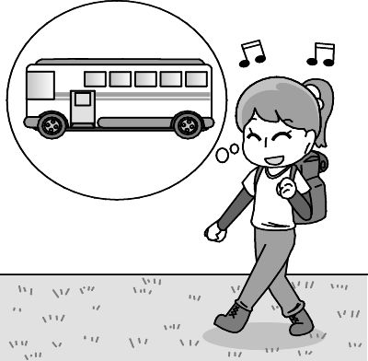
( )02.
(A)   | (B)   | (C)  
( )03.
(A)  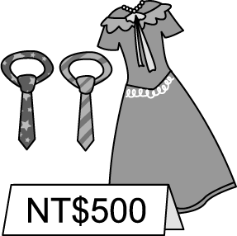 | (B)  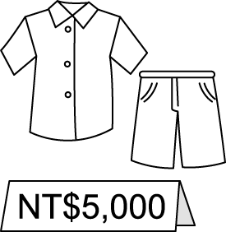 | (C)  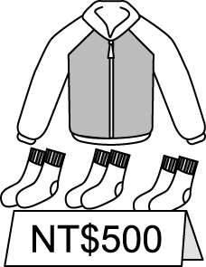
( )04.
(A) 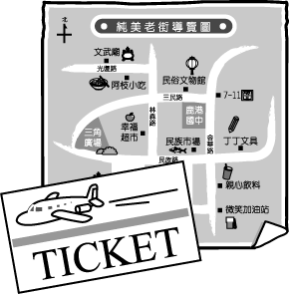 | (B) 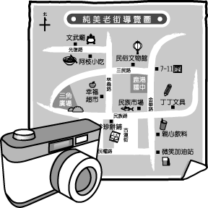 | (C) 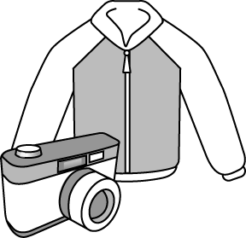
( )05.
(A)  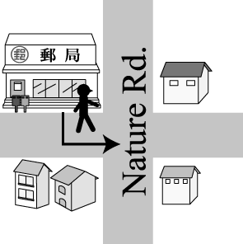 | (B)  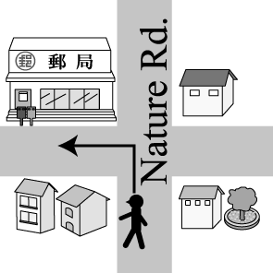 | (C)  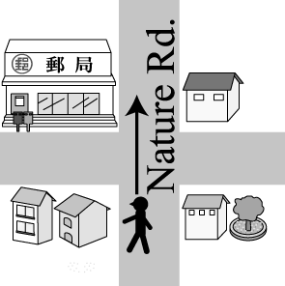
- 基本問答：選出最適合的回答，完成對話。(每題2分, 10%)
( )06. (A) It’s near the bus station.
(B) Go along the road and turn left.
(C) How about riding my new motorcycle?
( )07. (A) I’ll get it for you.
(B) Its color is warm.
(C) I want to sell it.
( )08. (A) Oh, no. We lost the map!
(B) There are many stores on these two roads.
(C) We need to walk for two more blocks.
09.（ ）(A) I seldom listen to music.
(B) Go straight along the road for five blocks
and turn left. .
(C) You can have free classes there
10.（ ）(A) I can’t wait to watch the plants there.
(B) Let’s drive our jeep to watch the seabirds.
(C) It will take us years to learn about the
weather.
C. 言談理解： 請聽對話或短文，選出問題最適合的答案。
(每題2分, 10%)
（ ）11. (A) By bus.
(B) By MRT.
(C) By bicycle.
（ ）12. (A) It’s next to the shoe store.
(B) It’s next to the library.
(C) It’s across from a shoe store.
（ ）13. (A) Go to Lula Library to meet Nita.
(B) Give the money to the man.
(C) Study science with Nita in the library.
（ ）14. (A) A policeman stopped the man from parking his car in the parking lot.
(B) The man and woman are going to buy flowers and a hat for Tina.
(C) The flower shop and the hat store are both on Banana Road.
（ ）15. (A) The woman is old, but she has a young heart.
(B) All four people in the talk are eighty years
old.
(C) Piñatas with a lot of snacks are the man’s favorite.
第二部分：綜合選擇題 75%
16-20每題1分﹔5%﹔21-55每題2分﹔70%

16.( )    (A) train (B) ship  (C) scooter (D) jeep | 17. （ ）  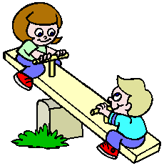  (A) swing (B) seesaw  (C) bus stop (D) desert

18.( )    (A) go surfing  (B) go fishing  (C) go sailing  (D) go biking | 19. （ ）  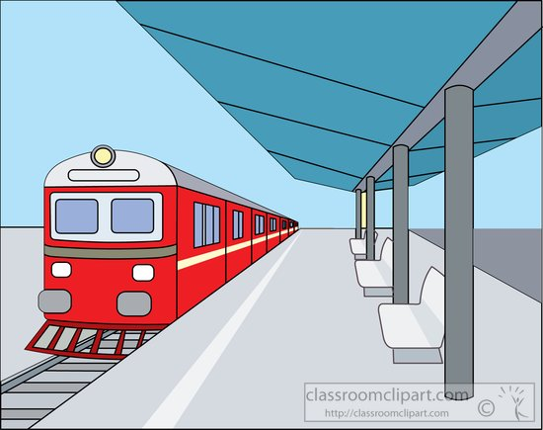  (A) railway station  (B) post office  (C) fire station  (D) police staion

20. （ ）   | (A) duck  (B) goat  (C) chicken  (D) sheep

21.( ) Neil has green fingers. He takes good care of these ________ well. Our garden is so beautiful
(A) pants (B) plants (C) purple (D) insects
22.( ) Look! There’s a UFO flying high in the sky. Maybe there are some ______ in it. They don’t live on Earth.
(A) counries (B) rings (C) aliens (D) sweaters
23.( ) My car ______ this morning, so I decided to ride
a U-bike near my house to work.
(A) started off (B) got ready
(C) dressed up (D) broke down
24.( ) My granddaughter is going to be seven years old this August. She will study at FuDe ________ School.
(A) Junior High (B) Elementary
(C) Department (D) Train
25.( ) Going surfing is too _______ for you,Grandma.
You are 85 years already. How about going
jogging with me after work tonight?
(A) sweet (B) thirsty
(C) delicious (D) exciting
26. ( ) My grandmother knows a lot about insects and plants in the desert. She’s really ______.
(A) on the corner. (B) around the world
(C) all over the world (D) out of this world
27.( ) Sending an e-amil to your friends in Los Angels
at Christmas won’t ______ you any money and it
only ______you a few seconds.
(A) cost﹔takes (B) cost﹔spend
(C) spend﹔spends (D) spend﹔takes
28.( ) On New Year’s Eve, ______ people go to Taipei 101 to watch the fireworks show.
(A) thousands of (B) over ten thousands
(C) many thousands (D) fifty thousands of
fireworks煙火
29.( ) There a fun movie on TV tonight.
We fun watching it. Let’s watch it
together tonight.
(A) is going to have；will be
(B) is going to be；will have
(C) will be；are going to be
(D) will have；are going to have

30.( ) Mr. Wu：Will we arrive at the airport soon?
Jason:Yes. Grandma is going to pick us up
there ________.
(A) ten minutes ago (B) the next ten minutes
(C) in ten minutes (D) the day after tomorrow.
31.( ) Amy shared her trip to New York with her friend,
Kevin, by sending him a postcard. Can you help
her to write the address in a right way?
(A) Kevin Hu  Fude St., Lane 221,No.15,  Taipei City 110,  Taiwan (U.S.A.) | 
(B) Kevin Hu
Taipei City 110,
No.15, Lane 221,Fude St.,
Taiwan (U.S.A.)
(C) Kevin Hu
No.15, Lane 221,Fude St.,
Taipei City 110,
Taiwan (R.O.C)
(D) Taiwan (R.O.C)
Taipei City 110,
No.15, Lane 221,Fude St.,
Kevin Hu

32.( ) David：______ did it take you ______to Kaohsiung by plane last night?
Jenny：About half an hour.
(A) How long﹔getting (B) How long﹔to get
(C) How far ﹔got (D) How much﹔to get
33. ( ) Angel：What’s taking you so long? The movie is on already.
Bill：Sorry! _______________.
(A) I won’t be late for school again.
(B) Finding a parking lot cost me lots of money.
(C) It takes me lots of time to find a parking lot.
(D) I will go running to find the place.
34.( ) Megan：It’s so hot today. __________ Harry：Good idea! I like water activities.
(A) Let’s go bird watching in the mountains
(B) Do you want to go surfing with me?
(C)What about going jogging at the beach?
(D)Let’s go horseback riding on the country roads.
activity活動
35.( ) Jill：What a cool cellphone! _________________
Leo：Well,…you guess. The price is not too bad.
(選錯的)
(A) Did it cost you an arm and a leg?
(B) How much did it cost you?
(C) How much did you spend on it?
(D) How much did you pay it?

克漏字：每題2分，20%
36-40
There are many different ways to go to work. Some people go to work 36. foot. Some people ride a scooter to work . Some people 37. taxi or bus to work. As for Mark, he goes to work 38. . He lives on a small island in Penghu. He gets up at five and goes to his office in Magong(馬公)
39. . It usually takes Mark a lot of time to get to his office. Especially, it’s tiring and dangerous on windy and rainy days. He is tired but happy. 40.
 island 島; especially特別的是
( )36. (A) with (B) on (C) at (D) in
( )37. (A) ride a (B) fly a
(C) take the (D) take a
( )38. (A) on his way (B) all together
(C) in a special way (D) out of the world
( )39. (A) by boat (B) by bike
(C) by MRT (D) by taxi
( )40. (A) He hates taking a boat to work there.
(B) He hates to live a farm life on the island.
(C) He enjoys making friends and living the
life there.
(D) He enjoys working as a fisherman.
41-45
Ben： 41. I want to go to the National Palace
Museum. Could you show me the way ?
Alice： 42. First, you should take the MRT and get off at Shi-Lin Station.
Ben：And Then?
Alice：You have to go there by bus.
Ben： 43.
Alice：Take Bus 255,304, or Red 30 and get off at
the National Palace Museum stop.
Ben：By the way, 44.
Alice：About half an hour.
Ben：OK, I think I can meet my friends there on
time. Thanks a lot. It’s very kind of you to
help me.
Alice： 45.
( )41. (A) Sorry. (B) Excuse me.
(C) How are you? (D) Where are you?
( )42. (A) Of course. (B) That’s too bad.
(C) You made my day. (D) Sounds great.
( )43. (A) What is the price? (B) Which one?
(C) How come? (D) How far?
( )44. (A) what time is it there?
(B) how many times will you go there?
(C) how much will it cost to get there?
(D) how long will it take to get there?
( )45. (A) Here comes the MRT. Have a nice trip.
(B) Does taking the MRT take lots of time?
(C) Thanks for taking me me to the MRT station.
(D) Would you like to go there by bicycle with
me?

閱讀測驗：每題2分，20%
46-49
Nemo is Marlin’s son. He went out with classmates this morning. He didn’t get home before dinner. Marlin tried to call Nemo on the cellphone but Nemo didn’t answered it. Marlin is really worried now. Can you help them?
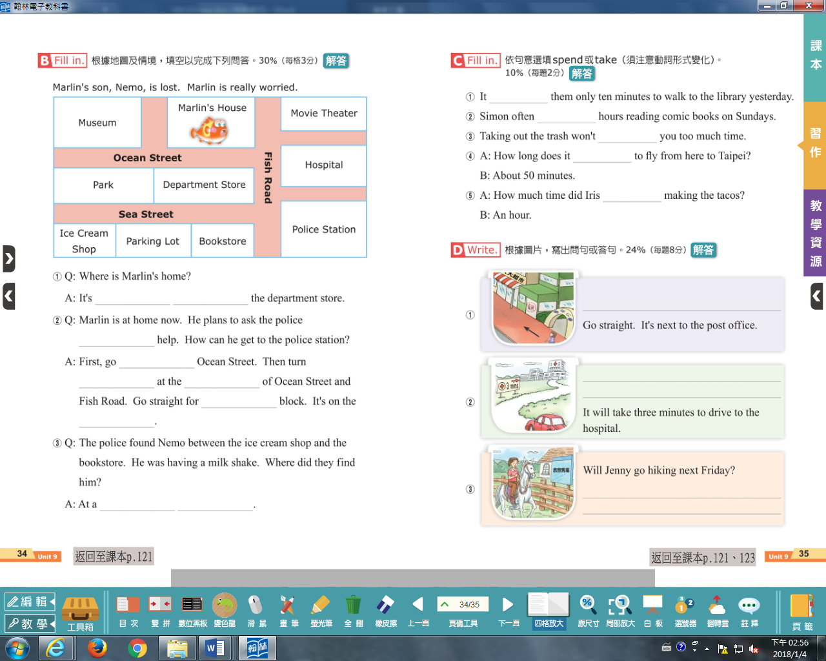
( )
46. Where is Marlin’s home?
(A) It’s between the museum and the movie theater.
(B) It’s on the Sea Street and Fish Road.
(C) It’s next to the movie theater.
(D) It’s across from the department store.
( ) 47. Marlin is home now. He plans to ask the police
for help. How can he get to the police staion?
(A) First, go along Ocean St. Then turn right on
Fish Rd. Then go straight for two blocks. It’s on
the right.
(B) First, go along Ocean St. Then turn left on
Ocean St. Go straight for one block. It’s on the
left.
(C) First, go along Ocean St. Then turn right at
thecorner of Ocean St. and Fish Rd. Go straight
for one block. It’s on the left.
(D) First, go along Ocean St. Then turn left at the
corner of Ocean St. and Fish Rd. Go straight for
one block. It’s on the right.
( )48. The police found Nemo between the ice cream
shop and the bookstore. He was having a pearl
milk tea. Where did they find him?
(A) In a museum. (B) At a parking lot.
(C) At a park. (D) In a department store.

( )49. Marlin was happy to find Nemo and then took
Nemo to see the movie “Finding Nemo.” After they watched the movie, Marlin and Nemo
walked along Fish Road and turn right on Ocean
Street.It’s on their left. Where are they?
(A) Department Store.
(B) Bookstore.
(C) Police Station.
(D) Ice Cream Shop.
50-52
Today is Ron’s first day at work. Because he’s still on trial, he needs to be careful enough not to make any mistakes, or he may not be able to get the job.
Ron：Good morning, ma’am. How I may
help you?
Ms.Peterson：May I try these on?
Ron：No problem, ma’am. You wear size six
and a half, right.
Ms.Peterson：Wow, how do you know?
Ron：It’s my job. Please take a seat first,
and I ‘ll bring your size for you.
Ms.Peterson：Thanks.
Ron：Here, ma’am. Let me put them on for
you.Now, you may stand up and walk
around to see if you feel comfortable
in them.
Ms.Peterson：Yes, I feel comfortable in them. They’re right for me. I need to stand and walk all the time.
Ron： May I ask what you do, ma’am?
Ms.Peterson：Oh, I’m a school teacher at a junior high
school. OK, I’ll take them.
Ron：Thank you, ma’am. Have a nice day,
and come back again.
Ms.Peterson：I will.
 ma’am 女士﹔or 否則
( )50. What does Ron do?
(A) A farmer at a farm.
(B) A waiter at a restaurant.
(C) A taxi driver.
(D) A clerk at a shop.
( )51. What does on trial mean in the reading?
(A) To try a little food to see if it is yummy.
(B) To try on clothes to see if they look great on
you.
(C) To put something on your head to see if it is beautiful.
(D) To let someone do the work for a short time to see if he/she is a right person for the job.
( )52. What did Ms.Peterson buy?
(A) 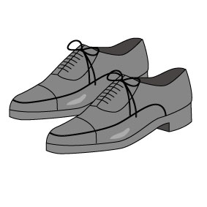 | (B)  | (C) 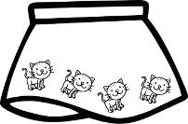 | (D)  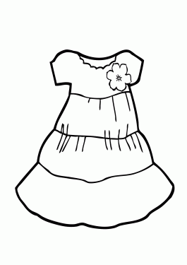

53-55
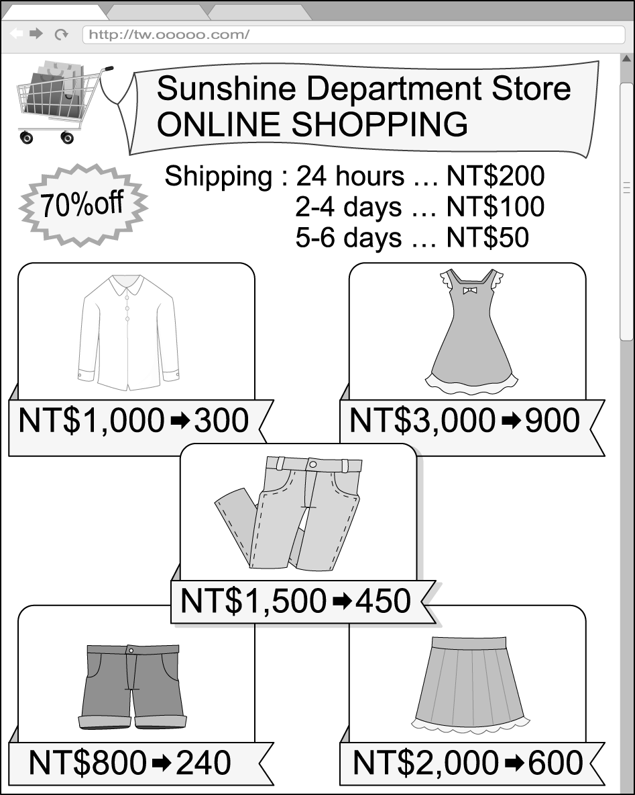
( )53. If you buy a pair of pants and shorts, how much
will they cost you after discount (折價)?
(A) NT$240. (B) NT$2,300.
(C) NT$690. (D) NT$1050.
( )54. Mary bought a dress for her birthday party. She
paid 50 dollars for the shipping. How long will it
take her to get the dress?
(A) In 24 hours. (B) In 2-4 days.
(C) At least 5 days. (D) Over 7days.
( )55. Tina paid NT$650 for a skirt, and she will get it
on April 15. When did she most likely
（最可能）buy it?
(A) April 14. (B) April 12.
( C )April 13. (D) April 10.

~The End~

Winter Vacation Is Around the Corner!!

Have a Nice Vacation!

