台北市立瑠公國民中學107學年度第一學期九年級第二次段考 英語科 考試卷
年 班 座號： 姓名：

第一部分：聽力測驗 25 %
一、辨識句意：根據聽到的內容，選出符合描述的圖片或符合圖片的描述。(每題1分，共5分)
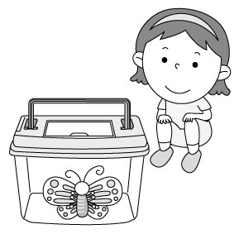
1.(Ａ) (Ｂ) 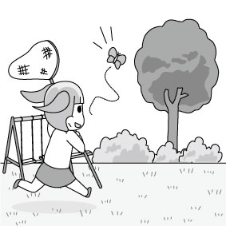(Ｃ)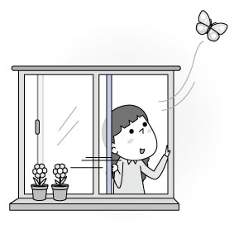
2. 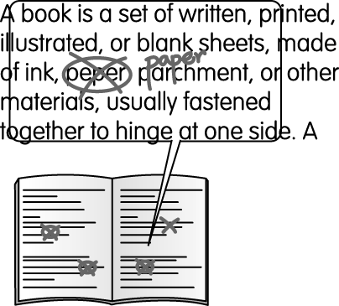[選項在聽力中]

3. (Ａ) 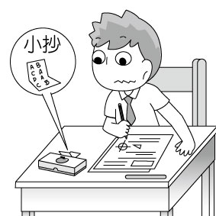(Ｂ) 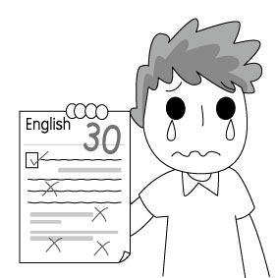(Ｃ) 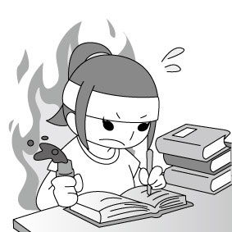

4.(Ａ) 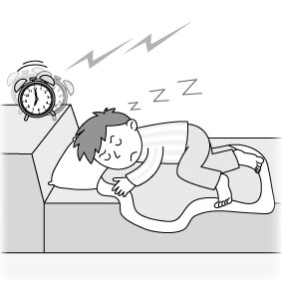(Ｂ) 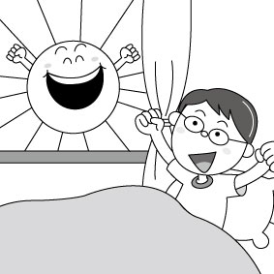 (Ｃ) 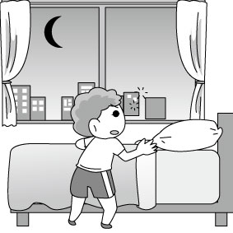
5.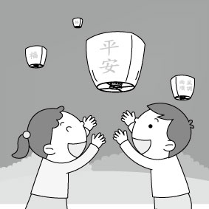 [選項在聽力中]
二、基本問答：根據聽到的內容，選出一個最適合的回應或最適合的問句。(每題2分，共10分)
6. (Ａ) Because I cry very often, I always feel sad.
(Ｂ) The old dog I have kept for 10 years was hit by a taxi and died.
(Ｃ) Today I learned for the first time that butterflies could live through winter.
7. (Ａ) Cooking isn’t difficult, but cooking well is another story.
(Ｂ) Of course. I’ve been a cook for fifteen years.
(Ｃ) Yes, it was cooked by my parents.

8. (Ａ) Sorry. We don’t have a restroom here.
(Ｂ) Go straight for two blocks. It’s on the left.
(Ｃ) This restaurant has a long interesting history.
9. (Ａ) I’m not sure.
(Ｂ) I got a day off last week.
(Ｃ) Yes, Christmas day is on December 25th.
10. (Ａ) You’re welcome.
(Ｂ) Yes, it costs you only NT$ 5,000.
(Ｃ) The bikes in this row are very expensive.

三、言談理解：根據聽到的內容，選出一個最適合的答案。(每題2分，共10分)
11. (Ａ) The woman went to Cambodia with the man.
(Ｂ) The man didn’t like the food in Cambodia.
(Ｃ) The man didn’t like anything in Cambodia.
12. (Ａ) To the south.
(Ｂ) Across the highway.
(Ｃ) To the north.
13. (Ａ) An ant always works by itself.
(Ｂ)Both ants and bees are hard-working.
(Ｃ)Bees don’t live in groups.
14. (Ａ) He wants to talk with his parents about his future plan.
(Ｂ) He hopes his parents can tell him how to study
well.
(Ｃ) He wants to talk to his parents about
how to become a good cook.
15. (Ａ) He was too full to eat anything.
(Ｂ) He is staying in hospital because of the
stomachache.
(Ｃ) He sent the woman to the hospital right
after he got home.

第二部分：選擇題 44 % (每題2分)
16. The walls of our school ____ Macron colors.
(A) are painting (B) have painted
(C) are painted (D) has been painted
17. If we want to enjoy studying in a clean place, our classroom needs ____.
(A) to be cleaned (B) being cleaned
(C) be cleaned (D) to clean

18. The game will ____ tomorrow whether the weather ____ fine or not.
(A) hold; is (B) hold; will be
(C) be held; is (D) be held; will be
19. Our school concert band practiced ____ hard that they finally won the first prize in Taipei.
(A) so (B) very (C) enough (D) such
20. Tell me if your children, Tina and Joe, ____ to our Christmas party. I have to prepare dessert for the kids.
(A) will come (B) comes
(C) to come (D) has come
21. All the ninth graders, ____ 5 people, will go to the trip to Taichung next week. They were asked not to go because of smoking.
(A) besides (B) except
(C) with (D) as for
22. Please tell me how long ____ to climb to the top of Mountain Tiger.
(A) it cost (B) I will spend
(C) will it take (D) it takes
23. Do you know who ___ when you are in need?
(A) you talk (B) should you talk to
(C) to talk to (D) talking to
24. I don’t remember _____.
(A) how much is it
(B) what does she talk about
(C) when did they leave
(D) how often they come here
25. This desk was made ____ John.
(A) by (B) on (C) with (D) in

克漏字
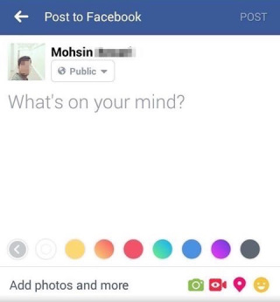

In today’s math class, Mr. Lin was angry with Teresa while she was using her mirror. I just couldn’t understand __26.__ some girls at my school always spent so much time looking into the mirror or kept combing their hair in class. It was so __27.__ to our teachers. Besides, in the restroom, they chatted aloud about the color of their hair without even __28.__ others waiting in line. I really don’t like what they did. __29.__ isn’t everything, is it?

Tintin

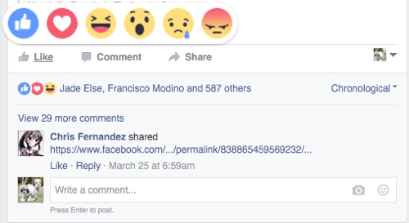

Come on! Those girls are very hot! I __30.__ that you just don’t like their beautiful face.


Teresa? The girl with a lot of acne on her face? >///<

26. (A) when (B) what
(C) why (D) how
27. (A) glad (B) rude
(C) serious (D) lost
28. (A) wondering (B) choosing
(C) serving (D) noticing
29. (A) Grade (B) Appearance
(C) Friendship (D) Study
30. (A) supposed (B) appeared
(C) knew (D) raised

閱讀測驗 (每題2分，共14分)
A. Reading 31-33

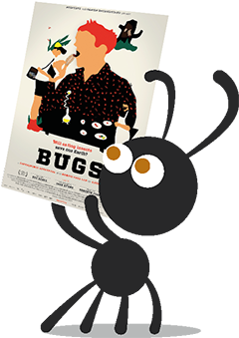
Each year, around 70 million people are born. By 2050, there will be 9 billion people in the world. In order to feed all those hungry mouths, we will need almost twice as much food as we do now. But we won’t have enough land or ocean to raise animals or fish at that time.
Do we have any possible way to solve the problem? Yes. Insects!
You might not know how important the idea is, but around 20 million people have eaten insects as food. They eat spiders, bees and ants. So what’s so good about insects?

Insects Are Healthy
Insects have high protein. They’re almost the same as fish and meat.
Bugs Are Green
Insects are cold-blooded and don’t need much energy to grow up. People can use less food to raise insects so there will be enough land and ocean in the future.
*protein 蛋白質*billion十億 *cold-blooded冷血
*energy精力能量

31. According to the reading, which is TRUE?
(A) Insects are healthier than fish and meat.
(B) The number of insects has reached 900,000.
(C) There’re not any people eating insects now.
(D) Insects might be people’s main(主要的)food in the
future.
32. According to the reading, which chart (圖表) most likely shows the number of people eating insects from 2018 to 2050?
(A) (B)
(C) (D)

33. The reading is from a report. What kind of report might this reading belong to?
(A) Work.
(B) Science.
(C) Festival.
(D) Beauty.

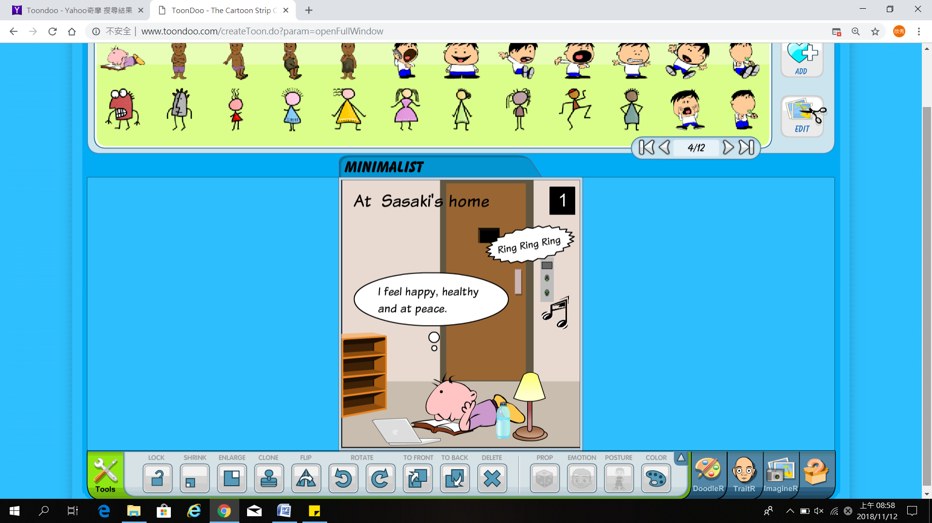
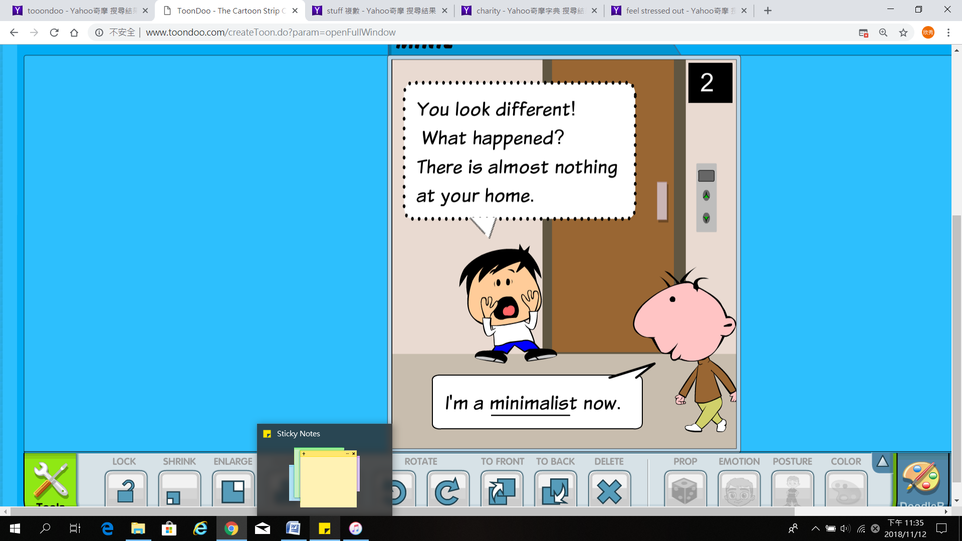

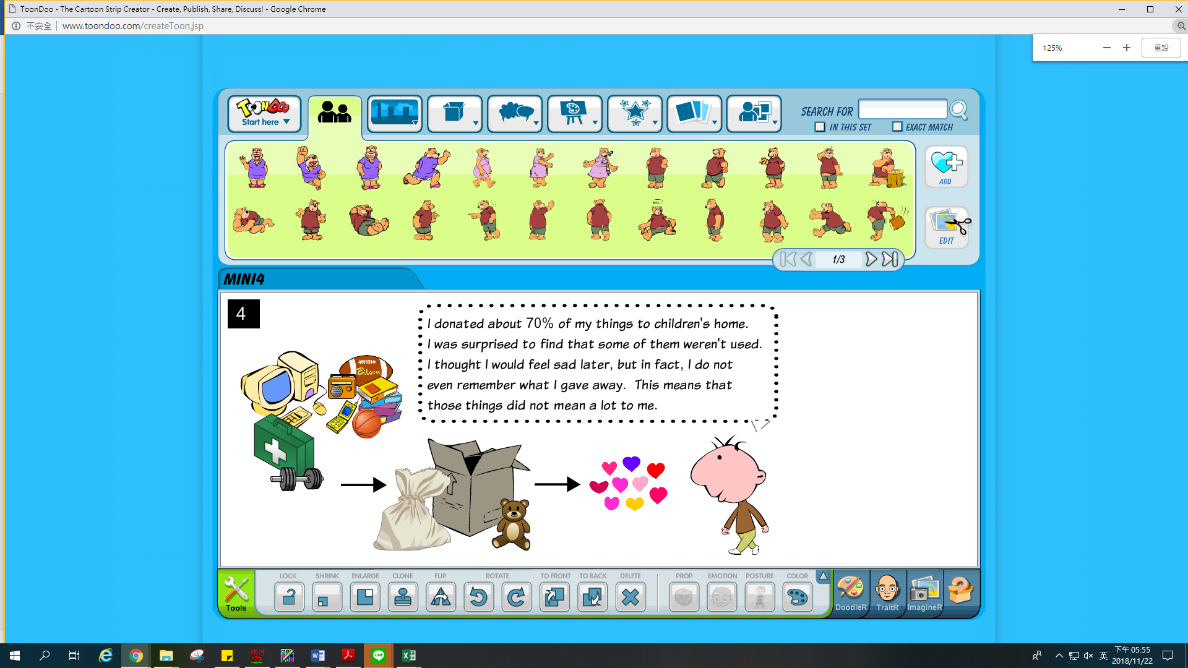
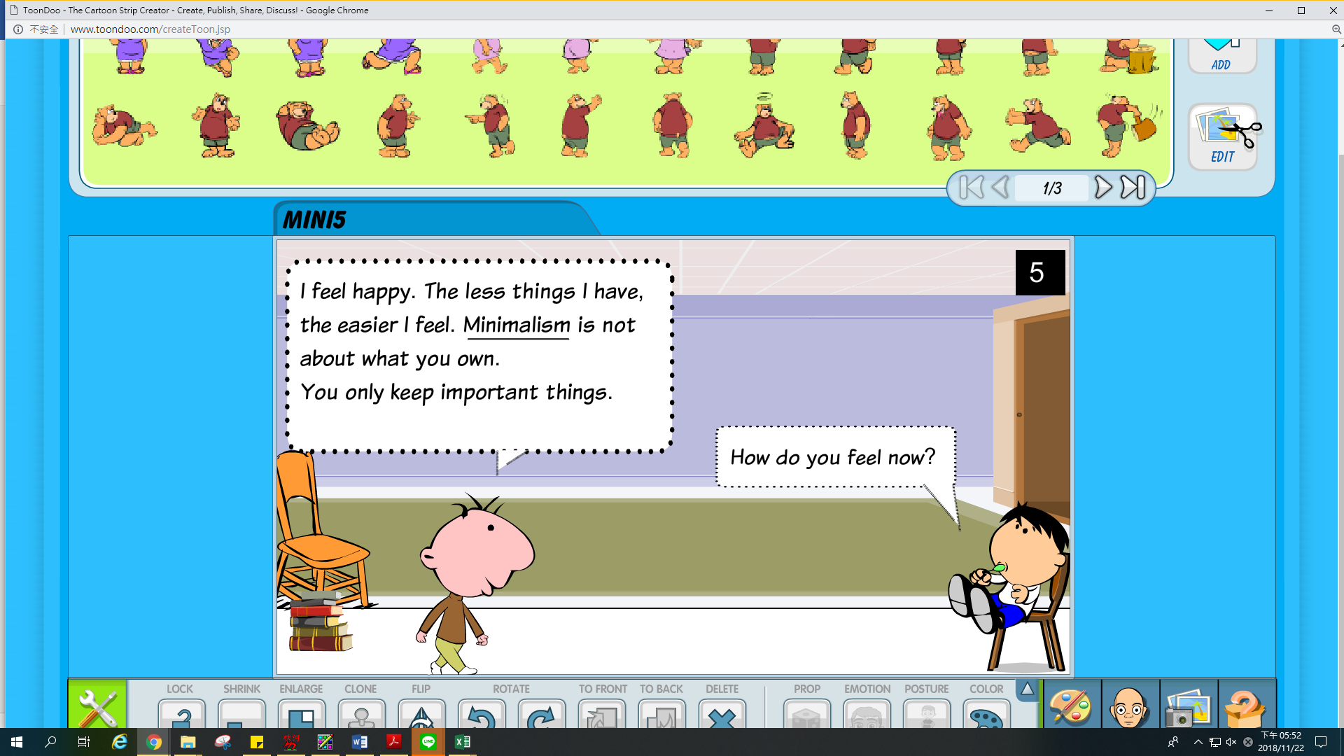
B. Reading 34-35

34. Why didn’t Sasaki feel sad after giving away what he had?
(A) Those things were not important to him any more.
(B) Those things were not good enough to keep.
(C) Those things were too old to remember.
(D) His house is so small that he can’t keep those things.

35. Who might be a minimalist?
(A) Mary. She is interested in online shopping.
(B) Christine. She only buys things in need and always feels happy.
(C) Justin. He often exercises in the gym and plays video games in Internet Cafe.
(D) Coco. He takes trips to many countries in every summer and winter vacation.
C. Reading 36-37

Is Eating Fries Good for Your Body?
A new study has found that people who eat fries two times a week will have a higher risk of death. There were 4,440 people joining this 8-year experiment. Their ages were around 45 to 79.
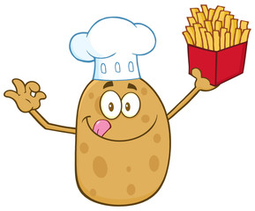
The study collected information about each person’s eating habits. During the study, 236 people passed away. These people died because of their eating habits. They mostly ate fried potatoes, including French fries and potato chips at least two times a
week. However, people were fine if they ate spoiled potatoes.

The study said that eating fried potatoes could lead to early death and people should be careful about what they eat and how the food is cooked.
*risk風險 *experiment實驗 *fried炒;炸*spoiled水煮

36. What does ‘passed away’ mean in the reading?
(A) to live
(B) to eat
(C) to die
(D) to work

37. What was found in the new study?
(A) How to cook potatoes is important to body.
(B) Potato is not good for people’s health.
(C) It is good for people to eat potatoes twice a week.
(D) French fries is popular with people.

第三部分：手寫題 31%
一、文意字彙 (每題2分，共18分)
38. The t___c light turns red now. Let’s stop walking.
39. Taipei is in the n___h of Taiwan.
40. In Asian countries, most high school students wear u_____ms to school.
41. My boyfriend and I have c____n interests. We both love sports.
42. Murphy has made a big d___n that she will go to a foreign country for study next year.
43. The c____e stores in Taiwan open 24 hours a day and many people buy things there.
44. Riding in a car is more c____e than riding on a scooter on rainy days.
45. The t____n was so big that several roads were washed away by the rain.
46. Miss Lin is our new n____r. She just moved in next to us last weekend.
二、依提示改寫句子/合併句子 (每題2分，共6分)
47. The food is so delicious that you can’t miss it.
(too…to…)

48. The water is too dirty to drink.
(not…enough to…)

49. Will we get a day off tomorrow?/ Do you know? (…if…)

三、翻譯題 (共7分)
50. 我們應該跟我們的父母多溝通，以更加互相彼此了解。3%
51. 這個問題太困難以致於不能解決，所以請告訴我該怎麼辦。4%

-- 試題結束 --

