臺北市立瑠公國中一０七學年度第二學期九年級英文科第一次定期評量試題B
班級:____ 座號:____ 姓名:__________

※聽力測驗：24%
- 辨識句意：根據聽到的內容，選出符合描述的圖片5%
1.( ) (A)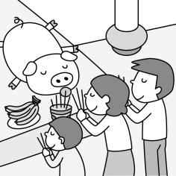 (B) 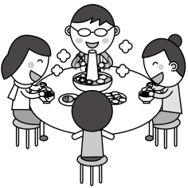
(C) 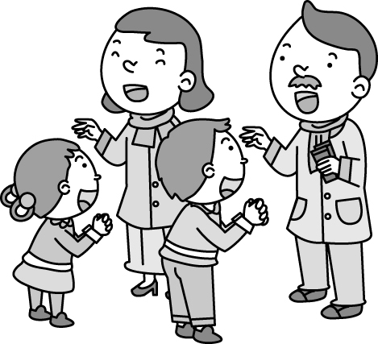
2.( )
(A) 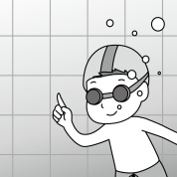 (B) 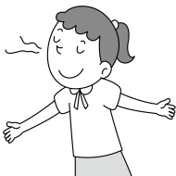 (C) 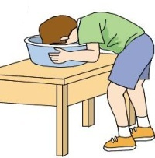
3.( ) (A) 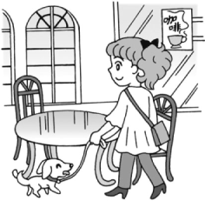 (B) 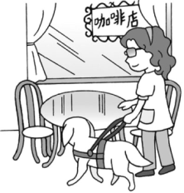
(C) 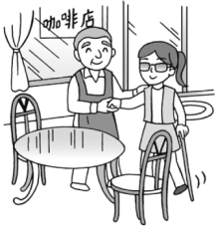
4.( ) (A) 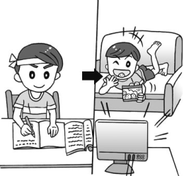 (B) 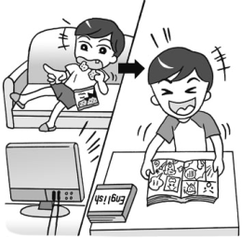
(C) 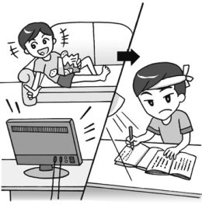
5.( ) (A) 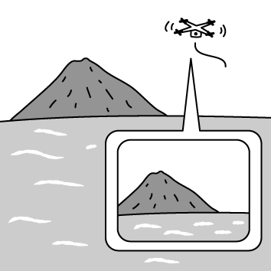 (B) 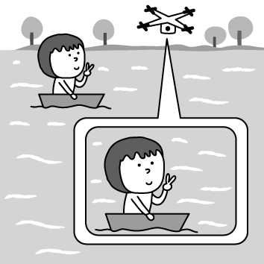
(C) 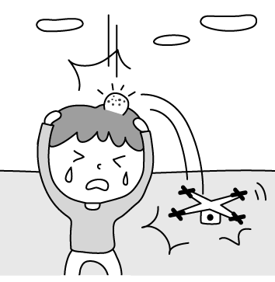

二、基本問答：根據聽到的內容，選出一個最適合的回應9% (第6題1分，第7~10題每題2分)
6.( ) (A)OK! Let’s shout loud for help.
(B)He has always been a good swimmer.
(C)I’ll jump into the river as soon as possible.
7.( ) (A)Nothing much. Thanks.
(B)Just look on the bright side.
(C)I’m almost late for the bus.
8.( ) (A)I couldn’t find any candles.
(B)I was doing my homework.
(C)I always turn off the gas after use.
9.( ) (A)At about 5 p.m.
(B)I think she will.
(C) At Coco Snack Bar.
10.( )(A)She’s in the ninth grade now.
(B)She has no idea about the English class.
(C)I know she’s quite interested in English.

三、言談理解：根據聽到的內容，選出一個最適合的答案10%
11.( ) (A)He lived in the USA before.
(B)He’s going to study in a foreign country.
(C)He speaks English very well.
12.( ) (A)A secretary.
(B)A reporter.
(C)A boss.
13.( ) (A)She is blind.
(B)She is fixing the pipe.
(C)She is small.
14.( ) (A)He wants Lisa to be a salesman.
(B)He thinks being a salesman is good.
(C)He doesn’t agree with Lisa.
15.( ) (A)A waitress.
(B)A robot.
(C)A smart phone.

【聽力測驗結束，請繼續作答】

※選擇題：76%
- ( ) Nick counted ______ the whole night but still couldn’t send himself to sleep. (A)pigs (B)oxen (C)hens (D)sheep
- ( ) My uncle works at an art museum and he has a great ______ of modern art. (A)relative (B)knowledge (C)microchip (D)sorrow
- ( ) Please don’t ______ what I have just told you to anyone else. It’s between you and me. (A)protect (B)imagine (C)repeat (D)nod
- ( ) Grandma rose ______ her seat and walked to the bathroom to wash her hands. (A)from (B)onto (C)off (D)with
- ( ) As a teenager, you should learn to be ______ for what you say and what you do. (A)cold-hearted (B)modern (C)lazy (D)responsible
- ( ) Something is wrong with my computer. I need some help from a computer ______. (A)lawyer (B)engineer (C)dentist (D)boss
- ( ) The sign says the swimming pool won’t open to the ______ until summer comes. (A)missing (B)dead (C)public (D)alive
- ( ) Judy has a big ______ at home. She often fills it with hot water and enjoys a long bath in winter. (A)tub (B)lid (C)pipe (D)cage
- ( ) Don’t exercise outside in the ______ of the day in summer. It’s too hot. (A)base (B)bottom (C)drawer (D)middle
- ( ) Thank you for taking care of the kids. I hope they didn’t ______ you any trouble. (A)paste (B)continue (C)deliver (D)cause
- ( ) Sam lost some information because his baby sister ______ his computer while he was still working on it. (A)turned off (B)closed (C)turned down (D)put out
- ( ) Kim: Why didn’t you answer the phone? Joe: I ______ fun at Gina’s birthday party when you called me. (A)am having (B)was having (C)have had (D)had had
- ( ) Either watching a movie or going fishing ____ John when he has to deal with stress. (A)relaxed (B)had relaxed (C)relaxes (D)relax
- ( ) Ava said to Ryan, “I _____ the cat already.” (A)am adopted (B)had adopted (C)was adopting (D)have adopted
- ( ) In the past, Sara used to get up late in the morning, but now she ______. (A)doesn’t (B)didn’t (C)isn’t (D)won’t
- ( ) If my brother, Ethan, ______ tomorrow, please give them this package. (A)will come (B)came (C)come (D)comes
- ( ) ______ the riddles were difficult, Gary still got many answers right. (A)When (B)Because (C)Although (D)If
- ( ) They are looking for a hotel ______ they can stay for a week. (A)that (B)which (C)whose (D)where
- ( ) Do you know ______ life was like 100 years ago? Was it easy or difficult? (A)what (B)that (C)how (D)which
- ( ) Grace not only shopped all day ________. (A)but also cost all her money (B)but didn’t buy anything (C)but spent much money (D)and so did my mother
- ( ) Do you see the salesmen ________? (A)that looks very handsome (B)who was pushed aside by a strong man (C)are standing over there just now (D)you met at the bus stop ten minutes ago
- ( ) Ivy: Did you see the news about a girl who was left in a car without anyone around? Kelly: Yes. I heard about that from the TV news. ____________ (A)It sounds too good to be true. (B)It happens from time to time. (C)You can’t always get what you want. (D)Don’t put all the eggs in one basket.
- ( ) Paul: Isn’t my shirt large enough for you? Greg: ____________. (A)I am afraid not. (B)No, do you have a smaller one? (C)Of course not. It’s large enough. (D)Yes, it may be too small for me.
(39-40)
Dear Mrs. Lin,
Thanks for buying the product from us. Please check the product again and see if it is what you want. If you have any problems, please call our customer service right away and we will be waiting to help you. To thank you for buying our product, we will give you a special coffee cup for free. We hope you will like it.
“Easy Shopping” is a very convenient service for people who are not able to go out or who do not like going from one store to another to buy what they want. You can simply shop by turning to Channels 35, 48 and 60, which are with you around the clock. Just call the phone number you see on the screen anytime and we will take your order right away. Please remember to tell us the product number, which is shown on the left of the screen. You will be able to get the product in a week. Also, you will have ten days to think about whether you really like the product or not. It will be free if you want to change or send back the product.
Easy shopping makes shopping easier and is with you day and night.
service服務; channel頻道
- ( ) What does “around the clock” mean in the reading? (A)Eight hours. (B)Twelve hours. (C)Sixteen hours. (D)Twenty-four hours.
- ( ) Which is NOT true? (A)People can do some shopping at home through “Easy Shopping.” (B)Mrs. Lin bought a coffee cup from a shopping channel. (C)Mrs. Lin is possibly too busy to go out for shopping. (D)If you don’t like the product from “Easy Shopping”, you can send it back.

(41-42)
A friend of mine was giving an English lesson to a class of fifteen people who had just arrived in the United States and planned to live there for life. After placing some everyday objects on a table, he asked everyone in the class to give him the ruler, the book, the pen, and so on. Everything seemed all right, and the students looked interested and serious about what they were told to do until my friend turned to an Italian student and said, “Could you give me the keys?” The man looked surprised. Seeing this, my friend thought that perhaps the student hadn’t heard him clearly, so he repeated his question. “Could you give me the keys, Luca?” The Italian did not say a word but threw his arms around the teacher’s neck and kissed him on both cheeks.
object物品; cheek臉頰
- ( ) Why did Luca kiss the teacher? (A)The teacher asked him to do it. (B)He fell in love with the teacher. (C)He wanted to show thanks to the teacher. (D)He misunderstood the teacher’s question. misunderstand誤解
- ( ) Which is true about the story? (A)The writer’s friend comes from Italy. (B)The writer’s friend is an English teacher. (C)The writer’s friend loves to kiss people. (D)The writer’s friend just arrived in the USA.
(43-46)
Toys are not for children only. In these days, many toy companies have found that more and more adults are buying toys not for children but for themselves. This change may come from the fact that adults are under a lot of stress when they work hard for a better future. Playing with toys not only brings them back to their happy childhood but helps them forget all the trouble in their lives. A 30-year-old man who goes to toy stores quite often said, “Visiting these stores makes me feel younger. Most of the toys give me a lot of room for thinking while playing with them.” To meet the growing need, one Taipei department store has even opened a toy section especially for adults. Some people might think of these adults as “overgrown babies.” But toy companies are trying hard to satisfy their needs.
childhood童年; section區; satisfy滿足
- ( ) What is the main idea of this article? (A)Adults shouldn’t play with toys like kids. (B)Adults, like kids, need toys to play with. (C)More and more adults are buying toys for themselves. (D)Children should share their toys with adults.
- ( ) What does “overgrown babies” mean? (A)Adults who act like babies. (B)Babies who have grown bigger than other babies. (C)Adults who love babies. (D)Babies who have grown up.
- ( ) Which is true about the reading? (A)Adults like toys more than children. (B)Adults who buy toys usually get in trouble in their lives. (C)Adults feel stressed out more easily than children do. (D)Toys help some adults feel better in their lives.
- ( ) How do the toy companies feel about these adults? (A)These adults create more chances for them to make money. (B)These adults are strange persons. (C)They hate to do business with adults. (D)They have some problems to meet these adults’ needs.
(47-49)
(Bill and Fred are talking in the park.)
Bill: Life has changed a lot, (47) it?
Fred: You are right. People used to watch black and white television in the 1960s and the Beatles used to be (48) rock band in England then.
Bill: Well, I really miss them. When they came to America in 1965, I saw them with my own eyes. That’s one of (49) things I have ever done in my life.
Fred: Yes, that was so cool. They are still my favorite band.
- ( ) (A)didn’t (B)has (C)is (D)hasn’t
- ( ) (A)popular (B)more popular (C)the most popular (D)less popular
- ( ) (A)excited (B)the most exciting (C)interesting (D)the most interested
(50-53)
One day, Patty was cooking in the kitchen (50) the doorbell rang. She ran quickly to open the door. To her surprise, her junior high school classmate, Tina, paid her a visit. They (51) for a long time, so they chatted with each other happily at the door. Tina told her (52) . What surprising news to Patty! She felt so happy for Tina.
Suddenly, Patty and Tina (53) . Patty remembered that she was cooking and ran back to the kitchen to turn off the gas. Luckily, nothing terrible happened. It was really a surprising and scary day to Patty.

- ( ) (A)when (B)as soon as (C)while (D)until
- ( ) (A)didn’t meet (B)weren’t met (C)haven’t met (D)hadn’t met
- ( ) (A)how wonderful they met again (B)if she forgot cooking in the kitchen (C)she was going to get married (D)which color she likes best
- ( ) (A)heard someone singing outside (B)smelled something burning (C)saw something going in but not out (D)felt like something was stuck at the door

【本次測驗結束】

