臺北市立瑠公國中一０七學年度第二學期九年級英文科第一次定期評量試題
班級:____ 座號:____ 姓名:__________

※聽力測驗：24%
- 辨識句意：根據聽到的內容，選出符合描述的圖片5%
1.( ) (A) 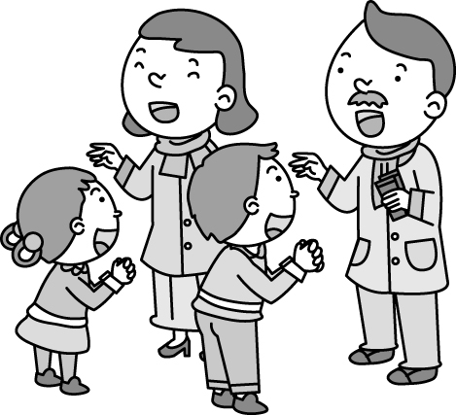 (B) 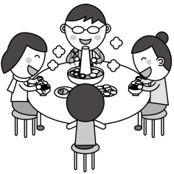
(C) 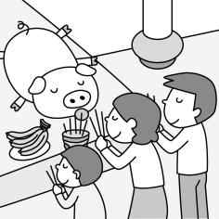
2.( )
(A) 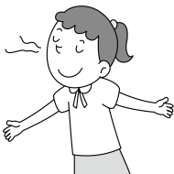 (B) 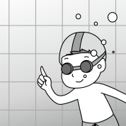(C) 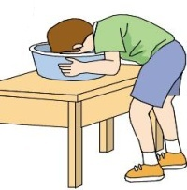
3.( ) (A) 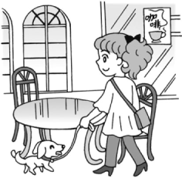 (B) 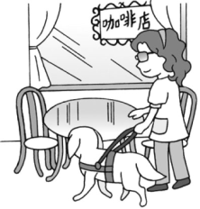
(C) 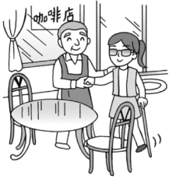
4.( ) (A) 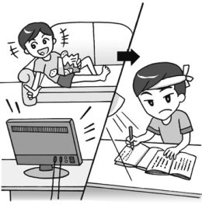 (B) 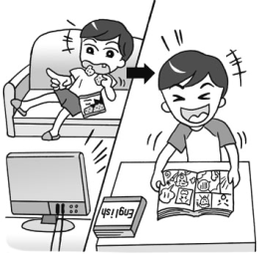
(C) 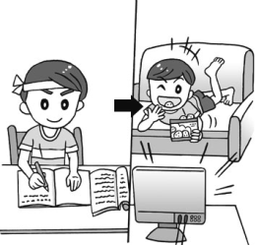
5.( ) (A) 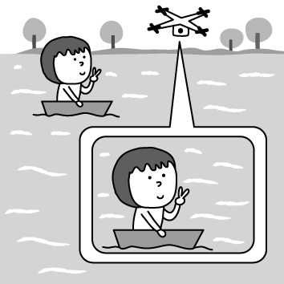 (B)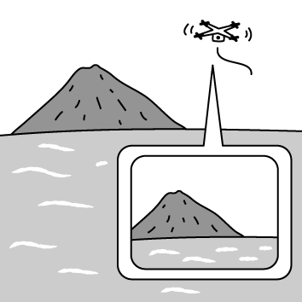
(C) 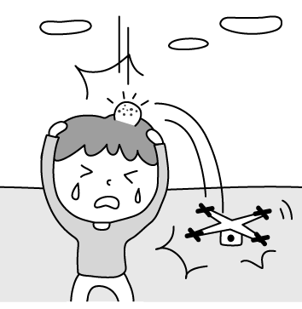

二、基本問答：根據聽到的內容，選出一個最適合的回應9% (第6題1分，第7~10題每題2分)
6.( ) (A)OK! Let’s shout loud for help.
(B)He has always been a good swimmer.
(C)I’ll jump into the river as soon as possible.
7.( ) (A)Just look on the bright side.
(B)Nothing much. Thanks.
(C)I’m almost late for the bus.
8.( ) (A)I was taking a bath.
(B)I couldn’t find any candles.
(C)I always turn off the gas after use.
9.( ) (A)At about 5 p.m.
(B)I think she will.
(C) At Coco Snack Bar.
10.( )(A)She’s in the ninth grade now.
(B)She has no idea about the English class.
(C)I know she’s quite interested in English.

三、言談理解：根據聽到的內容，選出一個最適合的答案10%
11.( ) (A)He lived in the USA before.
(B)He’s going to study in a foreign country.
(C)He speaks English very well.
12.( ) (A)A boss.
(B)A reporter.
(C)A secretary.
13.( ) (A)She is small.
(B)She is fixing the pipe.
(C)She is blind.
14.( ) (A)He wants Lisa to be a salesman.
(B)He thinks being a salesman is good.
(C)He doesn’t agree with Lisa.
15.( ) (A)A waitress.
(B)A robot.
(C)A smart phone.

【聽力測驗結束，請繼續作答】

※選擇題：76%
- ( ) Nick counted ______ the whole night but still couldn’t send himself to sleep. (A)pigs (B)oxen (C)sheep (D)hens
- ( ) Mr. Woods has a great ______ of Chinese history. He can answer all my questions. (A)relative (B)knowledge (C)microchip (D)sorrow
- ( ) Grandpa rose ______ his seat and walked to the garden with his tools. (A)off (B)onto (C)with (D)from
- ( ) As a teenager, you should learn to be ______ for what you say and what you do. (A)cold-hearted (B)modern (C)lazy (D)responsible
- ( ) Please don’t ______ what I have just told you to anyone else. It’s between you and me. (A)repeat (B)imagine (C)respect (D)nod
- ( ) Ted has a toothache. He needs to go to the ______ right away. (A)lawyer (B)cook (C)salesman (D)dentist
- ( ) Judy has a big ______ at home. She often fills it with hot water and enjoys a long bath in winter. (A)lid (B)cage (C)pipe (D)tub
- ( ) I am in the ______ of the meeting. Can I call you back later? (A)middle (B)drawer (C)base (D)bottom
- ( ) Thank you for taking care of the kids. I hope they didn’t ______ you any trouble. (A)paste (B)continue (C)deliver (D)cause
- ( ) The sign says the swimming pool won’t open to the ______ until summer comes. (A)missing (B)dead (C)public (D)alive
- ( ) Betty lost some information because her baby sister ______ her computer while she was still working on it. (A)turned down (B)closed (C)put out (D)turned off
- ( ) Ava said to Ryan, “I _____ the cat already.” (A)have adopted (B)had adopted (C)was adopting (D)am adopted
- ( ) Either listening to music or going hiking ____ Paul when he has to deal with stress. (A)relax (B)relaxes (C)had relaxed (D)relaxed
- ( ) Kim: Why didn’t you answer the phone? Grace: I ______ fun at Gina’s birthday party when you called me. (A)am having (B)was having (C)have had (D)had had
- ( ) In the past, Sara used to eat a lot of candy, but now she ______. (A)doesn’t (B)didn’t (C)isn’t (D)won’t
- ( ) The kid is asking his mother whether there ______ a swimming race tomorrow or not. (A)has (B)be (C)will be (D)will have
- ( ) ______ Mr. Chen is a rich man now, he drives his old car and cooks simple meals every day. (A)Because (B)If (C)Since (D)Though
- ( ) We should protect the forests ______ many different animals live. (A)where (B)which (C)whose (D)that
- ( ) Do you know ______ life was like 100 years ago? Was it easy or difficult? (A)that (B)which (C)how (D)what
- ( ) Mia not only shopped all day ________. (A)but also cost much money (B)but didn’t buy anything (C)but spent all her money (D)and so did my mother
- ( ) Do you know the women ________? (A)are smiling at you (B)that looks very young (C)you met at the park ten minutes ago (D)who was stopped by the police
- ( ) Terry: You know what? Coco Department Store just called me and said that I won two free tickets to New York! Dora: ____________ How lucky you are! (A)It sounds too good to be true. (B)It’s not that hard to win the free tickets. (C)Cheer up! It’s not the end of the world. (D)You can’t always get what you want.
- ( ) John: Isn’t my shirt large enough for you? Greg: ____________. (A)No, do you have a smaller one? (B)I am afraid not. (C)Of course not. It’s large enough. (D)Yes, it may be too small for me.
(39-40)
Dear Ms. Advice,
I felt so troubled today. I borrowed my brother’s bicycle and rode it to the park. I parked it under a tree near the basketball court. Then I met with my friends, and we began to play with other boys in the court. When the game was over, I found that the bike was gone. Someone stole the bike while I was playing basketball. I looked everywhere in the park, but I just couldn’t find it.
I really don’t know what I should do. Should I tell my brother I lost his bike? Should I give him some money, buy a new or second-hand bike, or just say sorry?
Andy
--------------------------------------------------------------
Dear Andy,
My advice is to be honest and tell your brother what happened to his bike. Have a talk with him. Say you’re really sorry and ask him what you should do with the lost bike. It won’t be so hard to deal with it if you face the music.
Ms. Advice
court球場
- ( ) Which is true about Andy? (A)He needed some advice from others. (B)He asked Ms. Advice to find the bike for him. (C)He knew what he should do with the lost bike. (D)He walked to the park to play basketball.
- ( ) If Andy “face the music”, what will he do? (A)He will play some music for his brother. (B)He will ask his brother to play basketball with him. (C)He will ask his friends to buy a new bike for his brother. (D)He will tell what happened to his brother.
(41-42)
A friend of mine was giving an English lesson to a class of fifteen people who had just arrived in the United States and planned to live there for life. After placing some everyday objects on a table, he asked everyone in the class to give him the ruler, the book, the pen, and so on. Everything seemed all right, and the students looked interested and serious about what they were told to do until my friend turned to an Italian student and said, “Could you give me the keys?” The man looked surprised. Seeing this, my friend thought that perhaps the student hadn’t heard him clearly, so he repeated his question. “Could you give me the keys, Luca?” The Italian did not say a word but threw his arms around the teacher’s neck and kissed him on both cheeks. object物品; cheek臉頰
- ( ) Why did Luca kiss the teacher? (A)The teacher asked him to do it. (B)He fell in love with the teacher. (C)He misunderstood the teacher’s question. (D)He wanted to show thanks to the teacher. misunderstand誤解
- ( ) Which is true about the story? (A)The writer’s friend is an English teacher. (B)The writer’s friend comes from Italy. (C)The writer’s friend loves to kiss people. (D)The writer’s friend just arrived in the USA.
(43-46)
Toys are not for children only. In these days, many toy companies have found that more and more adults are buying toys not for children but for themselves. This change may come from the fact that adults are under a lot of stress when they work hard for a better future. Playing with toys not only brings them back to their happy childhood but helps them forget all the trouble in their lives. A 30-year-old man who goes to toy stores quite often said, “Visiting these stores makes me feel younger. Most of the toys give me a lot of room for thinking while playing with them.” To meet the growing need, one Taipei department store has even opened a toy section especially for adults. Some people might think of these adults as “overgrown babies.” But toy companies are trying hard to satisfy their needs.
childhood童年; section區; satisfy滿足
- ( ) What is the main idea of this article? (A)Adults shouldn’t play with toys like kids. (B)Adults, like kids, need toys to play with. (C)Children should share their toys with adults. (D)More and more adults are buying toys for themselves.
- ( ) What does “overgrown babies” mean? (A)Babies who have grown bigger than other babies. (B)Adults who act like babies. (C)Adults who love babies. (D)Babies who have grown up.
- ( ) Which is true about the reading? (A)Adults like toys more than children. (B)Adults who buy toys usually get in trouble in their lives. (C)Adults feel stressed out more easily than children do. (D)Toys help some adults feel better in their lives.
- ( ) How do the toy companies feel about these adults? (A)These adults create more chances for them to make money. (B)These adults are strange persons. (C)They hate to do business with adults. (D)They have some problems to meet these adults’ needs.
(47-49)
(Bill and Fred are talking in the park.)
Bill: Life has changed a lot, (47) it?
Fred: You are right. People used to watch black and white television in the 1960s and the Beatles used to be (48) rock band in England then.
Bill: Well, I really miss them. When they came to America in 1965, I saw them with my own eyes. That’s one of (49) things I have ever done in my life.
Fred: Yes, that was so cool. They are still my favorite band.
- ( ) (A)didn’t (B)has (C)is (D)hasn’t
- ( ) (A)popular (B)more popular (C)the most popular (D)less popular
- ( ) (A)excited (B)the most exciting (C)interesting (D)the most interested
(50-53)
One day, Patty was cooking in the kitchen (50) the doorbell rang. She ran quickly to open the door. To her surprise, her junior high school classmate, Tina, paid her a visit. They (51) for a long time, so they chatted with each other happily at the door. Tina told her (52) . What surprising news to Patty! She felt so happy for Tina.
Suddenly, Patty and Tina (53) . Patty remembered that she was cooking and ran back to the kitchen to turn off the gas. Luckily, nothing terrible happened. It was really a surprising and scary day to Patty.
- ( ) (A)as soon as (B)when (C)until (D)while
- ( ) (A)didn’t meet (B)weren’t met (C)haven’t met (D)hadn’t met
- ( ) (A)if she forgot cooking in the kitchen (B)which college she went (C)she was going to get married (D)how wonderful they met again
college大學
- ( ) (A)saw something going in but not out (B)smelled something burning (C)heard someone crying outside (D)felt like something was stuck at the door

【本次測驗結束】

