臺北市立瑠公國中107學年度第二學期八年級英文科第一次定期評量試題
八年 班 號 姓名：
第1頁，共3頁

※選擇題請在電腦卡上作答，共分
一、聽力測驗20%
- 選出符合句子描述的圖片5 % (每題1分)
01.
(A)   | (B)   | (C)  
02.
(A)  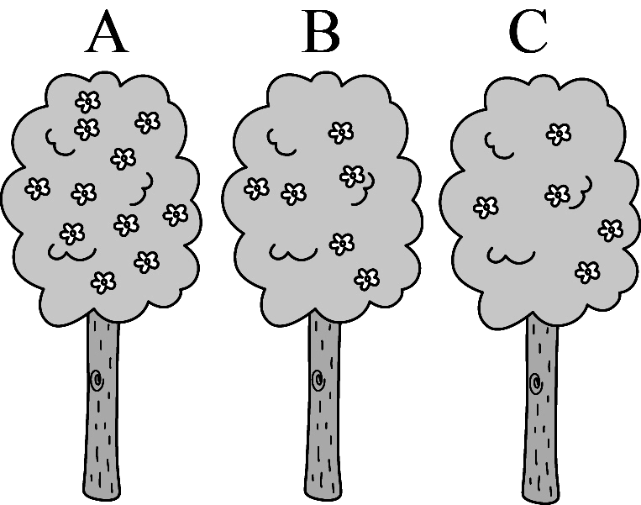 | (B)  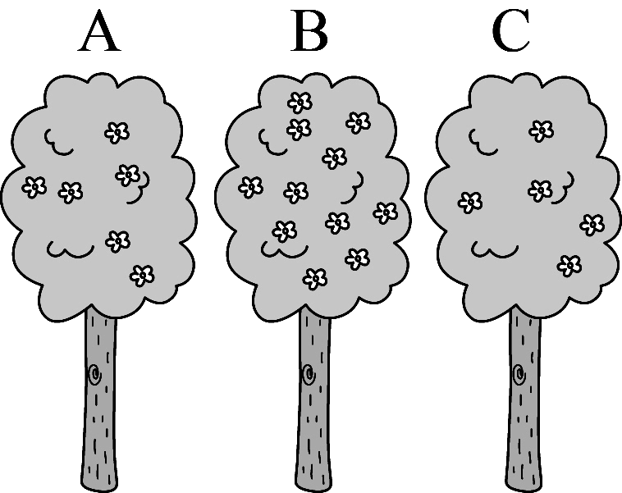 | (C)  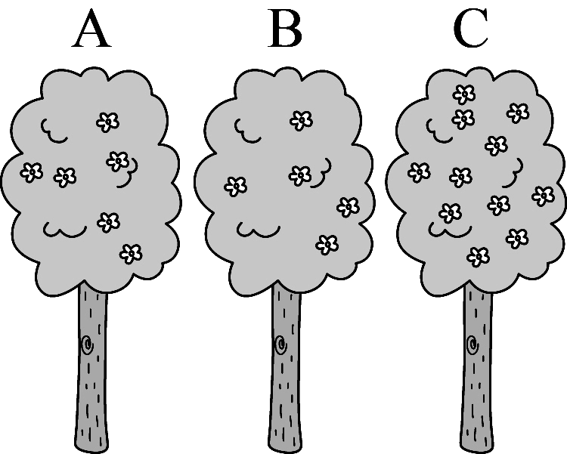
03.
(A)  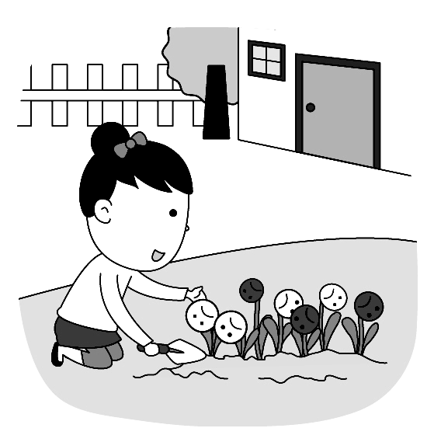 | (B)  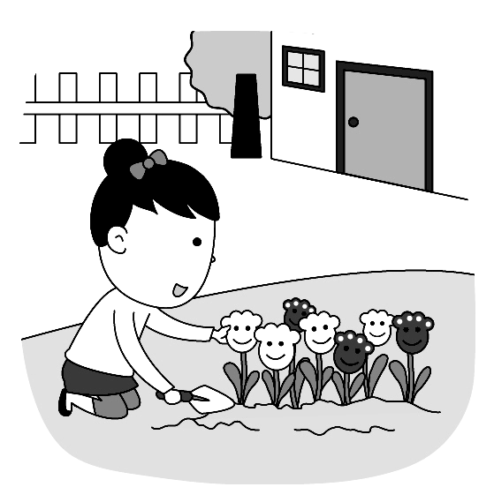 | (C)  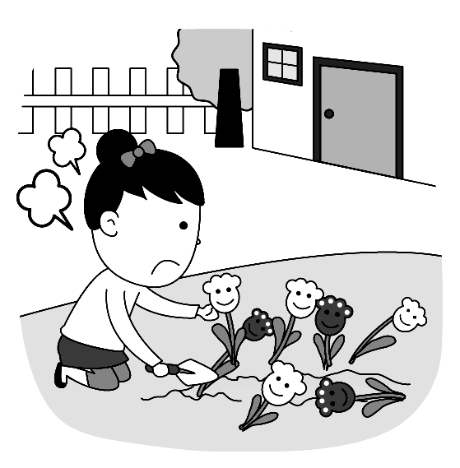
04.
(A)  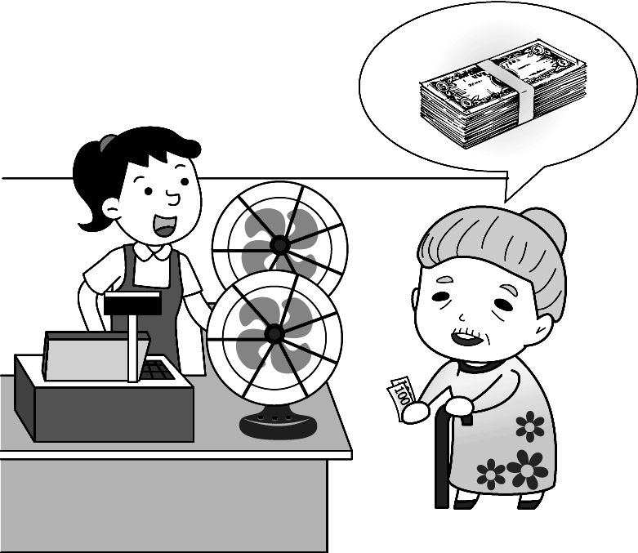 | (B)  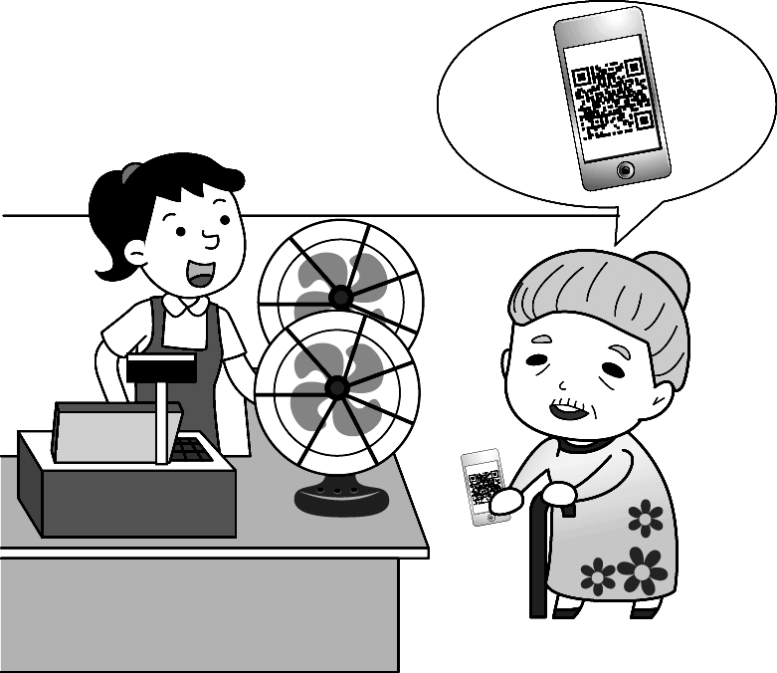 | (C)  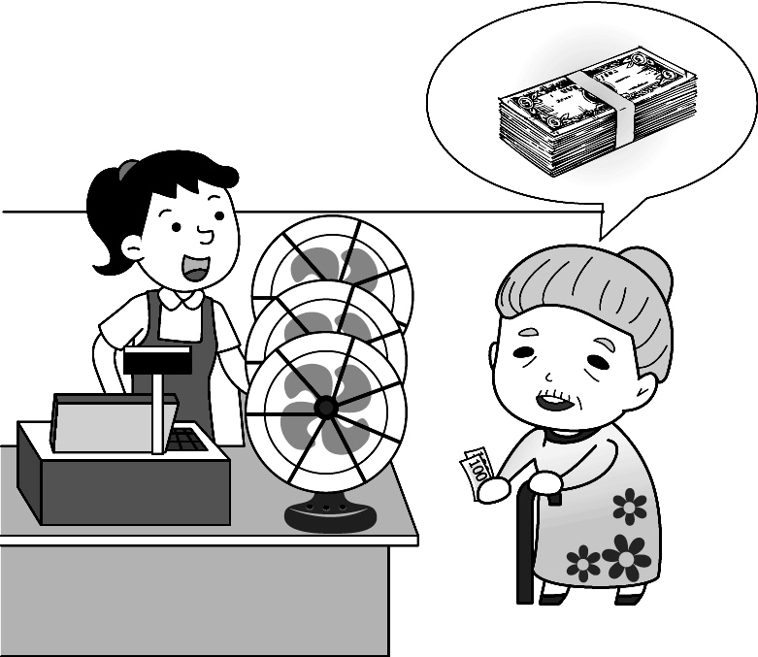
05.
(A) 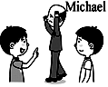 | (B)  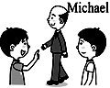 | (C) 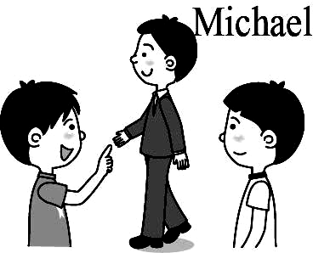
B. 選出最適合的回答，完成對話5% (每題1分)
06. (A) I like black coffee a lot.
(B) That’s too crazy
(C) What? Isn’t that milk?.
07. (A) A fish sandwich, please.
(B) Good. Here you are.
(C) Yes, I’m getting better.
08. (A) I enjoy having egg noodles.
(B) I just bought ten. Take them.
(C) I never hunt for eggs.
09. (A) You are very different now.
(B) Why not get some new games?
(C) My eyes are becoming better.
10. (A) I feel happy because you got a new job.
(B) Well, I feel sad about your grandma, too.
(C) Before you give up, think about it twice.
C. 請聽對話或短文，選出問題最適合的答案。10%
11. (A) Andy’s Shop sells pure juice.
(B) They both sell cheap juice.
(C) Amy’s Shop’s juice is better.
12. (A) He grew the prettiest flowers.
(B) He gave the woman some seeds.
(C) He is not good at growing flowers.
13. (A) She went to a welcoming party.
(B) She bought a special dress.
(C) She washed the wrong dress.
14. (A) Its vegetable dumplings are the most special in Forever Town.
(B) It sells the best beef noodles in Forever Town.
(C) Every dish there costs two hundred dollars.
15. (A) A papaya. (B) A watermelon. (C) A banana
二、單題選擇12%(16~21題，每題2分)
16. When you have someone to share with your dream,
your dream will become ______ than it is.
(A) so sweet (B) the sweetest
(C) even sweeter (D) less sweeter
17. ____ does the little tiger look like? ________.
(A) How; Cute (B) How; A cat
(C) What; Cute (D) What; A cat
18. Of all the tomatoes, the orange ones are ______.
(A) the most expensive (B) sweeter
(C) most popular (D) cheapest
19. A：Going egg hunting is free on Sunny Church. Would you like to join us this Sunday?
B：______________.
(A) The eggs taste like chicken.
(B) It sounds like a good idea to me.
(C ) What can I do for you?
(D) Rolling eggs doesn’t sound fun to me.
20. Lily: Didn’t your parents buy you a camera?
Leo: Yes, they bought ____ for me and I like ___.
(A) it; it (B) it; one (C) one; it (D) one; one
21. A：Why do you look so sad? What happened?
B：The tickets to Taylor Swift’s concert were______. I feel like crying.
(A) got on (B) sold out (C) ran away (D) took of
三、克漏字選擇 20%（每題 2分）
1. 22~25
Dear Jessica,
My uncle Billy was a great singer years ago; however, he wasn’t happy at all. One day in 2007, when he was visiting a fruit farm in Dream Town, he decided to move to the country. He bought a farm there and 22. .
At first, not many customers went to his farm however, after they tasted the freshest and best quality of the fruits in the town. Now, 23. people enjoy shopping from him. Even the farm is far from city and the price is a little higher than the market. They still like to buy fruit like strawberries and tomatoes from him. He works on the farm for over ten hours every day, but the busier he is, 24. . He thinks his fruit brings great joy to the people.
Next weekend, Billy Fruit Dream Farm will have an interesting activity :fruit Picking. The person who
25. in one hour will get the latest camera Pink L4. Do you want to become the luckiest person? Come and join it with us!
22. (A) he started growing fruits
(B) he felt as sad as a bird
(C) he was becoming weaker and weaker
(D) he was good at growing plants
23. (A) As many as (B) Less and less
(C) More and more (D) Fewer and fewer
24. (A) the happier he feels
(B) the weaker he gets
(C) the less money he makes
(D) the less fruit he can grow
25. (A) has the most money
(B) enjoys taking photos
(C) brings free seeds and tools
(D) picks up the most fruit
2. 26~30
Once upon a time, there was a young man, Jack. He owned a garden, and it was the most beautiful in his town because 26. . Everyone loved the flowers and the king did, too.
One day, the king 27. all the children and gave them a special task. “Grow these seeds for me”.
He wanted them to take good care of them and grew
the prettiest flowers in the whole country.
Jack planted the seeds in a pot and watered them
every day, but nothing happened. Jack kept on trying
and trying with many different ways and tools. Two
months 28. , still nothing happened to Jack’s
seeds. All the kids’ seeds 29. big flowers, but Jack didn’t.
“ 30. , but they didn’t grow at all” said Jack. “Of course they didn’t. I roasted the seeds. Because you’re 31. man here. I will let you marry my daughter.” After the king died, Jack became the new king.
26. (A) he had green fingers
(B) he used different tools
(C) he spent less time
(D) he sold the prettiest flowers
27. (A) called for (B) rolled off
(C) added into (D) poured into
28. (A) ran away (B) passed by
(C) went by (D) gave up
29. (A) put on (B) turned into
(C) set up (D) took off
30. (A) Hurry up (B) Watch out
(C) Take a break (D) I did my best
31. (A) more handsome
(B) the most popular
(C) the smartest
(D) the only honest

四、閱讀測驗 14% (每題2分)
1.32~34
Make your life amazing
Table of contents
1. You are what you give…………….1
2. It’s better to give than to receive………..6
3. The joy of giving and helping others…..11
4. How to get healthier and wiser…….23
5. Spend more time for your dreams……..39
6. Spend less time on your smartphone……..52
7. Not making more friends, but
making better friends…………….…64
8. How to get different travel ideas…………71
9. The 7 cheapest ways to travel…..88

32. Helen always goes traveling with her friends to
the same place. But she wants something different
this time. What page could she read?
(A) 88 (B) 64 (C) 39 (D) 71
33. Jeremy wants his daughter to find his dream job, but
his daughter likes playing online games with his
smartphone for hours. What topic could he ask his
daughter to read first?

(A) Spend more time for your dreams
(B) It’s better to give than to receive
(C) Spend less time on your smartphone
(D) How to get healthier and wiser
34. Which is NOT TRUE?
(A) Page 64 might show readers the better ways to make good friends
(B) Being a dancer won’t take lots of time, that’s
what Page 39 will teach readers.
(C) Page 88 helps travelers to save money.
(D) After readers finished reading Page 11, they will learn the key to happiness is sharing.
2. 35~38
Barcelona in Spain is the twentieth most popular city in the world, and the number of tourists just keeps growing, from 27 million in 2010 to more than 34 million in 2016. However, when people keep flying there, many locals want them to leave. Some of them even put up signs on the streets to keep them away.
In early years, most locals welcomed tourists a lot because money came along with them, and it
helped them have a better life. These years, more tourists bring more money to the city to the businessmen. However, the locals need to worry about trash, noise, terrible traffic and the price of food is getting higher and higher. Life for the locals is becoming more difficult and expensive.
Yet, stopping tourists from visiting the city is not the answer. A better way is to push the local government to face the problems and work with the locals together. For example, tourists can stay near the city, This way, there will be less and less tourists in the center of Barcelona. Tourists can still enjoy their trip and the life for the locals will become better. After all, most locals still need them to make a living.
1. tourists遊客 2.million百萬3. local當地人4. government 政府

4.
government

35. What does” them ” mean?
(A) other cities (B) visitors
(C) the locals (D) the businessmen
36. What words may you see on the sign?
(A) GO FOR IT, TOURISTS!
(B) WELCOME TO BARCELONA!
(C) COME AND LIVE WITH US!
(D) TOURISTS GO HOME!
37. Below are the writer’s points(觀點) in the reading:
a. Some locals ask tourists to leave.
b. A way to solve(解決) the problems.
c. The changes in Barcelona.
In what order does the writer talk about the points?
(A) a→b→c (B) c→b→a
(C) a→c→b (D) c→a→b
38. Which idea may be the writer’s idea?
(A) Close the city and let tourists visit or stay in other places.
(B) The local government should help the locals make money from tourists.
(C) All the locals are doing their best to get more visitors to visit the city.
(D) Tourists need to pay more than the locals when they shop in the city.
※下列題目請在答案卷上作答，共34分
五、文意字彙 39~48﹔20%(每題2分)
39. Don’t put all your eggs in one b t.
40. In the story of Momotaro, an old man picked a large
p h in the forest, and a baby boy was inside.
41. It might be true that people can take a time
m e to travel to the future.
42. People around the world c e their New Year
with different activities.
43. Eating enough fruits, meat and v es are very important to our health.
44. The job needs people with a lot of e e. You
can’t do well in the interview because you know
nothing about it.
45. A: How would you like to pay? B: In c h.
46. To keep food fresh, especially meat and milk, people store them in the r r.
47. Grandparents are old. They have lots of g y hair.
48. A ：Are these p es ? They smell so sweet.
B：Yes, they are large juicy tropical(熱帶的) fruits with thorns.(刺) They taste sweet and sour(酸).
六、寫出形容詞的比較級或最高級4%(每題1分)
49. Vincent Van Gogh cut his left ear off to give his girlfriend as a gift. I think he is _______(crazy) of artist in the world..
50. I enjoy living in the country because the air there is a lot ________(fresh) than in the cities.
51. I would like my coffee, the stronger, ______(good).
52. Today was not my day. It was __________(bad) day in my life. My kindest grandfather died this morning.
七、翻譯(中翻英) 10%
1. 只需在相機上按一下即可立即上傳照片!
2. 市場上，當季最新鮮的番茄正變得越來越便宜｡
3. 再過幾分鐘，一架直升機將會過來並投擲數以千

個復活節彩蛋到地上｡

