臺北市立瑠公國中 107 學年度 第 2 學期 七年級 第 3 次定期評量 英語科 試題

本試題共３頁

- 辨識句意：選出符合句子描述的圖片。4%
1.（ ）
Ａ) 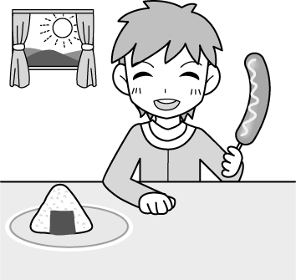Ｂ) 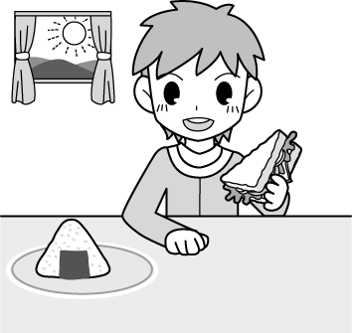Ｃ) 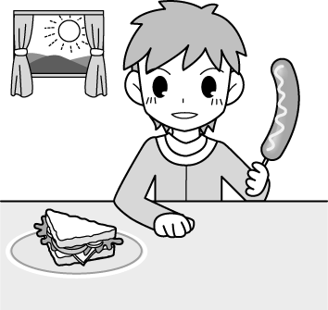
2.（ ）
Ａ) 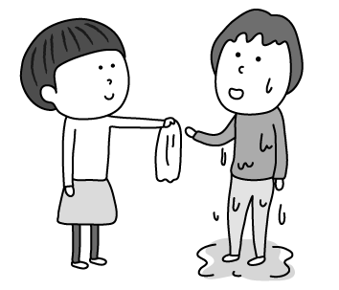Ｂ) 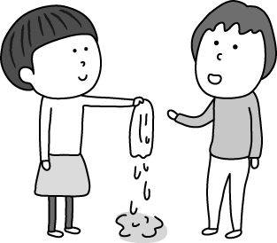Ｃ) 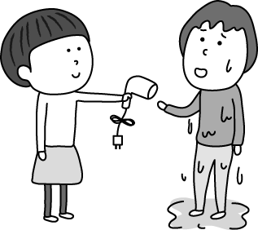
3.（ ）
Ａ) 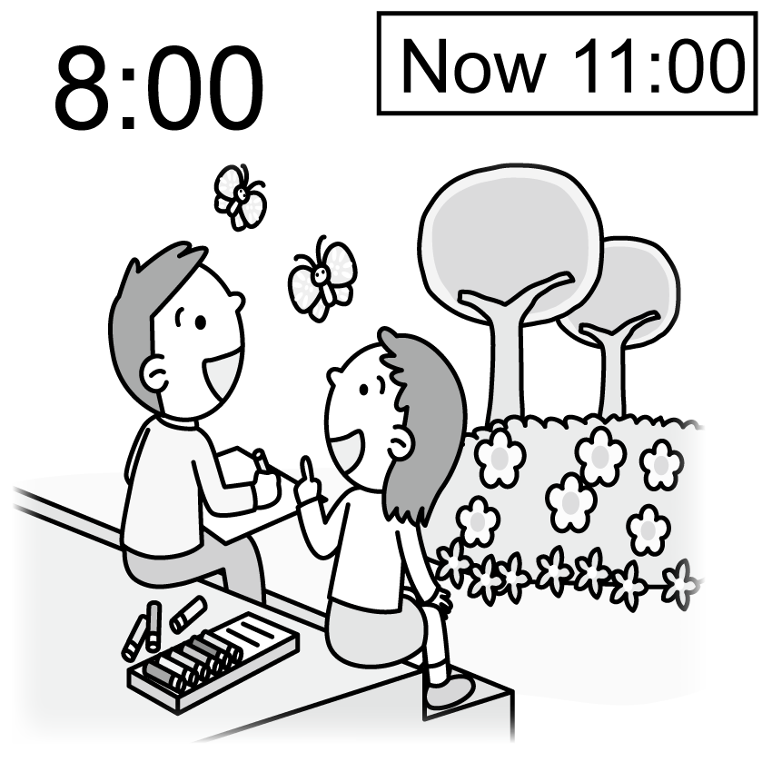Ｂ) 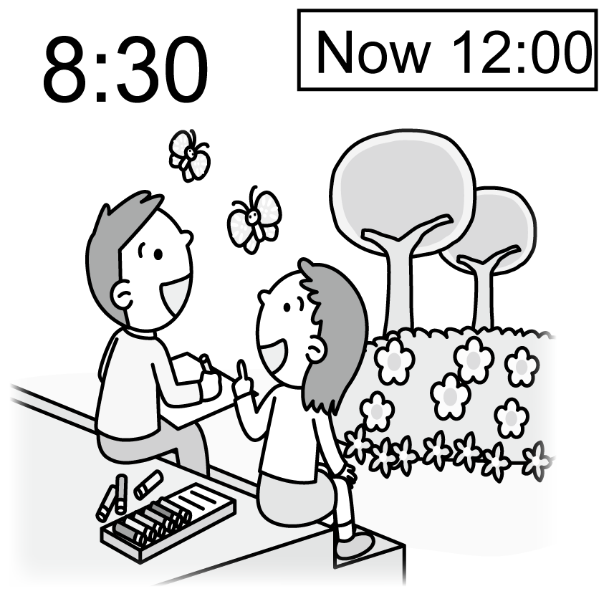Ｃ) 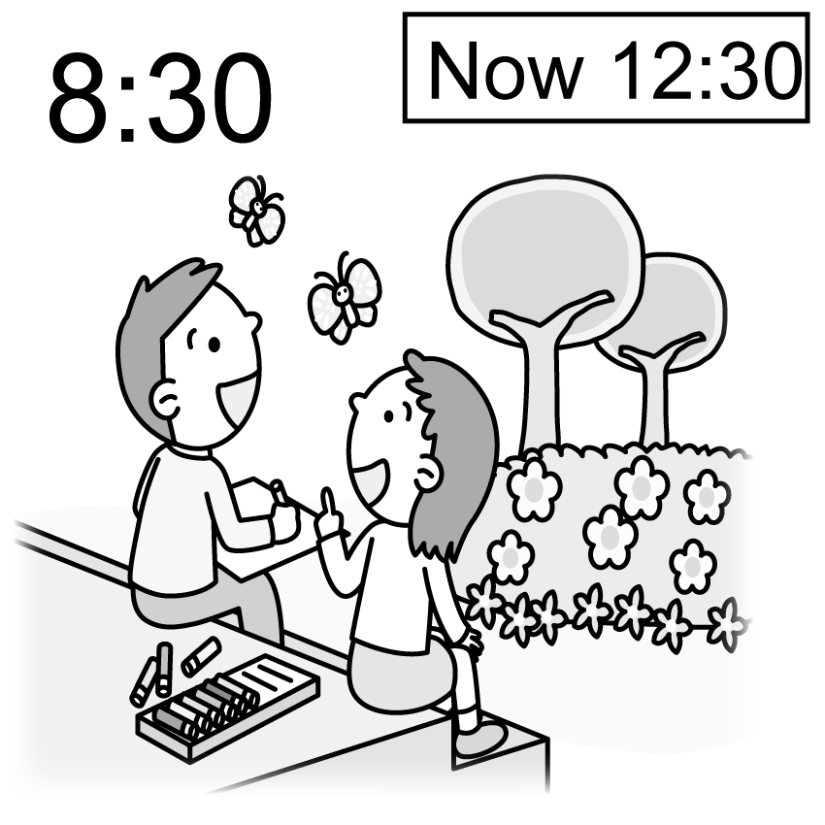
4. ( ) Ａ) 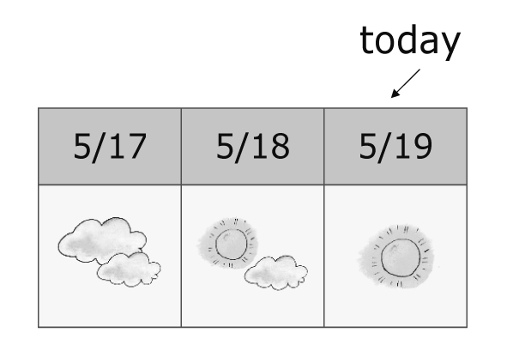
Ｂ) 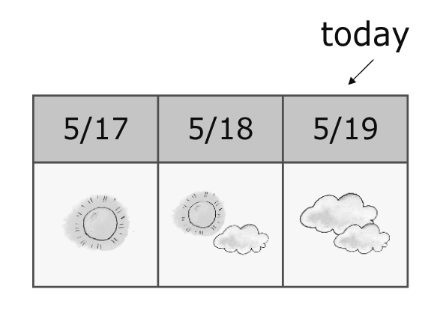
Ｃ) 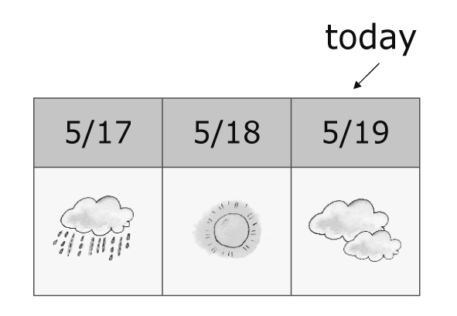

二、基本問答：根據聽到的內容，選出最適合的回應。4%
5.( )Ａ) She is in the classroom now.
Ｂ) Yes, she was there.
Ｃ) She was at the pond behind the house.
6.( )Ａ)This place is busy in fall.
Ｂ)This place is in the mountains.
Ｃ)The spring flowers. Many people come for
them.
7.( )Ａ)Yes, it’s dry this month.
Ｂ)Yes, it’s snowy and cold.
Ｃ)Yes, it’s our rainy season.
8.( )Ａ)Yes, but she seldom does.
Ｂ)No, the house is always dirty.
Ｃ)Yes, she cleans it once a year.

三、言談理解：根據聽到的內容，選出最適合的答案。8%
9.( )Ａ)Four times a month.
Ｂ)Twice a week.
Ｃ)Every two weeks.
10.( )Ａ)Some fish.
Ｂ)Some birds.
Ｃ)Some tadpoles.
11.( )Ａ)Once a year.
Ｂ)Twice a year.
Ｃ)Once in his lifetime.
12.( )Ａ)Tim keeps a dog only.
Ｂ)Tim keeps a rabbit only.
Ｃ)Tim keeps a dog and a rabbit.

四、綜合選擇。80% (13-18，每題1分；19-57；每題2分)
13.( )Two triangles make a ____.
A)tournament B)team C)circle D)diamond
14.( )I hurt my left foot, so I can only ____ on my right foot.
A)jog B)drop C)hop D)hit
15.( )Rose can’t go on a picnic with us. She feels ____.
A)round B)difficult
C)strange D)disappointed
16.( )Ben is a super-fast runner. He runs with his ____.
A)sneakers B)closet C)charge D)slippers
17.( )A ____ can look at your teeth.
A)hall B)dentist C)fan D)news
18.( )I love ____ with shaved ice in summer. They are tropical fruit with orange-yellow flesh, and a large, hard seed in the middle.
A)bananas B)pears C)grapes D)mangoes
19.( )Leo: You don’t look well. Are you ____?
Emily: No. I’m just very, very tired.
A)a breeze B)a wet blanket
C)on cloud nine D)under the weather
20.( )Remember to take a(n) ____ with you. It’s raining
outside.
A)lake B)umbrella C)vet D)frisbee
21.( )You are all wet. ____ your hair with the towel.
A)Keep B)Dry C)Feed D)Hate
22.( )It’s too ____ here. I can’t see anything.
A)cloudy B)warm C)dark D)heavy
23.( )My favorite ____ is autumn. The leaves on maple trees turn red and the weather is cool and windy. I feel comfortable.
A)times B)meal C)season D)snowman
24.( )Look at the Taipei tree frog in the tree. It has green ____ and short legs.
A)skin B)pond C)river D)tadpole
25.( )Yesterday was Tuesday, June twenty-fifth. June nineteenth was ____Wednesday.
A)last B)yesterday C)this D)then
26.( )Allen: I get a new alarm clock, my pet dog.
Melody: Oh, my! How can your pet dog be an
alarm clock?
Allen: He wakes me up in the morning, and I ____ him at the park before school.
A)take B)play C)climb D)walk

※ 背面有題，請繼續作答 ※
27.( )On summer days, people enjoy water sports ____.
A)on the hill B)in the mountains
C)at the beach D)in the garden
28.( )Disneyland is fun for kids. They can be there the ____ day and never feel bored.
A)grandparents’ B)lifetime C)whole D)snowy
29.( )Pam: Are your parents busy on weekends?
Jane: Yes, they ____ are. They ____ have any free
time on Saturdays and Sundays.
A)seldom; usually B)never; always
C)always; never D)often; sometimes
30.( )Kevin: You look strange when you see Lily today.
Aren’t you good friends?
Vivian: Well, we ____. But after the fight yesterday evening, we don’t talk any more.
A)were B)are C)is D)was
31.( )James: ____ the weather like yesterday?
Ken: It was cool and windy.
A)How was B)How’s
C)What’s D)What was
32.( )____ Mr. and Ms. Carpenter don’t cook. They
go out for dinner.
A)Sometimes B)Never C)Always D)Often
33.( )Polly: ____
Harry: At the zoo this afternoon.
A)Where were Jim and Ziv this afternoon?
B)Are you two at the zoo this afternoon?
C)What are Jim and Ziv like?
D)When were they at the zoo this afternoon?
34.( )Maggie: ____ a lot in New York in winter?
Jack: Yes. It is very cold.
A)Is there snow B)Is it snow
C)Do you have snow D)Does it snow
35.( )Emily ____ early for school, but Tom ____.
A)always; seldom is B)is always; seldom is
C)is always, is seldom D)always does; seldom does
36.( )John: Who ____ a bath for your little sister? Your
mother or your father?
Met: My father usually does.
A)is taking B)can take C)take D)takes
37.( ) here in spring.
A)It’s much rain B)We have rain very much C)There is very rainy D)There is a lot of rain

(38-42)
Sandy: You usually drink coffee, don’t you? _38_ do you
drink it?
Sean: Every day. I can’t live without coffee.
Sandy: _39_ is a cup of coffee?
Sean: NT$ 100.
Sandy: So you spend at least three thousand dollars a month on coffee. That’s very much money
Sean: _40_, but drinking coffee makes me energetic all day. How about you?
Sandy: I _41_ any drinks but water.
Sean: _42_ do you have a day?
Sandy: Eight. Water is healthy and not expensive.
※without沒有；spend花費；at least至少；energetic有活力的
38.( )A)How long B)How often
C)How tall D)How
39.( )A)How much B)How many
C)How old D)How often
40.( )A)Say that again B)That’s too cheap
C)Yes, it was D)You can say that again
41.( )A)am like B)like
C)don’t like D)am not like
42.( )A)How much water B)How many cups of coffee
C)How much tea D)How many glasses of water

(43-47)
Owen lives far from school, and he _43_ a bus to school every day. One day, he met a girl on the bus. The girl _44_ very beautiful, so Owen loved her at the first sight. To him, she was the most beautiful girl in the world. “_45_ catch every chance,” he told to himself. Some days _46_, he gave the girl a note and it said, “I want to make friends with you. If you say yes, please give the note back to me. If not, please throw the note away from the window.”
After a moment, the girl gave the note back to Owen. Owen was happy when he got it. He opened it quickly, and it said, “Sorry, I can’t _47_ the window. It is broken.”
met遇見；chance機會；told 告訴；throw…away丟棄；broken壞掉了
43.( )A)take B)taking C)takes D)is taking
44.( )A)was B)is C)were D)are
45.( )A)Always B)Never C)Seldom D)Often
46.( )A)before B)ago C)yesterday D)last
47.( )A)opens B)opening C)open D)be open

(48-50)
Just like people, animals also need to see a doctor when they get sick. Of course, a doctor for animals is different from that for people. He or she is called a veterinarian, or a vet.
Some vets work in big cities. They mostly take care of family pets. When your dog has a bad cold, or your cat eats bad food, you may need to take it to the vet. About every six months, you also need to take your pet to the vet for shots or have it checked. Some vets work on farms to help sick farm animals, such as pigs, horses, and sheep. Sometimes they help a cow to give birth to a baby.
There are still other vets working at the zoo. Zoo animals also need care. Can you imagine how a zoo vet helps ferocious animals, such as a lion or a tiger, or huge animals like an elephant, when they get sick?
shot預防針;check檢查;give birth to生產;imagine想像;ferocious兇猛的

48.( )From the reading, how many times a year should
you take your pet to the vet?
A)Once. B)Six times.
C)Twelve times. D)Twice.

- 尚有試題，請繼續作答 ※
49.( )How does a vet help sick zoo animals from the
reading?
A)Give them shots.
B)Check them every six months.
C)We don’t know from the reading.
D)Help them give birth to babies.
50.( )According to the reading, which are farm animals?
A)Elephants. B)Cows, pigs, horses, and sheep.
C)Cats and dogs. D)Lions and tigers.

(51-54)
Many people like to go on a trip to spend their vacation. Some go with their family or friends, and some like to go by themselves. It is very useful if they have more information before they go on a trip.
Where do you live? How’s the weather in your city? Where can people go if they visit your city? Leave your message and win a computer.
trip旅行；by themselves他們自己；visit拜訪
Ben
I live in Kaohsiung. The weather here is usually hot and sunny. If you visit Kaohsiung, you just need T-shirts, shorts and jeans even in fall and winter. When you come to Kaohsiung, don’t miss Love River and the night market. Love River is very beautiful, and food at the night market is cheap and yummy! Enjoy your trip in Kaohsiung.

Jane
I’m in Taipei. It’s hot in summer, but it sometimes rains in the afternoon. In spring and winter, we have rain. Taipei 101 is the most famous building here. Many people shop there and take pictures with it. If you like to get close to nature, Yangmingshan is a great place to go. It’s not too far away from the city center, and you can enjoy fresh air there! On your way back to the city center, you can go to Shi Lin Night Market. It’s one of the biggest night markets in Taipei.

information資訊；message訊息；building建築物；nature自然

information資訊；message訊息；building建築物；nature自然
51.( )Who needs the information from Ben and Jane?
A)Lisa. She is looking for a new T-shirt.
B)Iris. She works in a department store.
C)Michael. He wants to buy a new computer.
D)Thomas. He wants to visit another city in his
free time.
52.( )What does it mean?
A)Taipei. B)Taipei 101.
C)Yangmingshan. D)Shi Lin Night Market.
53.( )What is the best topic of the messages? topic主題
A)Great Weather and People in Taiwan
B)The Famous Building in Taipei
C)Cheap and Yummy Food in Taiwan
D)Weather and Fun Places in My City
54.( )From the above information, which is TRUE?
A)Ben lives in Taipei, and Jane lives in
Kaohsiung.
B)You can get close to nature in Shi Lin Night
Market.
C)You can wear T-shirt and shorts in winter in
Kaohsiung because it is not that cold.
D)Only Taipei has night markets, there aren’t any
in Kaohsiung.

(55-57)

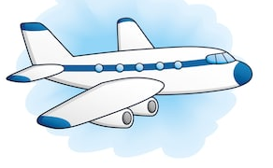

Flight Departures

Flight | Destination | Time | Gate | Information
AC171 | TORONTO | 16:30 | 11 | DELAYED 30 MINS
BA421 | LONDON | 16:30 | 23 | CLOSED
UA186 | CHICAGO | 16:50 | 17 | LAST CALL
AA755 | MOSCOW | 17:10 | 2 | NOW BOARDING
AM591 | PERTH | 17:20 | 6 | NOW BOARDING
ML632 | LIMA | 17:55 | 10 | WAIT IN LOUNGE
UA188 | CHICAGO | 18:20 | 15 | WAIT IN LOUNGE
BA409 | NEW YORK | 18:20 | - | DELAYED 60 MINS
UA218 | BOSTON | 18:40 | 23 | WAIT IN LOUNGE
VV201 | PARIS | 19:00 | 8 | WAIT IN LOUNGE
※delay延誤; board登機；lounge大廳；gate大門


55.( )Where can you see this kind of chart? chart 圖表
A)In a restaurant. B)In an airport.
C)At school. D)In a movie theater.
56.( )Mr. Brown is going to take Flight UA188 to
Chicago. Which boarding gate should he go to?
A)Gate 17. B)Gate 6.
C)Gate 23. D)Gate 15.
57.( )What does the word “destination” mean?
A)a name of the airplane
B)a place someone is going to
C)a thing someone buys
D)a place someone loves

※試題結束※

第

