臺北市立瑠公國民中學107學年度第二學期八年級第三次段考 英語科 考試卷
年 班 座號： 姓名：
第一部份：聽力試題 （25%）
- 辨識句意：根據聽到的內容，選出符合描述的圖片或符合圖片的描述。(每題1分，共5分)
- (Ａ) 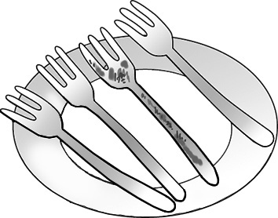 (Ｂ) 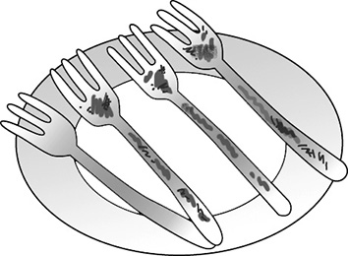 (Ｃ) 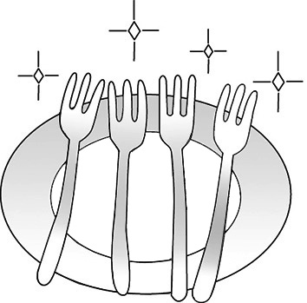
- (Ａ)  (Ｂ)  (Ｃ) 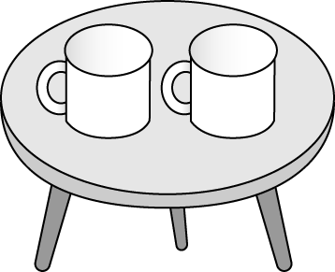
- (Ａ) 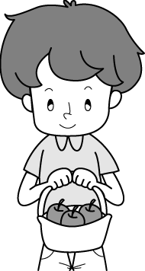 (Ｂ) 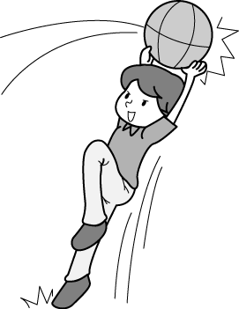 (Ｃ) 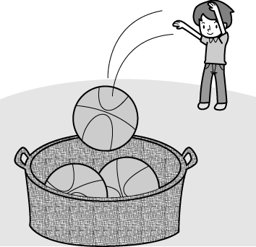
- (Ａ) 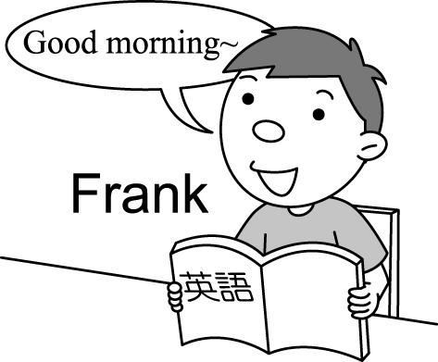 (Ｂ) 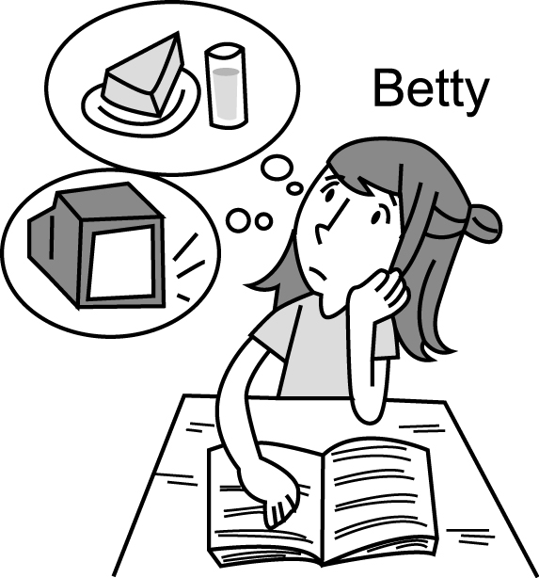 (Ｃ) 
- (Ａ) 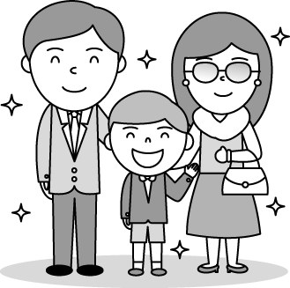 (Ｂ) 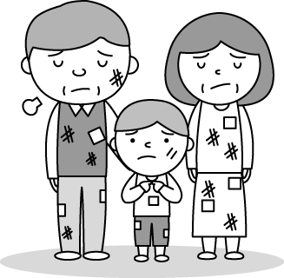 (Ｃ) 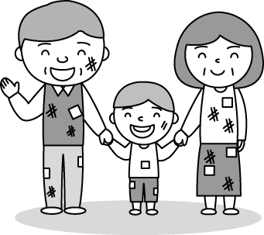
- 基本問答：根據聽到的內容，選出一個最適合的回應或最適合的問句。(每題2分，共10分)
- (Ａ) I prefer to order hamburgers.
(Ｂ) I would like to have three sandwiches.
(Ｃ) I’d like ham, cheese and lettuce, please.
- (Ａ) Medium.
(Ｂ) At the steak house.
(Ｃ) Both of them smell good.
- (Ａ) I just saw a zombie movie with him.
(Ｂ) A mean boy just took my money away.
(Ｃ) I saw the airplane land safely.
- (Ａ) Practice more, and you can shoot well, too.
(Ｂ) Come on! It’s just a computer game.
(Ｃ) Look! I’m good at shooting.
- (Ａ) It cost me NT$200.
(Ｂ) It takes two hours.
(Ｃ) Twice a month.
- 言談理解：根據聽到的內容，選出一個最適合的答案。(每題2分，共10分)
- (Ａ) A gym.
(Ｂ) An office.
(Ｃ) A student club.
- (Ａ) Many of Albert’s classmates gave him many gifts.
(Ｂ) Albert’s teacher also bought a novel for him.
(Ｃ) Albert didn’t have school yesterday.
- (Ａ) It is sunny outside.
(Ｂ) It is windy and cold outside.
(Ｃ) He is kidding.
- (Ａ) No, she won’t.
(Ｂ) Yes, she will.
(Ｃ) No, she doesn’t.
- (Ａ) He’ll stay at home.
(Ｂ) He’ll sing at a karaoke bar.
(Ｃ) He’ll go to the soccer practice.

第二部份：選擇題【16-42題，每題2分】
A.字彙題 (20%)
16. Tom: Who was that on the phone?
Mary: I have no idea, but it was a girl’s sweet . The call was for our son.
Tom: Does he have a new girlfriend again?
(Ａ) grade (Ｂ) voice (Ｃ) point (Ｄ) meaning
17. The sad movie “A Star Is Born” many people, and some of them even cried.
(Ａ) led (Ｂ) attacked (Ｃ) shot (Ｄ) touched
18. It’s to see someone with a smartphone in his or her hand on the MRT.
(Ａ) medium (Ｂ) common (Ｃ) national (Ｄ) plastic
19. Most of the members in my family hate the taste and smell of the stinky tofu. ___ of them like to eat it.
(Ａ) All (Ｂ) Both (Ｃ) Few (Ｄ) Every
20. _____ Harry and his wife Meghan are popular with people in England now. Many people like to talk about their marriage.
(Ａ) Arrow (Ｂ) Prince (Ｃ) Club (Ｄ) Princess
21. My parents to come to my birthday party last night because they were very busy.
(Ａ) failed (Ｂ) decided (Ｃ) got (Ｄ) checked
22. You always get the best grades in science in our class. Can you tell me some useful for learning English well?
(Ａ) tips (Ｂ) exercises (Ｃ) meanings (Ｄ) notes
23. Don’t your lunch box, or you will not have anything to eat when hiking in the mountain.
(Ａ) memorize (Ｂ) check (Ｃ) remember (Ｄ) forget
24. Sam, you should set a good to your little sister. Don’t talk with your mouth full.
(Ａ) menu (Ｂ) band (Ｃ) example (Ｄ) order
25. I read a terrible about activity in Hong Kong in the newspaper and felt sorry for those people.
(Ａ) meaning (Ｂ) article (Ｃ) answer (Ｄ) grade

B.文法選擇 (16%)
26. of the books on my desk is interesting. You can borrow of them from me.
(Ａ) One; both (Ｂ) All; every one (Ｃ) Both; two (Ｄ) Each; any
27. Jack, go finish all your homework before your dad home, or he angry with you again.
(Ａ) will get; will get (Ｂ) gets; gets (Ｃ) will get; gets (Ｄ) gets; will get
28. All of the money on the sofa mine, so please don’t take away.
(Ａ) are; them (Ｂ) are; ones (Ｃ) is; it (Ｄ) is; one
29. That’s a lot of food. Can you finish ?
(Ａ) all of it (Ｂ) each of it (Ｃ) most of them (Ｄ) few of them
30. If Jason something, he’ll ask the teacher or his classmates right away.
(Ａ) wasn’t understanding (Ｂ) won’t understand
(Ｃ) doesn’t understand (Ｄ) didn’t understand
31. The dog can’t eat meat it catches all the balls back to its owner.
(Ａ) when (Ｂ) but (Ｃ) because (Ｄ) before
32. Before __ the talent contest, she the piano a lot every day last month.
(Ａ) joins; practiced (Ｂ) joining; practiced
(Ｃ) she joins; practices (Ｄ) joining; practices
33. If you don’t know a word, you can ____.
(Ａ) prepare for tests (Ｂ) correct the mistakes
(Ｃ) look it up in the dictionary (Ｄ) mark important points

C.克漏字 (18%)
Long time ago, there was a mouse living in a hole of a wall. One day, __(34)__ he woke up, he smelled something delicious. He said happily to__(35)__, “That was cheese!” He wanted to take it for breakfast. He thought of what his parents said, “Always wait before you go for a piece of cheese.” He decided to wait quietly. He heard a cat’s sound and didn’t run out. He knew the cat was outside the hole. So he was happy that he listened to his parents. The next day, he still waited quietly in the hole. But this time, he heard a dog’s sound. He thought there was a dog outside, so the cat __(36)__ there. He thought he was __(37)__ and wanted to get the cheese. __(38)__ he ran out of the hole, the cat suddenly caught the mouse and ate him. The cat was happy that he listened to his parents and learned a second language.
34. (Ａ) if (Ｂ) and (Ｃ) because (Ｄ) when
35. (Ａ) himself (Ｂ) he (Ｃ) his (Ｄ) him
36. (Ａ) won’t be (Ｂ) isn’t (Ｃ) wouldn’t be (Ｄ) didn’t have to be
37. (Ａ) thirsty (Ｂ) yummy (Ｃ) safe (Ｄ) scared
38. (Ａ) Before (Ｂ) After (Ｃ) So (Ｄ) But

Do you always have a good sleep at night? Remember not to eat too much at night. Eating heavy and rich food within two hours before bedtime __(39)__ you awake. Before you sleep, also don’t forget to turn off all the lights. Do you ever wake up at midnight? __(40)__ you can’t fall asleep again, don’t just lie in bed. You should get up and do something easy and relaxing. Then go back to bed __(41)__ you feel tired. If you worry a lot, you can make a list of things you have to do the next day. Then you can get your worries __(42)__ your mind before you go to bed.
39. (Ａ) keep (Ｂ) keeps (Ｃ) keeping (Ｄ) kept
40. (Ａ) Although (Ｂ) Because (Ｃ) If (Ｄ) After
41. (Ａ) when (Ｂ) before (Ｃ) although (Ｄ) and
42. (Ａ) shot into (Ｂ) out of (Ｃ) fall into (Ｄ) pass away

D. 閱讀測驗 (21%) 【43-48題，每題2分；49-51題，每題3分】
a.

When David was young, he lived in a small town near the sea. His father was a fisherman. He had a small boat. He worked on the sea and always brought home a lot of fish. Before his father got the fish home, there were already some people waiting to buy the fish. When the baskets of fish were on the ground, people started to pick the fish they liked. His mother weighed the fish and collected the money. David put the fish in bags and gave them to the customers. It was a good experience. Now David buys fish from fishermen and sells them at the market. He is good at picking fresh fish, and he is also good at cooking fish. His customers buy fish from him and sometimes ask him the way to cook the fish. He teaches them different ways to make fish soup, fry fish, and make fish dumplings. David is a popular fish vendor at the market. His son, Sam, sometimes helps at his stand on weekends. Does Sam want to follow his father’s job? No. He goes to a cooking school. He wants to run a fish restaurant in the future.

*weigh 秤重 *collect蒐集 *customer顧客 *vendor 攤販

43. Which is true about David when he was young?
(Ａ) He wanted to have his own boat.
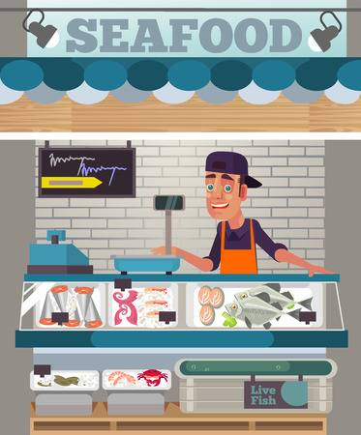
(Ｂ) He was crazy about the sea animals.
(Ｃ) He often went fishing with his father.
(Ｄ) He helped his mom sell fish in front of their house.
44. How does David make a living now?
(Ａ) He sells fish at a market.
(Ｂ) He works as a fisherman.
(Ｃ) He owns a fish restaurant.
(Ｄ) He teaches cooking lessons.
45. What can we know from the reading?
(Ａ) David still kept his father’s boat at home.
(Ｂ) David doesn’t want his son to follow his job.
(Ｃ) Sam has a clear idea about his future job.
(Ｄ) David’s wife cooks fish better than David does.

b.

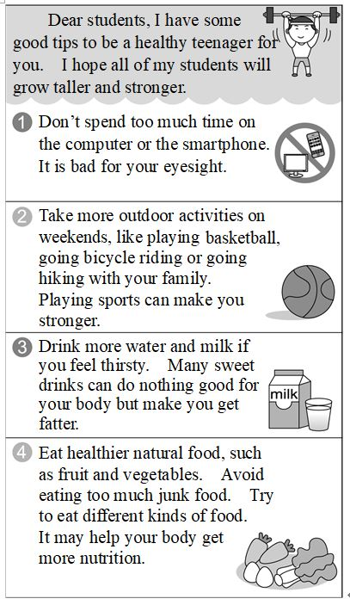
46. What is probably the speaker?
(Ａ) A cook.
(Ｂ) A farmer.
(Ｃ) A teacher.
(Ｄ) A writer.
47. What does the speaker ask the teenagers NOT to have?
(Ａ) Fruit.
(Ｂ) Vegetables.
(Ｃ) Milk.
(Ｄ) Cola.
48. What does the speaker talk about in the reading?
(Ａ) Spending too much time on the smartphone may be good
for your eyes.
(Ｂ) Eating fast food makes you healthier.
(Ｃ) Having many sweet drinks will make you become heavier.
(Ｄ) Taking exercise does nothing good for your health.

*such as譬如說 *avoid避免 *nutrition營養

c.
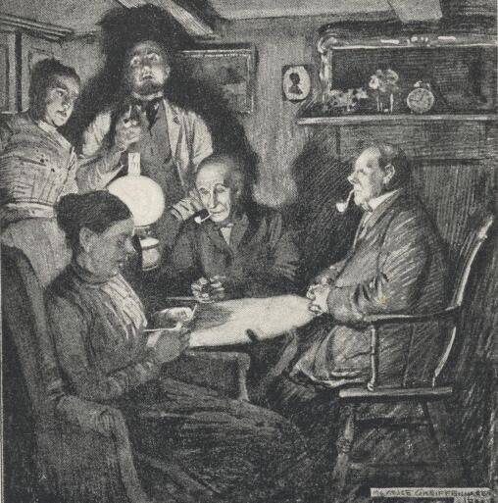
“The Monkey’s Paw”

“Morris! Come in, come in,” Mr. White’s old friend, soldier Morris entered the house.
The White family and their old friend, Morris, were now sitting in the living room.

“What happened to you, my old friend. You look scared.” said Mr. White.
“My life almost broke because of the Monkey’s paw” said Morris and he slowly took out a tiny skinny brown paw from his pocket.
“What is it for?” said Herbert, Mr. White’s son.
“It has magic. This paw grants three wishes for those who own it.” said Morris.
“Cool! Can I have it?” said Herbert.
“You’d better not. It is a curse.” said Morris.
Although Morris said so, he still gave the paw to the White family.

Without caring about Morris’s warning, the White family was excited and took a try right away. They wished for ’20,000 dollars” and the paw moved.

The next morning, while Mrs. White was knitting on the sofa, the doorbell rang. It was workers from Herbert’s factory. They said that Herbert was killed by the machinery in the factory and the White family could get ’20,000 dollars” as compensation.

After hearing the bad news, Mrs. White cried and asked her husband to wish for their son back.
"Do you really think that's wise?" said Mr. White. "After what just happened? Do you believe anything good can come from our wishes?"
"Don't you want your son back?" asked Mrs. White.
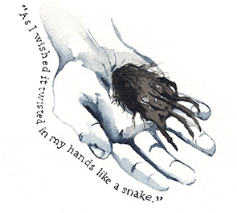
"Of course I do," said Mr. White.
He unlocked his desk drawer and took out the monkey's paw.
He closed his eyes. "I wish my son Herbert would come back." he said.
The paw moved.

A few minutes later, there was a voice from outside. It was Herbert’s footstep.
“THUMP! THUMP! THUMP!”
"We have one wish left," said Mr. White. "I wish..."
“THUMP! THUMP! THUMP!”
……
*tinny 小的 *skinny骨感的*grant贈與 *warning警告 *machinery機器 *compensation補償
49. What is the main idea of the story?
(A) Trust and listen to your friend.
(B) Love both your family and animals.
(C) Be happy with your life now.
(D) Think before you make a wish.
50. What does the word ‘curse’ mean?
(A) Bad luck. (B) Good luck. (C) Money. (D) Wish.
51. What might be Mr. White’s third wish?
(A) To wish for more wishes.
(B) To wish their son was dead.
(C) To wish for more money.
(D) To wish the paw was broken.

--試題結束--
Have a Good Summer Vacation.

