**臺北市立瑠公國民中學 107學年度第二學期第二次段考 七年級英語科試卷**

範圍：翰林版U4 ~ Review II **七年** **___班 座號：___ 姓名：__________**

**※選擇題請用2B鉛筆在電腦卡上劃記;非選擇題請用藍色或黑色原子筆在答案卷上作答**

**第一部分:聽力測驗 (第1-15題，共15題，25%)**

1. 辨識句意：選出符合句子描述的圖片。(每題1分)

1.（ ） (A)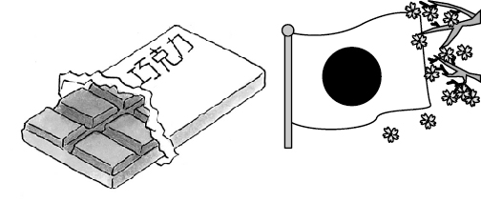 (B)**

(C)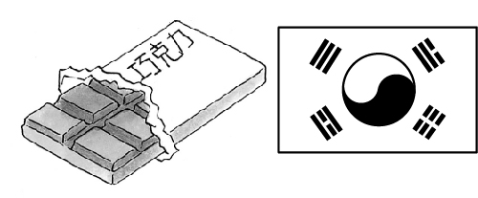

2.（ ） (A)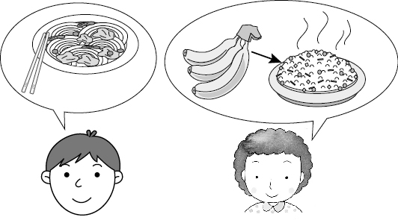 (B)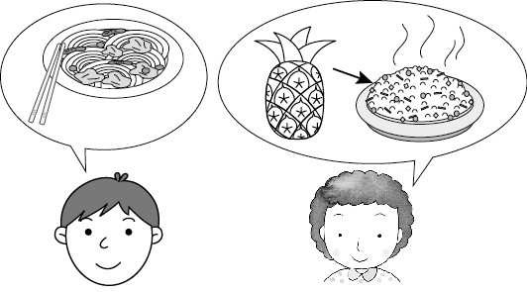

(C) 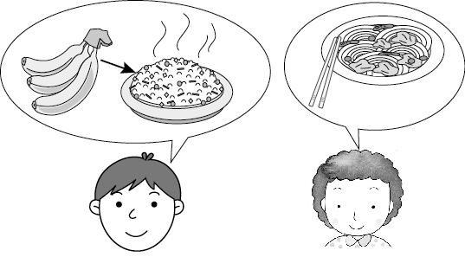

3.（ ） (A)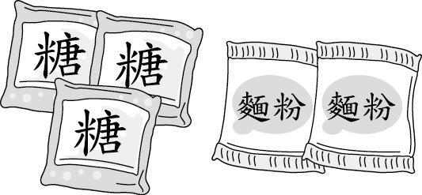 (B)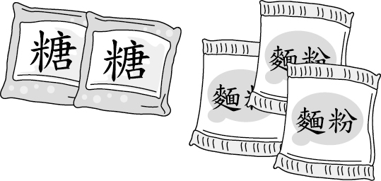

(C)

4.（ ） (A)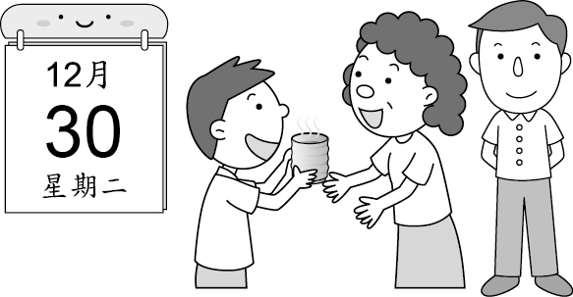 (B)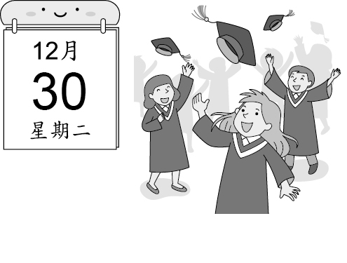

(C)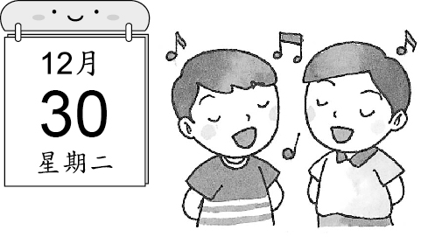

5.（ ） (A)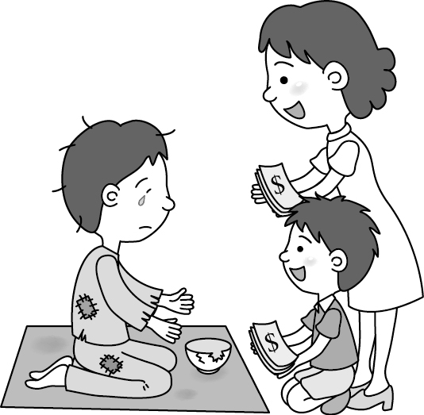 (B)

(C)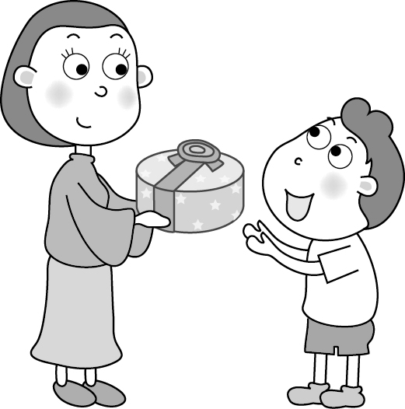

1. 基本問答：選出最適合的回答，完成對話。(每題2分)

6.（ ） (A) I don’t put any water in the juice!

(B) Five or six glasses of juice.

(C) The water is not cheap.

7.（ ） (A) I like lions.

(B) Who else? Kenny.

(C) Please write the card.

8.（ ） (A) No, I am not thirsty. You can drink it.

(B) No, it’s a banana cake. You can have it.

(C) No, you can make a pie for me.

9.（ ） (A) Well, I want bread and milk.

(B) Good! Chicken noodles are my favorite.

(C) We have breakfast before eight o’clock.

10.（ ）(A) I have two English classes on Monday.

(B) Monday is not the first day of the week.

(C) I don’t. I always have Monday blue.

C. 言談理解： 請聽對話或短文，選出問題最適合的答案。

(每題2分)

11.（ ）(A) On February 11th.

(B) On October 3rd.

(C) On October 10th.

12.（ ）(A) In a museum.

(B) In a zoo.

(C) In a restaurant.

13.（ ）(A) Making breakfast.

(B) Having breakfast.

(C) Selling breakfast.

14.（ ）(A) Four hundred dollars.

(B) Five hundred and seventy dollars.

(C) Sixty hundred dollars.

15.（ ）(A) To a guitar class.

(B) To the girl’s home.

(C) To the gym.

**第二部分:閱讀測驗 (第16-38題)**

**Ｄ. 單題 （第16-23題, 每題2分）**

1. ( ) Please show 　　　.

(Ａ)　it for me　 (Ｂ)　it me　

(Ｃ)　me for it　 (Ｄ)　it to me

17. ( ) Ken: 　　　 flour does she need?

Leo: She needs 　　　 flour.　

(Ａ)　How much; two　

(Ｂ)　How much; two bags of　

(Ｃ)　How many bags; two　

(Ｄ)　How many; two bags of

1. ( ) The dinner is not ready. Would you like some

first?　

(Ａ)　cookie　 (Ｂ)　hot dog　

(Ｃ)　milk　 (Ｄ)　noodle

1. ( ) There is not on TV tonight.

(Ａ)　any new things　

(Ｂ)　some new things　

(Ｃ)　anything new　

(Ｄ)　something new

1. ( ) Amy: Is it 　　　 March 8 today?

Ben: Yes. Hey, isn’t your birthday coming?

Isn’t it 　　　 March 12?

Amy: That’s right. It’s 　　　 this week.　

(Ａ)　×; ×; in　 (Ｂ)　on; on; ×　

(Ｃ)　×; on; ×　 (Ｄ)　on; ×; in

1. ( ) Cindy: How 　　　 milk is there in the bag?

Chris: There are 　　　.　

(Ａ)　many; a lot　

(Ｂ)　much; only one bottle　

(Ｃ)　many bottles of; two bottles　

(Ｄ)　much; three bottles

1. ( ) Mom, don’t worry the money. Here

our pocket money. You can use .　

(Ａ)　×; are; them　 (Ｂ)　about; are; them　

(Ｃ)　for; is; it　 (Ｄ)　about; is; it

1. ( ) The food at the stands 　　　 yummy.

(Ａ)　is　 (Ｂ)　are　 (Ｃ)　has　 (Ｄ)　have

**E. 題組 （第24-38題）**

**克漏字（第24-27題，每題2分）**

Do you know Margarita? It’s a famous kind of ___24___. It’s very delicious. It’s easy to ___25___. People can bake one by themselves at home. They only need three ingredients.  
　　First, they need basil. It’s like vegetable, and it’s green. Next, they need some ___26___. They are a kind of red fruit. ___27___ Cheese is white. Finally, they can put it into the oven.  
　　These ingredients are in three different colors. These colors are the colors of the flag of Italy. Where is Margarita from? Maybe you know the answer.  
kind種類 bake烤 ingredient食材 basil羅勒

oven烤箱 flag旗子  
（　）24. (A) bottle　(B) pizza　(C) cake　(D) stand  
（　）25. (A) make　(B) cook　(C) do　(D) get

（　）26. (A) bananas　(B) flour　(C) tomatoes　(D) sugar  
（　）27. (A) Then, they need cheese.  
　　　　 (B) After that, they get some chocolate.  
　　　　 (C) Now, they buy some eggs.  
　　　　 (D) Second, they enjoy the salad.

**閱讀理解（第28-38題，每題2分）**

**I.**



have to必須 pay付錢

（　） 28.　It’s 11:10 a.m. Albert is buying Set A at Jeremy’s Kitchen. What CAN’T he get for his meal?

(Ａ)　Fried rice.　(Ｂ)　French fries.

(Ｃ)　Apple pie.　(Ｄ)　Coffee.

（　）29.　Which is true?

(Ａ)　Amanda is ordering Set B at 12:00 p.m. If

she gets her meal at 12:30 p.m., she can get

free ice cream.

(Ｂ)　Nancy is buying Set A and Set B. She is

changing her cake and pie to fried chicken.

She has to pay three hundred fifty dollars.

(Ｃ)　George often eats at Jeremy’s Kitchen

before 11:30 a.m. He can get free French

fries.

(Ｄ)　Sandy is taking her meal out. She can get

a free rice ball.

II.

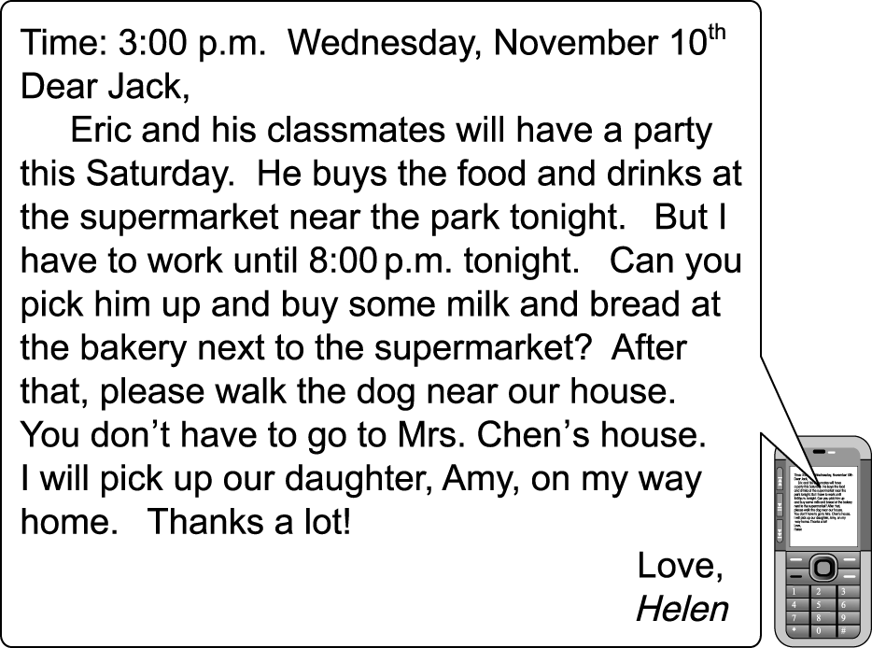

will將要 until直到 bakery麵包店 pick up接送

（　）30.　When is Eric’s party?

(Ａ)　On November 11.　(Ｂ)　On November 13.

(Ｃ)　On November 14.　(Ｄ)　On November 20.

（　）31.　Who is Jack?

(Ａ)　Eric’s classmate.　 (Ｂ)　Amy’s brother.

(Ｃ)　Helen’s husband.　 (Ｄ)　Eric’s brother.

（　）32.　What DOESN’T Jack have to do tonight?

(Ａ)　Pick up Eric.　 (Ｂ)　Pick up Amy.

(Ｃ)　Go to the bakery.　 (Ｄ)　Walk the dog.

（　）33.　Which is true?

(Ａ)　Helen has to work late.

(Ｂ)　Eric has a Christmas party on Saturday.

(Ｃ)　Jack doesn’t work today.

(Ｄ)　Amy has to buy some milk and bread.

III.

　　Betty buys some food at *Burger Queen*. Here is the receipt.

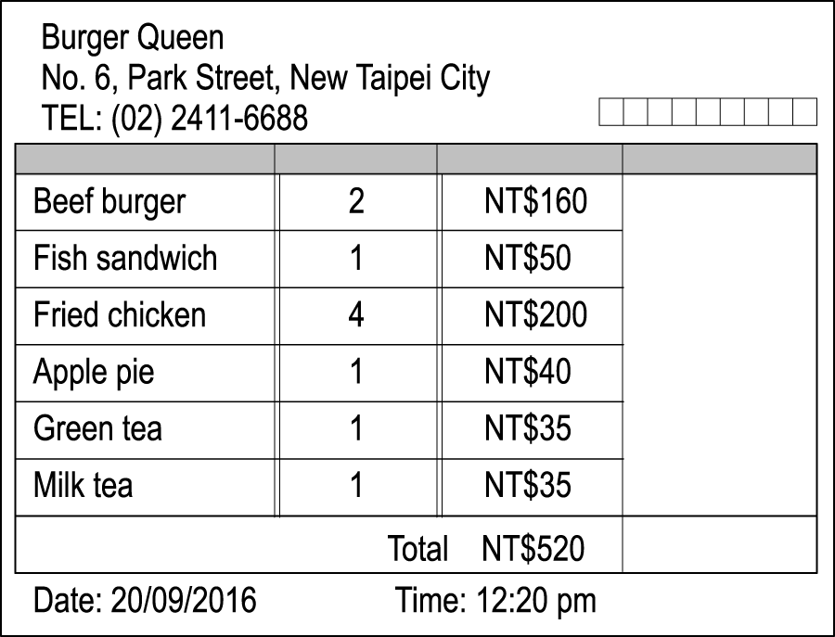

total總計

（　）34.　What date does Betty go to *Burger Queen*?

(Ａ)　September second.

(Ｂ)　September twelfth.

(Ｃ)　September twentieth.

(Ｄ)　September twenty-second.

（　）35.　How much is a beef burger?

(Ａ)　NT$40.　 (Ｂ)　NT$80.

(Ｃ)　NT$160.　(Ｄ)　NT$200.

（　）36.　Which is NOT true?

(Ａ)　*Burger Queen* is in New Taipei City.

(Ｂ)　Betty goes to *Burger Queen* in the

afternoon.

(Ｃ)　All the food is six hundred and fifty NT

dollars.

(Ｄ)　A fish sandwich is fifty NT dollars.

IV.

　　Mark loves his dad. His dad’s fiftieth birthday is coming. He wants to buy a great gift for him. He knows his dad likes watches, but his dad already has a new one. His dad takes pictures in his free time, but he already has a camera. Suddenly, he thinks of a good idea. His dad is a little heavy, but he does not have a lot of time to exercise. So he decides to buy a Wii. His dad can play Wii and lose weight. It will be a wonderful gift for his dad. But he doesn’t have that much money. His sister, Tracy, says, “Don’t worry. We can buy it together.”



（　）37.　What will be the gift for Mark’s dad?

(Ａ)　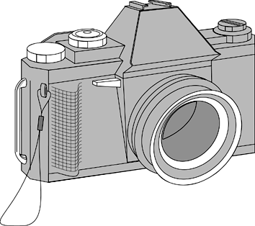　 (Ｂ)　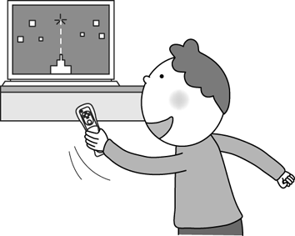　(Ｃ)　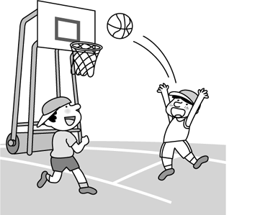　(Ｄ)　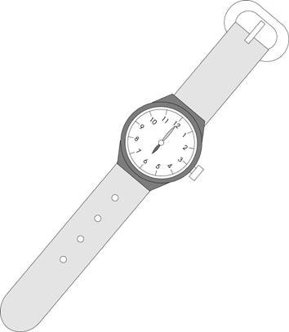

（　）38.　Which is true?

(Ａ)　Mark’s dad is 55 years old.

(Ｂ)　Mark’s dad can’t take pictures.

(Ｃ)　Mark’s dad doesn’t have a watch.

(Ｄ)　Mark and his sister will buy the gift

together.

**第三部分：非選擇題試題，請用黑筆寫在手寫答案卷**

**F. 文意字彙（第39-43題，共5題，每題2分）**

1. The watch is cool but e　　　e. I cannot buy it with my pocket money.

1. We have a Christmas party on D　　　r 25.

1. Just kidding! Don’t be angry. Today

is A　　　l Fool’s Day.

1. The girl in a pu　　　e dress is my cousin, Cathy.

1. Jane: Where do we eat for lunch? Hank: How about Johnny’s? It’s a new r　　　t.

**G.** 填入正確的人稱代名詞或介系詞**（第44-53題，每題1分）**

a. Jack and I are going to a movie tonight. Do you want to join

44 ?

b. Your brothers play basketball vey well. Are 45 players?

c. Kitty is a cute little baby cat. I like 46 so much.

d. The apples are great. I love 47 .

e. Is your mother here? I have some coupons for 48 .

f. Ryan and Linda are cousins. 49 mothers are sisters.

g. May is the fifth month 50 the year.

h. Students go to school 51 the morning.

i. Serena has a piano class 52 the morning 53 May 22nd.

**H. 中翻英（第54-56題，共9分）**

54. 你喜歡哪一個，美式麵條還是中式麵條？

55. 我只在母親節表達我的感謝。

56. 媽媽一天24小時一年365天全年無休地照顧我。

試題到此結束，辛苦了！