臺北市立瑠公國中107學年度第二學期八年級英文科第二次定期評量試題
八年 班 號 姓名：
第1頁，共3頁

※選擇題請在電腦卡上作答，共62分
一、聽力測驗20%
- 選出符合句子描述的圖片5 % (每題1分)
01.
(A)  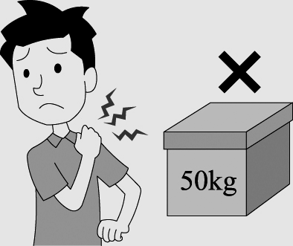 | (B)  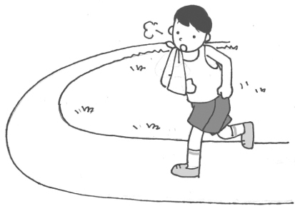 | (C)  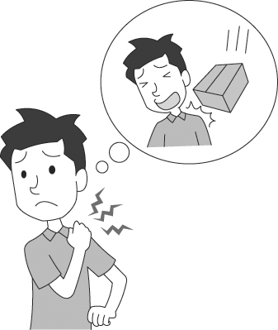
02.
(A)  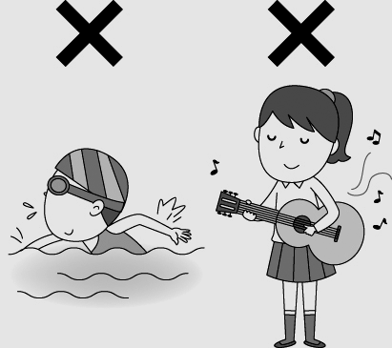 | (B)  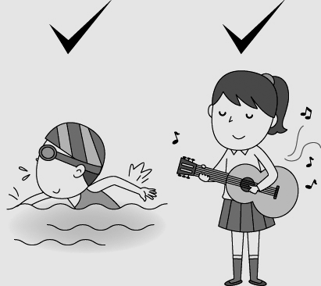 | (C)  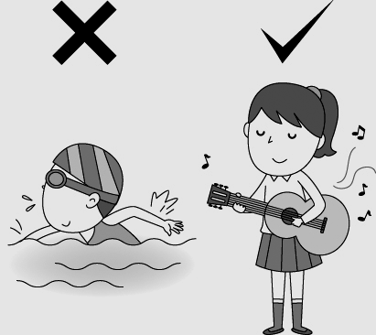
03.
(A)  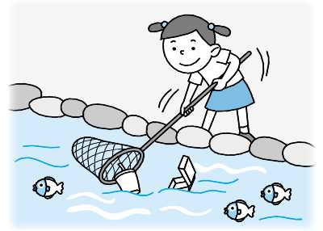 | (B)  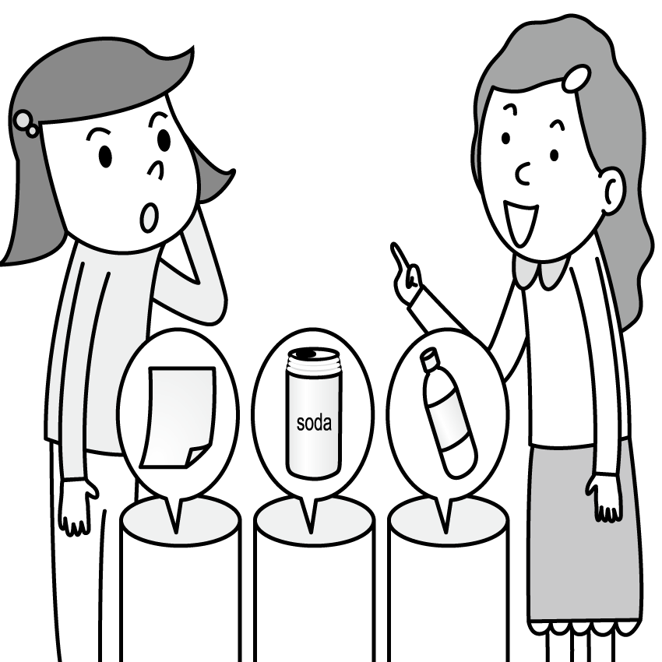 | (C)  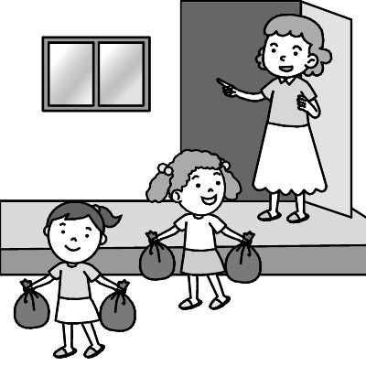
04.
(A)  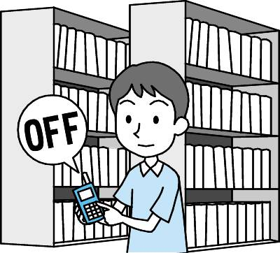 | (B)  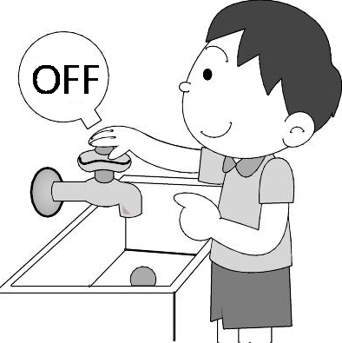 | (C)  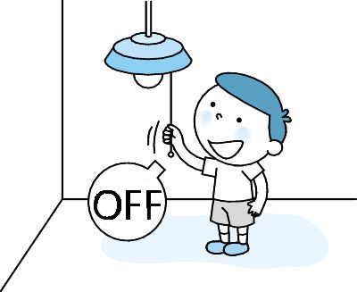
05.
(A)  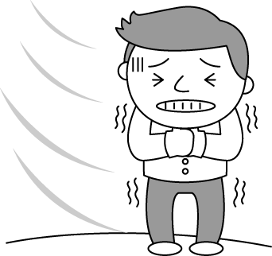 | (B)  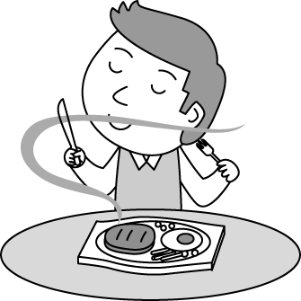 | (C)  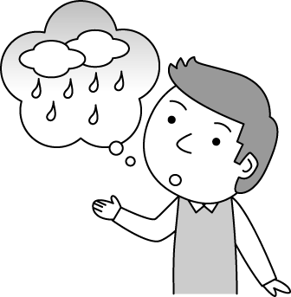
B. 選出最適合的回答，完成對話5% (每題1分)
06. (A) Thank you. I love you guys.
(B)However, you won in the end.
(C) Cheer up. You’ll do better next time.
07. (A) Terribly , so I eat out every day.
(B) It’s easy for me to cook for her.
(C) Your grandmother cooks very well.
08. (A) You got it.
(B) Thank goodness.
(C) Oops! I am sorry.
09. (A) Sure. Please help yourself.
(B) It’s spring water.
(C) I am sorry. I can’t see it clearly.
10. (A) By ourselves.
(B) Only a few miles.
(C) We shouldn’t ride on the turtles.

C. 請聽對話或短文，選出問題最適合的答案。10%
11. (A) The boy didn’t agree with the girl’s parents.
(B) The boy thought the girl’s parents were right.
(C) The boy’s parents told him not to go to bed late.
12. (A) Use the water wisely.
(B) Plant flowers in the yard.
(C) Have the woman keep water in the bathroom.
13. (A) Make his mom sort the socks.
(B) Help his mom roast the turkey.
(C) Let his mom clean his bedroom
14. (A) Went snorkeling
(B) Flew kites.
(C) Watched the sunset.
15. (A) He took away the books at the bookstore.
(B) He shouted at his daughter.
(C) He heard Mary shouting.
二、文法選擇20%(每題2分)
16. ___ did the students practice for the music contest?
They practiced very _____.
(A) What; hardly (B) What; hard
(C) How; hardly; (D) How; hard
17. A: Did you _____ your arm? B: Yes, it ____ now.
(A) hurt; hurts (B) hurt; is hurt
(C) get hurt; hurts (D) get hurt; hurt
18. My dad won’t let me own a smartphone, and my mom _______.
(A) will; too (B) is, too
(C) won’t, either (D) isn’t, either
19. Would you speak ________? I want to hear you ________ clearly.
(A) more loudly; less (B) louder; more
(C) less loudly; more (D) louder; less
20. Mom _____ me do the dishes every day.
(A) has (B) tells (C) asks (D) wants
21. I don’t think Mom will _____ us watch the movie, Avengers: Endgame. This _____ us sad.
(A) let; lets (B) let; makes
(C) make; lets (D) make; makes
22. John looked _______ at the party, and he looked ________ at everyone around him.
(A) happy; happy (B) happily; happily
(C) happy; happily (D) happily; happy.
23. Everyone, it’s party time. Please help _______ to the food, and let’s enjoy _______ the whole night.
(A) himself; yourselves (B) herself; themselves (C) herself; yourself (D) yourselves; ourselves.
24. Those workers _______ be tired. They _______ to stop woring right now.
(A) must; have (B) should; must
(C) have to; must (D) must; should
25. A: Does Roy cook more _____ than Joy or Leo?
B: That’s right. He cooks ___________ of the three.
(A) badly; most poorly (B) worse; the worst
(C) poor; the poorest (D) terribly; most terribly
三、克漏字選擇 10%（每題 2分）
Ethan and his family wanted to take a trip to Mt. Ali. They planned to watch the sun (26) , but they got up too late. They changed their minds and went biking at the beach. They took their bikes by train and then rode (27) miles to the beach. While they were riding the bike, they felt the wind (28) and saw the sunset. They also heard the waves hitting the rocks and (29) many people flying kites over there. That was a beautiful picture. They enjoyed the day a lot. Now, they are planning to go biking by (30) again to travel around the beautiful island next time.
26. (A ) to come up (B) come up (C) came up
(D) is coming up
27. (A) little (B) a little (C) few (D) a few
28. (A) to blow (B) would blow (C) blows
(D) blowing
29. (A) looked at (B) saw (C) felt (D) listened to
30. (A) them (B) they (C) their (D) themselves

四、閱讀測驗 12% (每題2分)
1.
Here is a poster of the JOYGO Summer Camp. Read it and answer the questions.

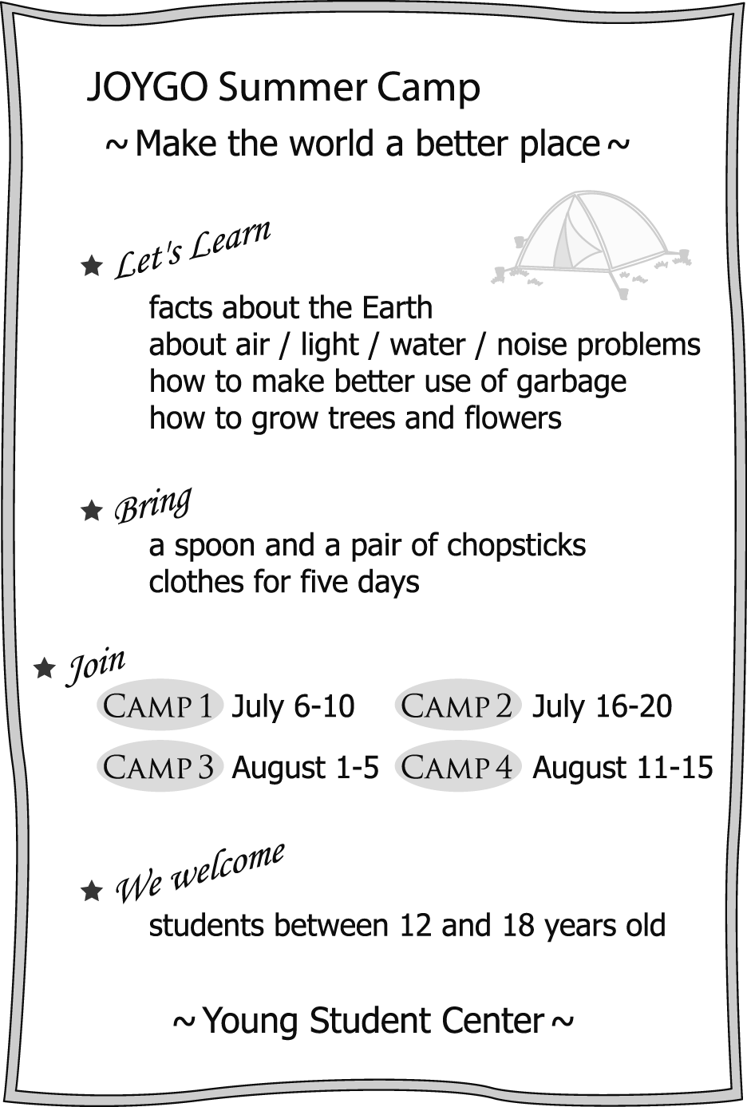

31. Which is the best logo for the JOYGO Summer Camp ?
(A)  | (B) 
(C)  | (D) 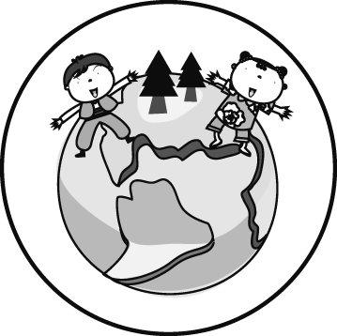
32. Which helps reduce the trash?
(A) Bringing one’s own spoon and chopsticks. (B) Bringing one’s clothes for less than a week (C) Throwing the garbage away every day .
(D) Picking different kinds of flowers.
33. Emily, a junior high school student, wants to go to the JOYGO Summer Camp, but she has to take math and science lessons from July 10 to 31, and her parents will take her for a trip on August 12. Which camp could Emily join?
(A) Camp 1. (B) Camp 2.
(C) Camp 3. (D) Camp 4.
2.
34. Who is NOT from Class 809?
(A) Christy. (B) Patty. (C) David. (D) John.
35. According to the reading, which is NOT true?
(A) The PE teacher taught them some tips for
tug-of-war.
(B) Patty enjoys working together with her
classmates.
(C) Christy is excited and hopes that her class can
win the game.
(D) David believes that winning the game is the
most important.
36. What does Cooperation mean?
(A) Winning a game.
(B) Keeping a healthy body.
(C) Working together.
(D) Fighting until the end.

※下列題目請在答案卷上作答，共38分
五、文意字彙 20%(每題2分)
37. Kenny got down on one k_____e and proposed (求婚) to his girlfriend.
38. They shouted the actor’s name and ch___ed loudly.
39. Ann cut her f_____r when she cut the carrot in the kitchen.
40. We need to stop using p_____c cups and bags to save our earth.
41. Dad p_______ed to take us to see the movie “Avengers: Endgame ” after the mid-term.(期中考)
42. Mrs. Chen wants us to use money more w___ely.
43. It’s very c_________t to go everywhere by MRT.
44. Don’t sit on that b_____ch! The paint is still wet.
45. Wendy likes to wear b______t colors, like yellow and red.
46. There were too many people in the concert so she couldn’t see her friends in the c______d.

六、依提示寫出正確詞類變化,每題不限一字8%
47-48.Allen can speak ________ English. He speaks English very _________. (good)
49. Becky ran _________(far) than Amy.
50. Anita jumps ________(high) in her school.
51. The boy helps his father _____ (feed) the cows.
52. No one heard the boy ______(cry) in the pool.
53. This morning, I saw Tom talk to ___ in the corner.
54. Boys, make _________ at home and have fun.
七、翻譯(中翻英) 10%
55. 我沒有跑這場接力賽是因為我跑得比其他跑者
慢多了。然而，勝利不代表一切。(3%)
56. 請記住這一點：我們應該養成使地球保持乾淨和
健康的習慣(3%)
57. 為何我們不自己去綠島？我們將可以同時一邊去浮潛一邊看著漂亮的魚在海裡游泳(4%)

