台北市立瑠公國民中學909第二次英文段考

班級 _______ 座號_________姓名 ______________
- 中翻英（14%）

1. 微笑 _____________ 2. 北方的______________ 3. 青少年 _____________ 4. 高速公路____________

5. 咬傷；咬 _____________ 6. 景象 _____________________ 7.或許___________________
II. 依照圖，填入正確的單字（8%）

1. 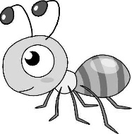  __________________ | 2. 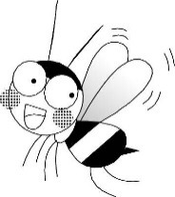  __________________ | 3. 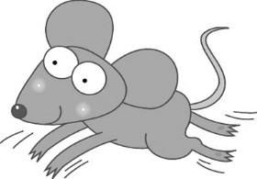  ___________________ | 4. 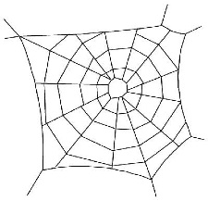  __________________
- 文意字彙（40%）
almost angry appears built choose collects comfortable cross exceept glad lonely neighbor notice outside quit serious shy solve traffic uniform

quit 1. Helen was that her boyfriend forgot her birthday.
uniforms 2. Students in Taiwan are asked to wear in Taipei.
almost 3. Terry was hit by a taxi. Luckily, the taxi driver stopped when he saw him.
shy 4. She is a girl. She seldom talks in front of people.
glad 5. A: Mark, I’m to see you again. B: Me, too.
collects 6. My brother MLB baseball cards. He has about a hundred of them.
quit 7. You should smoking because it’s bad for your health.
built 8. The house was about 150 years ago. It’s an old house.
except 9. To me, nobody my mom can make good pumpkin pies. She is the best.
notice 10. A: Did you that I got my hair cut? B: No, did you?
outside 11. A: Mom, can we go ? I have been doing my homework for hours.
cross 12. Be careful when you the street.
traffic 13. A: Hey, you are one hour late. B: Sorry, the was busy.
comfortable 14. That sofa is so . I’d like to take it.
appears 15. The actress to be young in the red dress.
lonely 16. Grandma felt last weekend because there was no one home.
gry solve 17. You should take action to the problem.
neighbor 18. Danny is my . He lives next door.
choose 19. Which senior high school will you , the one near home or the one close to the train station?
serious 20. What’s wrong? Mr. Brown looks today.
- 選擇（20%）

( B ) 1. Can you let me know to do?
(A) why (B) what (C) how (D) who
( C ) 2. The television when they left the room.
(A) turned off (B) are turned on (C) was turned off (D) should turn off
( B ) 3. this old lady sent to the hospital?
(A) Will (B) Has (C) Did (D) Was
( A ) 4. A new supermarket is going to in town.
(A) build (B) be built (C) building (D) have built
( C ) 5. Do you know ?
(A) what time did you see that old man (B) what time can I see her
(C) what time it is (D) what time does he come
( B ) 6. Was the garbage ?
(A) collect (B) collected (C) be collected (D) collecting
( B ) 7. The sea from his window.
(A) can see (B) can be seen (C) have seen (D) will see
( B ) 8. Kelly is a new student, so she doesn’t know the restroom is.
(A) whether (B) where (C) how (D) that
( D ) 9. Please tell me .
(A) when did he come (B) where did I put my wallet
(C) who is the girl (D) how long you will stay here
( A ) 10.Most of the painter’s best paintings when he was poor.
(A) were painted (B) painted (C) have painted (D) would paint

V. 依提示作答（12%）
1. Someone found the bicycle in front of the bus stop.（用The bicycle開頭）

_____________________________________________________________________________________________
2. How far is the library? I have no idea.（合併句子）e been collected these spiders and bugs. _____________
3. These spiders and bugs have been collected by Sokha.（用Sokha開頭）
Wasup brok_____________________________________________________________________________en he

4. The problem is not that hard. Let’s work it out. （翻成中文）_______________________________________________

5. This is Judy’s last year in senior high school. （翻成中文）_______________________________________________

6. Mount Fuji is always covered with snow. （翻成中文）___________________________________________________

VI. 閱讀測驗（根據故事，回答以下問題，對的寫T，錯的寫F）（6%）

Sokha is a young boy from Cambodia. He isn't very tall. He's small for his age because he doesn't get enough meat to eat. His family raises geese, but they will only be served as food on special days. So, what does Sokha do when he wants to have some meat? He hunts for big spiders.
( )1. Soka is strong because he eats a lot of meat.
( )2. Soka’s family raises geese.
( )3. Soka hunts for spiders for food.

