臺北市立瑠公國民中學 108學年度第一學期第二次段考 八年級英語科試卷
範圍：翰林版U4~ Review II 八年 ___班 座號：___ 姓名：__________
※選擇題請用2B鉛筆在電腦卡上劃記;非選擇題請用藍色或黑色原子筆在答案卷上作答

第一部分:聽力測驗 (第1-15題，共15題，20%)
- 辨識句意：選出符合句子描述的圖片。(每題1分)

1.（ ） (A)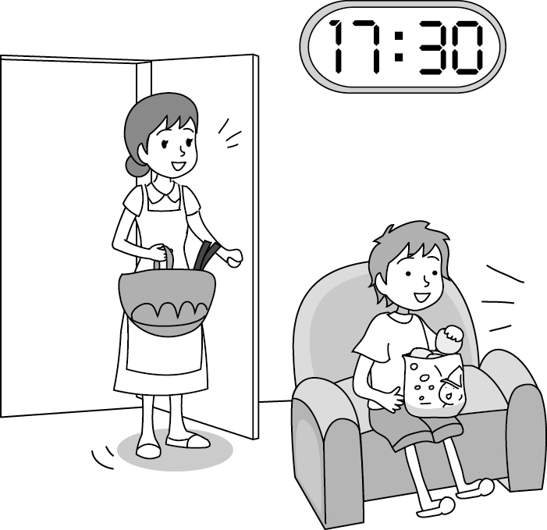 (B)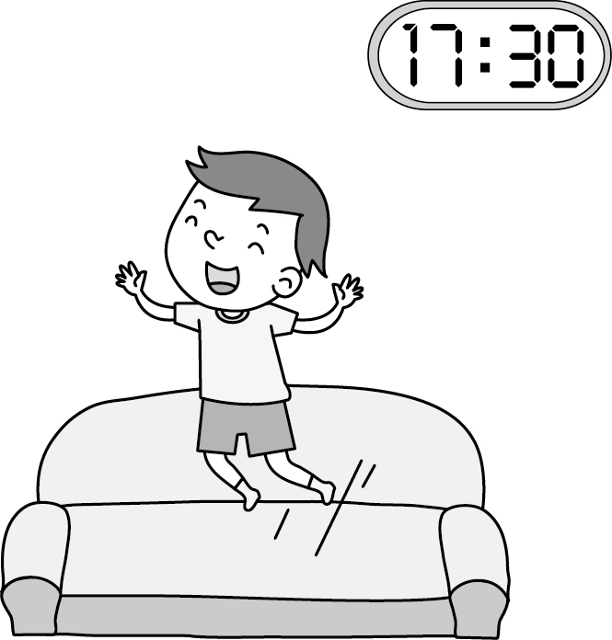
(C)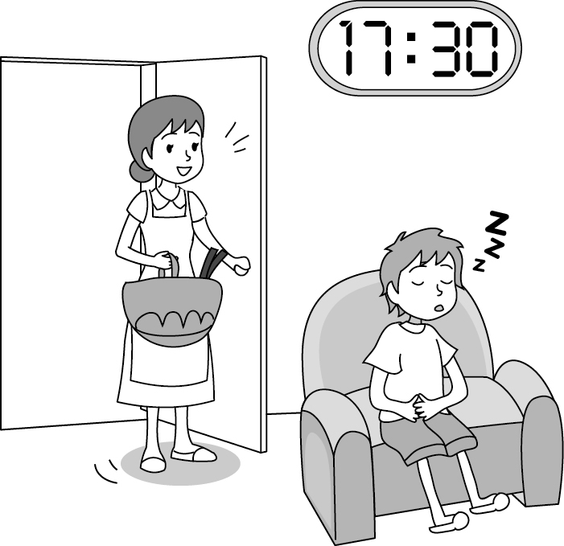
2.（ ） (A)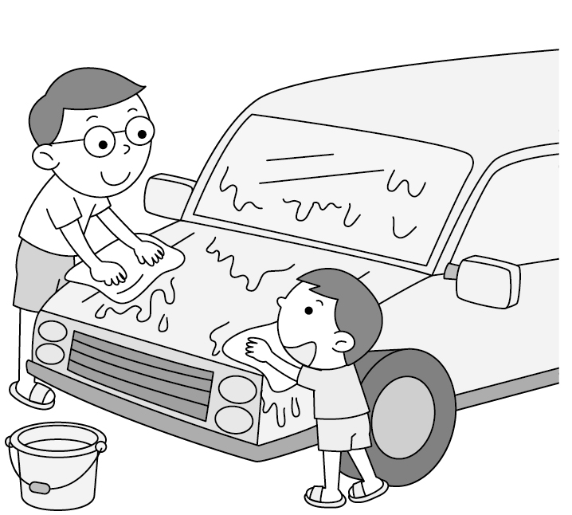 (B)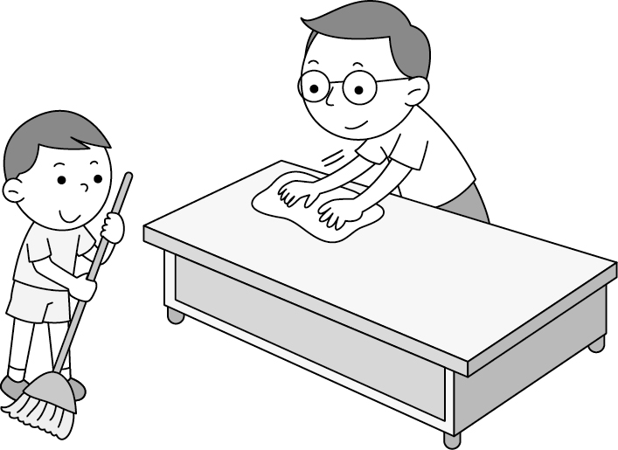
(C)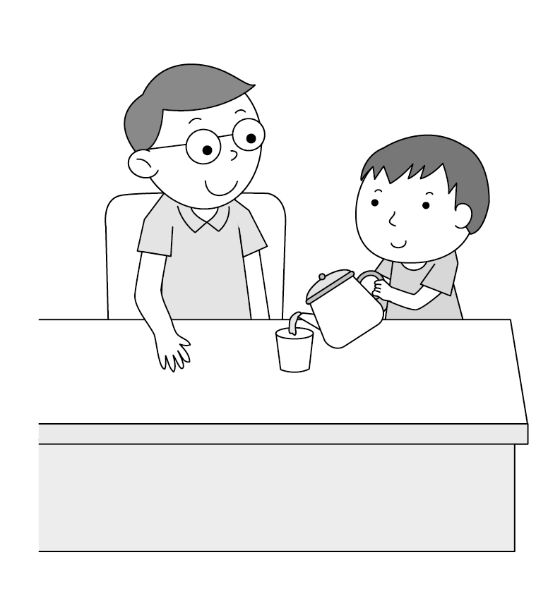
3.（ ） (A)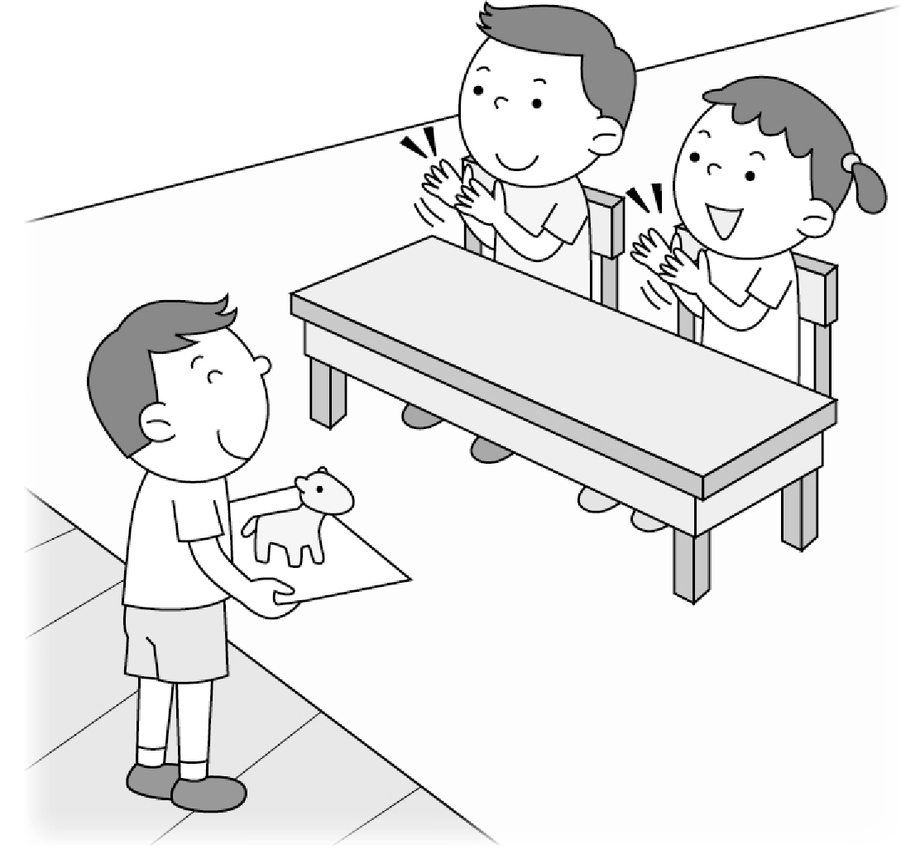 (B)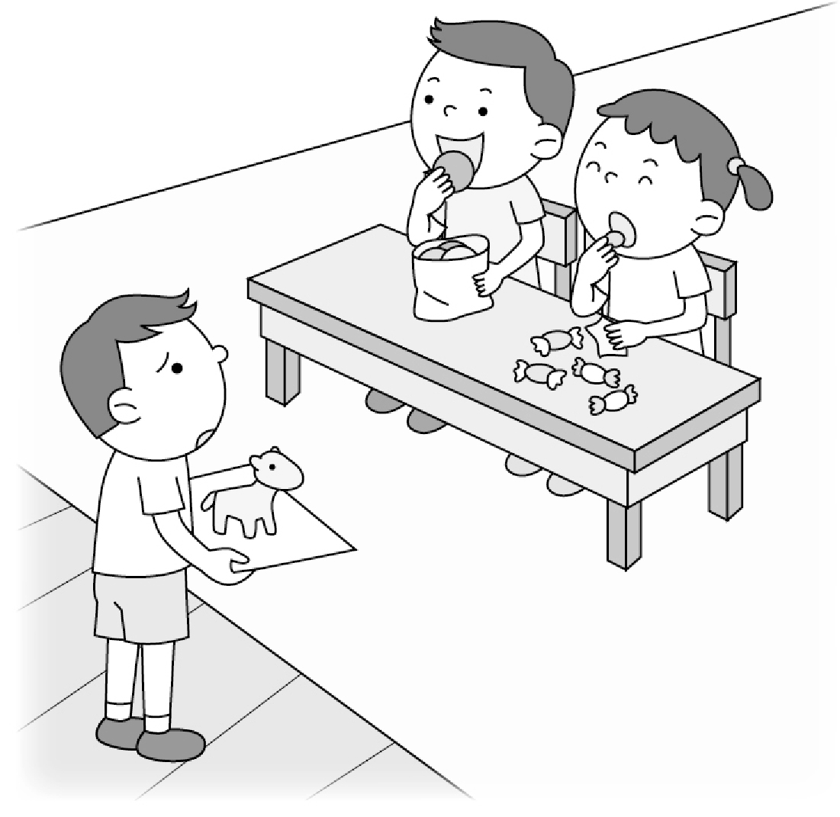
(C)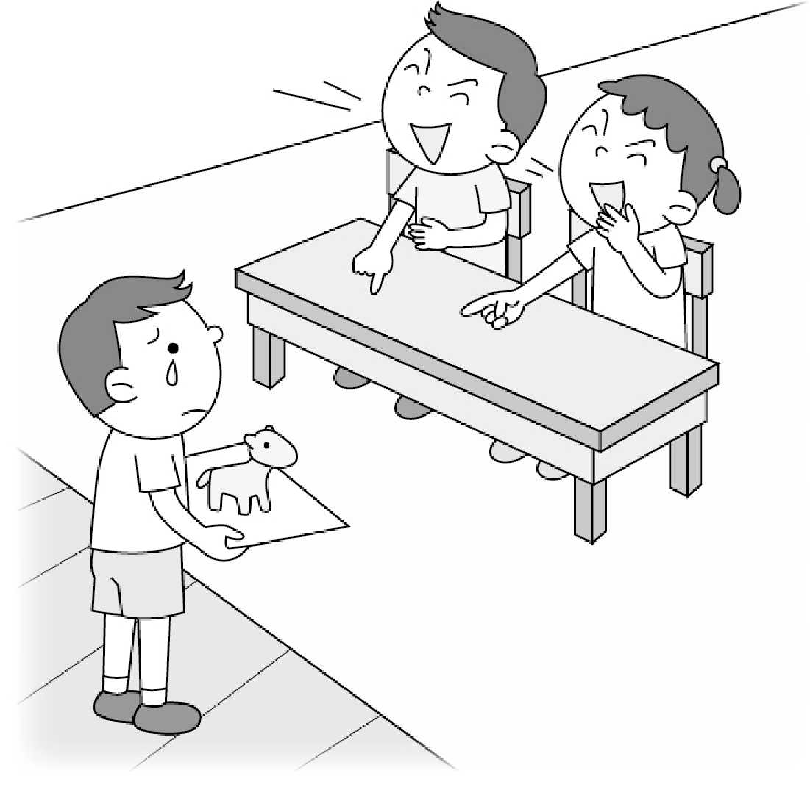
4.（ ） (A)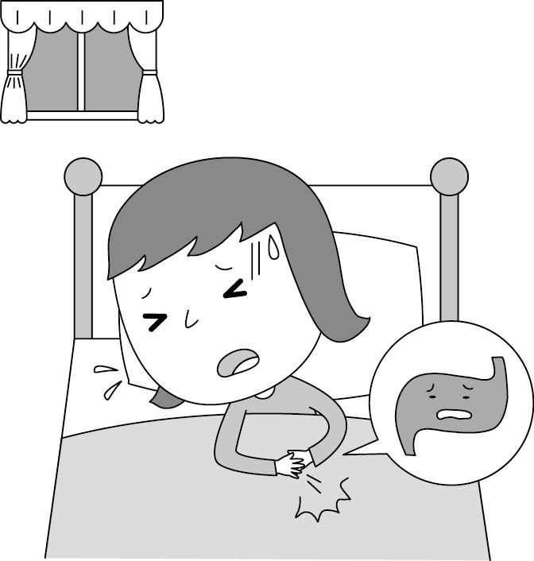 (B)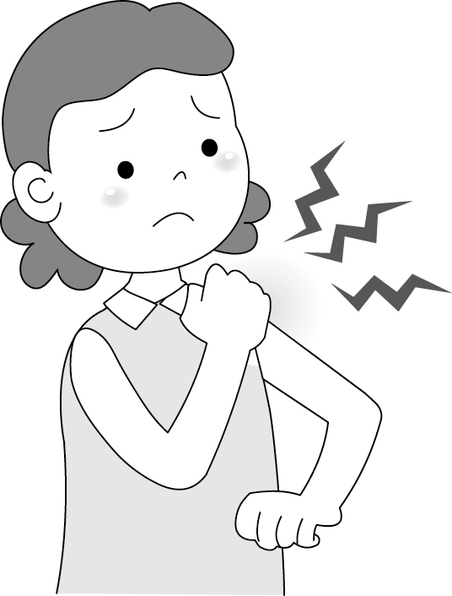
(C)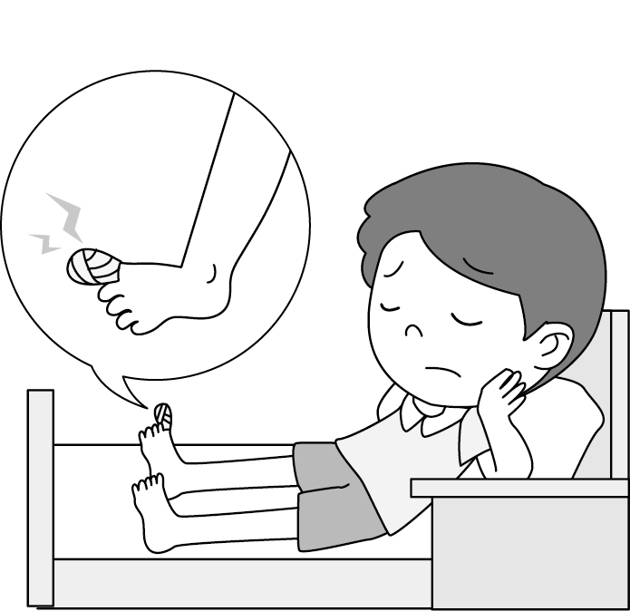
5.（ ） (A)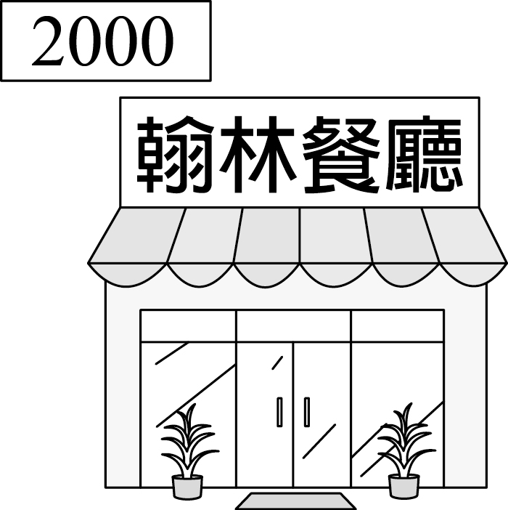 (B)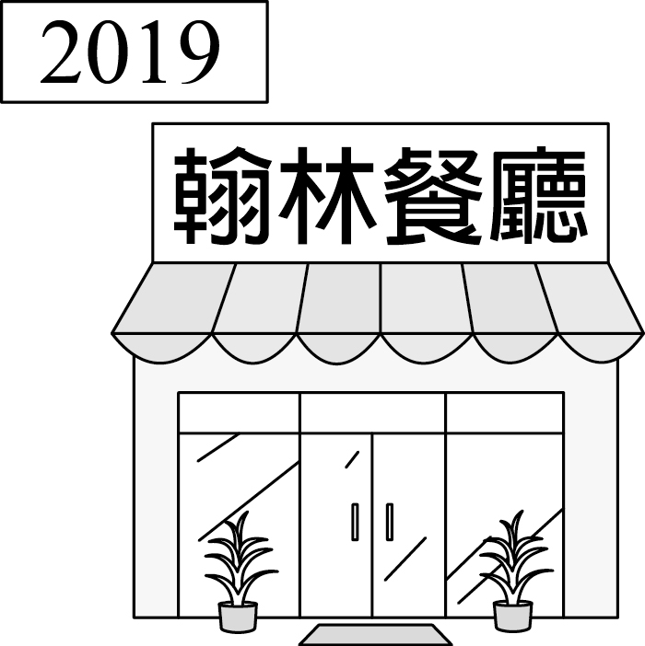
(C)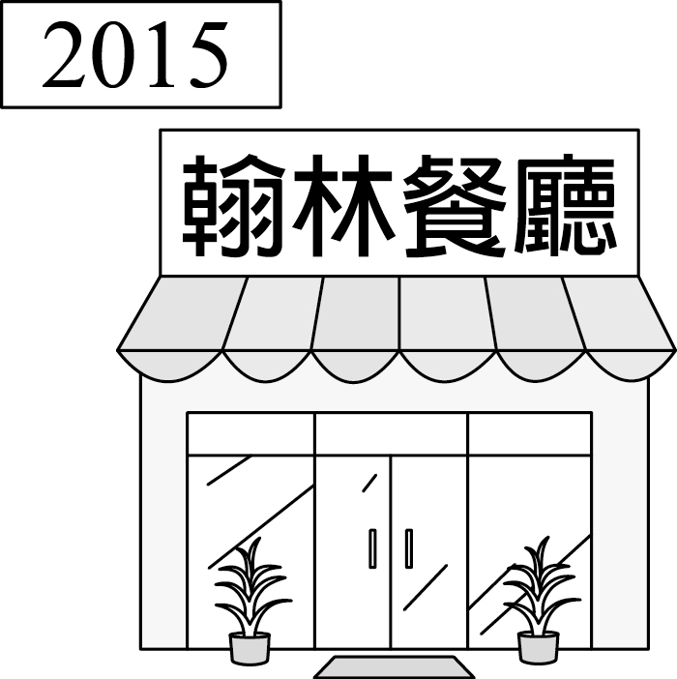

- 基本問答：選出最適合的回答，完成對話。(每題1分)
6.（ ） (A) You can sing here.
(B) I am all ears.
(C) I seldom write stories.

7.（ ） (A) We were hanging out all night.
(B) We love having a big dinner with him.
(C) No one remembers to celebrate it with me.

8.（ ） (A) But going to work is not easy for her.
(B) Yes, it is wonderful to live in a tree house.
(C) Now let’s clean the house for her family.

9.（ ） (A) Yes, the dinner party was terrible.
(B) Please take me to Dr. Su for my backache.
(C) Come on! I always think of giving you a hand.

10.（ ）(A) Cool! You are my hero.
(B) Great! I also like Stanley’s comic books.
(C)Well, he asked me to give them back.

C. 言談理解： 請聽對話或短文，選出問題最適合的答案。
(每題2分)
11.（ ）(A) Say no to his brother.
(B) Finish the woman’s dish.
(C) Prepare noodles for his family.

12.（ ）(A) Samantha is a good student.
(B) Being a writer is difficult for Samantha.
(C) Bruce thinks Samantha’s dream can come true.

13.（ ）(A)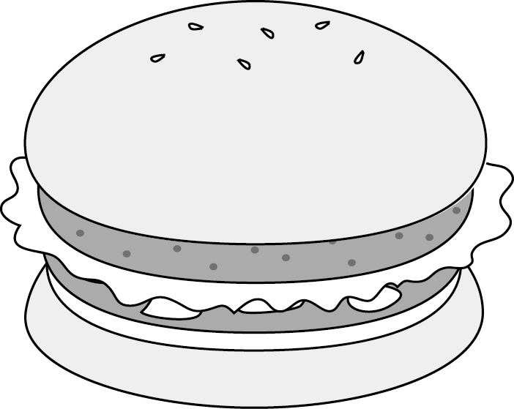 (B)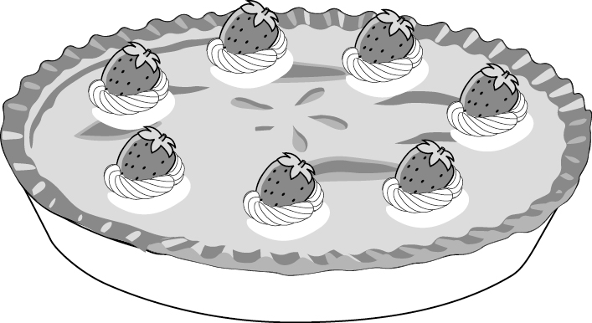 (C)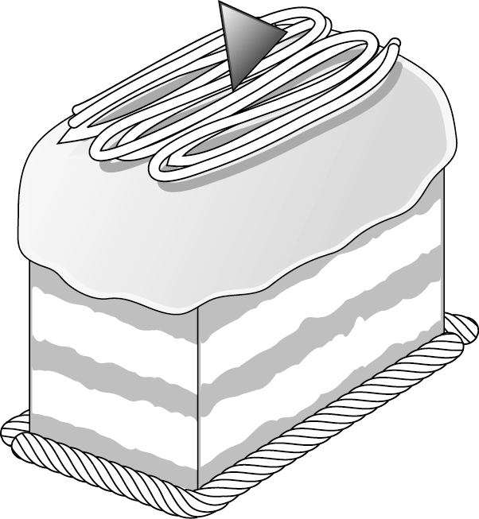

14.（ ）(A) Louis and his mom loved watching the TV show.
(B) Louis didn’t find his wallet.
(C) Louis was watching TV and doing the homework at seven.

15.（ ）(A) Spiderman is a new movie.
(B) The man can get a book and two pictures.
(C) The comic book is five hundred for each.
第二部分:閱讀測驗 (第16-45題)
Ｄ. 單題 （第16-27題, 每題2分）
- ( )My grandpa likes up early and going jogging at the park.
(Ａ) to get (Ｂ) getting (Ｃ) gets (Ｄ) got
- ( )Never stop English. Always keep speaking English every day.
(Ａ) to learn; to practice (Ｂ) to learn; practicing (Ｃ) learning; practicing (Ｄ) learning; to practice
- ( )Reading tips（訣竅） very important and helpful when you are reading.
(Ａ) are (Ｂ) is (Ｃ) does (Ｄ) was
- ( ) the game next week, they practice hard every day.
(Ａ) Win (Ｂ) Winning
(Ｃ) Won (Ｄ) To win
- ( )The Beck family planned a barbecue party this Sunday.
(Ａ) not to have (Ｂ) not having
(Ｃ) not have (Ｄ) didn’t have
- ( ) easy to make a chocolate cake?
(Ａ) Does it (Ｂ) Is it (Ｃ) Is that (Ｄ) Is there
- ( )Did you have some snacks your way here?
(Ａ) in; × (Ｂ) in; to (Ｃ) on; × (Ｄ) on; to
- ( )Playing sports at least three times a week good for your health.
(Ａ) have (Ｂ) are (Ｃ) has (Ｄ) is
- ( )Students, let’s look at the picture the right. (Ａ) on (Ｂ) in (Ｃ) at (Ｄ) to
- ( )We did not ask him to help us, but he wanted . (Ａ) helping (Ｂ) to help (Ｃ) to (Ｄ) ×
- ( )Wendy and Jenny were doing the housework, but Hebe .
(Ａ) isn’t (Ｂ) wasn’t
(Ｃ) didn’t (Ｄ) doesn’t
- ( )When Mom ______ into the room, my brother and I
computer games.
(Ａ)are walking; are going to play
(Ｂ)walked; were playing
(Ｃ)walked; played
(Ｄ) walks; play

E. 題組 （第28-43題）
克漏字（第28-35題，每題1分;第32題2分）
I.
Emi: Ken, Mom is busy doing some food shopping. Let’s help do the housework. Mom asked you (28) the dishes after lunch.
Ken: Why me?
Emi: Dad’s wiping the table, and I’m cleaning the kitchen. All of us need to do our part.
Ken: But I have a lot of homework today. Can you...
Emi: Come on! You have (29) , and I have (29) , too. Don’t just keep (30) excuses. Go do it now!
Ken: I have a headache, and (31) .
Emi: No more excuses.
（ ）28.(Ａ) did (Ｂ) doing (Ｃ) do (Ｄ) to do
（ ）29.(Ａ) your; my (Ｂ) yours; my
(Ｃ) yours; mine (Ｄ) your; mine
（ ）30.(Ａ) make (Ｂ) made
(Ｃ) making (Ｄ) to make
（ ）31.(Ａ) it hurt a lot
(Ｂ) I need to rest in bed
(Ｃ) I plan to skip dinner
(Ｄ) I want to make some changes for my health
II.
Jack: I called you this morning, but there was no answer.
Willy: Really? What time did you call me then?
Jack: At about (32) .
Willy: 6:15? Oh, I (33) the floor at that time, so I didn’t answer your phone. Why did you call me?
Jack: I (34) your math workbook in my schoolbag.
Willy: Oh, thank you very much. I (35) everywhere last night.
Jack: Don’t worry. I will give it to you this afternoon.
（ ）32.(Ａ) a quarter after six
(Ｂ) a quarter to six
(Ｃ) a quarter past seven
(Ｄ) a quarter to seven
（ ）33.(Ａ) to mop (Ｂ) mopped
(Ｃ) am mopping (Ｄ) was mopping
（ ）34.(Ａ) was finding (Ｂ) am finding
(Ｃ) find (Ｄ) found
（ ）35.(Ａ) took it easy (Ｂ) picked it up
(Ｃ) looked for it (Ｄ) laughed at it

閱讀理解（第36-43題，每題2分）
I.
Taking vitamins is good for our health. Doctors say there are thirteen kinds of vitamins, and they are helpful for our bodies in different ways. For example, taking vitamin A can help us have good eyes, beautiful skin, and strong teeth. Taking vitamin B keeps you energetic. Taking vitamin C can keep us stay away from colds. Taking vitamin D can help us have strong bones. And taking vitamin K can stop us from losing too much blood when we get hurt. We can get vitamins from the food we eat every day. The food with vitamins keeps us healthy. So, don’t say no when your mom wants you to eat vegetables or fish!
There is a war in Syria. It started in 2011. Many people there were worried about their lives, so they decided to run away. About 4 million people said goodbye to their homes in Syria and became refugees. They went a long way to other countries on foot or by boat. Then they walked to refugee camps. It usually took them months to get to one. Because the trip was dangerous, many people died along the way.
Abdallah, a 13-year-old boy from Syria, is now staying in a refugee camp with his parents. He and his parents want to go back home, but they need to wait until there is no war in Syria. "It is very dangerous now in Syria. We have an old cellphone, and it’s very important to us; it’s the only way to talk to our relatives in Syria. I hope they are okay,”
said Abdallah to the reporter.
（ ）36. Tracy doesn’t feel well today. It seems（似乎）she is going to have a cold. What may she take? (Ａ) Vitamin A. (Ｂ) Vitamin B.
(Ｃ) Vitamin C. (Ｄ) Vitamin K.
（ ）37. What will happen if people don’t have enough vitamin B?
(Ａ) They will feel tired and sleepy.
(Ｂ) They can’t sleep well.
(Ｃ) They will catch a cold.
(Ｄ) They will lose too much blood.
（ ）38. What is the reading about?
(Ａ) Vitamins are in the food.
(Ｂ) There are 13 kinds of vitamins.
(Ｃ) People just need to eat vegetables and fish. (Ｄ) People need vitamins to keep healthy.
II.
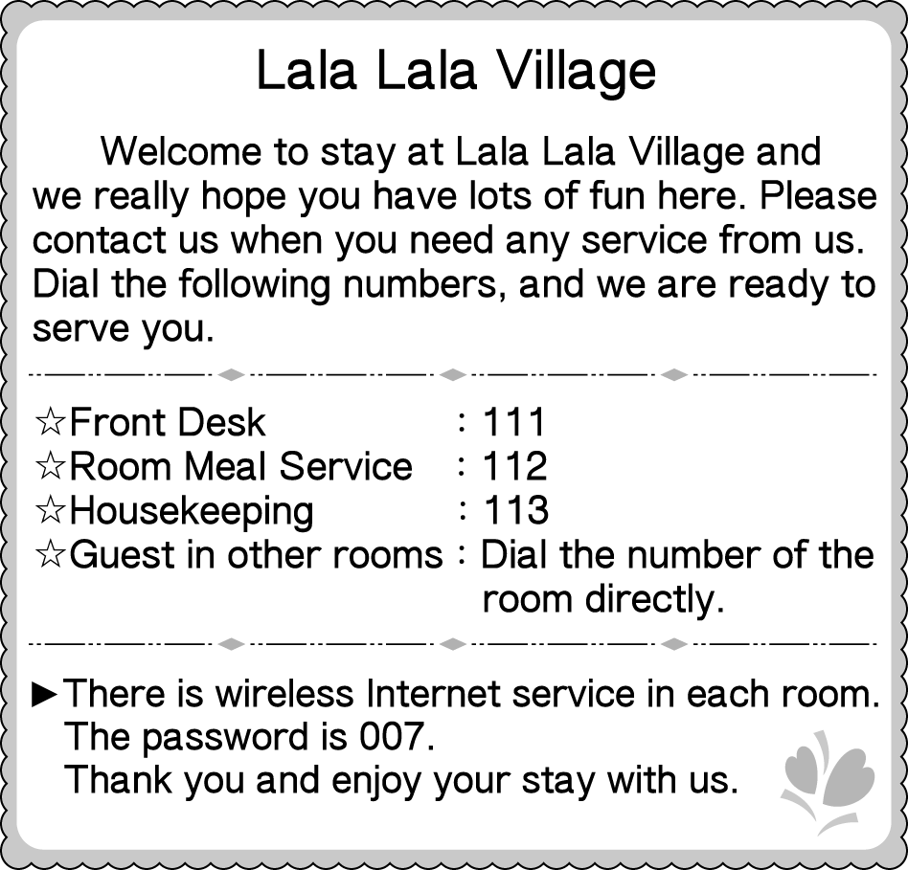
（ ）39.What is Lala Lala Village?
(Ａ) A hotel. (Ｂ) A restaurant.
(Ｃ) A beach. (Ｄ) A school.
（ ）40.Mrs. Wang is staying at Lala Lala Village and wants to call her friend, Mike. He is staying there in Room 505, too. Which number can she dial to call Mike?
(Ａ) 007. (Ｂ) 112. (Ｃ) 113. (Ｄ) 505.
（ ）41.Which is NOT true about Lala Lala Village?
(Ａ) People cannot enjoy their meals in their
rooms.
(Ｂ) People can surf the Internet in each room.
(Ｃ) People can dial 113 when they want their rooms cleaned.
(Ｄ) People can dial 111 to ask for more service.

III.
war戰爭 million百萬 relative親戚
（ ）42.Who may be a refugee?
(A) Lamma; he ran away from his country because
of war.
(B) Tanaka; he doesn't have enough money to buy a
house.
(C) Nada; her parents are not nice to her, so she ran
away from home.
(D) A-di; she can't stay in her country because she
can't find a job there.
（ ）43. What can we know from the reading?
(A) The war began three years ago.
(B) It is dangerous to live in a refugee camp.
(C) Abdallah is on his way to a refugee camp.
(D) Abdallah and his parents talk to their relatives on
the old cellphone.

第三部分：非選擇題試題，請用黑筆寫在手寫答案卷
F. 文意字彙（第44-51題，共8題，每題2分）
44. I walked to school every day u l my dad bought me a bike last month. It’s really fun and convenient（便利的）to go to school by bike.
45. My dad is a b n. I want to be like him and make more money for poor kids all over the world.
46. Grandma is sick and needs to take the m e
three times a day.
47. Ms. Chen can’t talk today because she
has a s e t t.
48. Ken: Mom, you sl ked again at 2:30 a.m. today. Mom: Really? What did I do this time? Ken: You ate all the bread for breakfast this morning. Mom: Oh my!
- Jolin is a p r singer here in Taiwan. How come you don’t know her?
- Mike is my p t husband. He never lets me do any housework at home.
- Liz: Who t t you math last year? Ben: Ms. Wu was my math teacher last year.

G. 依提示作答（第52-55題，共15分）
52. 我待在床上一整天，因為我發燒了並且胃痛得很厲害。
（中翻英）
53. 蘇醫師告訴我：『每天有規律的吃三餐並且吃健康食物很
重要。』（中翻英）
54. 我決定要聽從醫生的建議，並且為了我的健康做一些改
變。（中翻英）
55. Skipping breakfast all the time is terrible for teenagers.
(以It為首改寫句子)
試題到此結束，辛苦了！

