台北市立瑠公國民中學108學年度第一學期七年級第二次段考 英語科 考試卷
年 班 座號： 姓名：

第一部分：聽力測驗
- 辨識句意：根據聽到的內容，選出符合描述的圖片或符合圖片的描述。(每題1分，共5分)
- (Ａ) 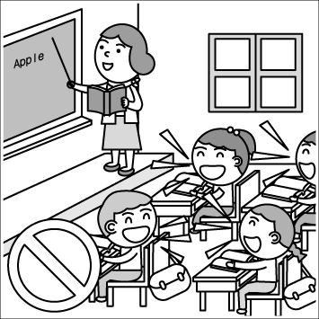 (Ｂ) 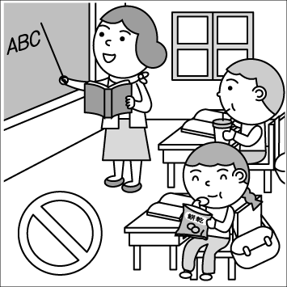 (Ｃ) 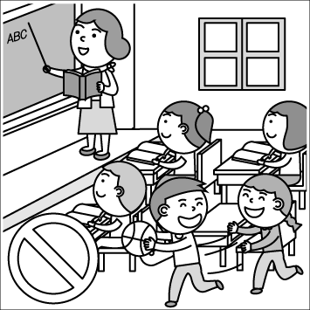
- (Ａ) 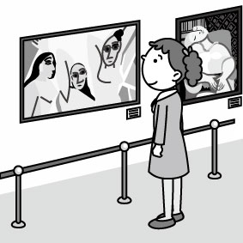 (Ｂ) 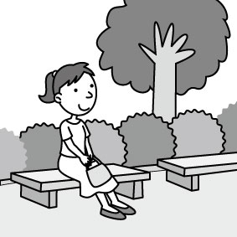 (Ｃ) 
- (Ａ) 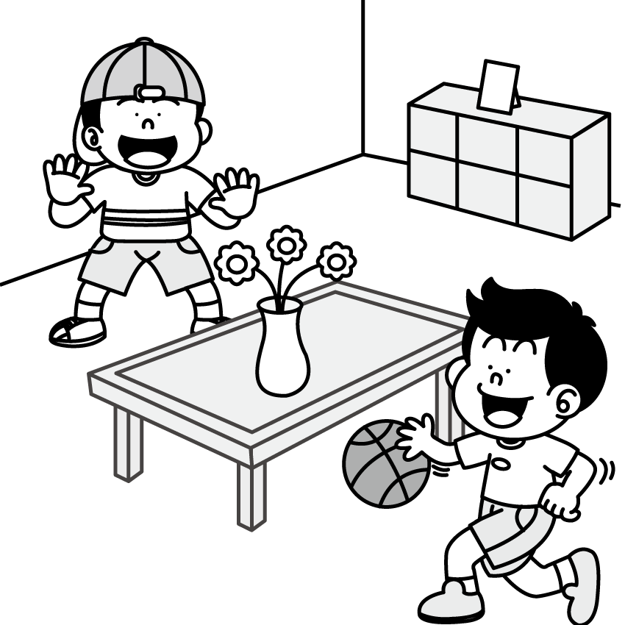 (Ｂ) 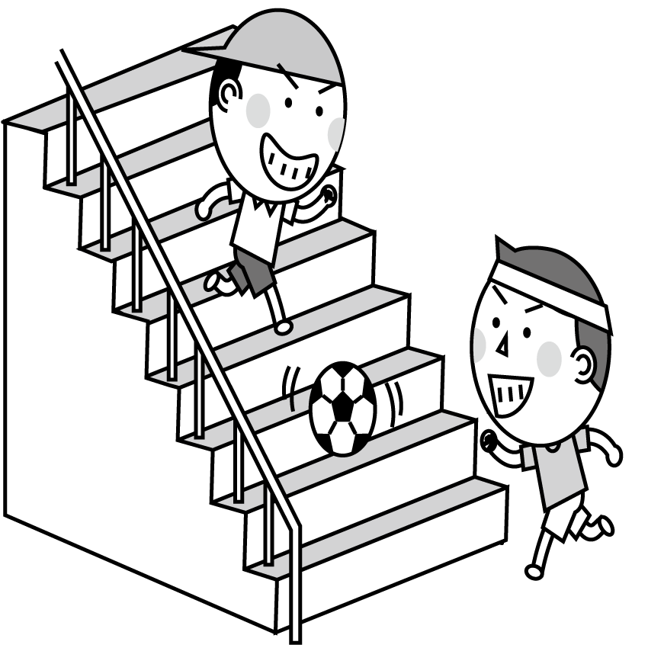 (Ｃ) 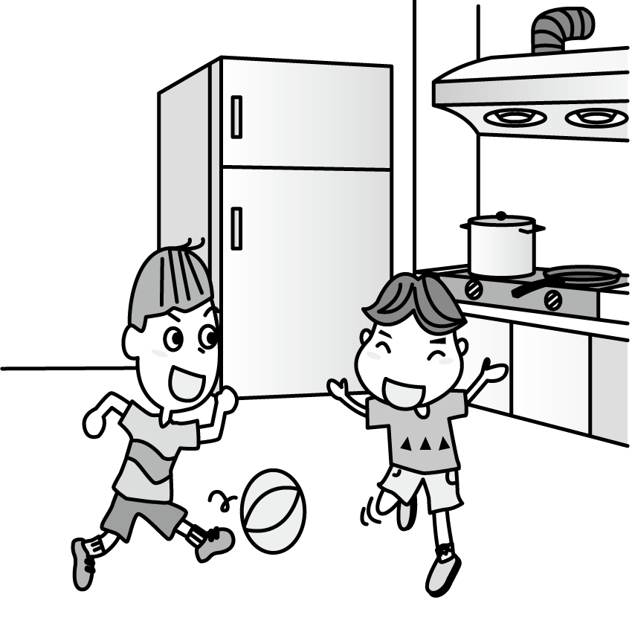
- (Ａ) 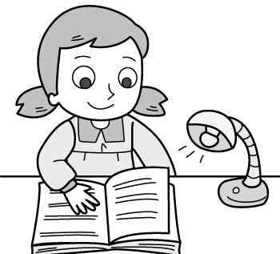 (Ｂ) 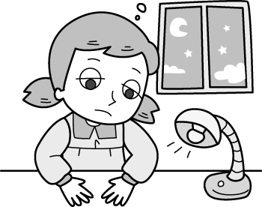 (Ｃ) 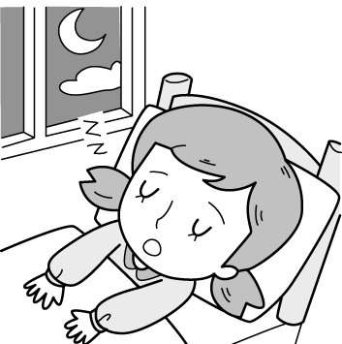
- (Ａ) 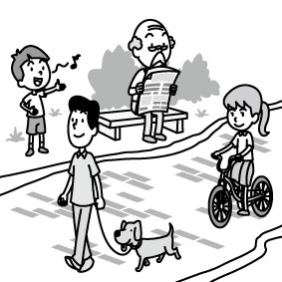 (Ｂ) 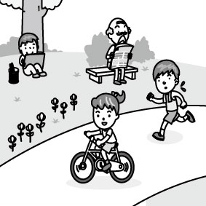 (Ｃ) 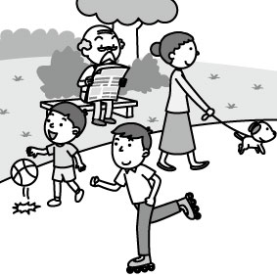

- 基本問答：根據聽到的內容，選出一個最適合的回應或最適合的問句。(每題2分，共10分)
- (Ａ) Yes, he is a police officer.
(Ｂ) We wait for the bus on the street.
(Ｃ) Be careful. Let’s look at the sign first.
- (Ａ) Turn off the computer.
(Ｂ) Please wait for your turn.
(Ｃ) Don’t play computer games.
- (Ａ) Sorry. Let’s be quiet, Larry.
(Ｂ) Yes, we are very good students.
(Ｃ) OK! Let’s dance in the new museum.
- (Ａ) It’s Monday.
(Ｂ) It’s a great day.
(Ｃ) It’s my dad’s birthday.
- (Ａ) No, they are playing at the park.
(Ｂ) Aren’t they your students?
(Ｃ) Guess! They are happy.

- 言談理解：根據聽到的內容，選出一個最適合的答案。(每題2分，共10分)
- (Ａ) The girl wakes up at 10 o’clock.
(Ｂ) They want to eat breakfast at home.
(Ｃ) They have breakfast with Aunt Lily.
- (Ａ) The girl can use the boy’s pen.
(Ｂ) The boy can use the girl’s pencil.
(Ｃ) The girl doesn’t bring her pencil box.
- (Ａ) In the dining room.
(Ｂ) In the living room.
(Ｃ) In the bedroom.
- (Ａ) To the park.
(Ｂ) To the snack bar.
(Ｃ) To Mr. and Mrs. Wilson’s home.
- (Ａ) Jason is waiting for Terri in a toy shop.
(Ｂ) Terri’s cousin is handsome and young.
(Ｃ) Terri is waiting for the bus with Jason.

第二部分：選擇題(每題2分;共56分)
16. A: _____ is it? B: It’s 10:26.
(A) What (B) What day
(C) What time (D) How old
17. A: _____ is it? B: It’s Sunday.
(A) What (B) What day
(C) What time (D) Where
18. A: Is ____ Tuesday today?
B: Yes. We can go to school at 7:30 today.
(A) this (B) it (C) that (D) there
19. A: What time is the concert?
B: It’s ____ five.
(A) to (B) after (C) at (D) on
20. A: Is Joanne talking on the phone now?
B: Yes, _____.
(A) she’s (B) Joanne’s not
(C) she isn’t (D) she is
21. A: ____ they dancing? B: No, _____.
(A) Can; they can’t (B) Are; we’re not
(C) Can; they’re not (D) Are; they’re not
22. A: Who is he singing _____? B: His brother. I like ____ song very much.
(A) with; their (B) X; his
(C) at; it (D) with; them
23. A: What are you ____? B: I am reading.
(A) do (B) to do (C) doing (D) can do
24. Let’s ___ chat or laugh in class.
(A) not (B) no (C) can’t (D) don’t
25. Sam, ___ a good boy, please. Listen to your parents.
(A) be (B) is (C) am (D) can
26. Mr. Chen: Now, write “Rhinocerotidae” in your notebook.
Ben : ____.
(A) You’re welcome.
(B) Don’t talk to him in class.
(C) Sorry. Say that again, please.
(D) With the pen, I can write in my notebook.
27. Tim: ______
Bill: Yes. I can’t wait.
(A) Are you free now?
(B) Can they wait there?
(C) Can you wait for me?
(D) Is the dance party this Thursday?
克漏字測驗

Ginny: Is Tommy’s Restaurant new open today?
Ron: On Saturday _28._ Sunday. I’m not sure.
Ginny: Let’s take a look at its website. Look! It is open
__29.__ Friday afternoon.
Ron: Great! Here are two invitation cards of Tommy’s.
Ginny: Are those cards for __30.__?
Ron: Of course they are. What are we waiting __31.__?
Let’s go!
Ginny: Wait. It’s only Tuesday today. The opening is
three days __32.__ today.
Ron: Oops. invitation邀請

28. (A) and (B) or (C) but (D) so
29. (A) in (B) at (C) on (D) next
30. (A) it (B) her (C) us (D) them
31. (A) to (B) with (C) at (D) for
32. (A) from (B) to (C) at (D) on

On Friday, Ginny and Ron are walking to the restaurant.
Ginny: Look. Are those black clouds?
Ron: Yes. That is a __33.__ of rain. __34.__.
(At the restaurant)
Ginny: This__35.__ is beautiful!
Ron: Everyone __36.__eating in the restaurant. And listen! It’s Ed Shereen’s song.
Ginny: Wow! Ed is singing on the stage and he is blowing kissing to the fans.
Ron: We are lucky. Isn’t he your favorite singer? Let’s go and __37.__with him.

33. (A) guy (B) lab (C) sign (D) fan
34. (A) Let’s hurry. (B) That’s it for today.
(C) We are ready. (D) Wake up.
35. (A) rule (B) band (C) museum (D) place
36. (A) be (B) is (C) are (D) am
37. (A) take a walk (B) take a picture (C) take a shower (D) take a break
閱讀測驗
(A)
Welcome to Traffic Report with Alex. This is Alex Wang, and I’m reporting two studies about traffic. Let’s take a look!
Study1

There are many drivers using Snapchat in a car. They are taking pictures and driving on the road. They’re even using the app’s own speed filter to show off. We’re worried about it.

Study2
There are more “Zombie Pedestrians” using their phones on the road. Their heads are down and they’re looking at their phone. And the cars are running just next to them. Isn’t it dangerous? Let’s not do it!
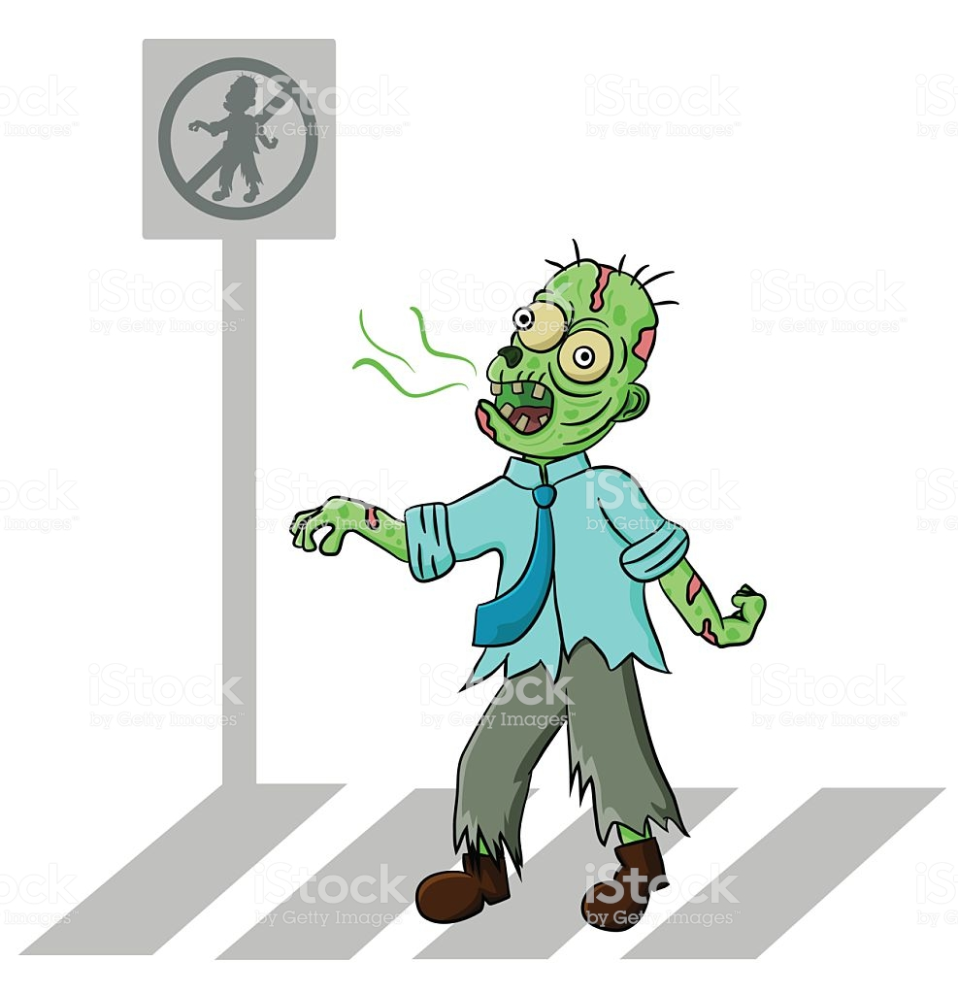
That’s it for today’s report.
You’re watching Traffic Report.
Stay tuned!

traffic交通 study研究 road路speed filter加速濾鏡
show off炫耀dangerous危險的

38. What might be the best (最好的)sign for people after reading this report?




(A) (B) (C) (D)

39. Sally is “Zombie Pedestrian.” What might she do on the road?
(A) Study English.
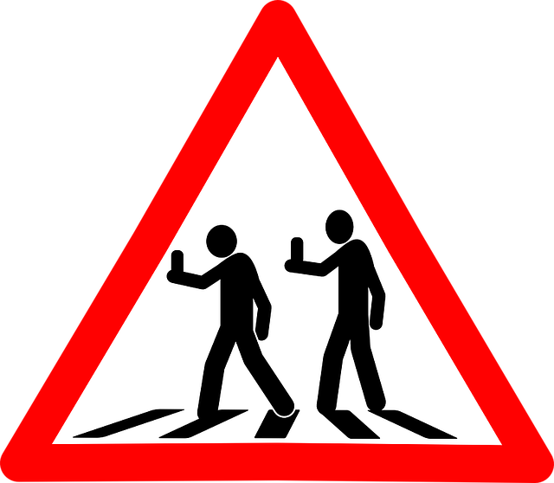
(B) Play baseball.
(C) Post her pictures on IG.
(D) Shake hands with people.

40. Kate is making rules for the road users. What might not be the rules?
(A) Keep your head up.
(B) Follow the traffic lights.
(C) Look out before you walk.
(D) Check your phone anywhere.
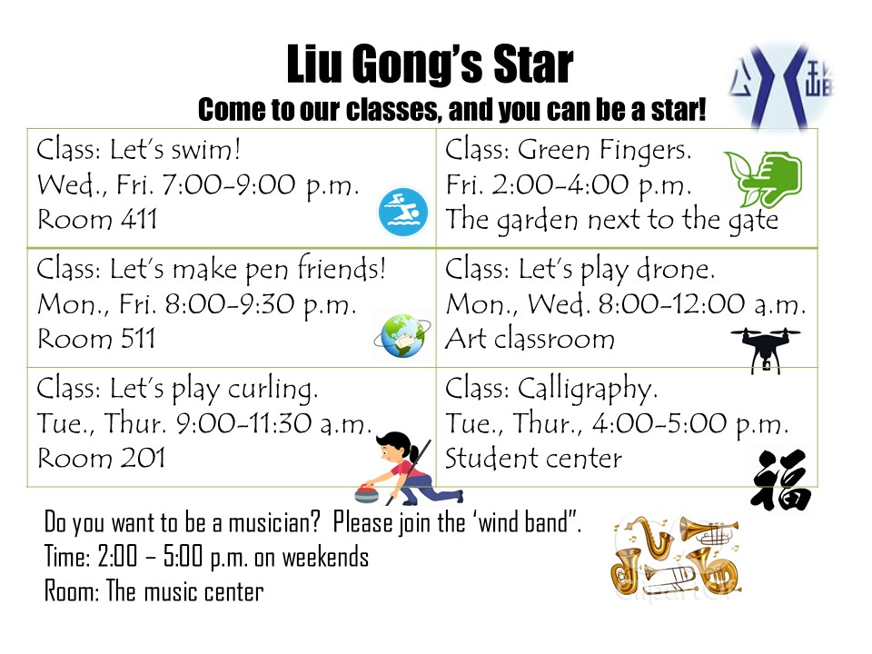
(B)
*to play curling 冰壺運動 drone無人機 calligraphy書法
41. It’s 8:45 in the evening, and it’s Monday. Jeff is in the Liu Gong junior high school. What is he doing?
(A) He is singing a song.
(B) He is writing a letter.
(C) He is playing curling.
(D) He is swimming.

42. Jolin is good at music. What time might she show up at school?
(A) Only weekday.
(B) On Fridays.
(C) Every Saturday.
(D) From Monday to Thursday. *show up出現
43.
Jill: Those flowers are beautiful. You have green fingers.
Lucy: Thanks. Your flowers are great, too. I can’t write or swim, so I plant. What about you?
Jill: Hmmm…I don’t know.
Lucy: Come on! You can do a math or play sports.
Jill: Maybe you’re right. I can be a sport player or an engineer one day.
Lucy: Are you ready for today’s class? Let’s go together.
Jill: OK. We are both good at it. *plant種植

What class might Jill and Lucy go to?
(A) Class: Let’s play curling.
(B) Class: Calligraphy.
(C) Class: Green Fingers.
(D) Class: Let’s play drone.

第三部分：手寫題 (共19分)
文意字彙(每題2分;共12分)
  - Jason’s son is in a f______t with his friend, Tom.
Let’s go stop them.
  - A big rain is coming. Let’s c_____k the windows
for cracks.
  - This song is really p_______r with high school
students.
4. Are your f__e this weekend? Let’s go to the zoo.
5. W_____y is the day after Tuesday.
6. Be c______l ! Don’t go near that mean cat.
翻譯題(共7分)
1. 粉絲們正為了這場見面會在隊伍中等待著嗎？(3分)
2.遵守這些規則，而且要安全。(2分)
3.那個木乃伊正一邊跑步一邊跳舞。(2分)

