臺北市立瑠公國中 108 學年度 第 1 學期 七年級 第 3 次定期評量 英語科 試題

- 辨識句意：選出符合句子描述的圖片。5%
1.( )
Ａ) 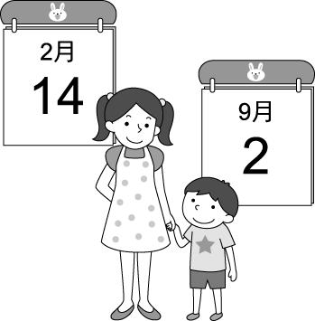Ｂ) 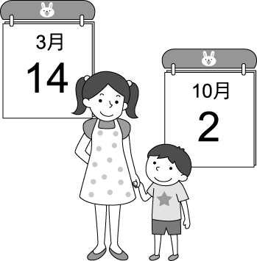Ｃ) 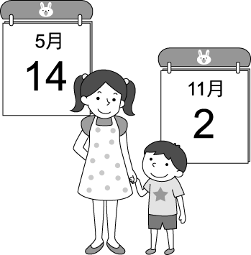
2.( )
Ａ) 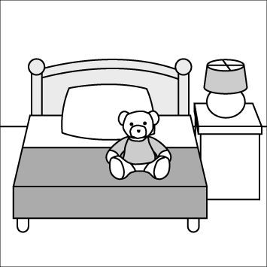Ｂ) 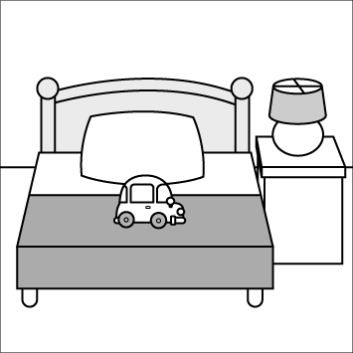Ｃ) 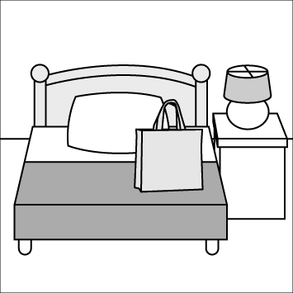
3.( )
Ａ) 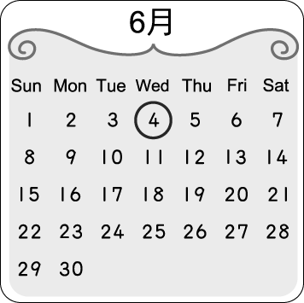Ｂ) 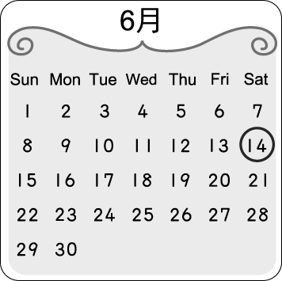Ｃ) 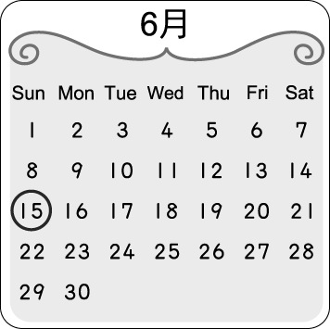
4.( )Ａ) 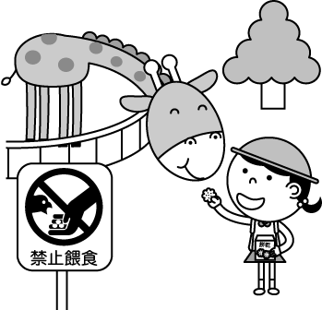Ｂ) 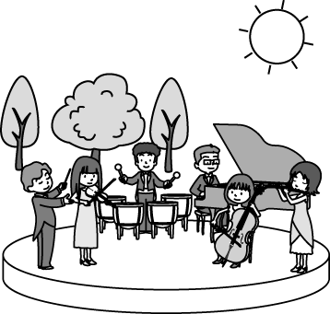Ｃ) 
5.( )
Ａ) 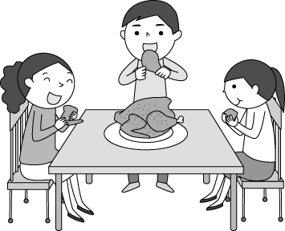Ｂ) 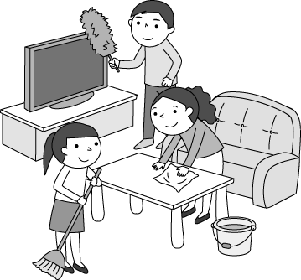Ｃ) 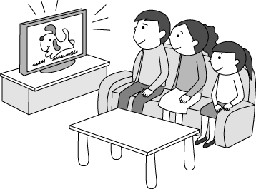

二、基本問答：根據聽到的內容，選出最適合的回應。10%
6.( )A) My mom is busy every day.
B) Yes, I give my mom flowers.
C) No. It’s on the second Sunday of May.
7.( )A) My favorite book is Time Machine.
B) Let’s go to our favorite park next time!
C) April. It’s usually warm during that time.
8.( )A) They are comic books.
B) No, let’s read it to him.
C)Yes, they are for you.
9.( )A) You are really a good writer to me.
B) There are some apples in the kitchen.
C) I’m thankful for my nice classmates.
10.( )A) I am ready for it.
B) Everyone in our family.
C) Let’s go around and give our thanks.

三、言談理解：根據聽到的內容，選出最適合的答案。10%
11.( )A) October 24.
B) September 27.
C) September 28.

12.( )A) Ms. Li is Mike’s English teacher.
B) Mike has a good time in Chinese class.
C) Zebras can help Mike.
13.( )A) August 30. B) July 4. C) May 10.
14.( )A) The man’s house is very big.
B) There are ten rooms.
C) Their bedrooms are white.
15.( )A) The famer and his wife.
B) The rabbits and the dogs.
C) The man and the woman.

四、綜合選擇。75% (第16題1分；第17~53題，每題2分)
16.( )I have a ____ to Taichung with my family this July.
A)tent B)camp C)trip D)flashlight
17.( )My dad is a doctor, and he works in a ____.
A)hospital B)kingdom C)back D)farm
18.( )It’s raining. Take a/an ____ with you.
A)apartment B)oxpecker
C)temperature D)umbrella
19.( )Ben ____ boy in his family. He has no brothers or sisters.
A)is the next B)is the second
C)is the only D)is also a
20.( )The month before May is ____. Fool’s Day is this
month.
A)April B)June C)March D)February
21.( )____ Dr. Wu’s help, my pet dog is happy and
healthy.
A)So B)Thanks to
C)Thank goodness D)Luckily,
22.( )You know so much about animals. You really are
an animal ____ to me.
A)herd B)coat C)example D)expert
23.( )The watch from my grandpa is ____ to me. It is
my favorite gift, too.
A)healthy B)full C)important D)nervous
24.( )Tina: Tigers are from Africa.
Eason: That’s not ____. They come from Asia.
A)lovely B)cloudy C)terrible D)right
25.( )Today is a big day for Jenny. It’s ____ birthday. Look! Those are gifts for her.
A)Jenny’s twelve B)her twelfth
C)her twenty D)Jenny’s twelveth
26.( )Mom: New Year’s Day is coming. Time for
cleaning your room. Hang(懸掛) your hat
____ the door and put the pictures ____.
Angela: Okay, Mom.
A)on; on the TV B)on; on TV
C)at; on TV D)at; on the TV
27.( )Amy: Are there ____ monkeys in the tree?
Ken: Yes, there are ____.
A)some; any B)any; some
C)any; one D)many; any

※ 背面有題，請繼續作答 ※

28.( )Eric: Is there a bathroom in your bedroom?
Sunny: ______
A)Not really, but it’s very small.
B)Sure, there is a bedroom.
C)Yes, and it is a big one.
D)Good to know. There is a bathroom in your
room.
29.( )Jerry: What’s the date?
Linda: ____
A)It’s a holiday today.
B)Isn’t it the third of January?
C)Today is Thursday.
D)It’s on February sixteenth.
30.( )The final exam is coming. There are so many students ____ in the library.
A)not studying B)study
C)studying D)not study
31.( )Brendan: ____ is Mark’s concert?
Rilla:This weekend. It’s at seven o’clock on July
fourth.
A)When B)When date
C)What day D)How
32.( )We have a big dinner ___ the night of Thanksgiving.
Come and join us.
A)on B)in C)at D)X
33.( )Chinese New Year’ Day is ____ next week. It’s my favorite time ____ the year.
A)on; in B)of; in
C)on; of D)X(不用填字); of
34.( )Betty:I’m hungry. Is there anything to eat?
Maggie: Yes, ____ some food on the table.
A)it is B)they are C)there is D)there are

(35-38)
Lisa: Hello, my name is Lisa. Today is __35__ day here at
Taipei Zoo.
Leah: Nice to meet you. I’m Leah, and I am new here, too.
I come here __36__.
Lisa: Wow. That’s the day before Father’s Day.
Leah: Yeah. We are safe and never hungry here.
Don’t worry and be happy.
Lisa: Thanks. You are so nice. I am not that nervous now. Apples are my favorite. __37__
Leah: I also like apples best. We can be good friends.
Lisa: Sure. I am very __38__ today.

35.( )A)first B)my first C)one D)the one
36.( )A)in August B)on August ninth
C)on August eighth D)on August seventh
37.( )A)How about you?
B)Look over there!
C)Are you a big help to me?
D)How are you?
38.( )A)popular B)clean C)valuable D)lucky

(39-43)
Today is Thanksgiving. Thanksgiving is __39__ every
year. It’s raining outside now, but it’s very warm inside
our house. It’s six p.m. Mom __40__ for the dinner
party tonight. Look! __41__ already some dishes on the
dining table. Wow! The roast turkey this year is really
big, and it smells so good. Grandpa and Grandma can’t
join us this year. They are on the trip to Japan. Little
Joey is __42__ because he can’t wait for the roast turkey.
The dinner is finally ready. Everyone sits down __43__
the table. Dad says, “Before we eat, let’s __44__ our
family.”
※roast烤的；smell聞起來；join加入

39.( )A)on November
B)November twenty-eighth
C)on the fourth Thursday of November
D)in the fourth month
40.( )A)cooking B)is cooking C)cook D)is cook
41.( )A)There has B)There have
C)There is D)There are
42.( )A)jumping up and down B)hiding in bed
C)crying out for help D)cleaning the house up
43.( )A)on B)in C)around D)under
44.( )A)thanks B)thankful for
C)be thankful D)give thanks to

(45-47)
OK, everybody. Here we are at Animal Dream. There are cats, dogs, fish, and birds at this special pet café. See? Some cats are sleeping on the sofa, and some dogs are walking around. A big fish tank is on that long table there. Those green, blue, and orange fish are so beautiful, right? Please don’t tap the tank when you watch them.
In the room behind the sofa, the birds are talking in English! It’s OK to have a chat with the birds and make some noise there. Well, don’t be sad when you say hello and they say good-bye.
Now, take a seat and have a drink. They have juice or coffee for you. Let’s be nice to the animals and have fun!
※café 咖啡廳 fish tank 魚缸 tap 輕拍

45.( )What are “them”?
A)The fish. B)The cats.
C)The dogs. D)The tank.
46.( )What are in a room behind the sofa?
A)The cats. B)The birds.
C)The dogs. D)The fish.
47.( )Which is true about the café?
A)Its name is Animal Dream.
B)Dogs there can say hello to people every
morning.
C)They have cakes for those people.
D)There are only green and orange fish.

※ 尚有試題，請繼續作答 ※

(48-50)
: Noah, welcome to Taiwan.
: Thank you. It’s my first time here. Everything
is new to me.
: New Year’s Day is in two days. Let’s watch the
fireworks display.
: In two days? It’s also my birthday!
: Really? Happy birthday to you. Maybe after
the fireworks display, we can see a movie.
: Good. How about dinner before the fireworks
display?
: Good idea. Let’s have beef noodles.
: No problem.
: Let’s meet at the park at 6 p.m. the day before
New Year’s Day.
: OK. I can’t wait.
※fire display煙火；beef noodles牛肉麵

48.( )What is the date today?
A)December thirty-first. B)January first.
C)January second. D)December thirtieth.
49.( )What date is Noah’s birthday?
A)December thirty-first. B)January first.
C)December thirtieth. D)January second.
50.( )What is Kate and Noah’s schedule?
A)Fireworks display → dinner → movie.
B) Movie → dinner → fireworks display.
C)Fireworks display → movie → dinner.
D)Dinner → fireworks display → movie.

(51-53)
These are four students’ answers to the teacher’s question.
※roar吼叫；speed速度；spend花費；leaves 樹葉
furry毛茸茸的；meow喵

Billy
It has beautiful brown long hair around its neck, and it roars very loudly. It has great power and speed. It’s the king of animals. I love this animal because it looks very strong and powerful.
Helen
My favorite animal is not big. But it has big ears, a big black nose, small eyes, and gray hair all around its body. It spends much time eating leaves and sleeping on the tree. It’s from Australia and looks so cute.

Melody
It looks just like a horse, and it has black and white lines all over its body, even on its face. It is my favorite animal.

Sam
It is small. It has a furry body and has so many different colors. When it really likes you, it meows around you and rub their body against you. It’s too lovely. It’s my favorite and I have one at home.

51.( )What animal is Helen talking about?


A) B)

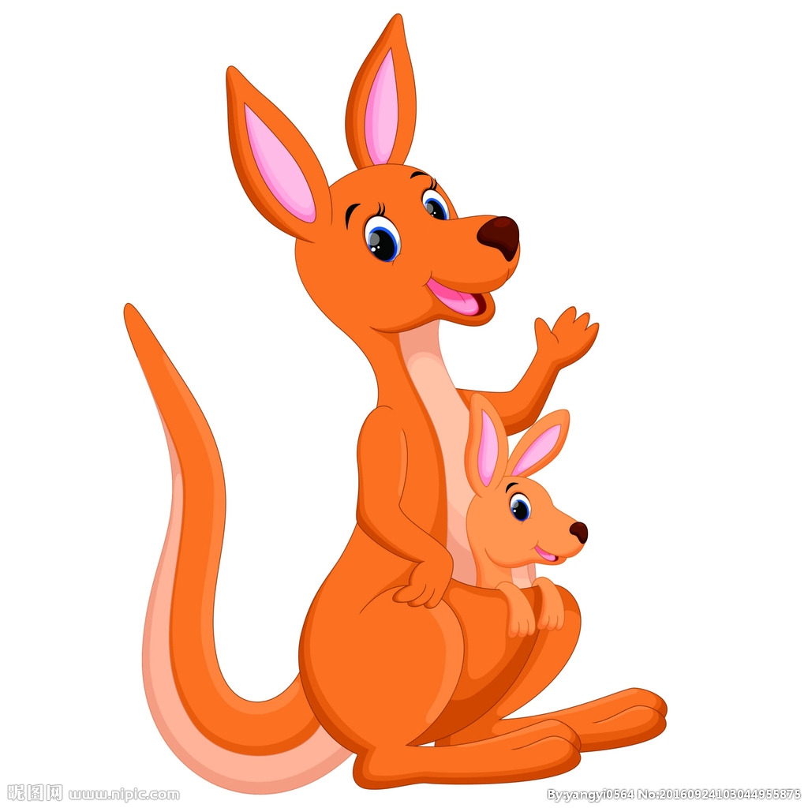

C) D)

52.( )Whose(誰的) animal can be a pet?
A)Billy’s. B)Helen’s. C)Sam’s. D)Melody’s.
53.( )What may the teacher’s question?
A)What animals are three in the zoo?
B)Let’s talk about your pet.
C)What is your favorite animal?
D)Tell us the animals on the farm.

※試題結束※

第

