臺北市立瑠公國中一０八學年度第一學期七年級英文科第一次定期評量試題
班級:____ 座號:____ 中文姓名:__________

【選擇題1~37題請用２Ｂ鉛筆劃記在電腦卡上，手寫題38~55題請用黑色原子筆寫在作答卷上】

※聽力測驗：23%
- 辨識句意：根據聽到內容，選出符合描述的圖片3%
- ( ) (Ａ) 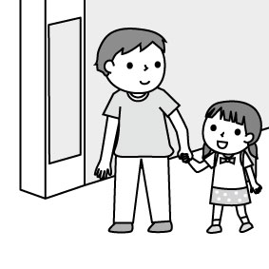 (Ｂ) 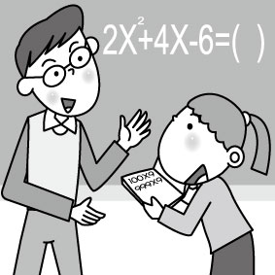 (Ｃ) 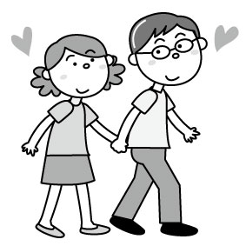
- ( ) (Ａ) 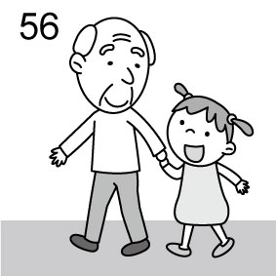 (Ｂ) 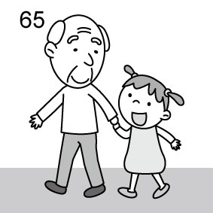
(Ｃ) 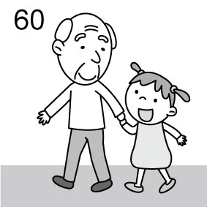
- ( ) (Ａ) 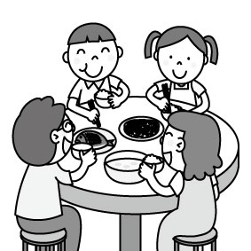 (Ｂ) 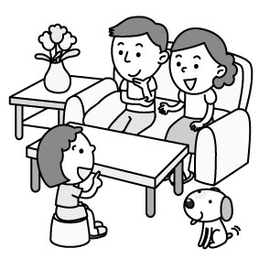 (Ｃ) 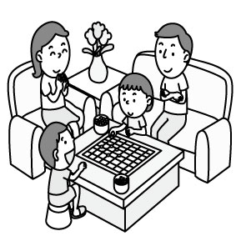

- 基本問答：根據聽到內容，選出一個最適合的回應10%
- ( ) (A)I’m your father. (B)His name is Bill. (C)Tim. T-I-M.
- ( ) (A)He is thirty-five. (B)He is an office worker. (C)It’s 727-4567.
- ( ) (A)No, she’s my mother. (B)She is a teacher. (C)My teacher is very nice.
- ( ) (A)Yes, it’s a box. (B)No. That’s a red pen. (C)Those are small boxes.
- ( ) (A)She’s very short. (B)She’s seven. (C)She’s my student.

- 言談理解：根據聽到內容，選出一個最適合的答案10%
- ( ) (A)Judy. (B)May. (C)Jennifer.
- ( ) (A)The boy’s uncle. (B)The boy’s father. (C)The boy’s friend.
- ( ) (A)Pens. (B)Markers. (C)Pencils.
- ( ) (A)They are on the desk. (B)They are on Vicky’s bed. (C)They are on the chair.
- ( ) (A)It is under the table. (B)It is on the table. (C)It is under the sofa.
【聽力測驗結束，請繼續作答】

※選擇題：47%
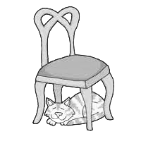
(第14題1分，第15~37題2分)
- ( ) Look at the picture. Where is the cat? (A)It is on the chair. (B)It is in the chair. (C)It is above the chair. (D)It is under the chair.
- ( ) Hello. My ______ is Mary Wang. (A)age (B)job (C)name (D)number
- ( ) A: How’s your ______? B: They are fine. Thanks. (A)grandma (B)husband (C)hedgehog (D)family
- ( ) Mom, I am ______ now. Can I eat the cake on the table? (A)hungry (B)gray (C)young (D)new
- ( ) A: Is your cat in front of the car? B: No. It’s ______ the cars. (A)above (B)in (C)at (D)between
- ( ) This is my ______. I sleep here. (A)bathroom (B)bedroom (C)living room (D)dining room
- ( ) A: ______ is that on the desk? B: It’s an eraser. (A)How (B)Where (C)Who (D)What
- ( ) Where is the ______? (A)John (B)Mr. Li (C)she (D)teacher
- ( ) A: Is Nick a writer? B: Yes, ______. (A)Nick is (B)he is (C)he’s (D)it is
- ( ) A: Are these not comic books? B: No, ______ notebooks. (A)those are not (B)these are not (C)they’re not (D)those are
- ( ) A: __________ B: No, she’s a doctor. (A)Is your aunt a nurse? (B)How old is your aunt? (C)Is your aunt young? (D)What is your aunt?
- ( ) A: What are these? B: ________ (A)My dad’s car. (B)Hank and his sister. (C)Kim’s old books. (D)They are singers.
- ( ) Jerry: Dave, this is Lisa. Dave: ________. Lisa: Nice to meet you, too. (A)What is your name? (B)Good night, Lisa. (C)Sorry! I’m not Lisa. (D)Nice to meet you, Lisa.
- ( ) A: __________ B: He’s my cook. (A)Who is the person? (B)What is your father’s job? (C)Is Zac in the kitchen? (D)How old is the man?
(28~31)
Hi, everyone! I am Anna. I am (28) years old. I am a junior high school student. My dad is a doctor, and my mom is an (29) . My twin sister, Peggy, is (30) . Our one-year-old baby brother, John, (31) . We love him very much. We are a family of five. We are a happy family. twin雙胞胎
- ( ) (A)two (B)ten (C)thirteen (D)thirty
- ( ) (A)police officer (B)English teacher (C)taxi driver (D)dancer
- ( ) (A)a student, too (B)a doctor, too (C)a sad girl (D)a thin boy
- ( ) (A)is dear to my family (B)is so bad (C)are very young (D)is not nice

(32~34)
Mr. and Mrs. Parker has a small house in Taipei. Their sons, Gary and Scott, live in the house, too. In the house, you can see a living room, a kitchen, a small bathroom and two bedrooms. They don’t have a dining room in the house, but there is a dining area in the living room. The bathroom is between the bedrooms. The house is not very big, but it is a very nice home for the Parker family.
live住; area區域
- ( ) How many people are there in the Parker family? (A)3 (B)4 (C)5 (D)6
- ( ) Which is NOT true? (A)Mr. Parker’s house is in Taipei. (B)The two bedrooms aren’t next to each other. (C)The bathroom is small. (D)The kitchen is in the living room.
which哪一個; true正確的
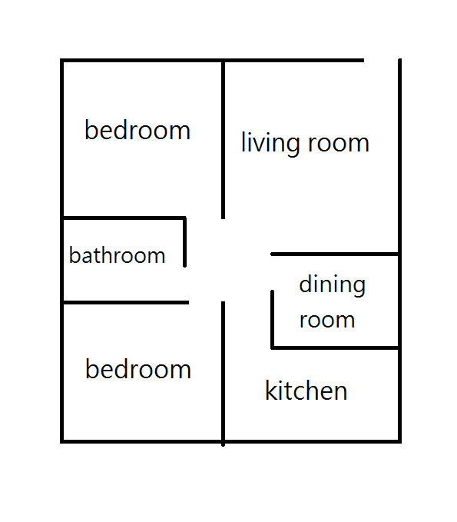
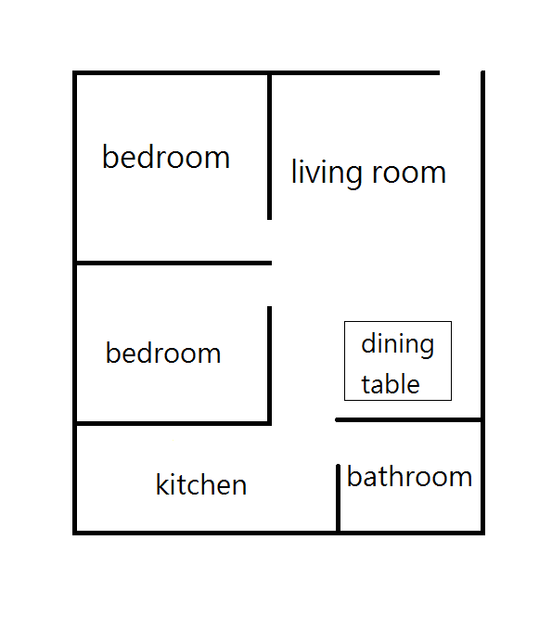
- ( ) Which is Mr. and Mrs. Parker’s house? (A) (B)

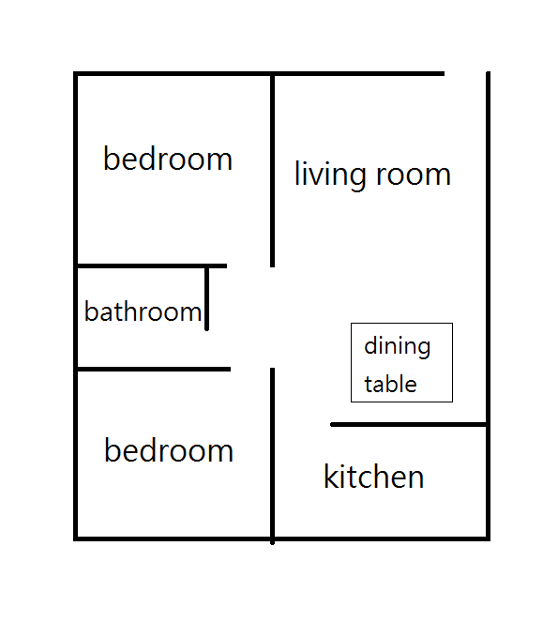
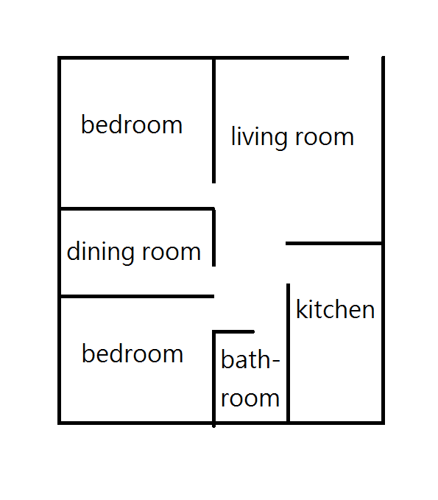
(C) (D)

(35-37)
Family Tree



Brad Amy




Joy Tom Tina



Sam Kate
- ( ) How many sons and daughters do Brad and Amy have? (A)One. (B)Two. (C)Three. (D)Four.
- ( ) Who is Tina? (A)She is Sam’s mother. (B)She is Joy’s cousin. (C)She is Kate’s aunt. (D)She is Tom’s wife.
- ( ) Which is true about the family? (A)Tom has two sisters. (B)Joy and Tom are brother and sister. (C)Amy is Tina’s grandmother. (D)Sam has only one sister.

-----------------------------------------
【以下為手寫題，請用黑色原子筆在作答卷上作答，鉛筆或其他顏色的筆作答依考試規則扣分】

※手寫題：30%
一、文意字彙：14%
- ____________ I am in Class 710. Victor is in Class 710, too. We are c_____es.
- ____________ A: I’m from ABC High School. B: R_____y? I am, too.
- ____________ Ben and Eric’s father is my uncle. They are my c______ns.
- ____________ My sister is 8 years old, and she is an e______y school student.
- ____________ The pencil is very s______l. It is 80 cm long, and it is from the Queen!
- ____________ Are they your p______ts? Yes, they are my mom and dad.
- ____________ Look at the clock on the w_____l. What time is it?

二、填空： 7%
(a)填入正確的Be動詞
- I ________ a happy student.
- My brother, Bob, ______ tall and handsome.
- Where ______ the women?
- The pencil case ______ for Ken.

(b)填入正確的所有格
- Jay and Ella are brother and sister. ______ father is a writer.
- Paul: Is Mrs. Brown your teacher? Nina: Yes, I am ______ student.
- Liz: What’s ______ phone number? Rick: My phone number is 2726-1481.

三、依指示作答：9%
- hello Ted how are you (寫出正確的句子形式) 2%
- Is she a housewife? (改成複數句) 2%
- 那間美麗的房子在我們學校的後面。(中翻英) 2%
- 紫色不是我女兒最喜愛的顏色。(中翻英) 3%

【測驗結束，請仔細檢查一遍，班級座號姓名要記得寫喔】

