臺北市立瑠公國中一０八學年度第一學期九年級英文科第一次定期評量試題
班級:____ 座號:____ 姓名:__________

※聽力測驗：20%
- 辨識句意：根據聽到的內容，選出符合描述的圖片或符合圖片的描述5%
01.( )
(A) 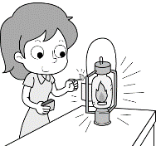 (B) 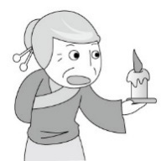 (C) 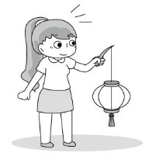
02.( )
(A) 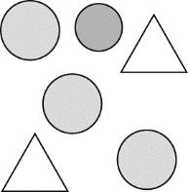 (B) 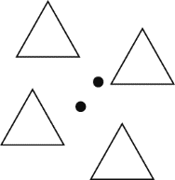 (C) 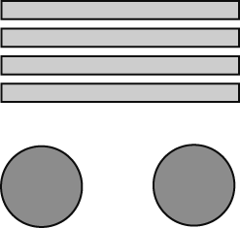
03.( )
(A) 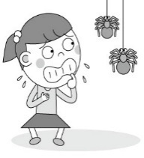 (B) 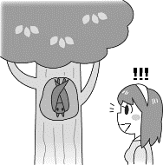 (C) 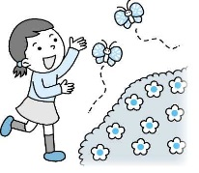
04.( )
(A) (B) 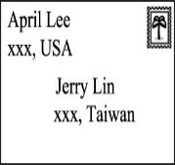 (C)
05.( )
(A) 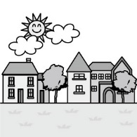 (B) 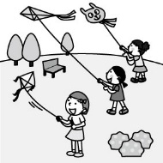 (C) 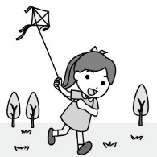
二、基本問答：根據聽到的內容，選出一個最適合的回應或最適合的問句5%
06.( ) (A) So far so good. And you?
(B) I was at the museum.
(C) I’ve been there twice.
07.( ) (A) You’re right. Triangle will be better.
(B) Me, either. And the next one is full of
circles. Well, that’s art!
(C) All the pictures in the museum are all
squares.
08.( ) (A) Don’t you agree with me?
(B) Really? Thanks for your help.
(C) Oh, it’s for my new play. I will play an
evil king in it.

09.( ) (A) Really? I always believe what I see.
(B) I won’t be tricked by others. Don’t worry.
(C) Our eyes are important. We underrtand the world through them.
10.( ) (A) Sounds great!
(B) Well, I have no idea at all.
(C) I need to buy a new dressyou’re your
wedding.

三、言談理解：請聽對話或短文，選出一個最適合的答案10%
11.( ) (A) The woman bought a paper umbrella from the man.
(B) The man thinks that circles can bring
him good luck.
(C) The woman didn’t believe the man.
12.( ) (A) Think twice before you decide to
answer a question.
(B) Actions always speak louder than
words.
(C) Seeing is not always believing.
13.( ) (A) Halloween is around the corner.
(B) The man’s sister is good at making
Halloween costumes.
(C) The man’s sister is making a
jack-o’-lantern with them.
14.( ) (A) He enjoys helping the customers.
(B) He is mean to the clerks.
(C) He is nice to the clerks.
15.( ) (A) Moon Fly is a machine to do the dishes.
(B) The man is tired of doing the dishes
after meals.
(C) The woman hates to make dinner for
her family.
【聽力測驗結束，請繼續作答】

- 選擇題：50%

( ) A：How long have they known each other?

B： _____________.

(A) In 2009

(B) 10 years ago

(C) When they first met at the park.

(D) Since the day they joined the costume

party together

( ) Mom: Have you chosen the date to marry

Mary?

Son: Yes, I ______ my mind ten minutes

ago.

(A) make (B) made

(C) will make (D) have made

( ) Little Prince ________ to my planet many times. Now, he _______ to the Moon already. I guess he will have a whale of a time dancing at the full moon party.

goes ；went

(B)has gone ；has been

(C) has been；has gone

(D) went；has been

( ) A：Why is my cellphone here on the table

in the living room? I put it on the

desk in my bedroom, _________?

B：Uh… I “borrowed” it just now.
(A) didn’t I (B) isn’t I
(C) wasn’t I (D) haven’t I

( ) You have to finish your homework now,

_______ you?

(A) have (B) do

(C) haven’t (D) don’t

( ) Don’t you hope ______ should be more and more students caring about their own studies at school?
(A) X (B) that
(C) there (D) it
- ( ) A：What will ________ you the most?
B：Traveling will be __________ to me.
(A) interest；interested
(B) be interested ；interested
(C) interested； interesting
(D) interest；interesting

(23-26)
Kate: Hi, Vivian. Do you plan to do something interesting for the coming weekend?
Vivian: 23 . Why do you ask?
Kate: William and I will go out and have some fun. Are you 24 in going out with us?
Vivian: Well, I’d love to, but I 25 busy since last month. I think I need to have more time to sleep and rest.
Kate: What are you busy with?

Vivian: I have been working on a report. My teacher is leaving for America this weekend and he asked me to finish it before he leaves.

Kate: I see. Then, when you have time to go out together, just let me know.
Vivian: Thanks, Kate. You’re so kind, 26 .
- ( ) (A) I haven’t decided yet
(B) I haven’t heard from that
(C) I haven’t heard of that
(D) I can’t make heads or tails of it
- ( ) (A) tired (B) bored
(C) interested (D) worried
- ( ) (A) am (B) have been
(C) was (D) will be
- ( ) (A) are you (B) aren’t you
(C) were you (D) weren’t you

(27-32)
Dear Amy, November 1,2019
27. ? Thanks for the two paper umbrellas. They are really beautiful and my 28. . My wife surfed the Net and told me that for Hakka people their round shapes mean “ 29. .” However, because I am from Taiwan, the word for umbrellas sounds like “separate” in Taiwanese. 30 ., I will give you one dollar; that means I buy them from you. You won’t get crazy about me, 31. ? By the way, Thanksing is around the corner, will you and your parents visit us in the USA ? You get to enjoy delicious Thanksgiving dinner in the newly open Wonderful Land. It is a very excellent restaurant and sells the best turkey, pudding, and pumpkin pie in our town.
32 .
Cousin Ted

- ( ) (A) How have you been
(B) Where have you been
(C) Where have you gone to
(D) How did you come here
- ( ) (A) for dear life
(B) piece of cake
(C) cup of tea
(D) topic of the report
- ( ) (A) crazy (B) perfect
(C) creative (D) scary
- ( ) (A) Just to play it safe
(B)I have heard of that
(C) For dear life
(D) Because of love
- ( ) (A) don’t you (B) do you
(C) won’t you (D) will you
- ( ) (A) I can’t help it.
(B) I can’t wait to go home.
(C) Hope to hear from you soon.
(D) I’m sorry that I missed it.

(33-36)
Eva: Karen, I'm going to the movies this evening. Are you coming?
Karen: When is the movie? I am going to Bed Head at five.
Eva: It starts at six. I guess I'll just have to go by myself then. What are you going to do with your hair?
Karen: I haven't decided yet. I'm tired of putting my hair in a bun like a ballet dancer every day. I need some changes.
Eva: Have you thought about an Afro? You might look great in it.
Karen: My head is already big. I don't need a cloud on my head to make it look bigger.
Eva: Hey, I remember you had a bowl cut when you were little. Maybe it's time to bring it back. Ha.
Karen: If I want a bowl cut, I can simply put a bowl on my head, and cut my hair myself. Maybe I should get cornrows.
Eva: Cornrows? You won't look good with lines of ropes on your head. Trust me.
Karen: Come on. Jamie wore them before, and she looked really cool.
Eva: Yeah, but you are nothing like her.
Karen: That's it. I'm getting cornrows.
Eva: All right. I hope you won't regret it.
Karen: I won't. You are going to be amazed by the whole new me. We can still meet after the movie if you want. I know a good restaurant near the movie theater.
Eva: The movie is about one and a half hours long. Are you able to come over by then?
Karen: Sure. Bed Head closes at seven. Besides, I don't think it will take that much time.
Eva: Great. Come meet me at the theater. I'll call you when the movie is over.
ballet 芭蕾
33. ( )When may Eva and Karen meet?
(A) At five. (B) At six.
(C) At six thirty. (D) At seven thirty.
34. ( )Which is true about Bed Head?
(A) People can go to Bed Head for a
haircut.
(B) Bed Head is a shop for selling all kinds of beds.
(C) Ballet dancers can buy ballet shoes at Bed Head.
(D) Bed Head is a restaurant near the movie theater.

35. ( ) From the talk above, we see the new word
"regret." Here is another example of
using this word: "If you don't do it now,
you'll only regret it later." According to
this example and the one from the talk,
which may be the closest meaning of the
word "regret"?
(A) To get close to something.
(B) To feel sorry about something.
(C) To be bored with something.
(D) To fill up with something.
36. ( ) What will Karen's hair look like when Eva
sees her later?
(A) (B)
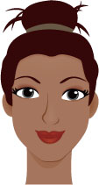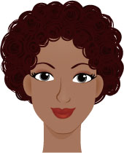
(C)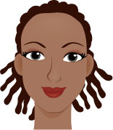 (D)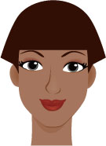

(37-40)
From: Harry 456@yahoo.com.tw
To: Emily 458@yahoo.com.tw
Subject: My winter vacation
Dear Emily,
My vacation to Egypt was great. My family and I went to many temples. We also saw some pyramids. We even went into one of them. Many important people or kings were buried there, but now people have moved those bodies to other places or put them in a museum. Some people didn’t go inside the pyramid because they thought it could bring bad luck. Visiting the pyramid has been a special experience for me. I also rode a camel there. The camel was taller than I thought, and I felt afraid while I was riding it. I took a lot of pictures and posted them on Facebook. If you are interested, you can take a look!
Egypt埃及 pyramid金字塔 bury埋葬
camel駱駝

37.( )What does “them” mean in the reading?
(A) Temples. (B) Pyramids.
(C) Museums. (D) Places.
38.( )What DIDN’T Harry do in Egypt?
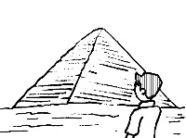
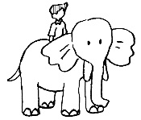
(A) (B)
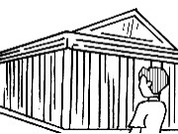
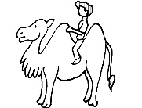

(C) (D)

39. ( )Why DIDN’T some people go inside the pyramid?
(A)It could be unlucky.
(B)There were snakes inside.
(C)The king’s body was there.
(D) It was too dark inside.
40. ( )Which statement is true?
(A) Harry went to Egypt in the summer.
(B) Harry rode a horse in Egypt.
(C)Harry didn’t go inside the pyramid.
(D) Visiting Egypt was interesting to
Harry.

【以下大題請寫在作答卷上】30%
五、文意字彙20%

41.Jeremy loves learning l s. He is good at speaking English, Japanese and even French.

42.What s e skirt do you wear? Medium.
43.This is my first time visiting New York. It is a
s e city to me and I know nobody here.

44.Frank put the love letter in the e e and then sent it to Maggie in person.

45.Is it p e for Helen to swim across Sun Moon Lake without any help in 6 hours? God bless her.

46.My friends told me that there was a big h e on my way home. Be careful not to fall into it when I was driving home.

47. 1,000 meters is 1 k r , isn’t it?

48.The idea for my science report is from a TV

p m. In Fact, it’s on now. Want to watch it

together?

49. Many people in Taiwan celebrate the Ghost Festival in the seventh l r month.

50. One of our classmates told me you’re married 10 years ago. I couldn’t believe it until you told me in person. How s g the news is.
六、中翻英10%

51.許多年來，一對油紙傘一直是一份祝好運的絕佳結婚禮物。4%

52.我們的眼睛獲取資訊，讓我們的大腦知曉(make…)我們所處的世界。3%

53.我認同萬聖夜是一個小孩和大人皆能驕傲地炫耀他們的創意服裝的時機。3%

【本次測驗結束】

