臺北市立瑠公國中108學年度第一學期九年級英文科第三次定期評量試題
九年 班 號 姓名：
第1頁，共4頁

一、聽力測驗30%
- 選出符合句子描述的圖片10 % (每題2分)
1.
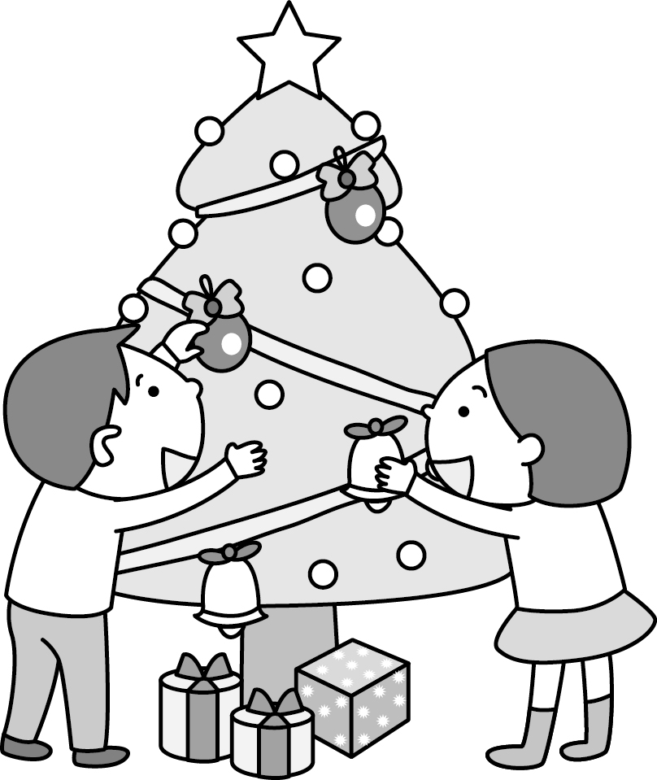  (A) | 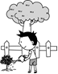  (B) |   (C)
2.
(A)  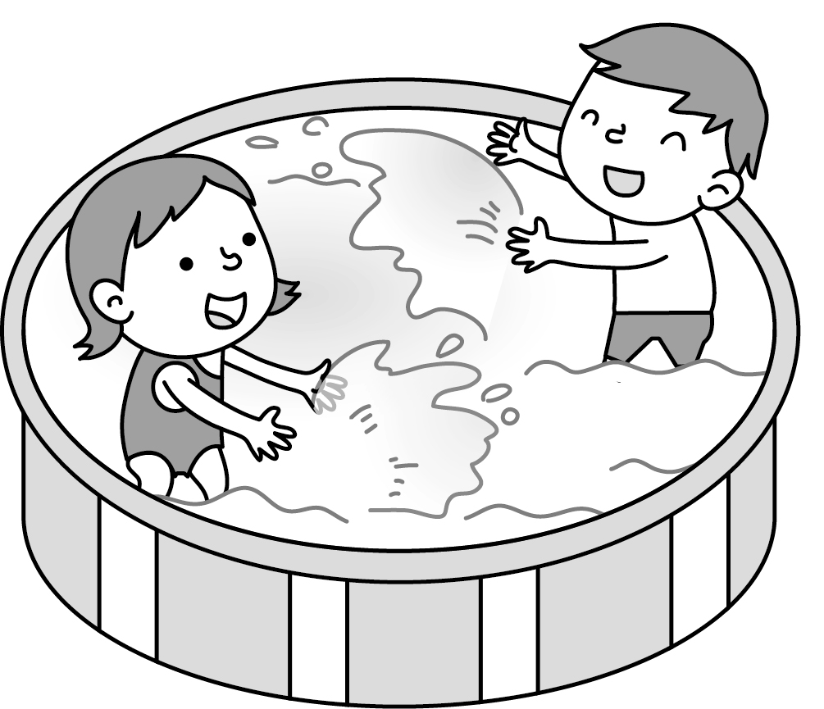 | (B)  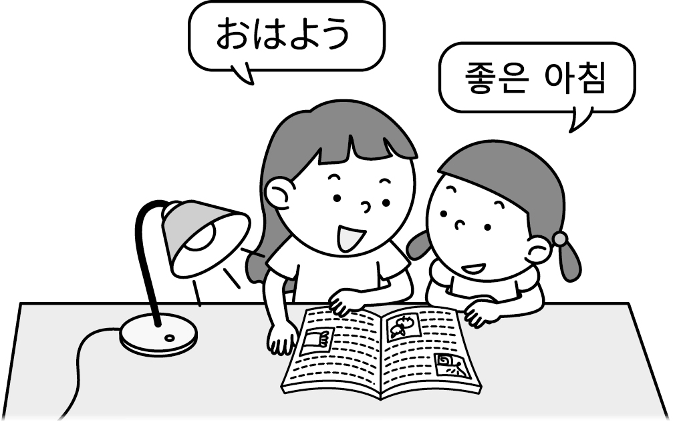 | (C)  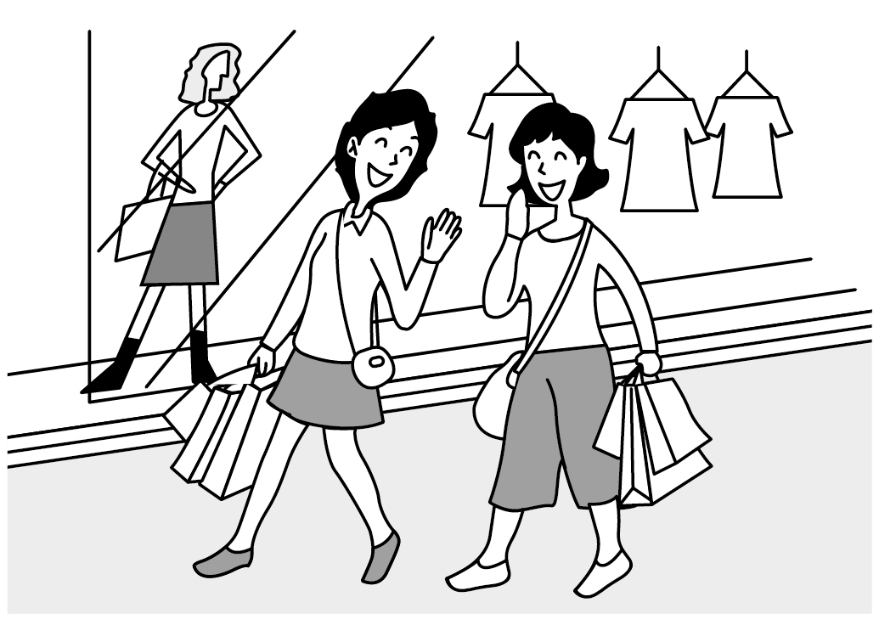
3.
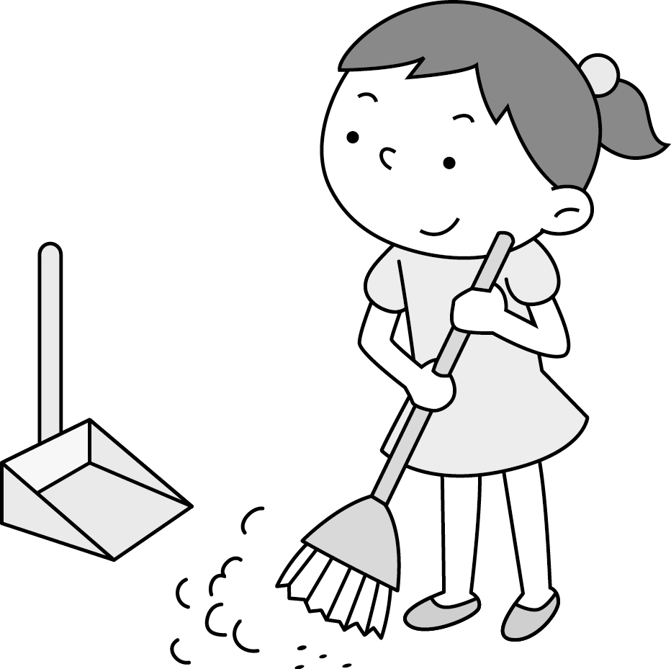  (A) | (B)  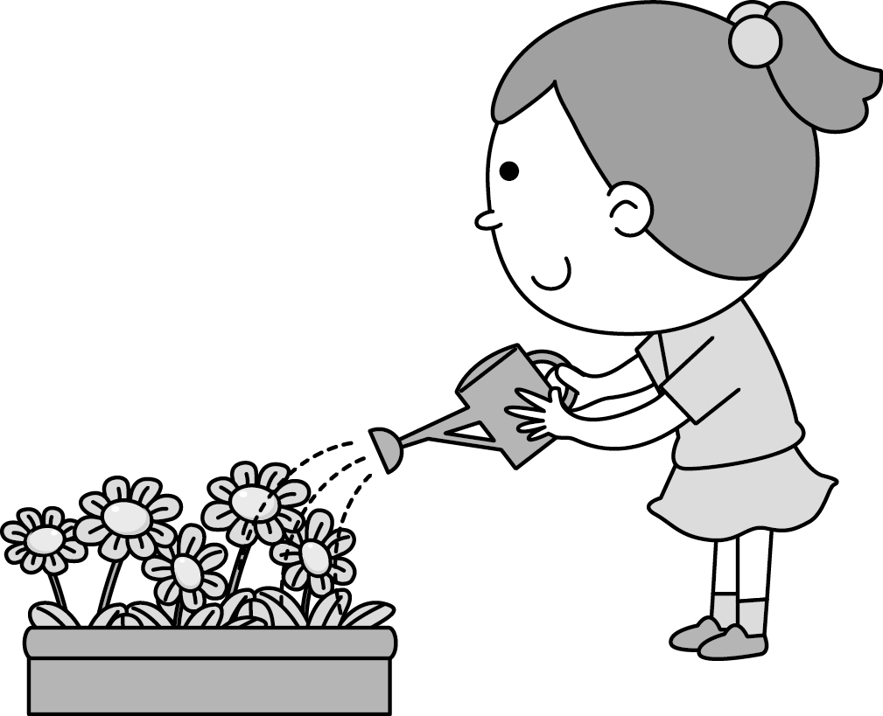 | 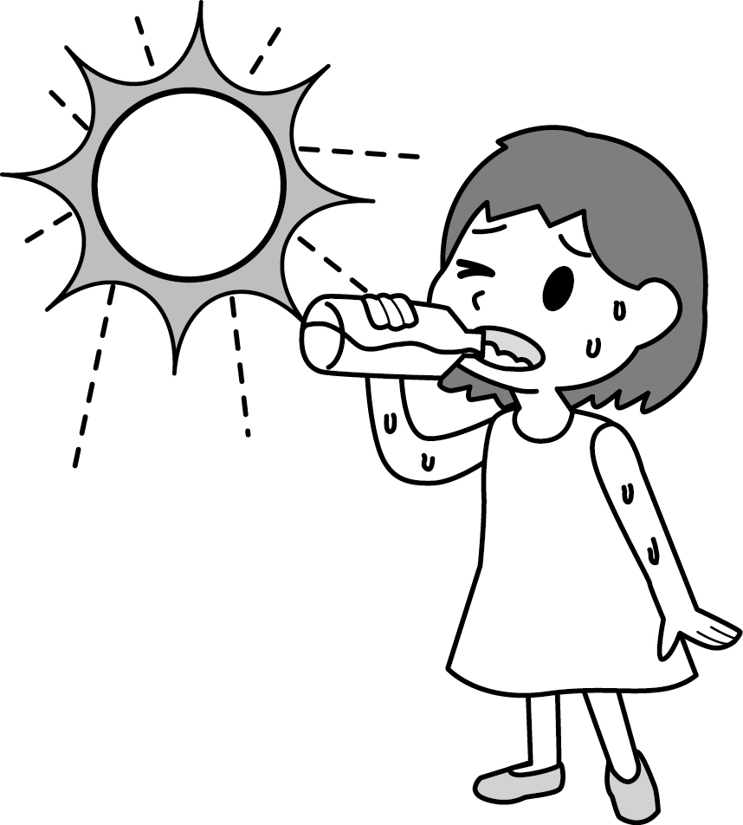  (C)
4.
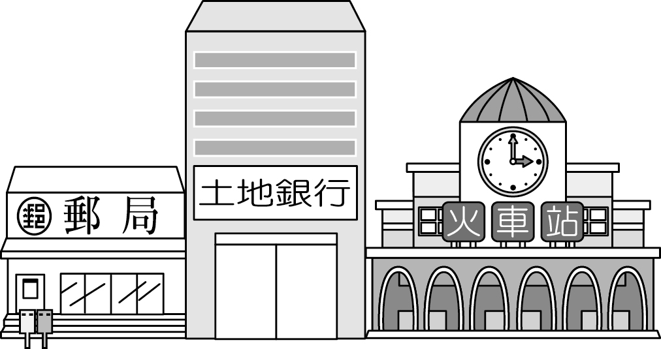  (A) | 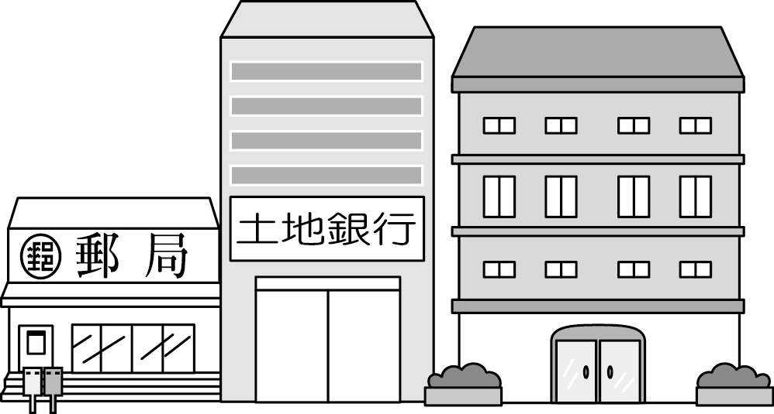  (B) | 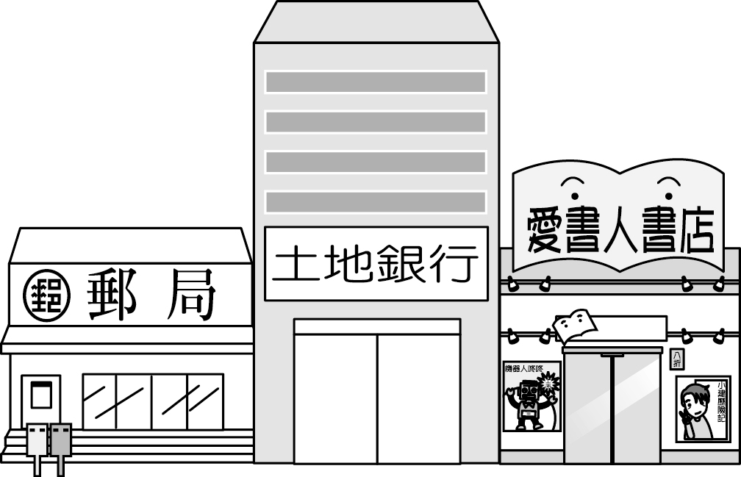  (C)
5.
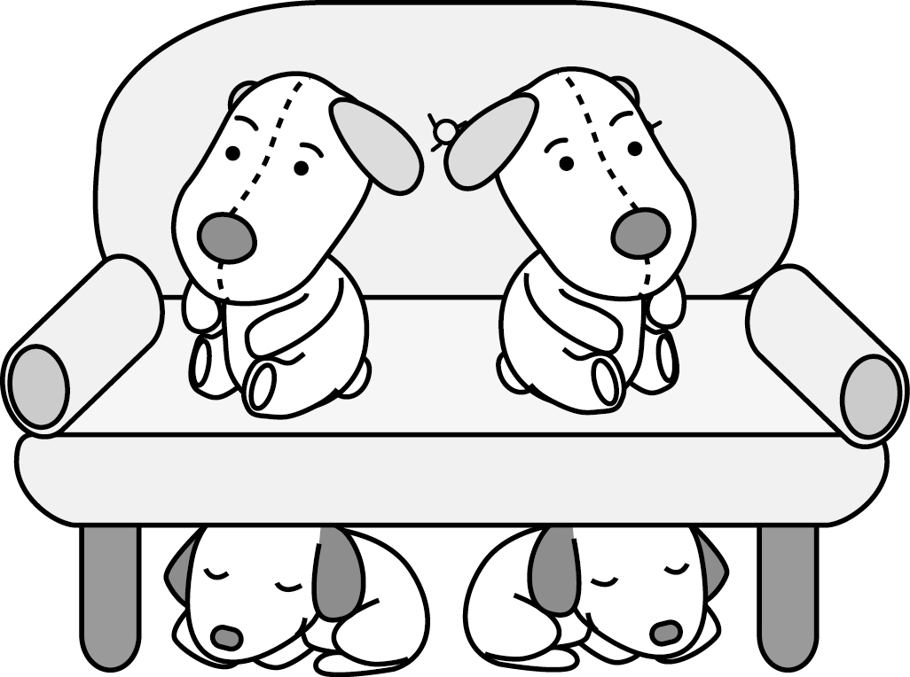  (A) | (B)  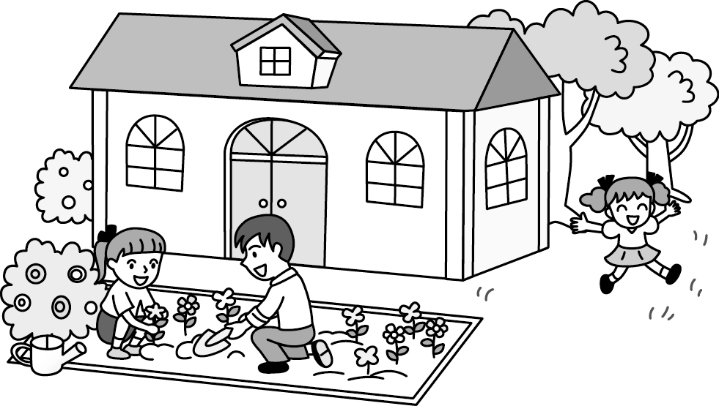 | (C)  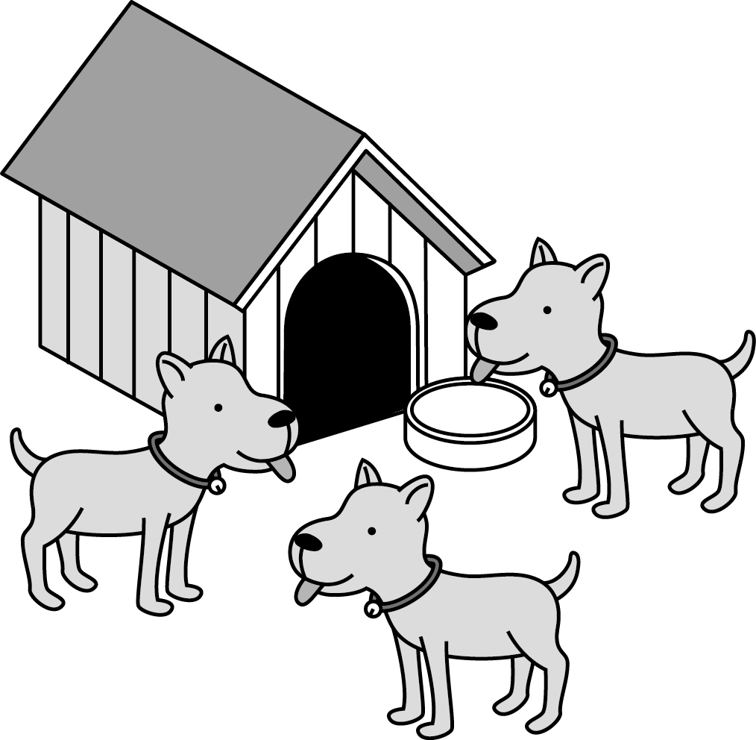
B. 選出最適合的回答，完成對話10% (每題2分)
6. (A) The girl who is a successful maker is my sister.
(B) The girl with a kind heart is my sister.
(C) The girl in a lion costume is my sister.
- (A) Hayao Miyazaki, a Japanese, wrote it.
(B) Great! He did a great job..
(C) No, it’s made up by another one.
- (A) Yes, I feel comfortable now.
(B) Sorry. I’ll do what you like.
(C) It’s up to you. I don’t mind.
9. (A) Thanks. I bought it last month.
(B) My husband is good, too.
(C) Sorry. I can’t own a car now.
10. (A) Yes, we will get old like them.
(B) Of course. I’m not sure what we can do.
(C) Well, let’s buy them something they need.
C. 請聽對話或短文，選出問題最適合的答案。10%
- (A) The man and the woman’s children.
(B) The animal shop the man runs.
(C) The pets the man and the woman keeps.
- (A) Music.
(B) Writing.
(C) Basketball.
- (A) A website that sells pets on the Net.
(B) A shop that helps to send food to people.
(C) A restaurant that gives free food away.
- (A) Go for a date on time.
(B) Always give ideas to a woman.
(C) Listen to a woman without saying anything.
- (A) Grow vegetables with farming tools from
Ms. Lo.
(B) Learn to cook vegetables Ms. Lo grows.
(C) Sign their names in Amy’s office.

二、選擇題30%(其餘每題2分)
16. Her ________ is collecting beautiful postcards.
(A) prize (B) career (C) hobby (D) stamp
17. The thief ran away _______ he saw the police.
(A) as long as (B) as soon as
(C) as fast as (D) as possible
18. Those students are going to work as ________ in Cambodia. We should donate some clothes and ask the students to bring them to Cambodia.
(A) strangers (B) stars
(C) leaders (D) volunteers
19. Make a ______ of all the things you need before you go to the supermarket.
(A) list (B) wish (C) habit (D) date
20. Kevin practices cooking very hard to become a cook. His dream will _______ sooner or later.
(A) take up (B) work out
(C) come true (D) pass by
21. Mandy really likes the gift _______.
(A) Brian gave it to her (B) was given to her
(C) Brian gave her (D) which were given to her
22. Do you think __ the girl ___I talked to is beautiful?
(A) that; which (B) what; who
(C) what; which (D) that; who
23. Mom asked me to buy ____ eggs on my way home.
- two dozens of (B) two dozen
(C) two dozens (D) dozen of
24. Joe is one of the boys _______ playing baseball very much. They are going to make a team soon.
(A) that hates (B) who enjoy
(C) who is good at (D) which are excellent at
25. ______ my mother is worried about is that my brother does not like the apartment ____ he lives.
(A) That; that (B) What; which
(C) Which; where (D) All that; in which
26. The boy ____ a blue shirt likes the girl ____ big eyes and long hair.
(A) in; in (B) with; with
(C) in; with (D) with; in
27. The farmer _____ son is a doctor grows rice here for over 20 years and he still enjoys doing it.
(A) who (B) which (C) whose (D) that
28. Choose the correct sentence.
(A) Cross the bridge which you come to it.
(B) Kindness is its own reward, isn’t it?
(C) All work and no play make Jack a dull boy.
(D) A great way that has fun is to take up a hobby.
29. Watch out for the little boy__________
(A) you played with him just now
(B) is drinking milk
(C) that are sleeping
(D) of whom Mom takes care
30. A: Look at how Mandy is dancing now. She catches everyone’s eye.
B: Yes, she’s such a _____ sometimes. She likes to show off .
(A) chicken (B) cold fish (C) butterfly (D) ham

三、克漏字選擇 20%（每題 2分）
There was a robbery in the bank near my house. It _31_ around three twenty in the afternoon. It was almost the time to be closed. Suddenly, a tall heavy man __32__ a black mask ran into the bank. All the people in the bank were too scared to move because the man had two guns. He asked the tellers __33__ money into his bag, and then he left the bank right away. The guard ran after him but failed to catch him, __34__ rode a scoter away fast. A young man recorded everything with his smartphone and gave it to the police. It is said that the robber __35__ this early morning and that all the money was taken back.
31. (A) happening (B) happened
(C) happens (D) to happen
32. (A) who wore (B) wore
(C) was wearing (D) worn
33. (A) putting (B) put (C) to put (D) puts
34. (A) who (B) which (C) that (D) whom
35. (A) was caught (B) has caught
(C) is caught (D) will be caught

四、閱讀測驗 30% (每題2分)
1.

A farmer had two water buckets. One was good and useful; the other one with some holes was broken. One day, the broken one told the farmer sadly, ”I am sorry. Over the past few years, the only thing I have done is carrying just half a bucket of water at a time. I’m not useful at all.”
Hearing this, the farmer just smiled. He took the broken bucket to the river where he got water every day. Then, he said, “Do you see the beautiful flowers along the road? They are only on one side. Because you give them water, they can grow up. This is what the good bucket can’t do. And now the flowers are even on my dining table. With them, all the meals look so delicious. Without you, there wouldn’t be so many beautiful flowers. And I can’t enjoy all the meals every day.”
After that, the broken bucket carries as much water as possible every day. And it waters the flowers along the road very hard, too.
36. What do They mean in the reading?
(A)The two buckets.
(B) The beautiful flowers.
(C) The seeds on the road.
(D) The meals on the dining table.
37. What lesson can we learn from the bucket’s story?
(A) Nothing is difficult for the man to try.
(B) Practice makes perfect.
(C) You can’t sell the cow and drink the milk at
the same time.
(D) People should notice what they can do.
38. What can we know about the broken bucket?
(A) It learned to make good use of itself.
(B) It can do nothing for its owner.
(C) It has stopped working since it was broken.
(D) The water from it made the flowers on the
farm grow up.
2.
The U.S. is planning to raise its tariff on things from Canada, Mexico and other countries. So these countries decided to fire back by raising its tariff. There were signs the world has been closer to another trade war than at any time since 1930s.

A trade war is a way that a country uses to help its own businesses. When a country raises its tariff on things from other countries, the foreign things will be more expensive and fewer people want to buy them. On the other hand, things which are made in their own country catch more people’s eye because they are cheaper. Tariff is the money a country collects when foreign things arrive. No one will be happy about being raised tariff. It may help its workers or farmers, but business would face the high cost to buy things from other countries.

39. Below are what the writer talks about in the reading:
a. Whether higher tariff is good to a country or not.
b. How a country helps its business with the tariff.
c. Why a trade war is talked about these days.
In what order does the writer talk about?
(A) c -> a -> b (B) b -> c -> a
(C) b -> a -> c (D) c -> b -> a
40. How may the writer feel at the end of the reading?
(A) Bored (B) Excited
(C) Worried (D) interested
41. From the reading, which may NOT one of the good things for high tariff?
(A) It pushes up the cost and factories can raise the price.
(B) Businesses can make more money with fewer sellers.
(C) A country can collect more money from other countries.
(D) People can enjoy cheaper things which are made in their own country.
3.
Nancy got the following poem from her friend’s e-mail. She tried to find the name of the writer online, bit failed. She just knew that it was made by a person form South Africa.
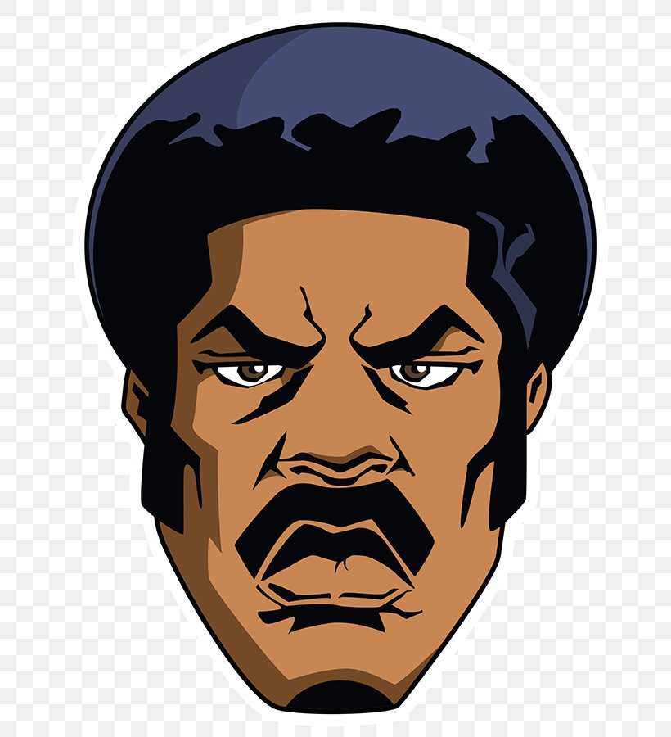
Dear white, something you got to know.
When I was born, I was black.
When I grow up, I am black.
When I’m under the sun, I’m black.
When I’m cold, I’m black.
When I’m afraid, I’m black.
When I’m sick, I’m black.
When I die, I’m still black!
＊＊＊＊＊＊
You—white people,
When you were born, you were pink.
When you grow up, you become white.
You’re red under the sun.
You are blue when you’re cold!

You are yellow when you’re afraid.
You’re green when you’re sick.
You’re gray when you die.
And you, call me “color”?

42. What’s the tone(語調) of the poem?
(A) Happy (B) Comfortable
(C) Easy (D) Unhappy
43. What is the main idea which we can learn from the poem?
(A) The writer must be white.
(B) This is an American poem.
(C) All men are created equal(平等的). We can’t treat people in different ways just because of their skin color.
(D) It’s true that white people are more changeable than black people.
4.

Students in Class 910 were asked some questions in English class by Ms. Lee. In the class, thirty students use Facebook, but five students don’t. Here are the results.
44. How many students are there in Class 910?
(A) 35. (B) 30. (C) 25. (D) 20.
45. How many students like to post their photos on
Facebook?
(A) 30. (B) 27. (C) 24. (D) 21.
46. How many of the students in Class 910 don’t use
Facebook?
(A) More than 15%. (B) About 14%.
(C) About 10%. (D) Less than 5%.
47. How many students don’t use Facebook because
they don’t know how to use it?

(A) 5. (B) 4. (C) 3. (D) 2.
5.

Ireland is a green country with lots of sheep. When the sun shines, it’s very beautiful. St. Patrick’s Day is celebrated on March 17. Patrick is a saint of Ireland, but he is not an Irish. He was born in Wales. When he was about 16 years old, pirates caught him and took him to Ireland. They sold Patrick to a rich man, and he took care of the man’s sheep. During this time, Patrick started to believe in God. After six years, Patrick ran away and then became a monk in France. Later he decided to go back to Ireland and tell people about God. Patrick taught there for about 30 years. He taught people about God, and he also taught them how to read.
48. Where was Saint Patrick born?
(A) In France. (B) In Ireland. (C) In the USA. (D) In Wales.
49. How old was Patrick when he became a monk in France?
(A) Over 40. (B) About 22. (C) 16. (D) Less than 16.
50. Which is NOT true about this reading?
(A) Patrick was an Irish person.
(B) St. Patrick’s Day is on March 17.
(C) Ireland is a country with a lot of sheep.
(D) Patrick taught people how to read in Ireland.

考試結束啦

