臺北市立瑠公國中108學年度第一學期八年級英文科第一次定期評量試題
八年 班 號 姓名：
第1頁，共3頁

※選擇題請在電腦卡上作答，共62分
一、聽力測驗20%
- 選出符合句子描述的圖片5 % (每題1分)
01.
(A)  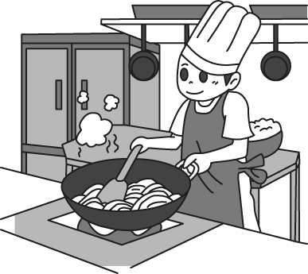 | (B)  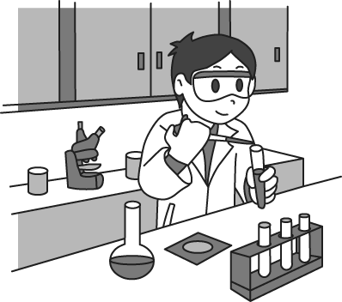 | (C)  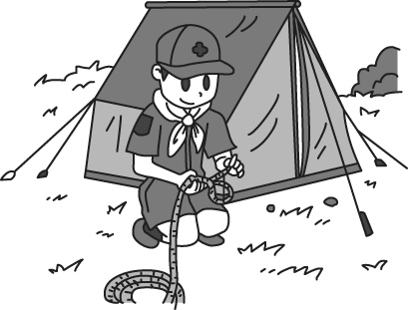
02.
(A)  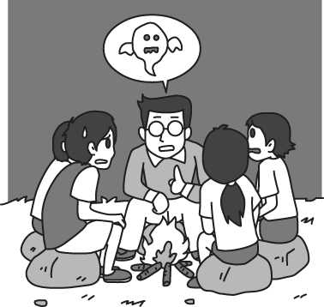 | (B)  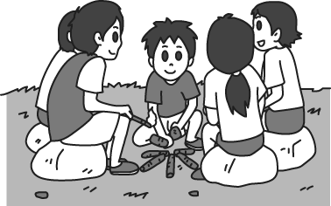 | (C)  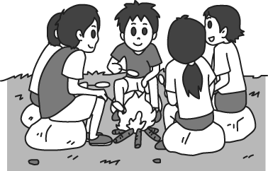
03.
(A)  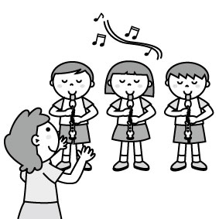 | (B)  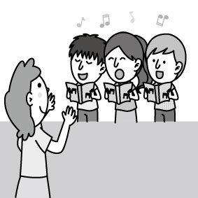 | (C)  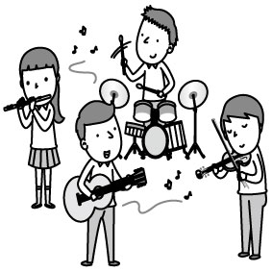
04.
(A)  INCLUDEPICTURE "http://hlart.hanlin.com.tw/artscript/art/artpreview.ashx?mode=show&fileID=561537&typeNo=false" \* MERGEFORMATINET 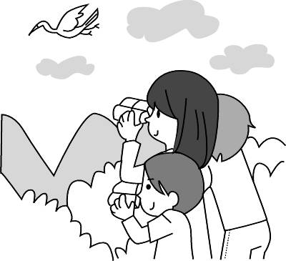 | (B)  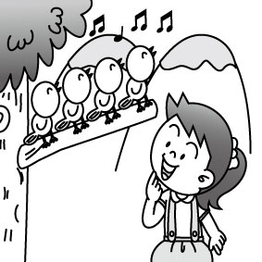 | (C)  INCLUDEPICTURE "http://hlart.hanlin.com.tw/artscript/art/artpreview.ashx?mode=show&fileID=744211&typeNo=false" \* MERGEFORMATINET 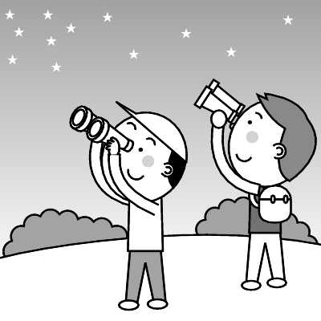
05.
(A)  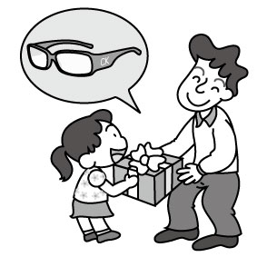 | (B)  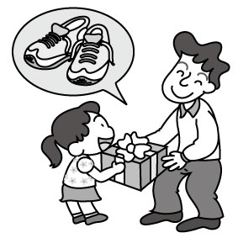 | (C)  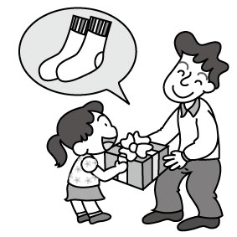
B. 選出最適合的回答，完成對話5% (每題1分)
06. (A) She asked a good question.
(B) No, she didn’t. She played computer games this evening.
(C) Remember to finish your homework today.
07. (A) I washed it with my dad.
(B) I washed it with a towel.
(C) I washed it the day before yesterday.
08. (A) Yes, it was great
(B) You bet. It was a wonderful trip.
(C) Nothing special. I just stayed at home and did my homework.
09. (A) It’s a cheap red car.
(B) It’s from Vicky and Simon.
(C) It’s Mr. and Mrs. William’s.
10. (A) Poor you!
(B) You’re so generous.
(C) That’s a good idea.
C. 請聽對話或短文，選出問題最適合的答案。10%
11. (A) The man didn’t do anything special on Mother’s
Day.
(B) Linda’s mother runs a snack bar.
(C) Simon is Linda’s brother.
12. (A) They are playing with water balls.
(B) They are playing water sports.
(C) They are talking about Water Festival.
13. (A) Cindy didn’t talk to the man after the contest.
(B) Cindy is good at singing and she did well on the
contest.
(C) Cindy was sad because she’s bad at singing.
14. (A) They are very expensive.
(B) The new shoes are beautiful.
(C) The old pair is too small.
15. (A) Fifty-five.
(B) Ninety.
(C) Two hundred.
二、文法選擇20%(每題2分)
16. Mom _________ the kitchen this morning, and it _____ very clean now.
(A) cleans; is (B) cleaned; was
(C) cleans; was (D) cleaned; is
17.The computer game ____ a lot of fun and my son _____ fun playing it in his free time.
(A) has; has (B) is; is
(C) has; is (D) is; has
18. _______ Maria was very busy last night, ____ she didn’t go to Ellen’s birthday party.
(A) Because; X (B) Because; so
(C) X; because (D) So; X
19. Thanks ____ you, little Leo had a wonderful birthday party. Thanks again ___ everything.
(A) to; to (B) for; for
(C) to; for (D) for; to
20. Can you give_____?
(A) the card for me (B) it for me
(C) me it (D) me the card
21. ______ car is in front of the house, and ____ is under the tree.
(A) You; his (B) She’s; mine
(C) Your; our (D) Their; ours
22. He put his toys back in his bedroom, but his brother ________.
(A) does (B) did
(C) doesn’t (D) didn’t
23. Jill: Did your mom _____the cake for you?
Ben: No, she _______ me the cake.
(A) bought; made (B) made; bought
(C) make; bought (D) give; sent
24. What _______?
(A) did it happen (B) that happened
(C) you happened (D) happened
25. Choose the right (正確的) sentence.
(A) There wasn’t rain a lot here last night.
(B) My brother often put his trash under his bed before, but now he didn’t.
(C) Mark lost his key somewhere, so he can’t get inside the house now.
(D) Because your help, we could finish our report in time.
三、克漏字選擇 10%（每題 2分）
Last October, my parents brought a little boy home. He became a new member of my family. At that time, I was the apple of my parents’ eye_ (26) I was their only child. Dad and Mom thought I needed a brother. They named him Jacky.
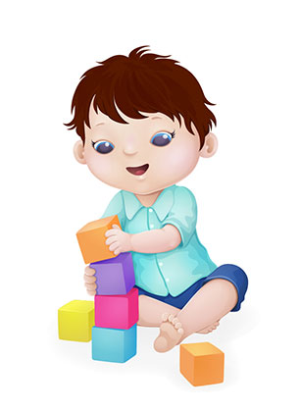
Jacky was three years old. He was cute but thin when he first came to our house. He lived at a (27) ; both his father and mother (28) in a car accident. How lucky I _(29)_ to have a brother now. I will be kind (30) him and be a good sister.
26. (A ) ,but (B) ,so (C) ,or (D) because
27. (A) magic house (B) tree house
(C) children’s home (D) house for old people
28. (A) died (B) fell (C) dropped (D) donated
29. (A) am (B) was (C) are (D) were
30. (A) of (B) to (C) in (D) for
四、閱讀測驗 12% (每題2分)
1.
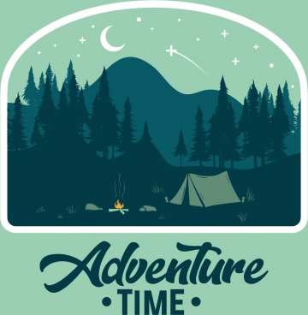
Holmes and Watson went mountain climbing. After six hours of hiking, they set up a tent by a lake. They were very tired, so they went in to sleep. Hours later, Holmes woke his friend up.
Holmes: Watson, wake up! Look around us.
Watson: Wow! How beautiful! A sky full of stars.
Holmes: What does that tell you?
Watson: It tells me three things. First, there might be aliens living up here. Second, the world is so big, and we are so small. Third, the weather tomorrow should be nice. What about you, Holmes? What do you think?
Holmes: Watson, someone took our tent.
31. What can we learn from the dialogue?
(A) Watson was good at counting stars.
(B) Watson spotted aliens near the tent.
(C) Watson and Holmes may need a raincoat tomorrow.
(D) Watson and Holmes weren’t in their tent in the end.
32. What does that mean in the dialogue?
(A) Seeing the stars.
(B) Camping by a lake.
(C) Getting enough rest.
(D) Waking up a sleeping friend.
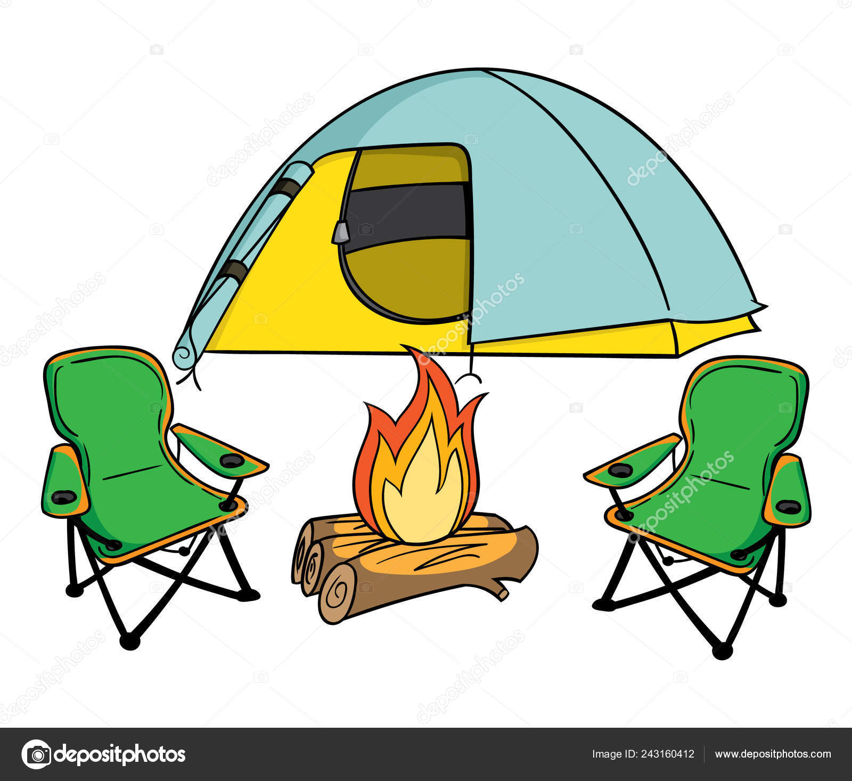
33. Two people walked by Holmes and Watson’s tent that night and took their tent. Which could be a conversation between the two?
(A) A: Whose tent is this? It’s big and beautiful.
B: I don’t know. Let’s ask the other campers.
(B) A: Hey, look! They are sleeping like a baby.
B: We’re so lucky. Let’s do it.
(C) A: Sleeping under the stars looks great.
B: Yeah. We should try it someday.
(D) A: Nice tent! Where can we get one?
B: Look at that corner. The tent is from Marco’s Shop.
2.
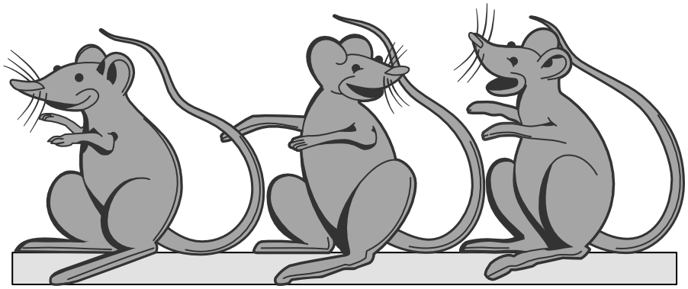
There were three mice living in a deserted(廢棄的) house. Their biggest dream was to find a lot of food. One day, an oil businessman came to the town to sell oil and stayed in the deserted house for one night. In the late night, the good smell of the oil filled the room and the three mice sniffed (聞)it. But the oil was on the bottom(底部) of a big tub, and they could not get it from the rim(邊緣). Then the three mice thought of a smart way. Biting the former’s(前者的) tail, they could line up and hang down to the oil. After the first mouse was full, he had to climb up to be the last one. In this way, all of the three mice could take turns (輪流) drinking oil. In the beginning, things went well. But when the first mouse drank the oil, he changed his mind. The oil was so delicious and he decided to drink it up. The second mouse wanted to be the first one to drink the oil, so he opened his mouth and tried to get as much oil as possible(可能的). Worrying his two friends would drink up all the oil, the third mouse opened his mouth, too. Just at that moment, the three mice dropped. Although(雖然) they all drank the oil successfully(成功地), they could never get out of the tub.
34. What can we know about the three mice?
(A) They learned to share everything with friends.
(B) They planned to leave the place where they lived for food.
(C) They worked wisely and got what they wanted at last.
(D) They once thought they could make their dream come true by working together.
35. What lesson do we learn from the story?
(A) Two heads are better than one.
(B) If you only think of yourself, you can’t get any help from others.
(C) Those who climb the highest(最高) also fall the most heavily(最重).
(D) Everyone’s business is nobody’s business.
36. Why did the last two mice open their mouths?
(A) To have water.
(B) To drink some oil.
(C) To get some fresh air.
(D) To talk to each other.

※下列題目請在答案卷上作答，共38分
五、文意字彙 20%(每題2分)
37. What did you learn in sc____e class today? Frogs?
38. Don’t go near those monkeys. They may a__k you.
39. Bryan is taking English l_____ns. He likes his English teacher, Amada, very much.
40. It was sunny yesterday afternoon, so we had a p______c at the park.
41. Anny is a w_______l teacher. She is always there for her students but never spoils(寵壞) them.
42. I ate too much and I b____ped during the English speech contest, so I didn’t win anything.
43. People like to play v_____ll or swim at the beach.
44. I got a pair of bi______rs as a gift so I can watch the stars at night.
45. Someone d_____ted a lot of money to help the poor children to have a free(免費的) dinner after school.
46. Mr. Smith is a ge_______s person and he likes to give money or help people in need.

六、47-50寫出介係詞，51-54寫出正確動詞形式8%
47. Did you send the card ____ Leo?
48. Please buy a bottle of water ___ me.
49. It’s kind ___ you to write me a card.
50. Thanks ___ you, I won the contest.
51. She _____ (draw) an elephant on the blackboard.
52. My mom ________ (read) a story to me last night.
53-54. Judy _______ (hate) English in the past, but she _______ (like) it now.
七、翻譯(中翻英) 10%
55. 我們爬進樹屋，吃完一整盤袋鼠肉，以及在營火 旁聽故事。(3%)
56. 這寶寶熟睡著，所以他的母親在他眼睛上親了
下來喚醒他。(3%)
57. 這雙跑步鞋對我而言是個大驚喜。我可以
為你做一頓大餐(晚餐)來親自感謝你 (4%) (授予動詞要用介係詞的用法)



考試結束，辛苦啦！

